Outline Image (Case domention is about)
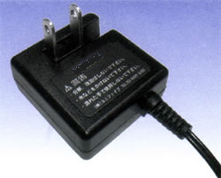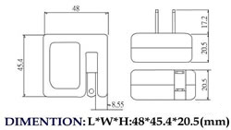

5.5mm
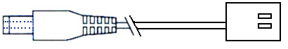
Cord length About 2m
2.1mm
9.5mm

