
-------------------------------------------------------------------------------------------------------
13W Board with ICE2A0565

The board described here was designed as a typical power supply in flyback converter topology with four output voltages and secondary control. This type of switching mode power supply is particularly suitable as an AC/DC power supply for DVD. The switching mode power supply ICE2A0565 chip used is a current-controlled pulse width modulator with integrated CoolMOS power switch.

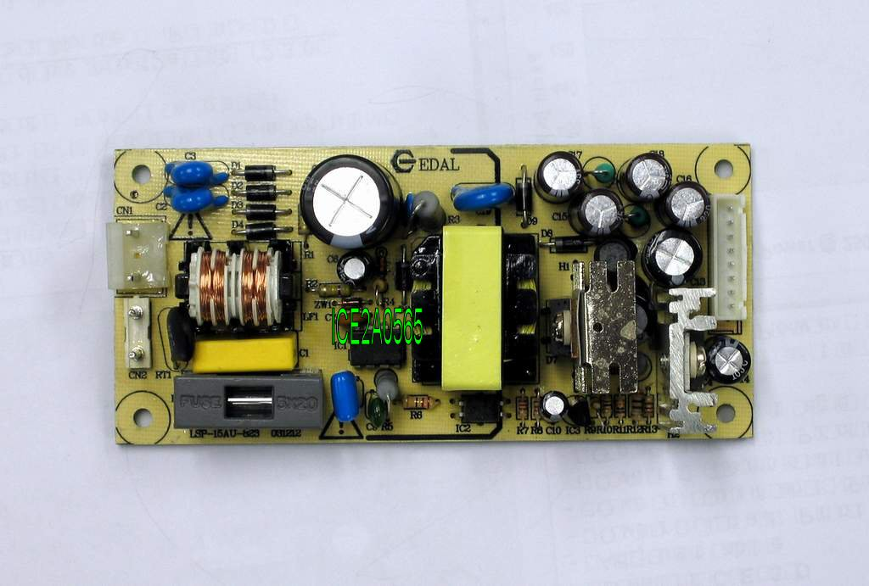
Other output voltages can also be implemented very easily by simple modification of the transformer and the output circuitry.

Technical Specification:

Input Voltage Range | 85 … 270V AC
Operation Frequency | 100 kHz
Output Voltage | 12V ±10% /100mA；  -12V±10% / 50mA；  5V ±5% / 1.5A；  3.3V ±5% / 1.5A
Output Power | 13W
Temp Range | 0 … 70 ℃
Output Ripple Voltage | < 100 mV

