Country | Certification Body | Approval Logo | Safety/EMC Requirement |  | Required Sample | Lead Time
Singapore | Spring (PSB) |  | Yes | No | 2 | *2-3 weeks
Japan | PSE (JET) |  | Yes | Yes | 3 | 5 weeks
 |  |  |  |  | 2 | *4 weeks
Japan | PSE (JQA) |  | Yes | Yes | 6 | 5 weeks
 |  |  |  |  | 2 | *4 weeks
Japan | PSE  (TUV Rheinland) |  | Yes | Yes | 6 | 5 weeks
 |  |  |  |  | 1 | *4 weeks
Rep. Korea | EK (KTL) |  | Yes | Yes | 2 | *6 weeks
Rep. Korea | EK (KETI) |  | Yes | Yes | 2 | *4 weeks
Rep. Korea | MIC (RRL) |  | No | Yes | 2 | 3-4 weeks
Hong Kong | S mark  (TUV Rheinland) |  | Yes | No | No | *3 weeks
India | STQC |  | Yes | Yes | 2 | *6 weeks
India | BIS |  | Yes | No | -- | --
Israel | SII |  | Yes | Yes | -- | --
Saudi Arabia | SASO |  | Yes | No | -- | --
Mexico | NOM (NYCE) |  | Yes | No | 1 | 4 weeks
Brazil | UCIEE |  | Yes | No | -- | --
Argentina | S mark  (IRAM) |  | Yes | No | 2 | *4 weeks
Argentina | S mark  (TUV Rheinland) | 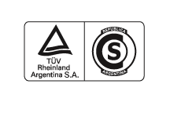 | Yes | No | No | *3 weeks
Australia | DOFT | -- | Yes | No | No | *3 weeks
Australia | DOIR | -- | Yes | No | 2 | *3 weeks
Australia | OCEI | -- | Yes | No | 1 | *3 weeks
Australia | SAI |  | Yes | No | -- | --
Australia | C-tick (ACA) |  | No | Yes | No | 1-2 weeks
 | VDE |  | Yes | No | -- | --
Russia | GOST |  | Yes | Yes | 2 | 4 weeks
Belarus | BELLIS |  | Yes | Yes | 1 | *3 weeks
Poland | PCBC |  | Yes | Yes | -- | --
Poland | BBJ-SEP |  | Yes | Yes | 1 | *4 weeks
Poland | PREDOM-  OBR |  | Yes | Yes | -- | --
Hungary | MEEI | 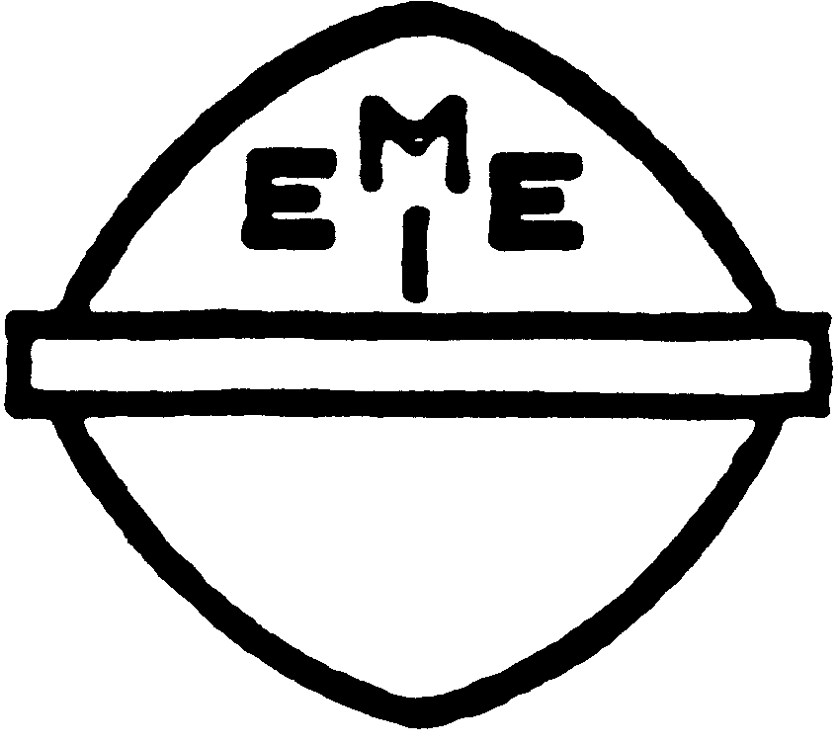 | Yes | Yes | -- | --
Hungary | S mark  (TUV Rheinland) |  | Yes | Yes | No | *4 weeks
Czech Republic | EZU |  | Yes | No | -- | --
Slovakia | EVPU |  | Yes | Yes | -- | --
Slovenia | SIQ |  | Yes | Yes | -- | --
France | NF mark  (LCIE) |  | Yes | Yes | -- | --
Ireland | NSAI |  | Yes | Yes | -- | --
The Netherlands | KEMA |  | Yes | Yes | -- | --
Switzerland | SEV |  | Yes | Yes | 0 | *2 weeks
Belgium | CEBEC |  | Yes | No | -- | --
Estonia | EEI |  | Yes | Yes | -- | --
Latvia | LVS | -- | Yes | Yes | -- | --
Lithuania | INFOSTRUKTŪRA |  | Yes | Yes | -- | --
Croatia | KONCAR |  | Yes | Yes | 0 | *4 weeks
Italy | IMQ |  | Yes | Yes | -- | --
Ukraine | UkrTEST |  | Yes | Yes | 0 | *3 weeks
Serbia and Montenegro | SZS |  | Yes | Yes | -- | --
Austria | OVE |  | Yes | Yes | -- | --
United Kingdom | BEAB | 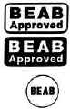 | Yes | Yes | 0 | *4 weeks
United Kingdom | BSI |  | Yes | Yes | -- | --
United Kingdom | ASTA |  | Yes | Yes | -- | --
Spain | AENOR | 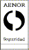 | Yes | Yes | -- | --
Portugal | CERTIF |  | Yes | Yes | -- | --
Greece | ELOT | 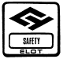 | Yes | Yes | -- | --
Turkey | TSE |  | Yes | Yes | -- | --
South Africa | SABS |  | Yes | Yes | 0 | *4 weeks

Note:
- In the lead-time column, an asterisk indicates the lead-time was estimated when CB report is ready.
- The charge for local representative is excluded.

