中国标准电源插头
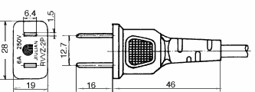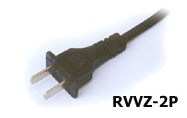
227IEC42(RVB)2×0.5mm² 6A250V
227IEC42(RVB)2×0.75mm² 6A250V
227IEC52(RVV)2×0.5mm² 6A250V
227IEC52(RVV)2×0.75mm² 6A250V
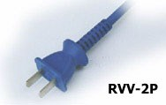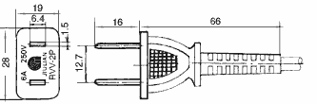
227IEC52(RVV) 2×0.75mm² 6A250V
227IEC53(RVV) 2×0.75mm² 6A250V
227IEC53(RVV) 2×1.0mm² 10A250V
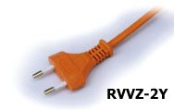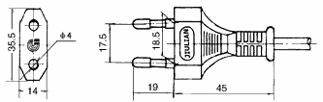
227IEC42(RVB)2×0.5mm² 6A250V
227IEC42(RVB)2×0.75mm² 6A250V
227IEC52(RVV)2×0.5mm² 6A250V
227IEC52(RVV)2×0.75mm² 6A250V
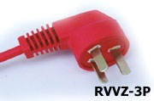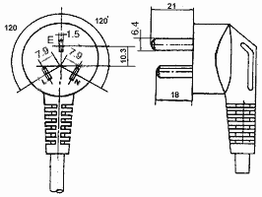
227IEC52（RVV）3×0.5mm² 6A250V
227IEC52（RVV）3×0.75mm² 6A250V
227IEC53（RVV）3×0.75mm² 6A250V
227IEC53（RVV）3×1.0mm² 10A250V
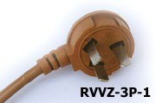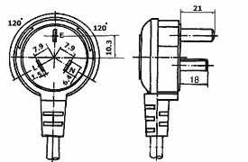
227IEC52（RVV）3×0.5mm² 6A250V
227IEC52（RVV）3×0.75mm² 6A250V
227IEC53（RVV）3×0.75mm² 6A250V
227IEC53（RVV）3×1.0mm² 10A250V
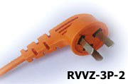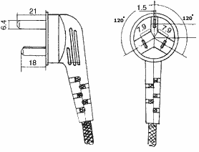
227IEC52（RVV）3×0.5mm² 6A250V
227IEC52（RVV）3×0.75mm² 6A250V
227IEC53（RVV）3×0.75mm² 6A250V
227IEC53（RVV）3×1.0mm² 10A250V
RX 300/300V 3×0.75mm² 6A250V
RX 300/300V 3×1.0mm² 10A250V

欧洲标准电源插头
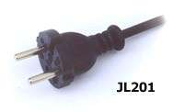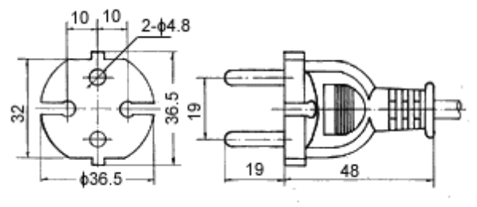
H03VVH2 -F | 2X0.5mm² | 10/16A250V
H03VVH2 -F | 2X0.75mm² | 10/16A250V
H03VV -F | 2X0.5mm² | 10/16A250V
H03VV -F | 2X0.75mm² | 10/16A250V
H05VVH2 -F | 2X0.75mm² | 10/16A250V
H05VVH2 -F | 2X1.0mm² | 10/16A250V
H05VV -F | 2X0.75mm² | 10/16A250V
H05VV -F | 2X1.0mm² | 10/16A250V
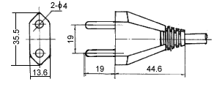

H03VVH2 -F | 2X0.5mm² | 2.5A250V
H03VVH2 -F | 2X0.75mm² | 2.5A250V
H03VV -F | 2X0.5mm² | 2.5A250V
H03VV -F | 2X0.75mm² | 2.5A250V
H05VVH2 -F | 2X0.75mm² | 10A250V
H05VVH2 -F | 2X1.0mm² | 10A250V
H05VV -F | 2X0.75mm² | 10A250V
H05VV -F | 2X1.0mm² | 10A250V
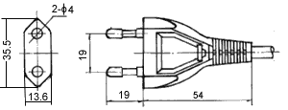
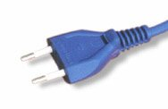
H03VVH2 -F | 2X0.5mm² | 2.5A250V
H03VVH2 -F | 2X0.75mm² | 2.5A250V
H03VV -F | 2X0.5mm² | 2.5A250V
H03VV -F | 2X0.75mm² | 2.5A250V
H05VVH2 -F | 2X0.75mm² | 10A250V
H05VVH2 -F | 2X1.0mm² | 10A250V
H05VV -F | 2X0.75mm² | 10A250V
H05VV -F | 2X1.0mm² | 10A250V
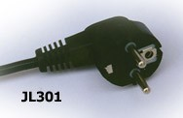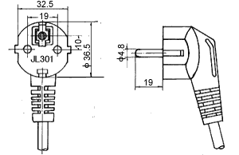
H03VV -F | 3G0.5mm² | 10/16A250V
H03VV -F | 3G0.75mm² | 10/16A250V
H05VV -F | 3G0.75mm² | 10/16A250V
H05VV -F | 3G1.0mm² | 10/16A250V
H05VV -F | 3G1.5mm² | 10/16A250V
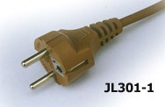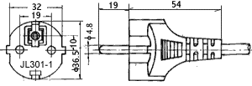
H03VV -F | 3G0.5mm² | 10/16A250V
H03VV -F | 3G0.75mm² | 10/16A250V
H05VV -F | 3G0.75mm² | 10/16A250V
H05VV -F | 3G1.0mm² | 10/16A250V
H05VV -F | 3G1.5mm² | 10/16A250V
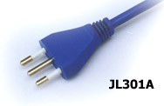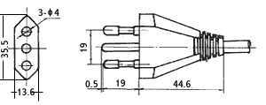
H03VV -F | 3G0.5mm² | 10A250V
H03VV -F | 3G0.75mm² | 10A250V
H05VV -F | 3G0.75mm² | 10A250V
H05VV -F | 3G1.0mm² | 10A250V
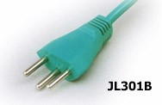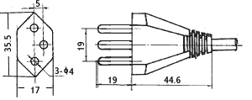
H03VV -F | 3G0.5mm² | 10A250V
H03VV -F | 3G0.75mm² | 10A250V
H05VV -F | 3G0.75mm² | 10A250V
H05VV -F | 3G1.0mm² | 10A250V
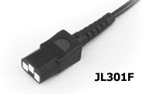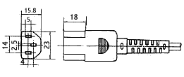
227IEC52(RVV) | 3X0.75mm² | 10A250V
227IEC53(RVV) | 3X0.75mm² | 10A250V
227IEC53(RVV) | 3X1.0mm² | 10A250V
H03VV -F | 3G0.75mm² | 6A250V
H05VV -F | 3G0.75mm² | 10A250V
H05VV -F | 3G1.0mm² | 10A250V
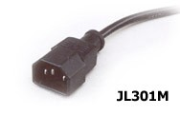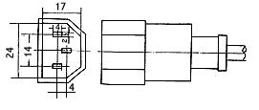
227IEC52(RVV) | 3X0.75mm² | 10A250V
227IEC53(RVV) | 3X0.75mm² | 10A250V
227IEC53(RVV) | 3X1.0mm² | 10A250V
H03VV -F | 3G0.75mm² | 6A250V
H05VV -F | 3G0.75mm² | 10A250V
H05VV -F | 3G1.0mm² | 10A250V
澳大利亚标准电源插头
SAA
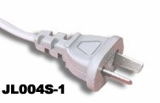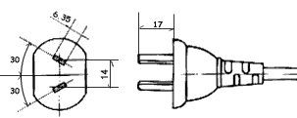
H05VVH2 -F | 2X0.75mm² | 7.5A250V
H05VV -F | 2X0.75mm² | 7.5A250V
H05VV -F | 2X1.0mm² | 10A250V
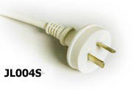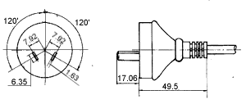
H05VVH2 -F | 2X0.75mm² | 7.5A250V
H05VV -F | 2X0.75mm² | 7.5A250V
H05VV -F | 2X1.0mm² | 10A250V
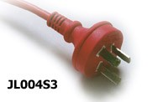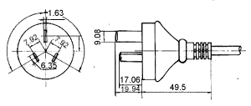
H05VV -F | 3G0.75mm² | 7.5A250V
H05VV -F | 3G1.0mm² | 10A250V
H05VV -F | 3G1.5mm² | 15A250V
美国标准电源插头
C-UL
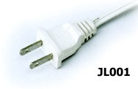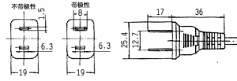
SPT-1 | 18AWG/2C
SPT-2 | 18AWG/2C
SPT-2 | 16AWG/2C
SPT-3 | 18AWG/2C
SPT-3 | 16AWG/2C
SVT | 18AWG/2C
SVT | 17AWG/2C
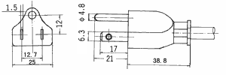  NISPT-1 | 18AWG/2C
NISPT-2 | 18AWG/2C
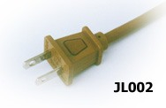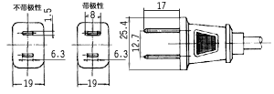
SVT | 18AWG/2C
SVT | 17AWG/2C
ST | 18AWG/2C
ST | 16AWG/2C
SJT | 18AWG/2C
SJT | 16AWG/2C
NISPT-1 | 18AWG/2C
NISPT-2 | 18AWG/2C
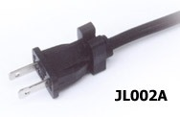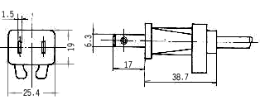
SVT | 18AWG/2C
SVT | 17AWG/2C
SVT | 18AWG/2C(齿形)
SVT | 17AWG/2C(齿形)
ST | 18AWG/2C
ST | 16AWG/2C

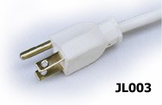

SPT-1 | 18AWG/3C
SPT-2 | 18AWG-16AWG/3C
SPT-3 | 18AWG-16AWG/3C
SVT | 18AWG- 17AWG/3C
SVT | 18AWG-17AWG/3C(齿形)
ST | 18AWG-16AWG/3C
SJT | 18AWG-16AWG/3C
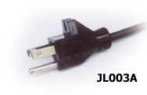
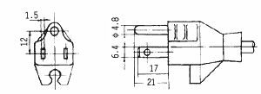

SVT | 18AWG/3C
SVT | 17AWG/3C
SVT | 18AWG/3C(齿形)
SVT | 17AWG/3C(齿形)
ST | 18AWG/3C
ST | 16AWG/3C
SJT | 16AWG/3C
SJT | 18AWG/3C

日本标准电源插头
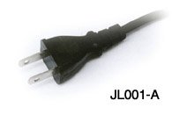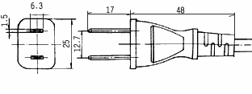
VFF | 2X0.75mm² | 7A125V
VCTF | 2X0.75mm² | 7A125V
VCTFK | 2X0.75mm² | 7A125V
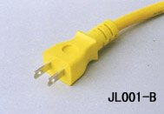

以色列 南非 英国电源插头
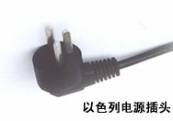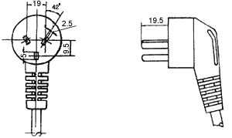
H03VV-F | 3G0.75mm²
H05VV-F | 3G0.75mm²
H05VV-F | 3G1.0mm²
H05VV-F | 3G1.5mm²
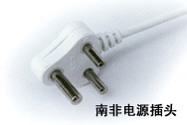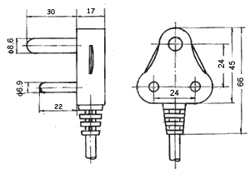
H03VV-F | 3G0.75mm²
H05VV-F | 3G0.75mm²
H05VV-F | 3G1.0mm²
H05VV-F | 3G1.5mm²

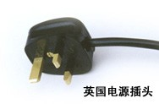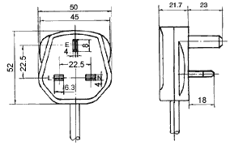

H03VV-F | 3G0.5mm²
H03VV-F | 3G0.75mm²
H05VV-F | 3G0.75mm²
H05VV-F | 3G1.0mm²
H05VV-F | 3G1.5mm²

欧洲标准电源线
· | 标准: | DIN VDE0281
· | 型号: | H03VVH2-F H03VV-F  H05VVH2-F H05VV-F
· | 额定电压: | H03 300/300V
· | 额定电压: | H05 300/500V
· | 应用: | H03型适用小功率家用电器、电动工具及动力照明等。  H05型适用大功率家用电器电动工具及照明等
· | 构造

H03VVH2-F & H05VVH2-F
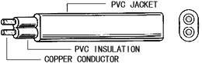
H03VV-F & H05VV-F
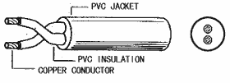 | 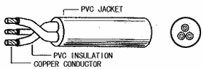
H03VVH2-F & H03VV-F
芯数 | 面积(mm²) | 结构(No/mm) | 绝缘厚度(mm) | 护套厚度(mm) | 完成外径(mm)
2 | 0.5 | 28/0.15 | 0.5 | 0.5 | 3.3X5.4
2 | 0.5 | 28/0.15 | 0.5 | 0.5 | 5.4
2 | 0.75 | 42/0.15 | 0.5 | 0.5 | 3.4X5.6
2 | 0.75 | 42/0.15 | 0.5 | 0.5 | 5.6
3 | 0.5 | 28/0.15 | 0.5 | 0.5 | 5.6
3 | 0.75 | 42/0.15 | 0.5 | 0.5 | 6.1

H05VVH2-F & H05VV-F
芯数 | 面积(mm²) | 结构(No/mm) | 绝缘厚度(mm) | 护套厚度(mm) | 完成外径(mm)
2 | 0.75 | 42/0.15 | 0.6 | 0.8 | 6.5
2 | 0.75 | 42/0.15 | 0.6 | 0.8 | 4.1X6.5
2 | 1.0 | 32/0.2 | 0.6 | 0.8 | 6.7
2 | 1.0 | 32/0.2 | 0.6 | 0.8 | 4.3X6.9
2 | 1.5 | 48/0.2 | 0.8 | 0.8 | 7.7
3 | 0.75 | 42/0.15 | 0.6 | 0.8 | 6.8
3 | 1.0 | 32/0.2 | 0.6 | 0.8 | 7.3
3 | 1.5 | 48/0.15 | 0.8 | 0.9 | 8.4

中国标准电源线
导线
· | 标准: | GB5023.3-1997
· | 型号: | 227 IEC 02(RV),227 IEC 08(RV-90)
· | 额定电压: | 227 IEC 02(RV) 450/750V
· | 额定电压: | 227 IEC 08(RV-90) 300/500V
· | 应用: | 02型适用各种家用电器、仪器仪表连接等
· | 应用: | 08型适用各种家用电器高温下连接

· 构造
227 IEC 02(RV) & 227 IEC 08(RV-90)
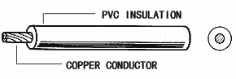
227 IEC 02(RV)
导体 |  | 绝缘
面积(mm²) | 构造(No./mm) | 标称厚度(mm) | 完成外径(mm)
1.5 | 48/0.2 | 0.7 | 3.0
2.5 | 80/0.2 | 0.8 | 3.65
227 IEC 08(RV-90)
导体 |  | 绝缘
面积(mm²) | 构造(No./mm) | 标称厚度(mm) | 完成外径(mm)
0.75 | 42/0.15 | 0.6 | 2.6
1.0 | 32/0.2 | 0.6 | 2.8
1.5 | 48/0.2 | 0.7 | 3.05
2.5 | 80/0.2 | 0.8 | 3.7

扁型软线
· | 标准: | GB5023.5-1997
· | 型号: | 227 IE C42(RVB)
· | 额定电压: | 300/300V
· | 应用: | 适用于小功率家用电器及照明。

·构造
227 IEC 42(RVB)
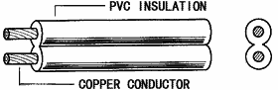
227 IEC 42(RVB)
导体 |  |  | 绝缘厚度(mm) | 完成外径(mm)
芯数 | 面积(mm²) | 结构(No./mm) | 绝缘厚度(mm) | 完成外径(mm)
2 | 0.5 | 28/0.15 | 0.8 | 2.7×5.4
2 | 0.75 | 42/0.15 | 0.8 | 2.9×5.8

护套软电线
· | 标准: | GB5023.5-1997
· | 型号: | 227 IEC 52(RVV),227 IEC 53(RVV)
· | 额定电压: | 227 IEC 52(RVV)300/300V
· | 额定电压: | 227 IEC 53(RVV)300/500V
· | 应用: | 227 IEC 52(RVV)适用于小功率家用电器、电  动工具以及动力照明等。
· | 应用: | 227 IEC 53(RVV)适用于大功率家用电器、电  动工具以及动力照明等。
· | 构造

227 IEC 52(RVV) & 227 IEC 53(RVV)
扁型
圆型芯数
227 IEC 52(RVV)
芯数 | 面积(mm²) | 结构(No/mm) | 绝缘厚度(mm) | 护套厚度(mm) | 完成外径(mm)
2 | 0.5 | 28/0.15 | 0.5 | 0.6 | 5.3
2 | 0.5 | 28/0.15 | 0.5 | 0.6 | 3.26×5.3
2 | 0.75 | 42/0.15 | 0.5 | 0.6 | 5.7
2 | 0.75 | 42/0.15 | 0.5 | 0.6 | 3.4×5.8
3 | 0.5 | 28/0.15 | 0.5 | 0.6 | 5.6
3 | 0.75 | 42/0.15 | 0.5 | 0.6 | 6.05

227 IEC 53(RVV)
芯数 | 面积(mm²) | 结构(No/mm) | 绝缘厚度(mm) | 护套厚度(mm) | 完成外径(mm)
2 | 0.75 | 42/0.15 | 0.6 | 0.8 | 6.5
2 | 0.75 | 42/0.15 | 0.6 | 0.8 | 4.1×6.5
2 | 1.0 | 32/0.2 | 0.6 | 0.8 | 6.9
2 | 1.5 | 48/0.2 | 0.7 | 0.8 | 7.7
3 | 0.75 | 42/0.15 | 0.6 | 0.8 | 6.9
3 | 1.0 | 32/0.2 | 0.6 | 0.8 | 7.4
3 | 1.5 | 48/0.2 | 0.7 | 0.9 | 8.5

日本标准电源线
VFF
· | 标准: | JIS C 3306
· | 型号: | VFF
· | 额定电压: | 300V
· | 使用温度: | 75°C
· | 应用: | 适用于各种家用电器、电动工具及  动力照明。

· 构造
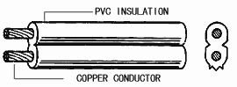
芯数 | 面积(mm²) |  | 结构(No/mm) |  | 绝缘厚度(mm) | 完成外径(mm)
2 | 0.5 |  | 20/0.18 |  | 0.8 | 2.5×5.0
2 | 0.75 |  | 30/0.18 |  | 0.8 | 2.7×5.4
2 | 1.25 |  | 50/0.18 |  | 0.8 | 3.1×6.2
· |  | 标准: |  | JIS C 3306
· |  | 型号: |  | VCTFK&VCTF
· |  | 额定电压: |  | 300V
· |  | 使用温度: |  | 75°C
· |  | 应用: |  | 适用于各种家用电器、电动工具及  动力照明。
· |  | 构造

VCTFK & VCTF
VCTFK
VCTF
VCTFK & VCTF
型号 | 芯数 | 面积(mm²) | 结构(No/mm) | 绝缘厚度(mm) | 护套厚度(mm) | 完成外径(mm)
VCTFK | 2 | 0.75 | 30/0.18 | 0.6 | 1.0 | 4.2×6.5
VCTFK | 2 | 1.25 | 50/0.18 | 0.6 | 1.0 | 4.7x7.4
VCTF | 2 | 0.75 | 30/0.18 | 0.6 | 1.0 | 6.6
VCTF | 2 | 1.25 | 50/0.18 | 0.6 | 1.0 | 7.4
VCTF | 3 | 0.75 | 30/0.18 | 0.6 | 1.0 | 7.0
VCTF | 3 | 1.25 | 50/0.18 | 0.6 | 1.0 | 8.5

美国标准电源线
C-UL

· | 标准: | UL62
· | 型号: | SPT-1，SPT-2，SPT-3，NISPT-2，  SVT，ST，SJT
· | 额定电压: | 300V，600V（ST）
· | 使用温度: | 60°C/105°C
· | 应用: | 适用于各种家用电器、电动工具及  动力照明。

· 构造
SPT-1 & SPT-2 & SPT-3
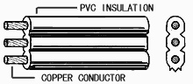
型号 | 芯数 | 线规 | 面积(mm²) | 结构(No/mm) | 护套厚度(mm) | 完成外径(mm)
PT-1 | 2 | 18 | 0.823 | 41/0.16 | 0.76 | 2.7X5.4
PT-1 | 3 | 18 | 0.823 | 41/0.16 | 0.76 | 2.7X7.5
SPT-2 | 2 | 18 | 0.823 | 41/0.16 | 1.14 | 3.5X6.9
SPT-2 | 2 | 16 | 1.31 | 2.6/0.253 | 1.14 | 3.7X7.5
SPT-2 | 3 | 18 | 0.823 | 41/0.16 | 1.14 | 3.6X8.6
SPT-2 | 3 | 16 | 1.31 | 26/0.253 | 1.14 | 3.9X9.6
SPT-3 | 2 | 18 | 0.823 | 41/0.16 | 1.52 | 4.4X7.8
SPT-3 | 2 | 16 | 1.31 | 26/0.253 | 1.52 | 4.5X9.1
SPT-3 | 3 | 18 | 0.823 | 41/0.16 | 1.52 | 4.3X9.8
SPT-3 | 3 | 16 | 1.31 | 26/0.253 | 1.52 | 4.6X11.8

NISPT-1 & NISPT-2
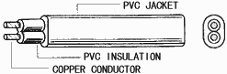
型号 | 芯数 | 线规 | 面积(mm²) | 结构(No/mm) | 绝缘厚度(mm) | 护套厚度(mm) | 完成外径(mm)
NISPT-1 | 2 | 18 | 0.823 | 41/0.16 | 0.38 | 0.38 | 3.1x6.0
NISPT-2 | 2 | 18 | 0.823 | 41/0.16 | 0.76 | 0.38 | 4.0x7.6

SVT & ST & SJT
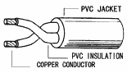 | 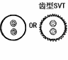
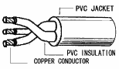 | 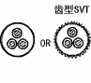
型号 | 芯数 | 线规 | 面积(mm²) | 结构(No/mm) | 绝缘厚度(mm) | 护套厚度(mm) | 完成外径(mm)
SVT | 2 | 18 | 0.823 | 41/0.16 | 0.38 | 0.76 | 5.9±0.1
SVT | 3 | 18 | 0.823 | 41/0.16 | 0.38 | 0.76 | 6.3±0.1
SVT | 2 | 17 | 1.04 | 52/0.16 | 0.38 | 0.76 | 6.4±0.1
SVT | 3 | 17 | 1.04 | 52/0.16 | 0.38 | 0.76 | 6.8±0.1
ST | 2 | 18 | 0.823 | 41/0.16 | 0.76 | 1.52 | 8.5±0.15
ST | 3 | 18 | 0.823 | 41/0.16 | 0.76 | 1.52 | 8.9±0.15
ST | 2 | 16 | 1.31 | 26/0.253 | 0.76 | 1.52 | 9.3±0.15
ST | 3 | 16 | 1.31 | 26/0.253 | 0.76 | 1.52 | 9.8±0.15
SJT | 2 | 18 | 0.823 | 41/0.16 | 0.76 | 0.76 | 7.4±0.15
SJT | 2 | 16 | 1.31 | 26/0.253 | 0.76 | 0.76 | 7.8±0.15
SJT | 2 | 14 | 2.08 | 41/0.253 | 0.76 | 0.76 | 8.6±0.15
SJT | 3 | 18 | 0.823 | 41/0.16 | 0.76 | 0.76 | 7.8±0.15
SJT | 3 | 16 | 1.31 | 26/0.253 | 0.76 | 0.76 | 8.4±0.15
SJT | 3 | 14 | 2.08 | 41/0.253 | 0.76 | 0.76 | 9.3±0.15

澳洲标准电源线
SAA

· | 标准: | SAA AS 3191-1994
· | 型号: | H03VVH2-F H03VV-F  H05VVH2-F H05VV-F
· | 额定电压: | H03 300/300V
· | 额定电压: | H05 300/500V
· | 应用: | H03型适用小功率家用电器、电动工具及动力照明等。  H05型适用大功率家用电器电动工具及照明等
· | 构造

H03VVH2-F & H05VVH2-F
H03VV-F & H05VV-F
H03VVH2-F & H03VV-F
芯数 | 面积(Sqmm) | 结构(No/mm) | 绝缘厚度(mm) | 护套厚度(mm) | 完成外径(mm)
2 | 0.5 | 28/0.15 | 0.5 | 0.5 | 3.3X5.4
2 | 0.5 | 28/0.15 | 0.5 | 0.5 | 5.4
2 | 0.75 | 42/0.15 | 0.5 | 0.5 | 3.7X5.8
2 | 0.75 | 42/0.15 | 0.5 | 0.5 | 5.6
3 | 0.5 | 28/0.15 | 0.5 | 0.5 | 5.6
3 | 0.75 | 42/0.15 | 0.5 | 0.5 | 6.1

H05VVH2-F & H05VV-F
芯数 | 面积(Sqmm) | 结构(No/mm) | 绝缘厚度(mm) | 护套厚度(mm) | 完成外径(mm)
2 | 0.75 | 42/0.15 | 0.6 | 0.8 | 6.5
2 | 0.75 | 42/0.15 | 0.6 | 0.8 | 4.1X6.5
2 | 1.0 | 32/0.2 | 0.6 | 0.8 | 6.9
2 | 1.5 | 48/0.2 | 0.8 | 0.8 | 7.7
3 | 0.75 | 42/0.15 | 0.6 | 0.8 | 6.8
3 | 1.0 | 32/0.2 | 0.6 | 0.8 | 7.3
3 | 1.5 | 48/0.15 | 0.8 | 0.9 | 8.4

Power Cord: European Standard 2-Pin

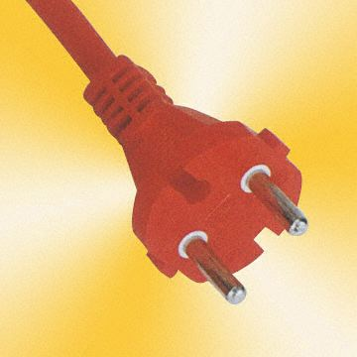
Power Cord: European Standard 3-Pin Angled Type
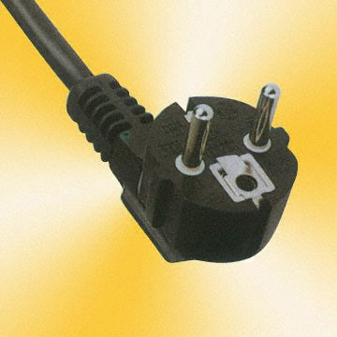
Power Cord: Waterproof European Standard 3-Pin
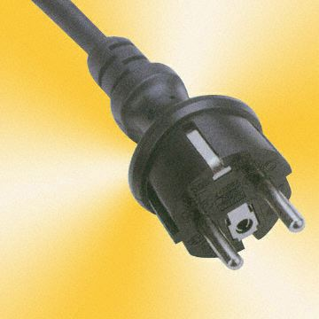
Power Cord: UK Standard 3-Pin
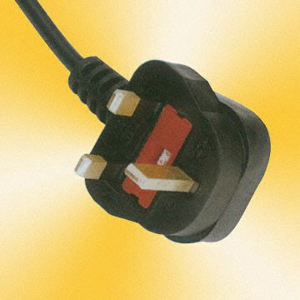
Power Cord: Australia Standard 3-Pin
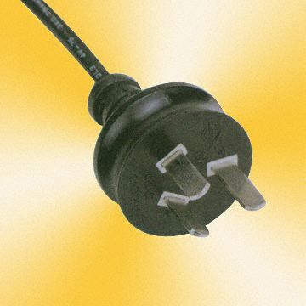
Power Cord: Italy Standard 3-Pin

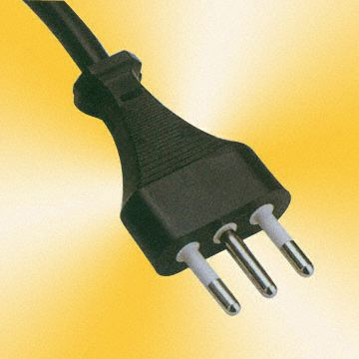

Power Cord: USA/Canada Standard 2 Pin

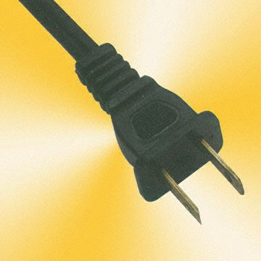

Power Cord: Waterproof European Standard 2-Pin



