Testing Waveforms of EEFL

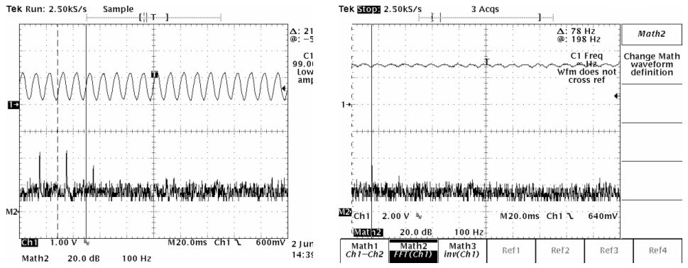

Fig1 Lighting Waveforms Emitted by EEFL Fig2 Lighting Waveforms Emitted by Steady-Lite¹

Note:

CH1: the current of photodiode that receives the lighting of EEFL or Steady-Lite

M2: the FFT calculation of CH1

(Steady-Lite: a laboratory grade fluorescent lighting system produced by Stocker Yale Inc)
- Problem Description

When we used the EEFL as backlighting source, we found that the grey level distribution between different frame images was unstable and its changed range was undesirable, even that some black or white stripes occurred in the same frame image when the exposure time was too long.
- Measurement Result
  - We used 03-20932, the missing die detector board used in die bonder machine, to test the lighting waveform generated by EEFL or Steady-Lite,
  - The above problem was occurred in EEFL but not Steady-Lite.
  - For EEFL
    - The V_{P-P} or low frequency ripple is larger in time domain.
    - The low frequency about 50 to 80 Hz and its second, third or fourth harmonic are main frequency components.
  - For Steady-Lite
    - The V_{P-P} or low frequency ripple is obviously less than EEFL
    - Although the low frequency about 50 to 80 Hz occurs, it’s second, third or higher harmonic are less.
- Testing Analysis
  - It is more reasonable for us reduce the low frequency component and V_{P-P} or the ripple amplitude of the light emitted by EEFL.
  - It is necessary to do further experiments to search the feature of EEFL lighting, such as using different inverter & EEFL.

