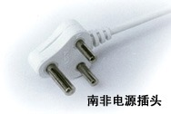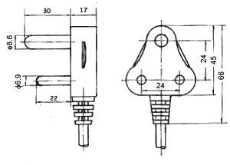
H03VV-F | 3G0.75mm²
H05VV-F | 3G0.75mm²
H05VV-F | 3G1.0mm²
H05VV-F | 3G1.5mm²

