产品说明规格书-安规电容X1：
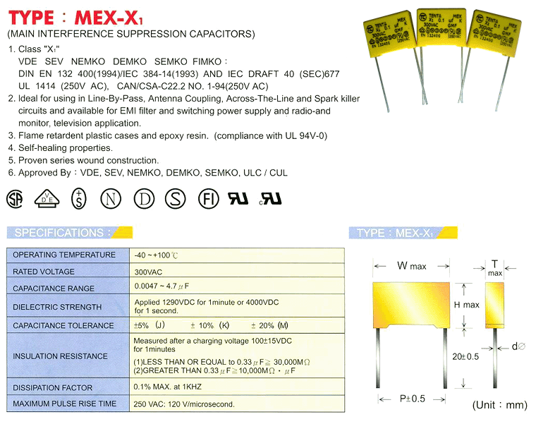

Normal Size
Size
CAP | W | H | T | P | d? | CAP | W | H | T | P | d?
0.0047 | 13.0 | 11.0 | 5.0 | 10.0 | 0.6 | 0.22 | 26.5 | 16.5 | 7.0 | 22.5 | 0.8
0.0056 | 13.0 | 11.0 | 5.0 | 10.0 | 0.6 | 0.33 | 26.5 | 17.0 | 8.5 | 22.5 | 0.8
0.0068 | 13.0 | 11.0 | 5.0 | 10.0 | 0.6 | 0.39 | 26.5 | 19.0 | 10.0 | 22.5 | 0.8
0.0082 | 13.0 | 11.0 | 5.0 | 10.0 | 0.6 | 0.47 | 26.5 | 19.0 | 10.0 | 22.5 | 0.8
0.01 | 13.0 | 11.0 | 5.0 | 10.0 | 0.6 | 0.47 | 32.0 | 20.0 | 11.0 | 27.5 | 0.8
0.012 | 13.0 | 11.0 | 5.0 | 10.0 | 0.6 | 0.56 | 32.0 | 20.0 | 11.0 | 27.5 | 0.8
0.015 | 13.0 | 11.0 | 5.0 | 10.0 | 0.6 | 0.6 | 32.0 | 20.0 | 11.0 | 27.5 | 0.8
0.018 | 13.0 | 12.0 | 6.0 | 10.0 | 0.6 | 0.68 | 32.0 | 20.0 | 11.0 | 27.5 | 0.8
0.022 | 13.0 | 12.0 | 6.0 | 10.0 | 0.6 | 0.82 | 32.0 | 22.0 | 13.0 | 27.5 | 0.8
0.027 | 13.0 | 12.0 | 6.0 | 10.0 | 0.6 | 1.0 | 32.0 | 22.0 | 13.0 | 27.5 | 0.8
0.033 | 18.0 | 11.0 | 5.0 | 15.0 | 0.8 | 1.0 | 37.0 | 24.0 | 12.5 | 31.5 | 0.8
0.039 | 18.0 | 11.0 | 5.0 | 15.0 | 0.8 | 1.2 | 37.0 | 24.0 | 13.5 | 31.5 | 0.8
0.047 | 18.0 | 11.0 | 5.0 | 15.0 | 0.8 | 1.5 | 37.0 | 26.0 | 15.0 | 31.5 | 0.8
0.056 | 18.0 | 12.0 | 6.0 | 15.0 | 0.8 | 1.8 | 37.0 | 29.0 | 19.0 | 31.5 | 0.8
0.068 | 18.0 | 12.0 | 6.0 | 15.0 | 0.8 | 2.2 | 37.0 | 29.0 | 19.0 | 31.5 | 0.8
0.082 | 18.0 | 12.0 | 6.0 | 15.0 | 0.8 | 2.7 | 37.0 | 29.0 | 19.0 | 31.5 | 0.8
0.1 | 18.0 | 13.5 | 6.0 | 15.0 | 0.8 | 3.3 | 39.0 | 32.0 | 22.0 | 31.5 | 0.8
0.12 | 18.0 | 13.5 | 7.5 | 15.0 | 0.8 | 3.9 | 50.0 | 30.0 | 20.0 | 44.5 | 0.8
0.15 | 18.0 | 14.5 | 8.5 | 15.0 | 0.8 | 4.7 | 51.0 | 32.0 | 22.0 | 44.5 | 0.8
0.18 | 26.5 | 16.5 | 7.0 | 22.5 | 0.8

MKP (X2 Class) 射频突波抑制X2电容器产品说明书

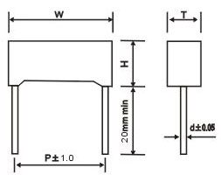 | 特点：  ★宽温度、频率范围内，容量和DF具有高稳定性  ★高电流承受及高绝缘强度  ★长时间工作稳定性  ★能承受高压冲击  用途：  ★线间旁路和天线耦合  ★线间跨接，电制回路花消  ★频率调至滤波  ★开关电源

详细介绍

技术要求：
◆ 介质：聚丙烯（聚脂）薄膜
◆ 电极：真空蒸金属
◆ 包封：阻燃盒子并以环氧树脂灌封
◆ 导线：径向镀锡导线或软导线
◆ 引用标准：IEC 384-14(2nd Edition,1993) UL1414,UL1283,GB/T14472-1998,EN132400
◆ 气候类别：40/85/21（GPE） 40/100/21(GMF)
◆ 静电容量与额定电压：0.001uF-2.2uF/275VAC (50/60Hz)
◆ 静电容量误差：M=+20% K=+10% J=+5%
散逸因素(损耗角正切):<=0.1%(PP聚丙烯)) <=1.0%(PE聚酯) （at 20`C,1KHz）
◆ 耐电压：4.3×Ur Unit：VDC (1 minute at 20`C)
◆ 绝缘电阻：C<=0.33uF IR>=15,000MΩ；C>0.33uF IR*C>=5,000S (1 minute at 20`C and RH<=65%)
◆耐久性：85`C试验温度下
Dimensions: (mm)± 0.5mm
CODE | MFD | 250/275VAC
CODE | MFD | W | H | T | P | d
102-103 | 0.001-0.01 | 13.0 | 11.0 | 5.0 | 10.0 | 0.6
103 | 0.01 | 18.0 | 11.0 | 5.0 | 15.0 | 0.8
123 | 0.012 | 18.0 | 11.0 | 5.0 | 15.0 | 0.8
153 | 0.015 | 18.0 | 11.0 | 5.0 | 15.0 | 0.8
183 | 0.018 | 18.0 | 11.0 | 5.0 | 15.0 | 0.8
223 | 0.022 | 18.0 | 11.0 | 5.0 | 15.0 | 0.8
273 | 0.027 | 18.0 | 11.0 | 5.0 | 15.0 | 0.8
333 | 0.033 | 18.0 | 11.0 | 5.0 | 15.0 | 0.8
393 | 0.039 | 18.0 | 11.0 | 5.0 | 15.0 | 0.8
473 | 0.047 | 18.0 | 11.0 | 5.0 | 15.0 | 0.8
563 | 0.056 | 18.0 | 11.0 | 5.0 | 15.0 | 0.8
683 | 0.068 | 18.0 | 11.0 | 5.0 | 15.0 | 0.8
823 | 0.082 | 18.0 | 12.0 | 6.0 | 15.0 | 0.8
104 | 0.1 | 18.0 | 12.0 | 6.0 | 15.0 | 0.8
124 | 0.12 | 18.0 | 13.5 | 7.5 | 15.0 | 0.8
154 | 0.15 | 18.0 | 14.5 | 8.5 | 15.0 | 0.8
184 | 0.18 | 18.0 | 14.5 | 8.5 | 15.0 | 0.8
224 | 0.22 | 18.0 | 15.5 | 9.5 | 15.0 | 0.8
224 | 0.22 | 26.5 | 16.5 | 7.0 | 22.5 | 0.8
274 | 0.27 | 26.5 | 17.0 | 8.5 | 22.5 | 0.8
334 | 0.33 | 26.5 | 17.0 | 8.5 | 22.5 | 0.8
394 | 0.39 | 26.5 | 19.0 | 10.0 | 22.5 | 0.8
474 | 0.47 | 26.5 | 19.0 | 10.0 | 22.5 | 0.8
474 | 0.47 | 32.0 | 20.0 | 11.0 | 27.5 | 0.8
564 | 0.56 | 32.0 | 20.0 | 11.0 | 27.5 | 0.8
684 | 0.68 | 32.0 | 20.0 | 11.0 | 27.5 | 0.8
824 | 0.82 | 32.0 | 22.0 | 13.0 | 27.5 | 0.8

金属化聚酯薄膜电容器CL21产品说明书
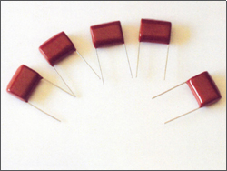 |  |  |  |  | CL21 金属化聚脂膜直流电容器  特点和用途：  特点： 以金属聚脂膜作介质和电极，用绝缘材料包封，单象引出，具有电性能优良 ，可靠性好，耐高温，体积小，容量大， 自愈性好等特点 。  用途：本产品广用于彩电，音响，灯具， 电话，计算机，程控交换机， 传真机及仪器表等直流和脉冲电路中。
技术指标：( GB/T7332-1996 SJ/T10874-1996)
Dimension: (mm)
MFD | 100V |  |  | 250V |  |  | 400V |  |  | 630V
MFD | L | OD | D | L | OD | D | L | OD | D | L | OD | D
0.01 | . | . | . | . | . | . | 16 | 6 | 0.6 | 16 | 6 | 0.6
0.015 | . | . | . | . | . | . | 16 | 6 | 0.6 | 16 | 7 | 0.6
0.022 | . | . | . | . | . | . | 16 | 8 | 0.6 | 16 | 8 | 0.6
0.033 | . | . | . | . | . | . | 16 | 6.5 | 0.6 | 16 | 9 | 0.6
0.047 | . | . | . | 16 | 6 | 0.6 | 16 | 7 | 0.6 | 21 | 8 | 0.6
0.068 | . | . | . | 16 | 6 | 0.6 | 16 | 9.5 | 0.6 | 21 | 9 | 0.6
0.1 | 16 | 6 | 0.6 | 16 | 7 | 0.6 | 21 | 8 | 0.6 | 21 | 10 | 0.8
0.15 | 16 | 6 | 0.6 | 16 | 7.5 | 0.6 | 21 | 8 | 0.6 | 26 | 11 | 0.8
0.22 | 16 | 7 | 0.6 | 21 | 8 | 0.6 | 21 | 9 | 0.8 | 26 | 13 | 0.8
0.33 | 21 | 7 | 0.6 | 21 | 8.5 | 0.6 | 26 | 10 | 0.8 | 26 | 14 | 0.8
0.47 | 21 | 7.5 | 0.6 | 21 | 9.5 | 0.8 | 26 | 12 | 0.8 | 31 | 15 | 0.8
0.68 | 21 | 8.5 | 0.6 | 26 | 9 | 0.8 | 26 | 12.5 | 0.8 | 31 | 18 | 0.8
1.0 | 21 | 10 | 0.8 | 26 | 11 | 0.8 | 31 | 15 | 0.8 | 31 | 20.5 | 0.8
1.5 | 26 | 10.5 | 0.8 | 26 | 12 | 0.8 | 31 | 18 | 0.8 | . | . | .
2.2 | 26 | 11 | 0.8 | 31 | 13.5 | 0.8 | . | . | . | . | . | .
3.3 | 26 | 14 | 0.8 | 31 | 16.5 | 0.8 | . | . | . | . | . | .
4.7 | 31 | 15 | 0.8 | . | . | . | . | . | . | . | . | .
6.8 | 31 | 17.5 | 0.8 | . | . | . | . | . | . | . | . | .
10.0 | 31 | 20.5 | 0.8 | . | . | . | . | . | . | . | . | .

MFD | 100V |  |  |  | 250V |  |  |  | 400V |  |  |  | 630V
MFD | L | H | T | D | L | H | T | D | L | H | T | D | L | H | T | D
0.01 | . | . | . | . | . | . | . | . | 16 | 7 | 4 | 0.6 | 16 | 8 | 5 | 0.6
0.015 | . | . | . | . | . | . | . | . | 16 | 7 | 4 | 0.6 | 16 | 8 | 5 | 0.6
0.022 | . | . | . | . | . | . | . | . | 16 | 8 | 4 | 0.6 | 16 | 9 | 5 | 0.6
0.033 | . | . | . | . | . | . | . | . | 16 | 8 | 4 | 0.6 | 16 | 9 | 5 | 0.6
0.047 | . | . | . | . | 16 | 7 | 4 | 0.6 | 16 | 8 | 5 | 0.6 | 21 | 10 | 5.5 | 0.6
0.068 | . | . | . | . | 16 | 7 | 4 | 0.6 | 16 | 9 | 5 | 0.6 | 21 | 11 | 7 | 0.6
0.1 | 16 | 8 | 4 | 0.6 | 16 | 8.5 | 4 | 0.6 | 21 | 9 | 5 | 0.6 | 21 | 12 | 8 | 0.6
0.15 | 16 | 8 | 4 | 0.6 | 16 | 8.5 | 4 | 0.6 | 21 | 10 | 6 | 0.6 | 26 | 13 | 8 | 0.8
0.22 | 16 | 8 | 5 | 0.6 | 21 | 9 | 5 | 0.6 | 21 | 12 | 7.5 | 0.6 | 26 | 15 | 9 | 0.8
0.33 | 21 | 8 | 5 | 0.6 | 21 | 10 | 6 | 0.6 | 26 | 13 | 8 | 0.8 | 26 | 17 | 11 | 0.8
0.47 | 21 | 9 | 5 | 0.6 | 21 | 10 | 6 | 0.8 | 26 | 14 | 8 | 0.8 | 31 | 17 | 12 | 0.8
0.68 | 21 | 11 | 6 | 0.6 | 26 | 12 | 7 | 0.8 | 26 | 17 | 10 | 0.8 | 31 | 21 | 15 | 0.8
1 | 21 | 12 | 7 | 0.8 | 26 | 13 | 7 | 0.8 | 31 | 18 | 10.5 | 0.8 | 31 | 22 | 16 | 0.8
1.5 | 26 | 13 | 7.5 | 0.8 | 26 | 15 | 8.5 | 0.8 | 31 | 19 | 11 | 0.8 | . | . | . | .
2.2 | 26 | 14 | 8.5 | 0.8 | 31 | 16 | 9 | 0.8 | . | . | . | . | . | . | . | .
3.3 | 26 | 17.5 | 9.5 | 0.8 | 31 | 19 | 12 | 0.8 | . | . | . | . | . | . | . | .
4.7 | 31 | 18 | 11 | 0.8 | . | . | . | . | . | . | . | . | . | . | . | .
6.8 | 31 | 20 | 11 | 0.8 | . | . | . | . | . | . | . | . | . | . | . | .
10 | 31 | 22 | 12 | 0.8 | . | . | . | . | . | .

