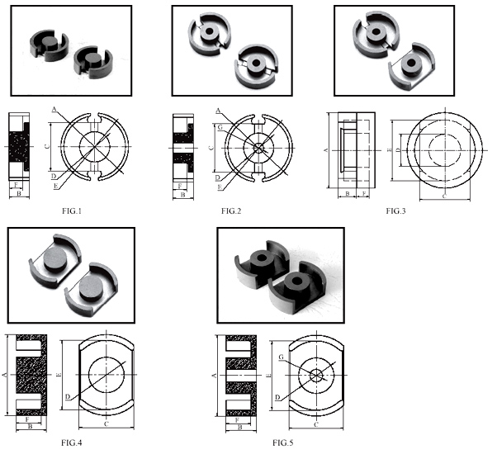
窗体顶端
型号 | FIG | A | B | C | D | E | F | G | H | C1 | Ae | Le | Ve | TP4 | TP4A | TP4W | Weight | 文档
P33.5/24 | 4 | 33.5±0.4 | 12.1±0.2 | 24.0±0.3 | 13.8±0.2 | 26.8min | 9.1±0.25 | 18.2min |  | 0.37 | 159.6 | 59.3 | 9458 | 5400 | 5450 | 6800 | 52.2

