7000W POWER SUPPLY
+48V150A
GND
AC220V

3000W

3000W
AC220V
AC220V
3000W

3000W POWER SUPPLY:
Vdc

Input filter
PFC
DCDC

48Vdc 62A
Vac
400Vdc

12Vdc 15A

5Vdc
3.3Vdc

PFC PCB:
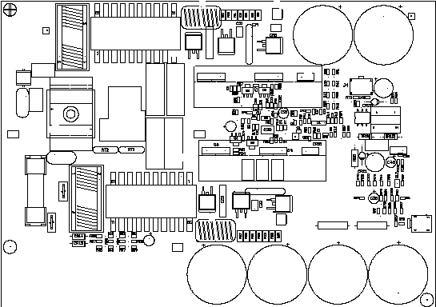

DCDC PCB

