UL 1082
Household Electric Coffee Makers and Brewing-Type Appliances
CONTENTS FOREWORD .
INTRODUCTION
1 Scope . . . . .范围 . . .
2 Glossary . 术语. . . . .
3 Components . . . . .组成 . . . .
4 Units of Measurement . . . . 单位测量法.
5 References . . . . . . . .参考 . . .
CONSTRUCTION 构造
6 General . . . . . . 普通. . . . . . . . . .
7 Frame and Enclosure . . 结构和外壳. . . . . .
8 Assembly . . .装配 . . . . . . . . . . . . . . . . .
9 Handles . . .手柄. . . . . . . . . . . . . . .
10 Corrosion Protection . .腐蚀保护 . . . . . . . .
11 Supply Connections . . 连接线路. . . .
11.1 General . . .普通 . . . . . . . . . .
11.2 Strain relief . . . . . . . . . . .
11.3 Pin terminals . . . . . . . . .
11.4 Bushings . . . . . . . . . . . .
12 Current-Carrying Parts . . . . . .
13 Internal Wiring . . . . . . . . . . . . . .
13.1 General . . . . . . . . . . . . . . . . . . .
13.2 Protection of wiring . . . . . . . .
13.3 Splices . . . . . . . . . . . . . . . . .
14 Secondary Circuits . . . . . . . . . . .
14.1 General . . . . . . . . . . . . . . . . . . . .
14.2 Limited-energy-secondary circuits . . . . .
15 Heating Elements . . . . . . . .
16 Electrical Insulation . . . . . . .
17 Thermal Insulation . . . . . . . .
18 Thermal Cutoffs . . . . . . . . .
19 Lampholders . . . . . . . . . . . . .
20 Switches . . . . . . . . . . . . .
21 Dual Voltage Appliance . . . . . .
22 Limit Controls . . . . . . . . . . . . .
22.1 General . . . . . . . . . . . . . .
22.2 Terminals of safety devices . .
23 Overheating Protection . . . . . . .
24 Spacings . . . . . . . . . . . . . . . . .
24.1 General . . . . . . . . . . . . . . .
24.2 Barriers . . . . . . . . . . . . . . . . .
25 Grounding . . . . . . . . . . . . . . . . . . . . . . . . . . . . . . . . .
26 Protection Against Injury to Persons . . . . . . . . . . . . . . . . . . .
27 Pressure Vessels and Parts Subject to Pressure . . .
PERFORMANCE
28 General . . . . . . . . . . . . . . . . . . . . . . .
29 Resistance of Grounding Test . . . . . . . . . . .
30 Power Input . . . . . . . . . . . . . . . . . . . . . . .
31 Leakage Current Test . . . . . . . . . . . . . . .
32 Operational Tests . . . . . . . . . . . . . . . . .
33 Normal Temperature Tests . . . . . .
33.1 General . . . . . . . . . . . . . . . . . .
33.2 Specific test conditions . . . . . . . . . . . . . . .
34 Leakage Current as a Result of Moisture Tests . . . .
35 Dielectric Voltage-Withstand Test . . . . . . . . . . . . . . .
36 Broken Element Test . . . . . . .
37 Strain Relief Test . . . . . . .
37A Push-Back Relief Test . . . . . .
38 Metal Enclosure Impact Tests . . .
39 Thermal Degradation . . . . . . . . .
40 Handle Securement Tests . . . . . .
40.1 General . . . . . . . . . . . . .
40.2 Oven conditioning . . . . .
40.3 Dishwashing . . . . .
40.4 Flexing test . . . . . . . .
40.5 Static load . . . . . . . . . .
40.6 Static force . . . . . . . .
41 Under-Cabinet and Wall Mounted Appliances-Impact Test . . . . . .
42 Loading Test . . . . . . . . . . . . .
43 Abnormal Operation Tests . . . . . .
43.1 General . . . . . . . . . . . . . . . . . . . . . . .
43.2 Specific test conditions . . . . . . . . . .
43.3 Dual voltage appliances . . . . . . . . . . . . . . .
44 Secondary Circuit Component Failure Test . . . . . . . . .
45 Automatic Controls Test . . .
45.1 General . . . . . . . . . . .
45.2 Endurance . . . . . . . . . . . . .
46 Permanence of Marking Tests . . . . . . .
MANUFACTURING AND PRODUCTION–LINE TESTS
47 Dielectric Voltage-Withstand Test . . . . . . . . . . . .
48 Polarization and Grounding Continuity Tests . . . . .
48.1 Polarization test . . . . . . . . . . . . . .
48.2 Continuity of grounding connection . . . .
48.3 Electrical indicating device . . . . . . . . .
RATINGS
49 Details . . . . . . . . . . . . .
MARKINGS
50 Details . . . . . . . . . . . . . . . . . .
51 Carton Marking . . . . . . . . . . .
INSTRUCTION MANUAL
52 General . . . . . . . . . . . . . . . .
53 All Appliances . . . . . . . . . . .
54 Specific Appliances . . . . . . .
55 User Maintenance . . . . . . .
SUPPLEMENT SA - HOUSEHOLD ELECTRIC DRIP-TYPE COFFEE MAKERS AND SIMILAR
DRIP-TYPE BREWING APPLIANCES
SA1 Scope . . . . . . . . . . . . . . . . . . . . . . . . . . . .
SA2 Assembly . . . . . . . . . . . . . . . .
SA3 Corrosion Protection . . . . . . . . . . .
SA4 Supply Connections . . . . . . .
SA5 Gaskets and Seals . . . . . . . .
SA6 Water Connections . . . . . . . . .
SA7 Thermal Conductivity . . . . . .
SA8 Grounding . . . . . . . . . . . . .
SA9 Operating Controls . . . . . . . . . .
SA10 Power-On Indicator . . . . .
SA11 Temperature Controls . . . . . .
SA11.1 General . . . . . . . . . . . . . . . .
SA11.2 Temperature regulating . . . . . .
SA11.3 Limiting-type devices . . . . . . . .
SA12 Operation Degradation . . . . . . . .
SA13 Leakage Current . . . . . . . . . . . .
SA14 Normal Temperature . . . . .
SA15 Leakage Current as a Result of Moisture . . . . . .
SA16 Stability . . . . . . . .
SA17 Loading Test . . . . . . . . . . .
SA18 Impact Test . . . . . . . . . . . . . . . . . .
SA19 Abnormal Operation . . . . . . . . .
SA19.1 General . . . . . . . . . . . . . . . . .
SA19.2 Specific test conditions . . . . . .
SA19.3 Dry operation . . . . . . . . . . . . .
SA19.4 Overfill . . . . . . . . . . . . . . . . . .
19.5 Restricted water inlet . . . . . . . . . .
SA20 Tests by Manufacturer . . . . . . . . .
SA20.1 Polarization verification . . . .
SA20.2 Continuity of grounding connection . . .
SA20.3 Indicator . . . . . . . . . .
SA21 Details . . . . . . . . . . . . .
SA22 Graphical Symbols and Supplemental Marking . . . . . .
SA22.1 No user-serviceable Parts compartment warning . . . .
SA22.2 Graphical symbol size and color . . . . .
SA22.3 Supplemental marking size and color . . . . . .
SA22.4 Size of outlines and symbols . . . . . . . .
SA22.5 Explanation of graphical symbols in the operating instructions . . . .
SA23 Important Safeguards . . . . . . . .
SA24 User Maintenance . . . . . .
Standards for Components. . . . . .
INTRODUCTION
1 Scope 范围
  - These requirements cover portable electric coffee makers, percolators, coffee urns, and other brewing-type appliances rated at a nominal 120 V, for use in accordance with the National Electrical Code.
1.1 本标准包括便携式咖啡器具、咖啡壶、咖啡瓮以及其他酿制型电器，额定电压为120V，并符合国家电气法规。
1.2 In addition to coffee makers, this Standard covers tea pots, water kettles, carafes, soup warmers, and other similar appliances in which liquid is heated to greater than 115°F (46°C), and are lifted and tilted to dispense the liquid in normal service.
1.2 除了咖啡器具外，本标准还包含茶壶、水壶、玻璃杯、煲汤器以及其他类似加热液体温度超过115°F（46°C），正常使用时，提起倾倒分配液体的电器。
1.3 These requirements do not cover coffee-making-type appliances with capacities of more than 250 oz (7.4 L), appliances intended for outdoor use, or appliances that are covered in individual requirements that are separate from this Standard. 1.3 本标准不包含容量超过250安士（7.4L）酿制咖啡的电器，以及室外使用的电器，或者包含有特别要求不同于本标准的电器。
1.4 In the following text, a requirement that applies to one type of equipment coming within its scope (percolators, and the like) will be so identified by a specific reference in that requirement to the type of equipment involved. In the absence of such specific reference or if the term ″appliance″ is employed, it is to be understood that the requirement applies to all of the types of equipment covered by the Standard.
1.4 以下的条文中，应用于某类产品之要求应符合其范围（如咖啡壶以及其它类似产品），并指明将特别参考的该类型产品所涉及之标准；没有类似的特别要求或如果使用术语“电器”，它将被理解为本标准所包含的所有产品之要求均适用。
1.5 A product that contains features, characteristics, components, materials, or systems new or different from those covered by the requirements in this standard, and that involves a risk of fire or of electric shock or injury to persons shall be evaluated using appropriate additional component and end-product requirements to maintain the level of safety as originally anticipated by the intent of this standard. A product whose features, characteristics, components, materials, or systems conflict with specific requirements or provisions of this standard does not comply with this standard. Revision of requirements shall be proposed and adopted in conformance with the methods employed for development, revision, and implementation of this standard. 1.5 revised May 4, 2001
1.5 产品包含的性能、特点、元件、材料，或系统新的，或不同标准涵盖的要求，隐含的火灾、电击或人身伤害之危险，必须使用合适的附加组件以及成品标准，并进行评估作为确保同本标准原来所考虑的安全水平一致。产品包含的性能、特点、元件、材料，或系统同特别要求发生冲突，或者本标准不能评估其符合性，对此认为合适本标准的修订，必须提出申请，规范使用方法，作为本标准的发展修订并发行。
2 Glossary2 术语
2.1 For the purposes of this Standard the following definitions apply.
2.1 本标准使用以下定义。
2.2 CIRCUIT, LINE-VOLTAGE – A circuit involving a potential of not more than 120 volts, and having
circuit characteristics in excess of those of a low-voltage or an isolated-limited-secondary circuit.
2.2 线压电路：电路具有不超过120V电压，具有低压或隔离限制二次电路以外的电路特性。
2.3 CIRCUIT, LOW-VOLTAGE (SECONDARY) – A circuit involving a potential of not more than 30 volts alternating-current, (42.4 volt peak or direct-current), and supplied by an isolating transformer. A circuit derived from a source of supply classified as a line voltage circuit, using impedance in series with the supply circuit as a means of limiting the voltage and current, is not considered to be a low voltage nor an isolated limited-energy-secondary circuit. See 14.2.1.
2.3 低压（二次）电路：电路交流电压不超过30V（其尖峰电压或直流电压42.4V），并由隔离变压器供电。电路从线压电路的电源分路而来，用电阻同电源连接限制电压和电流，不认为是隔离限制二次电路。见14.2.1
3 Components 组成
3.1 Except as indicated in 3.2, a component of a product covered by this Standard shall comply with the requirements for that component. See Appendix A for a list of standards covering components generally used in the products covered by this Standard.
3.1 除了3.2条规定的，由本标准包涵的元件必须满足这些元件的标准，见附录A。
3.2 A component is not required to comply with a specific requirement that: 3.2 不需满足特别要求的元件：
a) Involves a feature or characteristic not required in the application of the component in the
product covered by this standard, or A）所涵盖的特点与性能不在本标准包含产品的元件使用范围内；
b) Is superseded by a requirement in this standard.3.2 revised May 4, 2001 B）由本标准的要求取代。
3.3 A component shall be used in accordance with its rating established for the intended conditions of use. 3.3 revised May 4, 20013.3 元件的使用范围必须满足其已认可的额定范围。
3.4 Specific components are incomplete in construction features or restricted in performance capabilities. Such components are intended for use only under limited conditions, such as certain temperatures not exceeding specified limits, and shall be used only under those specific conditions. 3.4 revised May 4, 2001
3.4 特别的元件将进行认可，如不完善的结构特点或限制的执行功能，类似的部件仅能在限制的条件下使用，如包含的温度不得超过特定值，并且只能在它们被认可的条件下使用。
4 Units of Measurement4 测量的单位
4.1 Values stated without parentheses are the requirement. Values in parentheses are explanatory or
approximate information.4.1 revised May 4, 20014.1 如果一个作为测量的值跟在括号内具有另一单位的值之后，第二值仅作为近似值，则第一值必须被规定。
4.2 Unless indicated otherwise all voltages and current values mentioned in this Standard are root-mean-square (rms). 4.2 除非另外指明，本标准内所有的电压及电流值均为平方根值（rms）。
5 References5 参考
5.1 Any undated reference to a code or standard appearing in the requirements of this standard shall be
interpreted as referring to the latest edition of that code or standard.
5.1 某些参考法规或标准出现在本标准中，必须说明参考的法规或标准之最新版本。
CONSTRUCTION构造
6 General 总则
6.1 Only materials that are acceptable for the particular use shall be used in an appliance. An appliance shall be made and finished with the degree of uniformity and grade of workmanship practicable in a well-equipped factory.
6.1 特别应用的材料必须用在电器上，并且电器的制造和完成，必须在具有同样程度的工艺等级，精良装备的合适工厂中进行。
7 Frame and Enclosure7 结构与外壳
7.1 The frame and enclosure of an appliance shall be strong and rigid enough to resist the abuses likely to be encountered during normal service. The degree of resistance inherent in the appliance shall preclude total or partial collapse with the attendant reduction of spacings, loosening or displacement of parts, and other serious defects that alone or in combination constitute an increase in the risk of fire, electric shock, or injury to persons.
7.1 电器的结构与外壳必须坚固可靠，足以承担在正常使用中可预见的滥用情形，电器所固有的承受能力必须防止整体或局部变坏：如电气间隙减少，部件的松脱或移位，以及其它特有的，或者构成着火，电击或人身伤害等严重缺陷。
7.2 An appliance shall be provided with an enclosure of material acceptable for the particular application, that shall house all electrical parts, except a supply cord, that may present a risk of fire, electric shock or injury to persons under any conditions of use.
7.2 电器必须配备单个电器所允许之材料的外壳，用来隐藏所有的电器部件，除了电源线，在某些使用条件下防止着火、电击或人身的伤害。
7.3 Among the factors that shall be considered when an enclosure is being judged for acceptability are its:
7.3 评估外壳的可靠程度时，必须考虑以下因素：
a) Physical strength, a) 机械强度；
b) Resistance to impact, b) 耐冲击能力；
c) Moisture-absorptive properties, c) 防潮特性；
d) Combustibility, d) 易燃性；
e) Resistance to corrosion, and e) 防腐蚀能力，以及
f) Resistance to distortion at temperatures to which the enclosure may be subjected under conditions of normal or abnormal use. f) 外壳在正常或非正常使用的温度下防止变形的能力。
For a nonmetallic enclosure, see the enclosure requirements in the Standard for Polymeric Materials –
Use in Electrical Equipment Evaluations, UL 746C. A metal enclosure or enclosure part shall be tested in
accordance with Metal-Enclosure Impact Tests, Section 38 for resistance to impact.
对于非金属外壳，参见UL746C，金属外壳或外壳部件必须满足38部分的冲击测试。
Exception No. 1: When considering the abnormal and severe conditions tests of UL 746C, the appliance enclosure is to be judged under the abnormal operation tests of Abnormal Operation Tests, Section 43 of this Standard.
注1：当考虑进行UL746C中的非正常和使用条件测试时，电器外壳必须按本标准43部分的非正常条件进行评审。
Exception No. 2: Thermoset materials need not be subjected to the relative thermal capability requirements of UL 746C. For a thermoset material operating at a temperature above its temperature rating, the 1000 hour aging test as outlined in 39.1 shall be conducted. 注2：热塑材料不需要进行UL746C中的相关耐热性能的测试项目，对于工作在其额定工作温度外的热塑材料，将执行本标准39.1条描述的1000小时的热老化测试。
Exception No. 3: An appliance employing a thermoplastic enclosure with a HB flammability rating need not comply with the flammability requirements of UL 746C if it complies with the requirements in Table 7.1. 7.3 revised January 8, 1999 注3： 94HB的热塑材料外壳如果满足表7.1中的要求,不需满足UL746C的要求：
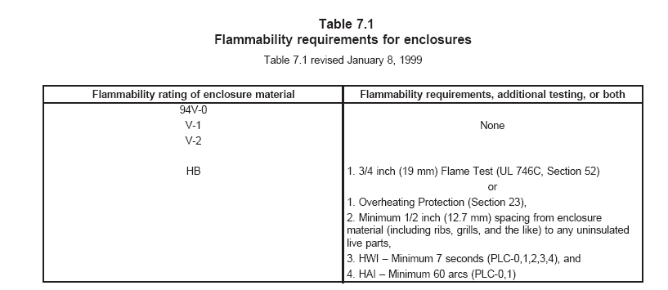
表7.1外壳燃烧测试要求
外壳材料的防火等级 | 燃烧测试要求及增加测试
94V-0  94V-1  94V-2 | 无
94HB | 1 3/4英寸（19mm）火焰测试；  或者  1 过热保护（见23部分）；  2 外壳材料（包括装饰、格架及类似部件）同裸露带电部分；  3 HWI-最小7秒（PLC-0、1、2、3、4）  4 HAI-最小60弧度（PLC-0、1）

7.4 Cast- and sheet-metal portions of the enclosure shall be no thinner than indicated in Table 7.2 unless
the enclosure is found to be acceptable when judged under considerations such as are mentioned in 7.3.
7.4 外壳的铸造部分和薄钢板部分的厚度不得小于表7.2，除非外壳按7.3条指明的因素进行评估时可以被认可。
7.5 Electrical parts of an appliance shall be so located or enclosed that protection against unintentional
contact with uninsulated live parts will be provided.
7.5 电器的电气部件必须固定或用外壳护罩起来，防止无意间触摸到裸露的带电部分。
7.6 For an appliance as mentioned in 43.2.6.4, the enclosure mentioned in 7.5 shall be provided with
drainholes located below the lowest live part.
7.6 对于43.2.6.4条规定的电器，7.5条中描述的外壳必须配置排水孔，其位置应在最低的电气部件以下位置。
7.7 The enclosure shall be constructed so that molten metal, burning insulation, flaming particles, or the
like will not fall on the supporting surface.
7.7 外壳的结构必须保证融化的金属、燃烧的绝缘、带火焰的颗粒或类似物，不能掉到放电器的桌面上。
7.8 The requirement in 7.7 necessitates that an enclosure bottom with an opening be provided with a
barrier above or below the opening if the opening is: 7.8 对于7.7条的要求，有必要在外壳的底部开孔，如果是以下情况，则必须在孔的上面或下面配置护栏：
a) Under a motor unless: a) 马达下面，除非：
- The structural parts of the motor or of the appliance provide the equivalent of such a barrier,
1) 马达或电器的结构部件配置同等的护栏；
2) The protection provided with the motor is such that no burning insulation or molten material falls to the surface that supports the appliance when the motor is energized under each of the following fault conditions: 2) 当马达按以下失效条件下通电时，随马达配备的保护装置，不得有燃烧的绝缘或融化的金属，掉到放电器的桌面上：
i) Open main winding, i 主绕组开路；
ii) Open starting winding, ii 起动绕组开路；
iii) Starting switch short–circuited; and iii 起动开关短路；并且
iv) For a permanent-split-capacitor motor the capacitor is short circuited. The short circuit is to be applied before the motor is energized and the rotor is to be blocked.
iv 对于分离电容器式马达的电容器将短路，进行该短路时，先将转子锁定，然后启动马达。
3) The motor is provided with a thermal motor protector (a protective device that is sensitive to both temperature and current) that prevents the temperature of the motorwindings from becoming more than 125°C (257°F) under the maximum load under which the motor runs without causing the protector to cycle, and from becoming more
than 150°C (302°F) with the rotor of the motor locked, or
3) 配置过热保护装置（该保护对电流及温度均敏感）的马达，防止马达在没有循环保护的条件下，最大负载运行时绕组的温度超过125°C（257°F），以及马达转子锁定的情况下绕组的温度超过150°C（302°F），或者；
4) The motor complies with the requirements for impedance-protected motors. 4) 马达满足阻抗保护要求。
b) Under wiring, unless the wiring complies with the VW-1 (FR-1) flame test or the Vertical Flame Test described in the Reference Standard for Electrical Wires, Cables, and Flexible Cords, UL 1581.
b) 电线的下面，除非电线符合VW-1（FR-1）火焰测试或UL1581相关要求；
c) Under an unenclosed switch, transformer, relay solenoid, and the like, unless it can be shown
that malfunction of the component is not likely to result in a fire.
c) 在没有外壳防护的开关、变压器、继电器线圈，以及类似部件的下面，除非元件的失效表明不会产生着火之后果；
d) Under field- and factory-made splices and overload and overcurrent protective devices. d) 在现场或工厂制作的联接片、以及过载过流保护装置的下面。
Exception: A barrier need not be provided if the opening is not within the area under the component
requiring a barrier as illustrated by Line D in Figure 7.1.
注：如果开孔不在图7.1中线D的图示的元件区域内，则不需要配备护栏。
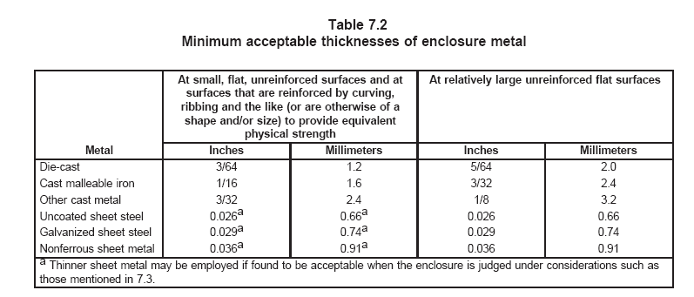

表7.2金属外壳允许的最小厚度
金属 | 小的、平的、不受力的表面以及弧形、加强筋及类似（其它开头或尺寸）的受力表面配置同等的机械强度 |  | 相对较大的平坦表面
金属 | 英寸 | mm | 英寸 | mm
模铸 | 3/64 | 1.2 | 5/64 | 2.0
可锻造的铸铁 | 1/16 | 1.6 | 3/32 | 2.4
其它的铸造金属 | 3/32 | 2.4 | 1/8 | 3.2
没有涂覆的薄钢板 | 0.026 ª | 0.66 ª | 0.026 | 0.66
电镀板 | 0.029 ª | 0.74 ª | 0.029 | 0.74
不含铁的薄板 | 0.036 ª | 0.91 ª | 0.036 | 0.91
ª当马口铁用作外壳，按7.3条规定的评估条件可以接受时是允许的。

7.9 The barrier mentioned in 7.8 shall be: 7.9 在7.8条中描述的护栏，如下要求：
a) Of metal, ceramic or a material that would be acceptable as an enclosure in accordance with 7.3, a) 金属的，陶瓷的或如7.3条中认可的外壳材料制作；
b) Horizontal, and b) 水平的，并且
c) Located as indicated in Figure 7.1, and shall not have an area less than that described in Figure 7.1.
c) 位置如图7.1规定，所具有区域不得小于图7.1中规定的面积。
图7.1 护栏的位置及范围
A- 由护栏防护的区域，包括组件的全部，如果没有其它的防护将包括由组件外壳或同等防护物的组件非防护部分；
B- 水平面上组件投影保护区；
C- 护栏最小面积的斜线轨迹；该线为：
1) 同组件正切；
2) 同垂直线成5°夹角；
3）如此定出水平面的最大轨迹。
D- 护栏的位置（水平）和最小区域，该区域为斜线C同护栏平面交叉形成的线内。
This is generated text for figtxt.
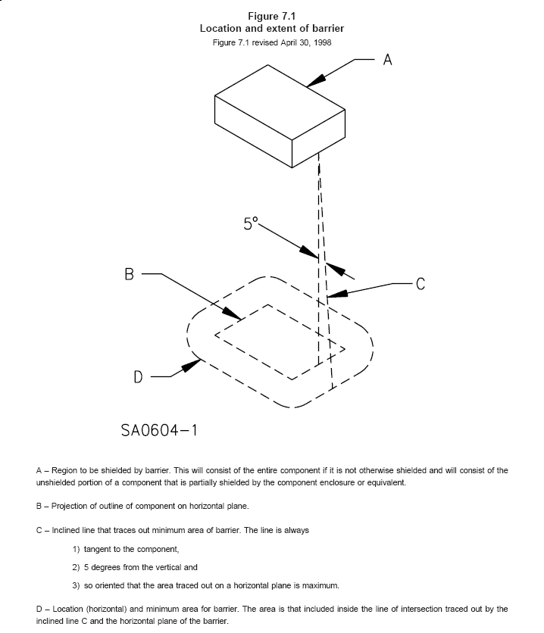

7.10 An opening in the enclosure that has a minor dimension of less than 1 inch (25.4 mm) is acceptable if a probe as illustrated in Figure 7.2, inserted through the opening, cannot be made to touch any uninsulated live part of film–coated wire that involves the risk of electric shock. The probe shall be applied in all possible articulated positions before, during, and after insertion. 7.10 外壳上开孔的有效尺寸小于1英寸（25.4mm），如果用图7.2中的带关节的探测指通过开孔处探入，不得触及具有触电危险的薄膜套线、或裸露的带电部分，探测指在探入前、探入中、完全探入后，所有的位置，关节尽可能弯曲进行测试。
7.11 An opening that has a minor dimension of 1 inch (25.4 mm) or more, in an enclosure, as illustrated in Figure 7.3, is acceptable if, within the enclosure, there is no uninsulated live part or film-coated wire less than;
7.11 外壳上开孔的有效尺寸等于或大于1英寸（25.4mm），如图7.3，如果在外壳内的裸露带电部分或薄膜套线至少不小于以下的距离是允许的：
a) R distance from the inside edge of the perimeter of the opening and a） R为距离开孔的边沿；
b) X distance from the plane of the opening. b） X为距离开孔平面的距离；
T equals the enclosure thickness, R equals X minus T, and X equals 5 times the diameter of the largest
round rod that can be inserted through the opening but not less than 6-1/16 inches (154 mm). In
evaluating an opening, any barrier located within the volume is to be ignored unless it intersects the
boundaries of the volume in a continuous, closed line.
T等于外壳之厚度，R等于X减去T，并且X等于探棒能被伸入的最大处，但不小于6-1/16英寸（154mm）园杆直径的5倍。在此区域内不得有裸露带电部分或薄膜套线。评估一个开孔时，某些在此固定的护栏将被去掉，除非它在交叉处形成连续、封闭的整体。
7.12 If a marking draws attention of the user to a hole of any size in the enclosure for the adjustment of
a thermostat or for a similar activity, it shall not be possible to damage insulation or contact uninsulated
live parts through the hole with a 1/16-inch-diameter rod (1.6 mm). 7.12 如果外壳上具有一定尺寸的孔被标识用于提醒用户注意该孔的作用是用来调节温控器或具有类似功能，用1/16英寸（1.6mm）直径的园杆通过该孔应不可能危及绝缘或触及裸露的带电部分。
7.13 During the examination of an appliance in connection with the requirements in 8.2 – 8.4, any part of
the enclosure is to be disregarded – that is, it will not be assumed that the part in question affords
protection against electric shock or injury to persons– if it either: 7.13 在评审8.2-8.4条中电器的连接要求时，如果它是以下某一种，外壳的某些部件忽视——也就是说，它将不是假设该部件承担保护，防止触电或人身伤害；
a) Must be opened or removed, with or without the use of tools, to perform manufacturer’s
recommended user servicing, maintenance, operating adjustments, attachment of accessories,
or other instructions, or a) 必须打开或拆卸，需用或不用工具进行制造商建议的用户维修、保养、运行调整、配件的更换或其它介绍，或者：
b) Can be opened or removed without the use of tools. b) 不用工具能被打开或拆卸。
Exception: A part that requires a tool for opening or removal to perform manufacturer’s recommended user servicing, maintenance, operating adjustments, attachment of accessories, or other instructions is to remain in place if the appliance is marked in accordance with 50.6.
注：如果电器的标识满足50.6条的规定，需用工具打开或拆卸的部件，进行制造商的建议的用户维修、保养、运行调整、配件的更换或其它要求，将保持原位。
图7.2 带关节的测试指

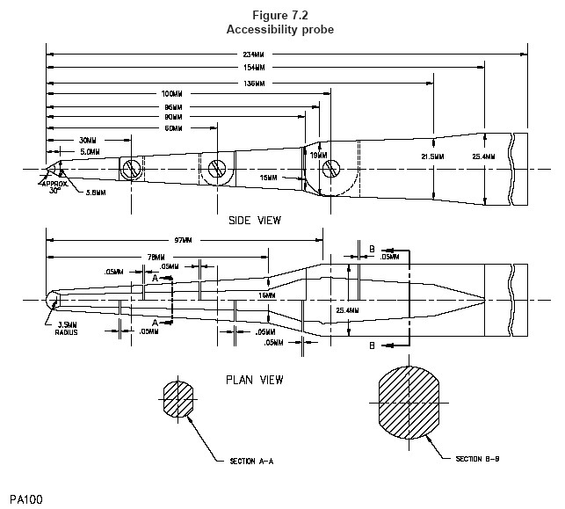

图7.3外壳上的开孔
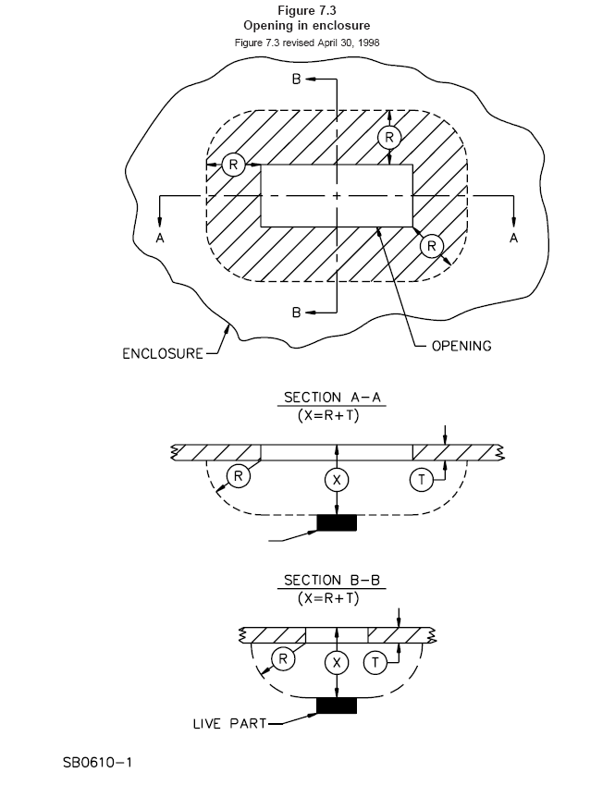
This is generated text for figtxt.

7.14 A component of an appliance that is likely to need inspection, replacement, cleaning, or other servicing shall be as accessible as possible. The component shall be readily accessible without the use of special tools (tools not available to other than service personnel) if it is intended to be manually operated or adjusted or periodically serviced. . 7.14 电器的组件很可能在检查，复位，清洁或其它的维护，必须尽可能接近，如果是为了手动操作、调整或定期服务，该部件可以不用特别的工具(专业人员用的工具)就可以接近。
7.15 The bulb and capillary tube of a thermostat shall be protected from mechanical damage if damage of the tube or bulb would increase the risk of fire
7.15 灯泡以及恒温控制器的毛细管，如果毛细管及灯泡受损将增加火灾危险，必须进行保护，防止机械损害。

8 Assembly8 组装
8.1 A switch, lampholder, or plug-type connector provided as a part of an appliance shall be mounted
securely and prevented from turning by means other than friction between surfaces. 8.1 开关、灯座或插头型连接器作为电器的一个部件，必须可靠安装，防止旋转。其固定方式除了采用表面磨擦方式均可。
8.2 A lock washer properly applied is acceptable as a means to prevent turning of a stem–mounted
switch. 8.2 锁定垫片的特性应用是认可的一种防止转柄开关旋转的方式。
8.3 Uninsulated live parts shall be so secured to the base or surface that they will be prevented from
turning or shifting in position as the result of stresses if such motion may result in a reduction of spacings
below the minimum required in 24.1.1 and 24.1.2. 8.3 裸露的带电部分必须安全固定在基座上，受应力时防止旋转或位移，因为类似的位移结果可能导致电气间隙降到24.1.1和24.1.2条的最小要求以下。
8.4 Friction between surfaces is not acceptable as a means to prevent shifting or turning of live parts, but
a lock washer properly applied is acceptable.
8.4 利用表面磨擦方式防止移动或位移是不允许的，可接受应用锁定垫片特性。
9 Handles9 手把
9.1 Unless determined to be acceptable for the purpose, fastening of the vessel handle assembly of an
appliance shall not rely on cement or equivalent materials alone. Mechanical means, such as pressure
clamping, bosses and lances, and the like, shall be provided. 9.1 除了作为评估适用性的目的，电器容器的手把组件不得依赖水泥或同等材料保持，必须采用机械方式，如采用压紧夹，突出或插入的方式以及类似的方法。
9.2 A handle assembly that is utilized to lift and tilt a vessel, which is either integral to the appliance or a separate unit, to dispense a heated liquid shall comply with the requirements in 9.3 – 9.7, and Normal Temperature Tests, Section 33, and Handle Securement Tests, Section 40. The handle assembly of an integrally heated vessel shall also comply with 43.2.3.6. 9.2 手把组件被用来提起并倾斜，不管是组装在电器上或者是单独的构件上，在分配加热的液体时必须满足9.3-9.7条以及33部分的正常温度要求，以及40部分的手柄安全可靠性要求，加热容器的手把配件同样必须满足43.2.3.6条。
Exception: A carafe type vessel having a capacity of less than 17.5 oz and provided with a product not employing a keep warm feature for the vessel. 注：具有小于17.5 安士容量的玻璃容器，并随产品配备不需对容器应用保温特性。
9.3 For an appliance or separate vessel that is provided with a webbed handle – that is a solid handle that cannot be grasped by wrapping the fingers around it – the web shall be a minimum of 1 inch in width and 3.25 inches in length. See Figure 9.1. 9.3 对于电器或可分离的容器配制有蹼形手把，应是实心的以致不能用手指环绕它握住，该蹼至少1英寸宽，3.25英寸长，见图9.1。
This is generated text for figtxt.
9.4 No portion of a nonmetallic handle whose failure could result in the loss of handle strength or integrity is to be subjected to a temperature in excess of the mechanical temperature index (without impact) of the material when tested as indicated in Normal Temperature Tests, Section 33. 9.4 当测试按33部分规定的正常温度测试时，超过机械温度指数（没有冲击）项目时，非金属手把任何部分不会失效造成手把的强度或完整性上存在某些缺陷。
9.5 On a vessel where handle securement is accomplished by a band around the body of the vessel, the diameter of the vessel above and below the band securement area shall be larger than the diameter at the area of securement. A handle shall be fastened so that a positive stop, interference screw, rivet, or other arrangement is provided so that with minor loosening, disengagement of the handle from the vessel will not result. 9.5 在容器上，手柄由箍子环绕在容器本体上安全固定，容器上下固定处箍子的直径应大于容器直径，手把必须被锁紧定位，防止螺丝，钉及类似物使手把同容器出现自由松动之结果。
Exception: The diameter of the vessel above and below the band securement need not be larger than the diameter at the area of securement if an equivalent means of preventing movement of the handle assembly is provided. 注：如果配备有同等防止手把组件松动的方法，则容器上下箍子的尺寸不需大于固定处的直径。
9.6 Iron and steel parts of a handle assembly shall be provided with corrosion protection in accordance with 10.1 or shall be constructed of stainless steel or other noncorrosive metal acceptable for the application. 9.6 对于手把组件采用钢铁部件必须具有10.1条的防腐蚀保护，或者使用不锈钢或其他允许的防腐蚀性金属材料。
9.7 A handle secured by a single fastening means shall be prevented from rotating by means other than friction. A lockwasher alone shall not be sufficient. 9.7 采用单个锁紧手把的固定方式必须采用合适的方法防止转动，除了表面磨擦方式，并且应用锁紧华司的特性也不够充分。
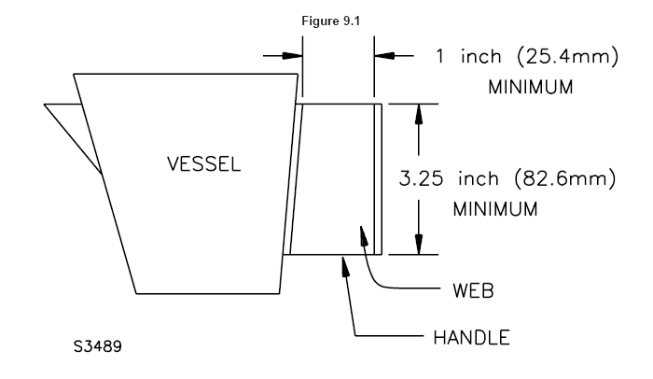
10 Corrosion Protection10 防腐蚀
10.1 Iron and steel parts shall be protected against corrosion by enameling, galvanizing, plating, or other equivalent means, if the deterioration of such unprotected parts would increase the risk of fire or electric shock.
10.1如果钢铁部件腐蚀恶化后将增加着火或电击危险，该部件必须用搪瓷、喷涂或同等手段防止腐蚀。
Exception: Where the oxidation of steel is not likely to be accelerated due to the exposure of metal to air and moisture or other oxidizing influence– thickness of metal and temperature also being factors – surfaces of sheet steel within an enclosure may not be required to be protected against corrosion. Cast-iron parts are not required to be protected against corrosion. A sheath employed on a heating element operating in air and terminal parts attached directly to the heating element need not be protected against corrosion.
注：由于金属暴露到空气中、潮湿环境以及其它氧化因素中、金属的厚度和温度，很可能加速金属的氧化。钢板的表面在外壳之内部、铸铁部件以及空气中使用的电热管之金属外鞘和直接装配在电热管上的端子不需防腐蚀保护。
10.2 The aging characteristics of plating or other finish used in an appliance shall be such that deterioration of the finish will not result eventually in unacceptable performance of the appliance.
10.2 电器上的喷涂或其它装饰的老化特性应不会对电器性能造成负面影响。
11 Supply Connections11 电源连接
11.1 General11.1 总则
11.1.1 An appliance shall be provided with a length of attached flexible cord and an attachment plug for connection to the supply circuit, or shall have male pin terminals that accommodate a detachable power–supply cord. The length of flexible cord shall be within the limits indicated in Table 11.1. 11.1.1 电器必须配置一定长度的软线并附带插头同电源电路连接，或必须装设公端子去连接可拆卸之电源线，软线的长度必须在表11.1的规定值之内。
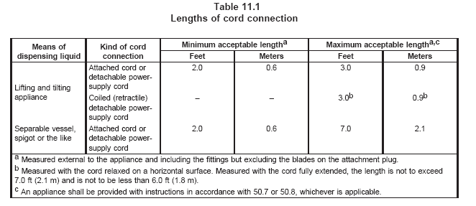
表11.1 软线连接的长度
倒水方式 | 软线连接种类 | 最小允许长度ª |  | 最大允许长度^{a，c}
倒水方式 | 软线连接种类 | 英尺 | m | 英尺 | m
提起倾倒液体之电器 | 附带软线或可拆卸式之软线 | 2.0 | 0.6 | 3.0 | 0.9
提起倾倒液体之电器 | 卷线(可伸缩的)拆卸式电源线 | - | - | 3.0^{b} | 0.9^{b}
分离容器、水喉式或类似 | 附带软线或可拆卸式之软线 | 2.0 | 0.6 | 7.0 | 2.1
ª 测量外部到电器并包括装配部分但不包括插头的插片；
^{b} 测量水平松驰状态。测量完全展开时，长度最大不超过7英尺(2.1m)，最小不小于6英尺1.8m)；
^{c} 电器必须配备满足50.7和50.8条的说明书，视适用情况而定。

11.1.2 The rating (both current and voltage) of the cord and the fittings of a nondetachable and a detachable power–supply cord, shall not be less than that of the appliance. 11.1.2 实配的软线以及不可拆卸和可拆卸式软线的额定值（包括电流和电压）不得小于电器的额定值。
11.1.3 A 3- to 2-wire grounding-type adapter shall not be provided with an appliance.
11.1.3 不得在电器中配置3线转接2线的接地型转换器。
11.1.4 An attached flexible cord and the cord in a detachable power-supply cord that is provided with an appliance shall be of a Type HPD, HPN, HSJ, HSJO, SP-2, SPE-2, SPT-2, SV, SVE, SVO, SVT, SVTO, J, SJE, SJO, SJT, or SJTO cord, or shall have such properties that will be at least equally as serviceable or the particular application.
11.1.4 随电器配备附带的软线以及可拆卸电源线上的软线必须为以下型号：HPD、HPN、HSJ、HSJO、SP-2、SPE-2、SV、SVE、SVO、SVT、SVTO、SJ、SJE、SJO、SJT或SJTO软线，或必须具有之特性足以适合单独电器的使用。
11.1.5 Supplementary insulation, if employed, shall not extend more than 1/2 inch (13 mm) outside the appliance (unless provided with additional mechanical protection), shall be prevented from fraying or unraveling, and shall not affect adversely the means for providing strain relief. 11.1.5 附加绝缘，如果用在电器的外部不得超过1/2英寸（13mm）（除非具有附加的机械保护），必须防止磨损或松脱，并且不得对拉力消除装置产生负面影响。
11.1.6 The attachment plug of the power supply cord of an appliance provided with a 15- or 20- ampere general use receptacle shall be of the 3-wire grounding type. The attachment plug of the power supply cord of an appliance provided with: 11.1.6 随电器附带电源线配备的15A或20A常用插头必须是接地型的，电器电源线上的插头同以下一起配置：
a) A manually operated, line-connected, single pole switch for appliance on-off operation or a） 一个手动操作，火线连接，单极开关作为电源通断操作；或者
b) An Edison-base lampholder shall be of the polarized or grounding type. b） 爱迪生型灯座必须是极性的或接地型的。
11.1.7 If a 3-wire grounding-type attachment plug or a 2-wire polarized attachment plug is provided, the attachment plug connection shall comply with Figure 11.1 and the polarity identification of the flexible cord shall comply with Table 11.3.
11.1.7 如果配置一个3线接地型插头或2线极性插头，插头的连接必须符合图11.1，并且软线的极性标示符合表11.3
表11.3注明预期被接地的电源导体。图11.1
插头的连接
接地型插头与软线的连接
导体绝缘外表为绿色或黄绿色ª
预期不接地的导体(非标识导体)
预期接地导体(标识导体) ^{b}
极性插头与软线的连接
预期不接地的导体(非标识导体)

预期接地导体(标识导体) ^{b}
a 在上面的图中，绿色导体的连接片的截面可以为U型或圆型
b 导体上的标识必须满足表11.3的要求
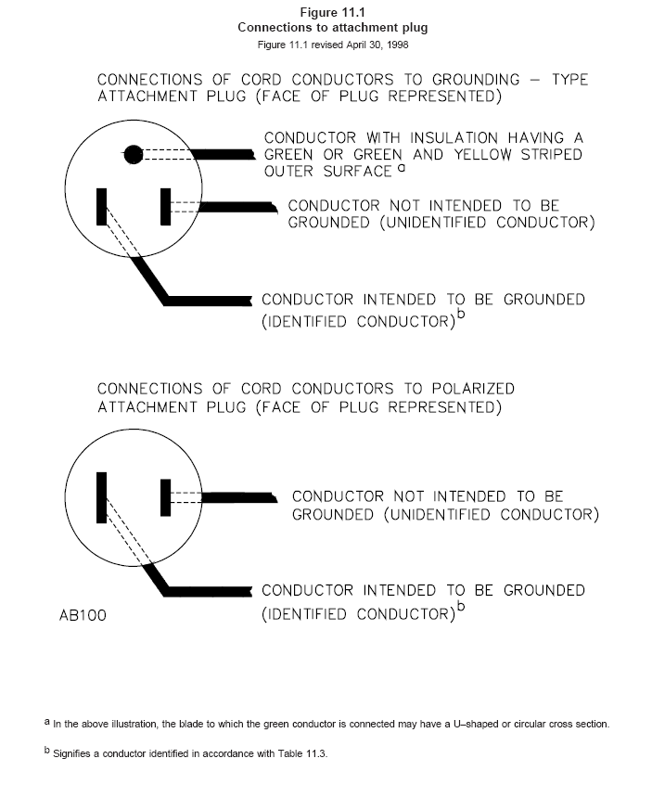
This is generated text for figtxt.
11.1.8 The conductor of the power supply cord that is intended to be grounded shall have the following
items connected to it: 11.1.8 预期接地的电源导体，必须按以下的要求进行连接：
a) The screw shell of an Edison–base lampholder and a） 爱迪生型灯座的螺壳；
b) The terminal or lead of a receptacle intended to be grounded. b） 插头预期接地的端子或引线。
Table 11.3 identifies the supply cord conductor intended to be grounded.

11.2 Strain relief11.2 拉力消除装置
11.2.1 Strain relief shall be provided to reduce the risk of a mechanical stress on an attached flexible supply cord from being transmitted to terminals, splices, or interior wiring. 11.2.1 必须配置拉力消除装置用以减少电器外附软线上的机械应力传递到端子、连接片或内配线上，造成危险。
11.2.2 If wood, pressed board, or other fibrous material is used to secure the strain–relief assembly, the fibrous material shall be secured to the appliance by a pin, setscrew, or other positive means. 11.2.2 如果木材、压合板或其它玻纤材料用来固定拉力消除之组件，玻纤材料必须用钉子，固定螺丝或其它方式安全固定到电器上。
11.2.3 Means shall be provided to reduce the likelihood of an attached supply cord or lead from being pushed into the enclosure of an appliance through the cord–entry hole. To determine compliance with this requirement, the supply cord or lead shall be tested in accordance with Push-Back Relief Test, Section 37A. 11.2.3 revised January 8, 199911.2.3 如果外露软线，可以通过电器外壳上的穿线孔推入电器的内部，该位移很可能导致软线受到机械伤害，或将软线暴露在高温下，或可能减少间隙（如到金属拉力消除夹）到最小允许值以下，必须采用合适的方法防止该位移。
11.2.4 If a knot serves as strain relief in an attached flexible cord, any surface with which the knot may come in contact shall be free from projections, sharp edges, burrs, fins, and the like, which may cause abrasion of the insulation on the conductors.
11.2.4 如果在附带软线打结作为拉力消除手段，该结能自由接触的表面必须充分保护。锐边、粗糙面、毛刺均可能伤及导体之绝缘层。
11.3 Pin terminals11.3 插销端子
11.3.1 If an appliance is provided with pin terminals, the design of the appliance shall be such that no live parts will be exposed to unintentional contact both during and after the placement of the plug on the pins, in the intended manner. 11.3.1 如果电器配置插销端子，电器的设计应使得电器在预期的使用时，插头同插销插接就位后，不得有裸露的带电体可以无意触及。
11.3.2 A pin guard is required, such that: 11.3.2 插销的防护要求如下：
a) A straight edge placed in any position, across and in contact with edges of the plug opening without the plug in place, cannot be made to contact any current-carrying pin. a) 任何位置具有连续的边缘，通过插头开孔（插头不在位时）不得触及承载电流的插销；
b) With the plug aligned with the pins and the face of the plug in a plane located perpendicular to the end or ends of the farthest projecting current–carrying pin, the probe illustrated in Figure 7.2 should not touch any current-carrying pin while the probe is inserted through any opening with the appliance in any position. b) 插头同插销排成一线连接，并且插头垂直锁定的末端表面或最远突出的承载电流的插销末端，用图7.2中示的探棒在电器的任何开孔位置插入不得触及承载电流的插销。
11.3.3 The plug used in 11.3.2 (b) is to be the plug intended for use with the appliance. 11.3.3 采用11.3.2(b)项中的插头将预期和电器一同使用。
11.3.4 If an appliance employs three or more pin terminals designed for use with a plug that covers all the pins, the terminals shall be so spaced that they will not accommodate a flatiron or appliance plug or cord-connector body. The plug which these pins will accommodate shall be acceptable for the particular application. 11.3.4 如果电器使用3个或3个以上的插销，被设计包含在插头中一同使用，端子所必须具有的空间将不能容纳片式插头、电器插头或软线连接器的本体。这些插销插头必须适用于单独的电器。
11.3.5 An appliance provided with three pin terminals, one of which is for grounding, shall not be provided with or capable of being used with a two-conductor detachable power-supply cord. 11.3.5 电器配置3个插销端子，其中一个用作接地，不得使用或配置只有两根导体的可拆卸式软线。
11.3.6 An appliance provided with two pin terminals shall not be provided with or capable of being used with a three-conductor detachable power-supply cord employing a grounding conductor. 11.3.6 电器配置两个插销端子不得使用或配置具有接地导体的3线式可拆卸软线。
11.3.7 A pin terminal shall be securely and rigidly mounted and shall be prevented from shifting in position by means other than friction between surfaces.
11.3.7 插销端子必须安全固定并具有足够的强度，而且必须采用合适方式防止移动。
11.3.8 The requirement in 11.3.7 is intended primarily to provide for the maintenance of spacings as given in 24.1.1 and to provide for the maintenance of proper spacings between pin terminals. Under this requirement, consideration is also to be given to the means for locking terminals in position to maintain tightness. 11.3.8 对于11.3.7条的要求主要是为了保证24.1.1条给定的间隙，并且保证插销端子特定的间隙，在此要求下，考虑用插销端子固定的方式作为保证。
11.3.9 The dimensions of pins and their center-to-center spacings (including the corresponding spacings of the female contacts of general-use plugs which these arrangements of pins will accommodate) are as indicated in Table 11.2.
11.3.8 插销的尺寸及其中心距（包括常用插头给母端子触点提供的相对空间）规定在表11.2中。
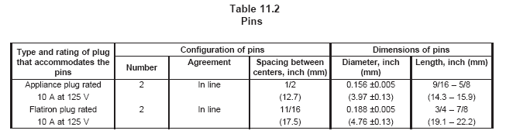
表11.2
插销
插头的插销类型及额定参数 | 插销的配置 |  |  | 插销的尺寸
插头的插销类型及额定参数 | 数量 | 排列 | 中心距  英寸（mm） | 直径  英寸（mm） | 长度  英寸（mm）
电器插头容量  10A125VAC | 2 | 一条线上 | 1/2  (12.7) | 0.156±0.005  (3.97±0.13) | 9/16/5/8  (14.3-15.9)
扁片插头容量  10A125VAC | 2 | 一条线上 | 11/16  (17.5) | 0.188±0.005  (4.76±0.13) | 3/4-7/8  (19.1-22.2)

11.4 Bushings11.4 护线套
11.4.1 At a point where a flexible cord passes through an opening in a wall, barrier, or enclosing case, there shall be a bushing or the equivalent which shall be substantial, reliably secured in place, and shall have a smooth, well-rounded surface against which the cord may bear. If Type SP-2, SPT-2, or other cord lighter than Type HSJ is employed, if the wall or barrier is of metal, and if the construction is such that the cord may be subjected to strain or motion, an insulating bushing shall be provided. The heat- and moisture-resistant properties of the bushing material shall be such that the bushing is acceptable for the particular application.
11.4.1 软线某点通过间隔层，护栏或外壳上的开孔时，该处必须用护线套或同等物确保安全，使该处具有平滑过渡的表面，从而确保软线不受伤害，如果使用SP-2，SPT-2或其他低于HST型号的软线，并且间隔层或护栏为金属的，在结构上软线可能受到拉力或移动，则必须配备绝缘护线套，护线套的耐热及耐潮特性必须满足单独电器的要求。
11.4.2 If the cord hole is in wood, porcelain, phenolic composition, or other acceptable nonconducting material, a smooth, well–rounded surface is considered to be equivalent to a bushing. 11.4.2 如果线孔是在木板、陶瓷、树脂成份或其他可接受的非导体材料上，并具有光滑表面则认为等同护线套功能。
11.4.3 Ceramic materials and some molded compositions are acceptable generally for insulating bushings, but a separate bushing of wood, hot-molded shellac and tar composition, or rubber material (other than in a motor) is not acceptable. Vulcanized fiber may be employed if the bushing is not less than 3/64 inch (1.2 mm) thick and if it is so formed and secured in place that it will not be affected adversely by conditions of ordinary moisture. 11.4.3 陶瓷材料及塑料材料允许作为常用的绝缘护线套，但是单独的木材，热塑虫胶及焦油材料或橡胶（除马达外）护线套不被接受。如果护线套不小于3/64英寸（1.2mm）的厚度并且正常的潮态条件下如果对制成及安全固定不产生负面影响，可以使用硬质纤维。
11.4.4 An insulated metal grommet may be accepted in place of an insulating bushing if the insulating material used is not less than 1/32 inch thick (0.8 mm), and completely fills the space between the grommet and the metal in which it is mounted.
11.4.4 绝缘金属扣眼，如果绝缘的厚度不小于1/32英寸（0.8mm）可以认为是一个绝缘护线套并且在安装后，扣眼同金属间的间隙应完全填满。
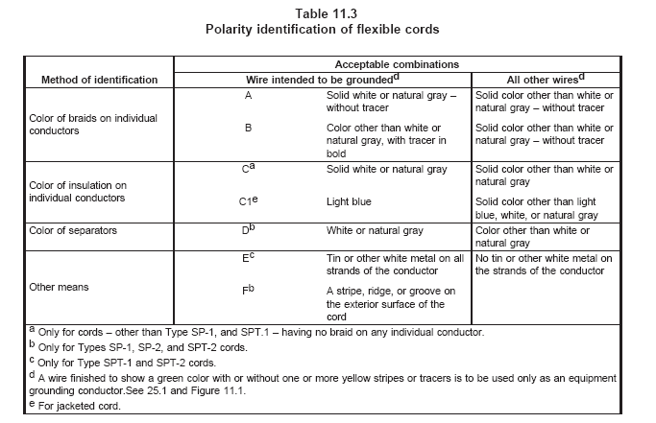
表11.3
软线的极性识别
识别方法 | 插头的组合
识别方法 | 预期接地的导线^{d} | 所有其它的导线^{d}
单独导体上的编织套颜色 | A 纯白或自然灰色—没有标识 | 除了白或自然灰色的纯色彩—没有标识
单独导体上的编织套颜色 | B 除了纯白或自然灰色之外还有标识 | 除了白或自然灰色的纯色彩—没有标识
单独导体绝缘上的颜色 | Cª 纯白或自然灰色 | 除了白或自然灰色的纯色彩
单独导体绝缘上的颜色 | C1e 淡兰 | 除了淡兰、白或自然灰色的纯色彩
区分的颜色 | D ^{b} 白或自然灰色 | 除了白或自然灰色的纯色彩
其它方式 | E ^{c} 锡或其它白色金属镀在所有绞股线上 | 没有锡或其它白色金属镀在所有绞股线上
 | F ^{d} 用线条，凸楞或凹槽在软线的外表面上
ª 仅针对颜色，除了SP-1和SPT-1，没有编织套在单独导体表面。
^{b} 仅对SP-1，SP-2和SPT-2。
^{c} 仅针对SPT-1和SPT-2。
^{d} 电线成品为绿色，带有或不带有一条或多条黄色条纹，仅用作设备的接地线，见25.1部分和图11.1。
^{e} 针对被套线。

12 Current-Carrying Parts12 承载电流的部件
12.1 Each current-carrying part shall be made of metal that is acceptable for the particular application. 12.1 每个承载电流的部件必须用金属制作的，可允许作为特别的应用。
12.2 Current-carrying parts made of corrosion-resistant alloys (for example, stainless steel) are acceptable regardless of temperature. Current-carrying parts made of ordinary iron and steel are not acceptable unless they are rendered corrosion-resistant by an appropriate coating and, even then, they are acceptable only as follows:
12.2 用耐腐蚀合金（如不锈钢）制作的承载电流的部件允许不管温度。不经处理的钢铁制作承载电流的部件是不允许的，除非它们采用合适的防腐蚀涂层，尽管如此，仅做如下部件才能接受：
a) Pin terminals. a) 插销端子；
b) Parts whose normal operating temperature is higher than 100°C (212°F). b) 部件的正常工作温度超过100℃（212℉）；
c) Parts of a component that the requirements referred to in 3.1 indicate as being acceptable
with coated iron and steel parts. c) 组件的部分参照3.1条的规定要求，具有涂层的钢铁部件可以接受。
12.3 If a reservoir is part of an appliance, all live parts shall be so located or protected that they will not be subject to dripping if the reservoir develops leaks, unless:
12.3 如果一个贮液容器作为电器的一个部件，所有的带电体之定位与保护必须在贮液器发生泄漏时不被滴溅，除非：
- The reservoir is adequately resistant to corrosion from the liquid intended for use in it, and
a) 该贮液容器足够承受预期使用时液体的腐蚀；
b) The reservoir does not develop cracks as a result of aging. b) 该贮液器老化的结果不会出现破裂。
13 Internal Wiring13 内配线
13.1 General13.1 总则
13.1.1 The internal wiring of an appliance shall consist of wire of a size and type or types which are acceptable for the particular application, when considered with respect to the temperature and voltage to which the wiring is likely to be subjected.
13.1.1电器的内配线必须包含线型与尺寸或者单独电器所允许的线型，在评估时要考虑电线的温度及电压等项目。
13.1.2 There is no temperature limit applicable to glass fiber, beads of inorganic material, or the equivalent employed as conductor insulation. 13.1.2 revised January 8, 199913.1.2 使用非填充石棉、玻璃纤维、无机材料的串珠或同等材料作为保护绝缘不存在温度限制，但石棉绝缘不允许用在潮湿的位置。
13.1.3 Thermoplastic-insulated wire employed for the internal wiring of an appliance shall be fixture wire, or appliance-wiring material acceptable for the particular application. 13.1.3 revised January 8, 199913.1.3 热塑绝缘线或填充石棉绝缘线用作电器的内配线，必须具有单独电器所能接受的设备线材和电气线材之绝缘保护。
13.2 Protection of wiring13.2 线的保护
13.2.1 If the wiring of an appliance is so located that it may be in proximity to combustible material or may be subjected to mechanical injury, it shall be protected. 13.2.1如果电器上的导线位置，有可能靠易燃材料很近，或者可能受到机械伤害，必须加以保护。
13.2.2 Wires within an enclosure or the like shall be so disposed or protected that no damage to conductor insulation can result from contact with any rough, sharp, or moving part. 13.2.2 外壳或类似部件内的导线不要同粗糙面、锐边或移动部件接触，或者进行保护，防止导体绝缘损坏。
13.2.3 A hole by means of which insulated wires pass through a sheet-metal wall within the over-all enclosure of an appliance shall be provided with a smooth, well-rounded bushing or shall have smooth, well-rounded surfaces upon which the wires may bear, to prevent abrasion of the insulation. 13.2.3 电器上，绝缘导线通过电器内部分隔层的开孔时，必须配置平滑过度的护线套，或者开孔具有平滑过度的表面，防止导线受力时，绝缘受损。
13.2.4 Insulated wires may be bunched and passed through a single opening in a metal wall within the enclosure of an appliance. 13.2.4 绝缘线可以串成一束从电器内部的金属分隔层上的单个开孔通过。
13.3 Splices13.3 连接片
13.3.1 All splices and connections shall be mechanically secure and shall provide adequate and reliable electrical contact. A soldered connection shall be made mechanically secure before being soldered if breaking or loosening of the connection may result in any risk of fire or electric shock. 13.3.1 所有连接片与联接器必须机械固定并配备合适可靠的触点，如果焊接点断开或松脱可能造成着火或电击危险，则在焊接前必须以机械方式安全固定。
13.3.2 A splice shall be provided with insulation equivalent to that of the wires involved if permanence of spacing between the splice and other metal parts of the appliance is not reliably maintained. 13.3.2 如果电器的连接片用其他金属部件间的必要间隙不可能保证，则连接片必须配备同电线一样的同等绝缘。
13.3.3 Insulation consisting of two layers of friction tape, two layers of thermoplastic tape, or of one layer of friction tape on top of one layer of rubber tape, is acceptable on a splice. In determining whether splice insulation consisting of coated fabric, thermoplastic, or other type of tubing is acceptable, consideration is to be given to such factors as its dielectric properties, heat resistant and moisture-resistant characteristics. Thermoplastic tape wrapped over a sharp edge is not acceptable. 13.3.3 连接上允许用两层绝缘胶布，两层热塑绝缘胶带，或者一层绝缘胶布在另一层橡胶带上作为绝缘。评估连接绝缘是否可用编织物，热塑材料或其他类型的套管包裹，通过它们的介电性能，耐热耐潮特性来评定。热塑材料胶带包裹锐边是不允许的。
13.3.4 Where stranded internal wiring is connected to a wire-binding screw, loose strands of wire shall be
positively prevented from contacting any other uninsulated live part that is not always of the same polarity
as the wire, and from contacting any dead metal part. This may be accomplished by the use of pressure
terminal connectors, soldering lugs, crimped eyelets, soldering all strands of the wire together, or other
equivalent means.
13.3.4 内配绞股线被联接到绑线螺钉上，该股内松散的线头必须防止同其他不同极性没有绝缘的带电体，以及非带电体接触。可以用压接端子联接器、焊接片、折叠扣、焊接或其它同等的方式使线头束在一起。
14 Secondary Circuits14 二次电路
14.1 General14.1 总则
14.1.1 Each secondary circuit shall be judged under the requirements for line-voltage circuits. 14.1.1 每个二次电路必须按火线电压电路的要求进行评估。
Exception: A secondary circuit need not be investigated if: 注：二次电路如果是以下情况的不需进行审查：
- It is not a circuit that is intended to reduce the risk of injury to persons, and
a） 不是一个为了减少人身伤害风险的电路；
- It complies with the requirements for a limited-energy-secondary circuit as described in 14.2.1 – 14.2.9.
b） 它满足14.2.1至14.2.9规定的限能二次电路的要求。
14.1.2 Secondary circuits may be connected to the frame of the appliance. Except as noted in 14.1.3 and
14.2.6, the connection shall be made at only one point in the appliance or system.
14.1.2 二次电路可以被连接到电器的结构上，除了14.1.3和14.2.6条的特别规定，该连接仅能同电器或系统上的某一点上进行
14.1.3 A grounding bus of adequate ampacity that is used as the return for a secondary circuit other than
as covered by 14.2.6 may be connected to the frame at more than one point. 14.1.3 用来作为返回二次电路并具有足够电流容量的接地母线，除了14.2.6条所涵盖的，可以在结构上多点连接。
14.1.4 If any secondary circuit having an open-circuit potential of more than 42.4 volts peak is connected
to the frame of an appliance, all exposed dead metal parts that may become energized, and all dead metal
parts within the enclosure that can be contacted during servicing and that may become energized, shall
be reliably connected together.
14.1.4 如果二次电路开路时，具有大于42.4V的尖峰电位，并且是同电器的结构连接，所有非带电金属部件可能会带电，并且所有外壳内非带电的金属部件，在正常使用过程中可能接触的部件均可能带电，必须可靠地连接在一起。
14.2 Limited-energy-secondary circuits14.2 限能二次电路
14.2.1 A limited-energy-secondary circuit shall be supplied from: 14.2.1 限能二次电路必须由以下供电：
a) A Class 2 transformer, or a) 用2类变压器输入；或者
b) An isolating transformer having an open-circuit sinusoidal potential of 30 volts, rms (42.4 volts, peak) or less, and that includes at least one of the following means, that limits the power available to the levels specified for a Class 2 transformer. b) 隔离变压器具有开路30V的正弦有效电压，rms（42.4V尖峰值）或更小，并至少包括以下某条要求，用来限制功率在2类变压器规定的有效范围内：
1) A reliable fixed impedance; 1) 一个可靠的固定阻抗；
2) A noninterchangeable fuse – the largest fuse that fits in the fuseholder provided; 2) 不可置换的保险管——最大的保险适合所配备的保险座;
3) A nonadjustable manually reset circuit protector; or3) 不可调节的手动复位的电路保护器；或者
4) A reliable regulating network. 4) 可靠的调节电路。
14.2.2 The impedance, the fuse, the protector, or the regulating network and the wiring between them and the isolating transformer described in 14.2.1 shall be judged as if they were part of a line-voltage circuit. 14.2.2 阻抗、保险、保护器，或者其它的可调电路，以及它们之间的连线和14.2.1条中描述的隔离变压器，如果它们是火线电压电路的一部分，则必须进行评估。
14.2.3 A fuse or a circuit protector used to limit the power as specified in 14.2.1 shall be rated or set at not more than 3.2 amperes for a circuit operating between 15 and 30 volts and at not more than 5.0 amperes for a 0 – 15 volt circuit. 14.2.3 保险或电路保护器用来限制14.2.1条中规定的功率，电路工作在15 ~30V时，电流不得超过3.2A；工作在0~15V时，电流不得超过5A。
14.2.4 An impedance or a regulating network that is used to limit the current shall be of such value or design as to limit the current under short-circuit conditions to not more than 8.0 amperes measured after 1 minute. 14.2.4 用来限制电流的阻抗或可调电路，其所限制的电流或设计短路情况下限制的电流，在1分钟后测量时不得超过8A。
14.2.5 The performance of a regulating network used to limit the power in accordance with 14.2.1 shall not be adversely affected by either a short circuit or an open circuit between any two terminals of any single rectifier, capacitor, transistor, or similar component in the network. 14.2.5 可调节电路的功能为了符合14.2.1用来限制功率，不会因为电路中的整流器件，电容器，变压器或类似的电子元件的两端短路或开路对其造成不良影响。
14.2.6 The frame may be used as the return for a limited-energy-secondary circuit. 14.2.6 电器的结构可以用作限能二次电路的回路。
14.2.7 The wiring in a limited-energy-secondary circuit shall be routed away from the wiring of other
circuits or shall be provided with insulation that is for use at the highest of the voltages in the other circuits. 14.2.7 限能二次回路的导线必须远离其他较高电压的电路电线，或者配备绝缘
14.2.8 The wiring in a limited-energy-secondary circuit shall be routed away from the uninsulated live components of other circuits. 14.2.8 限能二次回路的导线必须远离其他电路中裸露的带电元件。
14.2.9 Wires and cables that are part of a limited-energy-secondary circuit shall be provided with strain
relief in accordance with 37.1 and 37.2 if stress on the wire or cable could cause the internal wiring of the
circuits to contact uninsulated live parts of other circuits.
14.2.9作为限能电路的导线与电缆，如果压在其上能使电路内配件同其他电路裸露带电元件接触，必须配置符合37.1和37.2的应力消除装置。
15 Heating Elements15 加热元件
15.1 A heating element shall be supported in a sturdy and reliable manner. It shall be protected against mechanical damage and contact with outside objects. 15.1 加热元件必须可靠安装，防止机械损害，以及同外面物体接触。
15.2 In determining that a heating element is adequately supported, consideration is to be given to sagging, loosening, and other adverse conditions of the element resulting from continuous heating. For an open–wire (uninsulated resistance wire) heating element consideration is also to be given to breakage at any point.
15.2 判定加热元件是否可靠安装，通电加热后通过下垂、松脱以及其他的负面结果评估，对于一个裸线（无绝缘的电阻丝）加热元件在某处剪断进行评估。
15.3 An open-wire element, that is, uninsulated resistance wire, may be used in an appliance provided it
is enclosed or protected by barriers or covers that require tools for removal, and it complies with the
accessibility of live parts requirements outlined in 7.5 – 7.13 and the broken element test of Broken
Element Test, Section 36. 15.3 裸线加热元件是没有绝缘的电阻丝，可以用外壳、护罩或栅栏进行保护，这些保护物必须借助工具才可以拆卸，并且符合7.5～7.13各规定的带电体的要求，以及36部分剪断发热元件的要求。
15.4 A sheathed heating element, rope heater, or the like shall be judged under the applicable
requirements of this Standard.
15.4 铠装电热管、绳状加热器或类似加热器，必须在本标准的要求下进行评估。
16 Electrical Insulation16 电器绝缘
16.1 Insulating washers, bushings, and the like that are integral parts of an appliance and bases or
supports for the mounting of current–carrying parts shall be of a moisture-resistant material that will not
be damaged by the temperatures to which they will be subjected under conditions of actual use. Molded
parts shall be so constructed that they will have the mechanical strength and rigidity necessary to
withstand the stresses of actual service. 16.1 绝缘垫片、护套以及类似物作为电器的一部分，或者作为承载电流部件的基座或支撑体，应在正常的使用条件下不会受到温度损害的防潮材料制成，模制部件的结构必须具有足够的机构强度来承受实际使用中的应力。
16.2 Insulating material employed in an appliance shall be judged with respect to its acceptability for the
particular application. Materials such as mica, some molded compounds, and certain refractory materials
are usually acceptable for use as the direct support of live parts. Other materials which are not acceptable
for general use, such as magnesium oxide, may be acceptable if used in conjunction with other more
appropriate insulating materials or if located and protected against mechanical damage and the
absorption of moisture is minimized. When it is necessary to investigate a material to determine whether
it is acceptable, consideration is to be given to its mechanical strength, dielectric properties, insulation
resistance, heat-resistant qualities, the degree to which it is enclosed or protected, and any other features
having a bearing on the risk of fire, electric shock, or injury to persons involved, in conjunction with
conditions of actual service. All of these factors are considered with respect to thermal aging. The
appropriate tests in the Standard for Polymeric Materials – Use in Electrical Equipment Evaluations, UL
746C, see Temperature Considerations – General, Section 33, Functional-Use Temperature Indices,
Section 34, and Generic Thermal Indices, Section 35, are to be used to evaluate a material for the
above-mentioned properties. 16.2 用在电器上的绝缘材料必须评估其在单独电器上的应用性能，材料如云母，模塑件以及确实难以熔化的材料允许直接作为带电体的支撑。在正常使用不允许使用的其它材料，例如氧化镁，如果用于同其它合适材料的叠加相连时或用于固定防止机械伤害以及具有极小的吸潮性时是允许的，当有必要研究材料，评估其是否适用时，从其机械强度、介电性能、绝缘电阻，耐热性能以及包覆及保护的程度和在实际使用中，呈现出来的着火、电击、人身伤害的其他特点评估，所有的这些因素均在热老化过程中检查评估，相关的测试在UL746C中以及本标准节33、34、35部分中，必须使用以上规定的同等性能材料。
Exception: Thermoset materials need not be subject to the relative thermal capability requirements of UL
746C. For a thermoset material operating at a temperature above its temperature rating, the 1000 Hour
Aging Test as outlined in 39.1 shall be conducted. 注：热塑材料不需进行UL746C中有关耐热性能要求的项目，对于工作在其规定的温度之上的热塑材料，将执行39.1条的1000小时的热老化测试。
16.3 In the mounting or supporting of small fragile insulating parts, screws or other fastenings should not
be tight enough to cause cracking or breaking of these parts with expansion and contraction. Generally,
such parts should be slightly loose. 16.3 在安装易碎的绝缘部件时，螺丝或紧固装置不得太紧，否则这些部件会因为热胀冷缩而导致碎裂，通常这些部件必须松紧适宜。
16.4 Sleeving or tubing used as an insulator for uninsulated live parts (such as glass fiber in rope heaters)
shall be so disposed or protected that no damage to the sleeving or tubing can result from contact with
any rough, sharp, or moving part. The sleeving or tubing shall not be installed under a compression that
renders it incapable of complying with the dielectric voltage-withstand requirements in 35.1.
16.4 套管用作裸露带电体的绝缘（如绳状加热器的玻纤套），必须进行保护，防止套管受粗糙面、锐边或移动部件伤害；套管不得装在受压的条件下，进行35.1条的介电电阻测试时将呈现不良结果。
17 Thermal Insulation17 隔热体
17.1 Thermal insulation, if employed, shall be of such a nature and so located and mounted or supported
that it will not be adversely affected by any normal operation of the appliance. 17.1电器如果使用隔热体，必须顺其自然，并且其安装与定位不得对电器的正常工作造成反面影响。
17.2 Combustible or electrically conductive thermal insulation shall not make contact with uninsulated live
parts of an appliance. 17.2 易燃的或电器导体的隔热体不得同电器的裸露带电体接触。
17.3 Some types of mineral-wool thermal insulation contain conductive impurities in the form of slag,
which make its use unacceptable if in contact with uninsulated live parts. See 34.1.
17.3 某些矿棉隔热体中含有能够导电的杂物，如果能同裸露的带电体接触是不允许的。见34.1部分。
18 Thermal Cutoffs18过热断路器
18.1 If an appliance is provided with a thermal cutoff, it shall be secured in place and shall be so located
that it will be accessible for replacement without damaging other connections or internal wiring. See 50.6.
18.1 如果电器配备有过热断路器，必须安全固定，对于可更换的断路器，其安装的位置，更换时不得损害其它连接或内部配线，见50.6部分。
18.2 If an appliance is provided with a thermal cutoff, it shall be capable of opening the circuit in the intended manner without causing the short-circuiting of live parts and without causing live parts to become grounded to the enclosure when the appliance is connected to a circuit of voltage in accordance with 33.1.11, and operated in a normal position to cause abnormal heating. 18.2 如果电器配置一个过热断路器，当电器被接到符合33.1.11条的电压电路时，并且工作在非正常加热的正常位置，该断路器必须具有按预期方法断开电路的能力，而不是因为带电体短路，以及带电体同外壳短接造成的断路造成。
18.3 To determine whether or not a thermal cutoff complies with the requirement in 18.2 the appliance is
to be operated with separate cutoffs five times as described in 18.2 while any other thermally operated
control devices in the appliance are short-circuited. Each cutoff is required to perform acceptably. During
the test, the enclosure is to be connected through a 3-A fuse to a supply conductor not containing the
thermal cutoff.
18.3 为了评估过热断路器是否符合18.2条的要求，电器将按18.2条的规定，并且其它电器中的限温装置将被短路，电器将用单独的断路器工作五次，每个断路器的性能都必须认可。测试期间，外壳通过3A的保险连接到没有断路器的电源导体上。
19 Lampholders19 灯座
19.1 If an appliance is equipped with a polarized attachment plug, a lampholder supplied as a part of the
appliance shall be so wired that the screw shell is connected to the grounded conductor. 19.1 如果电器配备具有极性的插头，灯座作为电器的一部分，其电源引线必须将螺壳连接在接地导体上。
19.2 A lampholder shall be so constructed and installed that uninsulated live parts other than the screw
shell will not be exposed to contact by persons removing or replacing lamps in normal service. 19.2 灯座的结构和安装，必须使得其裸露的带电体，除了螺壳，不得在正常的使用过程中，搬动电器或更换灯泡时可以触摸到。
Exception: The requirement does not apply if, in order to remove or replace a lamp, it is necessary to
dismantle the appliance by means of tools. 注：如果为了拆除或更换灯泡，必须用专用工具才可能打开电器，本要求不须适用。
20 Switches20 开关
20.1 A switch or other control device provided as a part of an appliance shall be of a type intended for
the particular application and shall have a current and voltage rating not less than that of the circuit (load)
which it controls. 20.1 开关或其它的控制装置作为电器的一个部件，必须是适用于单独电器的某一类型，并且所具有的电流电压额定值不得小于其所控制的电路(负载)的实际值。
20.2 A switch employed on an appliance shall be so located or protected that it will not be subjected to
mechanical damage during use. 20.2 电器上的开关必须固定并进行保护，在使用过程中不得受到机械伤害。
20.3 A manually operated, line-connected, single pole switch for appliance on-off operation shall not be
connected to the conductor of the power supply cord intended to be grounded. Table 11.3 specifies the
identification of the power-supply cord conductor intended to be grounded.
20.3 手动操作、火线连接的单极开关作为电器的通断开关，不得连接到预期接地的电源线上，表11.3中对于预期接地的导体明确规定。
21 Dual Voltage Appliance21 双重电压电器
21.1 The construction of the circuit voltage selector shall be such that the circuit voltage setting cannot
be changed inadvertently. 21.1 电路电压选择的结构应使得设置好的电压不可能无意改变。
21.2 If the appliance is so constructed that the supply circuit voltage selector can be changed, the action
of changing the voltage selector setting shall also change the supply circuit voltage indication. 21.2 如果电器的结构使得电源电压可以改变，改变电压选择设定的机构应能将电压改变至所指定的电压。
21.3 An appliance that can be set to different rated supply circuit voltages shall be provided with the
statement required by 54.5. 21.3 具有设置不同的额定电源电压的电器，必须配备54.5条要求的标示语。
22 Limit Controls22 限制型控制器
22.1 General22.1 总则
22.1.1 A safety or temperature-limiting control constructed to reduce the risk of fire or electric shock shall
be operative whenever the appliance is connected to its power supply. 22.1.1 安全或温度限制型控制器用来降低火灾和电击危险，只要电器被通电，它们必须有效动作。
22.1.2 A control device shall not be constructed to deliberately overload the branch-circuit protective
device as a means of disconnecting the appliance from the supply. 22.1.2 控制装置不应是一种有意对分支电路进行过载，作为同电源分离的方式。
22.2 Terminals of safety devices22.2 安全装置的端子
22.2.1 The terminals of a safety device within the enclosure of an appliance shall be so located or further
enclosed that they will be protected against unintentional short–circuiting and damage.
22.2.1 在电器外壳内的安全装置的端子必须固定或进一步保护，防止它们无意短路或受到损害。
23 Overheating Protection23 过热保护
23 Overheating Protection
23.1 The requirements in 23.1.1 - 23.5 are applicable to all products. These requirements are in addition to or modify the applicable requirements in the Automatic Controls Test, Section 45.
Revised 23.1 effective November 28, 2003
23.1.1 An appliance shall be provided with a separate and distinct temperature-limiting device to limit temperatures within the appliance. A single combination regulating-limiting control is unacceptable for this purpose.

Exception No. 1: A temperature-limiting device is not required if, with all thermally responsive devices short-circuited, the results of all appropriate abnormal tests are in compliance with the Abnormal Operation Test, Section 43.
如果需要温度保护的装置，所有的温度控制器需要短路，所有的异常测试案异常测试方法进行见43部分。
Exception No. 2: A temperature limiting device, as specified in 23.2, is not required if an appliance is provided with: (a) a manually reset operating control that operates during each cycle of normal operation to terminate the heating process; and (b) a minimum of two independent temperature limiting thermostats, as specified in Table 45.1.
Revised 23.1.1 effective November 28, 2003
温度保护装置见23.2，
23.2 A limiting-type device shall be a thermal cutoff, a single-operation thermostat or a manual-reset thermostat that is inaccessible to the user without the use of tools. 23.2 限制型装置必须使用热断路器、一次性动作之温控器或手动复位之温控器，并且不使用工具用户不能接近它们。
23.3 A single-operation thermostat or a manual-reset thermostat that is provided as the thermal limiting device shall comply with the applicable requirements in the Standard for Temperature-Indicating and Regulating Equipment, UL 873 for limiting controls. 23.3 一次性动作的温控器，或手动复位式温度控制器必须满足UL 873的要求。
23.4 A thermal cutoff shall comply with the applicable requirements in the Standard for Thermal Cutoffs
for Use in Electrical Appliances and Components, UL 1020. 23.4 热断路器必须满足UL 1020的要求。
23.5 If a grounding-type attachment plug is provided or the enclosure of the appliance has metal parts that are likely to become grounded, such as a metal bottom with bumped-out metal feet, the limiting-type device shall be located in one supply conductor and the temperature-regulating control shall be located in the other supply conductor. If identifiable, the ungrounded supply conductor shall contain the limiting-type device.
23.5 如果使用接地型插头，或电器外壳是金属的可以被接地，例如金属底部有凸出的金属脚，限制型装置必须在一条电源线的导体上，而温度调节控制装置必须在另一条电源线的导体上，如果需要明确，即非接地电源线的导体上必须包含有限制型装置。
24 Spacings24 间隙
24.1 General24.1总则
24.1.1 The spacings in an appliance shall be 1/16 inch (1.6 mm) between uninsulated live parts of
opposite polarity; and between a rigidly mounted uninsulated live part and a dead metal part that either is
exposed for persons to contact or may be grounded. 24.1.1 电器内不同极性的裸露带电体之间，以及裸露带电体与可以触及的金属非带电体或被接地的金属部件之间的间隙必须保证1/16英寸（1.6mm）。
Exception No. 1: If exact centering of the cold pin of a sheathed-type heating element is required to maintain the 1/16–inch (1.6-mm) spacing, a spacing of 3/64 inch (1.2 mm) in one location is acceptable. 注1：如果是铠装型电热管，其冷导针之中心距应保证1/16英寸（1.6mm），其它位置的间隙允许保证3/64英寸（1.2mm）。
Exception No. 2: As indicated in 24.1.2. 注2：如24.1.2条描述。
24.1.2 At closed-in points only, such as the screw-and-washer construction of an insulated terminal mounted in metal, a spacing of 3/64 inch (1.2 mm) is acceptable. Within a thermostat, except at contacts, the spacings between uninsulated live parts on opposite sides of the contacts are to be not less than 1/32 inch (0.8 mm) through air and 3/64 inch (1.2 mm) over the surface of insulating material, and the construction is to be such that the spacings will be maintained permanently. 24.1.2 仅在近距离点，例如绝缘端子安装在金属上的螺丝及垫片结构，其间隙允许3/64英寸（1.2mm）。对于温控器，除了触点，对于触点相反面的裸露带电部分间的空气间隙不得小于1/32英寸（0.8mm），并且通过绝缘材料表面的间隙不得小于3/64英寸（1.2mm），并在结构上能永久保证该间隙。
24.2 Barriers24.2 护栏
24.2.1 An insulating liner or barrier of fiber or similar material employed where spacings would otherwise be unacceptable shall not be less than 1/32 inch (0.8 mm) thick and shall be so located or of such material that it cannot be adversely affected by arcing, except that fiber not less than 1/64 inch (0.4 mm) thick may be used in conjunction with an air spacing of not less than 50 percent of the spacing required for air alone. 24.2.1 绝缘衬垫或玻纤护栏以及类似材料用于间隙不够的位置，其厚度不得小于1/32英寸（0.8mm），并且必须固定，而且类似的材料不得对电弧产生反作用；除了1/64英寸（0.4mm）厚的玻纤材料可以在不小于50%空气间隙要求的地方叠加使用。
Exception: Insulating material having a thickness less than specified may be used if it is equivalent in
appropriate properties for the application. 注：对于应用时，如果同等合适的特性所具有的厚度可以小于规定值。
24.2.2 Unless protected from mechanical abuse during assembly and functioning of an appliance, a
barrier of mica shall be 0.010 inch (0.25 mm) or thicker.
24.2.2 除非在装配时，以及相对电器的功能，具有防止从机械上滥用，云母护栏的厚度必须具有0.01英寸（0.25mm）的厚度或者更厚
25 Grounding25 接地
25.1 On an appliance where grounding is provided, the flexible cord shall include a grounding conductor
that shall be: 25.1 接地的电器，其连接软线包含的接地导体具体要求如下：
a) Green with or without one or more yellow stripes, a） 绿色，带有或不带有一根或多根黄色条纹；
b) Connected to the grounding blade of an attachment plug of a grounding type, and
b） 连接到接地型插头的接地插片上；
c) Connected to the enclosure of the appliance by means of a screw not likely to be removed during ordinary servicing, or by other reliable means. Solder alone is not acceptable for making this connection. c） 采用螺丝的固定方式同外壳连接，正常使用时不可能拆卸，或者用其它的可靠方式。焊接的方式不允许。
25.2 All exposed dead metal parts of a cord-connected appliance that is equipped with a grounding
conductor, and all dead metal parts within the enclosure that are exposed to contact during any user
servicing and are likely to become energized, shall be conductively connected to the grounding conductor
of the power-supply cord. The grounding means shall comply with the requirements in Resistance of
Grounding Test, Section 29. 25.2 配备有接地导体软线连接电器的所有外露非带电的金属部件，以及外壳内所有金属部件，在正常使用时可以被用户接触，并且有可能变成带电体，必须保证同电源的接地导体连接，接地方式必须满足29部分接地电阻的测试要求。
25.3 A separable connecting device provided with a grounding connection shall be such that the appliance grounding connection is made before connection to, and broken after disconnection from the supply circuit. 25.3 随接地连接配备的断开电路装置，必须设置在电器同电源电路接地之前连接，并在同电源电路断开之后断开。
Exception: An interlocked plug, receptacle, and connector that is not energized when the appliance grounding connection is made.
注：联锁插头、插座、以及电器接地不被带电的连接器均可。
26 Protection Against Injury to Persons26 防止人身伤害
26.1 Materials employed in the construction of the appliance depended upon for protection against
personal injury shall be appropriate for the particular use. See 7.1 and 7.3. 26.1 用于电器结构上的材料，依赖其防止人身伤害，必须适合特别使用的要求，见7.1及7.3条。
26.2 An enclosure, a frame, a guard, a handle, or the like shall not be sharp enough to constitute a risk
of injury to persons during normal maintenance and use. 26.2 外壳、框架、防护物、手把，以及类似物不得存在锐边，以致在正常使用时对人身造成伤害。
Exception No. 1: A part or portion of a part needed to perform a working function need not comply with
this requirement. 注1：零件的某部分需要实现功能的不需满足本要求；
Exception No. 2: A part or portion of a inaccessible to the probe illustrated in Figure 7.2 need not comply
with this requirement. 注2：用图7.2示的探棒难以触及的零件或零件的某部分不需符合本要求。
26.3 Compliance with the requirement of 26.2 is determined by applying the test procedures, equipment, and acceptance criteria described in the requirements for tests for sharpness of edges on equipment, UL 1439. 26.3 对于26.2条要求的符合程度采用UL 1439 中的测试过程与设备，以及规定的细节要求进行评审。
26.4 The stability of an appliance shall be such that it will not be overturned readily in normal use. 26.4 电器的稳定性使得电器在正常使用过程中不得翻倒。
26.5 The appliance shall be placed on a plane inclined at an angle of 15 degrees to the horizontal. The
appliance shall be positioned and loaded with whatever combination of separable components, liquid,
saturated grounds, or other media (material) that results in the maximum tendency to overturn under
conditions of normal use. Saturated grounds shall be obtained from a normal brewing cycle. The
appliance shall contain a minimum of 5 oz (148 mL) of liquid. The appliance shall reduce the risk of sliding
on the inclined surface. The appliance shall not overturn as a result of this test.
26.5 电器必须放置在同水平面成15°的斜面上，电器必须站稳，电器按正常使用条件时最大可能翻倒的条件装上分离部件，注满液体，浸透的咖啡粉或其它的物质（材料）等，咖啡粉的数量可以作两次酿造过程，电器必须注入不少于5安士（148ml）的液体，电器必须防止在斜面上滑动，本测试的结果是电器应不能翻倒。
26.6 If any part of an appliance requires proper assembly, for example fully inserting a lid or engagement of a twist-lock part, in order to reduce a risk of injury to persons, then improper assembly that may result in a risk of injury to persons shall be clearly visible to the user. A coffee urn or similar water-heating appliance that is not lifted or tilted to dispense the liquid and that has a capacity of more than 17.5 oz (520 mL) shall be: 26.6 如果电器的某些部件需要适当的配件，例如完成塞入的盖子或扭曲锁紧部件的接合点，必须明确标示提示用户，此时使用不合适的配件可以导致人身伤害。咖啡瓮或类似不是提起倾倒分配液体的加热电器，以及大于17.5安士（520ml）容量的电器必须如下：
a) Provided with such a lid and a） 配备类似的盖子；
b) Tested as required by 26.9. b） 测试应满足26.9条的要求。
26.7 The construction of an appliance shall be such as to minimize the possibility of physical injury when
pouring under conditions simulating intended normal use. The pouring spout shall be constructed so that
the direction and rate of liquid flowing from the spout will be as anticipated. Liquid shall not be emitted
from other than the spout in the intended use. 26.7 电器的结构，应使得电器在正常倒水时的人身伤害降至最小程度，出水口的方向以及出水的速率将按预期使用时一样，液体不得从其它的出水口中射出。
26.8 An appliance, or that part of an appliance (such as a carafe), that requires lifting and tilting to
dispense the liquid and that has a capacity of more than 17.5 fluid oz (520 mL) shall withstand the tip-over
test described in 26.11, with the following acceptable results: 26.8 电器或者电器的部件（如玻璃杯），需提起倾倒分配液体，并且其容量超过17.5安士（520ml），必须能够承受26.11描述的翻倒测试，应是以下允许的结果：
a) The lid, if provided, shall stay in place. a） 如果配备有盖子，必须在原位；
b) The average rate of liquid emitted during the first 5 s from the appliance during any tip over shall not be more than 4-1/2 oz (133 mL)/s. The average of the average rates of liquid emitted for all tip overs shall not be more than 3-1/2 oz (104 mL)/s. The rate shall be computed by using the time period of 5 s.
b） 翻倒时开始5期间从电器射出液体的平均速率不大于4-1/2安士（133ml）每秒；整个翻倒过程的平均速率的平均值不大于3-1/2安士（104ml）每秒。该速率必须用5秒的时间段进行估算。
26.9 A coffee urn or similar water-heating appliance that is not lifted or tilted to dispense the liquid and that has a capacity of more than 17.5 oz (520 mL) shall be subjected to the test described in 26.11. The lid shall not become dislodged. 26.9 咖啡瓮或类似不是提起倾倒分配液体的加热电器，以及大于17.5安士（520ml）容量的电器必须进行26.11条描述的测试项目，盖子不得松脱。
26.10 An appliance or a separate vessel that is lifted or tilted to dispense the liquid need not comply with
26.8 if, when tested in accordance with 26.11, the critical angle of balance is 45 degrees or greater. 26.10 提起倾倒分配液体电器或分离容器，如果测试符合26.11条， 平衡临界角度为45度或更大，则不需满足26.8条的要求。
26.11 A total of three samples are to be tested and each sample is to be tested three times. Each sample
of the appliance, while in the well heated condition, is to be placed on a horizontal surface of laminated
thermosetting counter-top-type material. The appliances are to be oriented in a position that
is likely to occur in normal use, and are to contain whatever combination of separable components, liquid,
saturated grounds, or other media that results in the most adverse condition for this test. The sample is
then to be tilted such that, when released from its critical angle of balance, it will tip over due only to the
force of gravity (that is, free fall). 26.11 共使用三个测试样品，并且每个样品将进行三次测试；先将电器的每个样品充分加热，然后将放置在薄型热塑桌台材料的水平表面上；电器方向定为近似正常使用时出现情况放置，并且作为进行本测试的最不利条件，装上电器可以分离的组件，液体，浸透的咖啡粉或其它的物质（材料）等。样品此时不可以倾倒，当从平衡的临界点倾斜时，它仅在重力的作用下翻倒（如果是，任其自由跌落）。
26.12 An appliance or a separate vessel that is lifted or tilted to dispense the liquid need not comply with the requirements in 26.8 if, when subjected to a 0.75 ft-lbf (1.02 N·m) impact as described in 26.13, it complies with either (a) or (b) as follows: 26.12 提起倾倒分配液体的电器或分离容器不需满足26.8条的要求，如果进行26.13条描述的0.75ft-lbt（1.02N.m）冲击测试，它们满足以下a或b项之要求：
- If tip-over does not occur, the appliance, container, and the like is not to emit more than 3–1/2 oz (104 mL) of liquid as a result of any one impact.
a） 作为冲击的结果如果不出现倾倒，电器、容器及类似物不喷射3-1/2安士（104ml）的液体；
- If tip-over occurs, the appliance or separate vessel shall comply with the requirements in 26.8 (a) and (b), oriented in the position that caused the tip-over.
b） 如果倾倒，电器或分离容器必须满足26.8条（a）和（b）项之要求，电器按倾倒的方向定位。
26.13 With reference to 26.12, an appliance, container, and the like is to be subjected to the impact of 0.75 ft-lbf (1.02 N·m) on a horizontal surface consisting of laminated thermosetting counter top type material adhered to a wood base surface rigidly fixed for the intended use. 1/8 inch (3.2 mm) thick (uncompressed) polyurethane foam material, such as that used for packing, is to be placed under the bottom of the appliance to prevent sliding. The appliance is to be positioned and loaded to full capacity with the combination of materials specified in 26.5. If a lid is provided, it is to be placed on the appliance in the intended manner. A sphere, illustrated in Figure 26.1, is to be suspended from a cord and allowed to swing as a pendulum in such a manner as to strike the appliance with an impact of 0.75 ft-lbf (1.02 N·m) at a point most likely to cause tip-over. See Figure 26.2.
26.13 参见26.12，电器、容器及类似物进行0.75ft-lbt（1.02N.m）的冲击测试时，按预期使用时一样，将放置于薄型热塑桌台材料粘附在木板表面的水平面上。1/8英寸（3.2mm）厚的（非压缩型）聚氨脂泡沫材料（类似包装材料），放置在电器的底部防止滑动。电器必须定位并装载26.5条规定的可组合材料，如果配置有盖子，按预期的使用方法装在电器上，如图26.1所示的球体，将用绳子挂起来，并如钟摆一样摆动，产生0.75ft-lbt（1.02N.m）的冲击力，打击在电器某个可能导致倾倒的点上，见图26.2所示。

图26.1力平衡测试球
耳环：1-1/2英寸（38mm）长，10号钢
密封垫：天然橡胶或人造橡胶，具有1/32-3/32英寸（0.8-2.4mm）的壁厚，2-1/8~2-3/8英寸（54-60mm）
沙：60#颗粒
总重：0.3-0.36磅（136.1-163.3g）
This is generated text for figtxt.
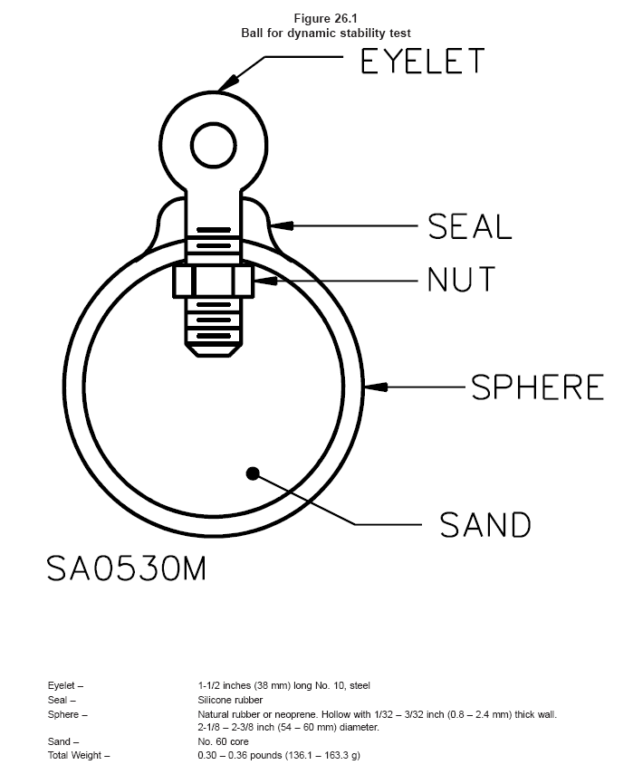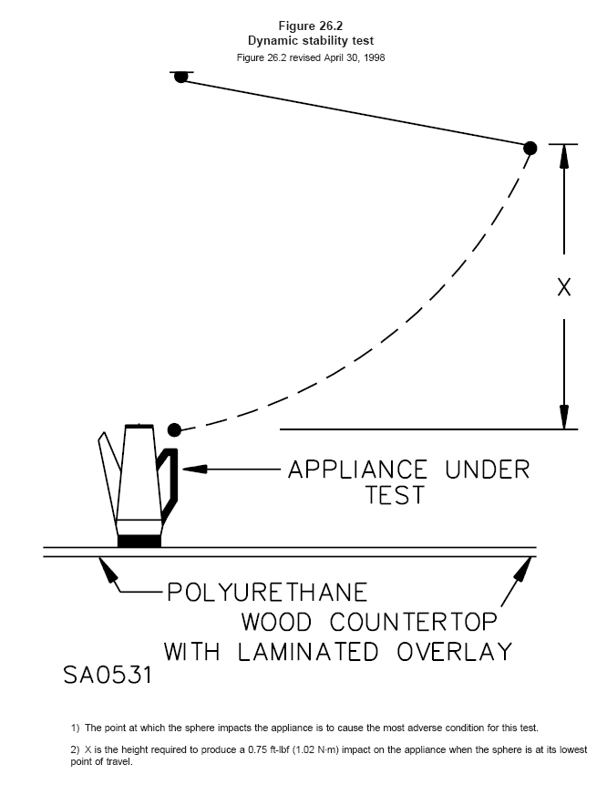

图26.2力平衡测试
1） 球体的冲击点为本测试最不利的地方；
2） X为产生0.75ft-lbt（1.02N.m）冲击力的高度。

26.14 The release mechanism for detachable handles shall be: 26.14 对于可拆卸式手把的松脱机械强度应如下要求：
a) So located and/or so guarded that inadvertent detachment of the handle does not occur
during normal use of the appliance, and a） 定位或防护方式不合适的松脱不得出现在电器的正常使用过程中；
b) So constructed that complete and proper engagement of the handle is obvious to the user
during the operation of attaching the handle.
b） 对于用户使用配置的手把操作时，在结构上应正确并且恰当的组合应是显而易见的。
27 Pressure Vessels and Parts Subject to Pressure27 涉及压力的容器和部件
27.1 Espresso coffee makers shall be so constructed that the coffee filter cannot be removed by a simple or unintentional operation when the vessel is pressurized. A coffee filter that can only be removed after having been rotated through an angle of at least 30 degrees is considered to comply with this requirement. A coffee filter holder provided with two separate and distinct means for securement onto the machine, accomplished either manually or by an automatic process, is also acceptable. 27.1 浓咖啡机的结构使得咖啡滤网承受压力时，不得由一个简单的动作或无意就可取下，咖啡滤网仅能在至少旋转30度后才可以取下，则认为满足本要求。咖啡滤网配置两个分离的支架，以明显的方式安装在机器上，不管自动或手动完成均可接受。
27.2 An expresso maker shall include a distinctive marking, such as an arrow, vertical bar, dot, or other equivalent marking, or the word ″lock ″, which clearly indicates the proper position to secure the coffee filter holder during the brewing cycle. This marking shall be located directly above the position of the filter holder handle when the filter holder is properly secured. 27.2 added November 22, 1997 27.2 浓咖啡机必须包括明显的标识，如箭头，垂线标志，点或其它等同的标志，或者单词“lock”，在酿制过程中应清楚地标识在咖啡滤网支架的正确位置上，当咖啡滤网正确安装后，该标识应直接位于支架的上面。
27.3 Except as noted in 27.4, a pressure vessel having an inside diameter of more than 6 inches (152 mm) and subject to a gauge pressure of more than 15 lbf/in2(103 kN/cm2 or 10.5 gf/mm2 ) shall be certified by the National Board of Boiler and Pressure-Vessel Inspectors and marked in accordance with the appropriate boiler and pressure vessel code symbol of the American Society of Mechanical Engineers (ASME) (″H ″, ″M ″, ″S ″, or ″U ″) for a working pressure not less than the pressure determined by applying 27.5.
27.3 除了27.4条的注意事项，压力容器内径超过6英寸（152mm）并涉及标准压力超过15-lbf/m²（103-kN/cm²/10.5-g/mm²）必须经国家压力容器机构认可，并标识符合ASME要求的字符（H、M、S或U）作为工作压力，不小于27.5条评估的压力值。
27.4 If a pressure vessel, because of its application, is not covered under the inspection procedures of the ASME code, it shall be so designed and constructed that it will comply with the requirements in 27.4 – 27.7. 27.4 如果一个压力容器，由于其应用不包含在ASME法规检查的内容中，其设计与结构应符合27.4-27.7条的要求。
27.5 The espresso-coffee maker is to be operated until maximum pressure is attained at rated voltage or at the upper limit of a rated voltage range, with the coffee-filter blocked and the steam valve, if provided, closed, except that, during the period that steam is produced, the supply voltage shall be such that the input is equal to the maximum rated input. If the steam valve is linked to the switch used for starting the production of steam, this link must not be disturbed during determination of maximum pressure. The maximum pressure is to be noted. 27.5 浓咖啡机工作在额定电压下或在额定电压的上限内，并且咖啡滤网将堵住，如果配备有压力阀，将其关闭，直至最大的工作压力出现，另外，在蒸汽产生的过程中，电源电压的输出必须等于最大电压的输入。如果蒸汽阀，被连到开关上作为蒸汽启动功能，该连接在评估最大压力期间不得弄混，并标明最大压力。
27.6 The espresso-coffee maker is then subjected for five minutes, to a pressure equal to twice the maximum pressure noted. The over pressure may be supplied from an external source, care being taken to ensure that the espresso-coffee maker is at its intended operating temperature for starting the brewing period. 27.6 咖啡机五次进行标示压力的两倍压力之测试项目。过压可以从外部供给，对于启动酿制期间，注意确认咖啡机是在它的预期工作温度下。
27.7 During the test described in 27.6, the espresso maker shall not rupture and there shall be no leakage other than at places intended for that purpose. Leakage is only acceptable through a self-resetting overpressure relief. At the conclusion of the test described in 27.6 the coffee-maker shall perform in its intended manner. 27.7 在27.6条描述的测试中，咖啡机不得破裂并且对于该目的不得从其它地方泄漏。泄漏仅允许通过自复式过压消除装置，在27.6条描述的测试结论必须能进行预期的使用。
27.8 Following the test outlined in 27.6, the coffee-maker is subjected to the same pressure as described in 27.6 except with any means for limiting the pressure during determination of the maximum pressure made inoperative. During this test the steam outlet is blocked, as it is regarded as the limiting device during determining the maximum pressure. The coffee-maker shall withstand this test without exploding or emitting hazardous jets of fluid.
27.8 以下的测试在27.6条中略述，咖啡机涉及与27.6条一样的压力，除了评估最大压力时被失效用来限制压力的方式，在本测试中蒸汽出口被堵塞，作为评估最大压力时压力的限制装置，咖啡机必须承受本测试而不会有破裂或液体的喷射现象。
27.9 If an intentionally weak part ruptures during the test in 27.8, a second sample is to be tested with identical results. Rupture of an intentionally weak part shall render the coffee-maker unfit for further use. 27.9 在27.8条的测试中，如果有意薄弱的部件破裂，用第二个样品测试具有相同的结果，有意薄弱部件的破裂必须表明咖啡机不适于将来的使用。
27.10 A means for relieving pressure shall be provided for all parts in which pressure might be generated in the event of fire. 27.10 所有用火产生压力的部件必须配置压力消除装置。
27.11 Pressure-relief devices (see 27.17), fusible plugs, soldered joints, nonmetallic tubing, or other pressure-relief means or the equivalent may be employed to comply with the requirements in 27.10. 27.11 压力消除装置（见27.17），熔断片、焊点、非金属套管或其它的压力消除装置，或者同等物可以应用，来满足27.10条的要求。
27.12 There shall be no shut-off valve between the pressure-relief means and the parts that it is intended to protect. 27.12 在压力消除装置间，同被保护的部件间不存在关闭阀，则认为该部件被保护。
27.13 A vessel having an inside diameter of more than 3.0 inches (76.2 mm) and subject to air or steam pressure generated or stored within the appliance shall be protected by a pressure–relief device. 27.13 内径大于3英寸（76.2mm），并涉及空气或蒸汽压力产生或贮存在电器的内部，必须用压力消除装置进行保护。
27.14 The start-to-discharge pressure setting of the pressure-relief device shall not be higher than the working pressure marked on the vessel. The discharge rate of the device shall acceptably relieve the pressure.
27.14 压力消除装置的启动泄压值不得高于标识在容器上工作压力，该装置的泄压额定参数应满足消除的要求。
27.15 A pressure-relief device shall comply with all four of the following:
27.15 压力消除装置必须满足以下所有的4个要求：
a) Shall be connected as close as possible to the pressure vessel or parts of the system that it
is intended to protect. a） 必须尽可能靠近被保护的压力容器或部件处连接；
b) Shall be so installed that it is readily accessible for inspection and repair and cannot be readily
rendered inoperative. b） 必须安装在容易进行检查及维修的位置，并且不得明显无效；
c) Shall have its discharge opening so located and directed that the risk of scalding is reduced to
a minimum. c） 必须使泄压开孔的位置与方向，应使危险降的可能性降至最小；
d) Shall have its discharge opening so located and directed that operation of the device will not
deposit moisture on bare live parts or on insulation or components affected detrimentally by
moisture. d） 必须使泄气孔的位置与方向，不得使潮气沉积在裸露的带电体上、绝缘上或者元器件上，使其性能恶化。
27.16 A pressure-relief device having an adjustable setting is judged on the basis of its maximum setting
unless the adjusting means is sealed at a lower setting. 27.16 具有调节设置的压力消除装置，必须在其最大压力的位置进行评估，除非调节装置用胶封在较低的位置。
27.17 A pressure-relief device is considered to be a pressure-actuated valve or rupture member intended
to relieve excessive pressures automatically. 27.17 压力消除装置被视为压力动作阀或破裂组件用作自动消除压力。
27.18 Where a pressure-relief device is required, the control responsible for limiting the pressure in the
vessel shall be capable of performing under rated load for 100,000 c of operation and shall prevent the
pressure from exceeding 90 percent of the relief device setting under any condition of normal operation.
27.18 本章所要求的压力消除装置，作为限制容器内压力的控制，必须在额定负荷下进行100000个周期的测试，并且在某些正常使用条件下，必须防止压力超过消除装置设定的90%。
PERFORMANCE性能
28 General28 总则
28.1 The performance of an appliance shall be investigated by subjecting the required number of
appliances to all the applicable tests as described in Sections 29 – 45. Appliances employed for
leakage-current tests shall be first tested for leakage prior to employing them for other tests. 28.1 电器的性能必须用一定数量来执行29-45部分的测试项目进行研究，电器的泄漏电流测试必须在所有的测试之前进行。
29 Resistance of Grounding Test29 接地电阻测试
29.1 The resistance between the point of connection of the equipment-grounding means at or within the
appliance and any other point in the grounding circuit of the appliance shall not exceed 0.1 ohms. 29.1 设备接地方式的连接点间的电阻或电器内同电器接地电路其它点之间的电阻值不得超过0.1欧姆。
29.2 Compliance with the requirement in 29.1 is to be determined by:
29.2 对于29.1条的符合性要求通过以下进行评估：
a) A resistance-measuring instrument, or a） 电阻测试仪器；或者
b) Passing an alternating current of at least 25 amperes from a power supply of not more than 12
volts from the grounding pin of the attachment plug cap to a point in the grounding circuit, and
then measuring the resulting drop in potential between the two points. The resistance in ohms is
to be determined by dividing the drop in potential in volts by the current in amperes passing
between the two points.
b） 用不大于12V，不小于25A的交流电源通过插头插片到接地点上，并测量这两点间的压降，电阻值通过压降和通过两点间的电流值进行评估。
30 Power Input30 功率输入
30.1 The power input to an appliance shall not be more than 105 or less than 90 percent of its marked
rating. 30.1 电器的功率输入不超过其标示额定值的105%，不小于90%。
30.2 To determine if an appliance complies with the requirement in 30.1, the power input is to be
measured with the appliance at normal operating temperature under full–load conditions and while
connected to a supply circuit adjusted to the highest voltage of the following: 30.2 评估电器是否符合30.1条的要求，功率输入测量是在电器工作于正常状态，满负载的条件下进行，供电电源调节至以下最高值：
- The marked voltage rating or a） 标识的额定电压值或；
- 120 V, whichever is appropriate for the appliance. b） 120V，选较合适的电压值。
31 Leakage Current Test31 泄漏电流测试
31.1 The leakage current of a cord-connected appliance rated for a nominal 120-V or 240-V supply when
tested in accordance with 31.1 – 31.7 shall not be more than: 31.1 对于软线连接，额定电源为120V或240V的电器，泄漏电流值按31.1-31.7条测试时不得超过以下要求：
a) 0.5 mA for an ungrounded (2-wire) appliance, a） 0.5mA对于不接地（2线）电器；
b) 0.5 mA for a grounded (3-wire) appliance that is easily carried or conveyed by hand, and b） 0.5mA对于接地（3线）便携式电器；
c) 0.75 mA for a grounded (3-wire) permanently connected appliance, or a cord connected
appliance that is intended to be fastened in place or located in a dedicated space and employing
a standard attachment plug rated 20 A or less. c） 0.75mA对于接地（3线）固定连接电器或软线连接电器，预期固定在位或指定空间并使用标准20A或较小的插头。
Exception: The leakage current of an appliance incorporating a sheath type heating element, when measured in accordance with 31.3 – 31.7, shall not exceed 2.5 mA during the first 5 min after reaching the leakage current limit of 0.5 mA or 0.75 mA, as applicable, and at the end of this time, the leakage current shall be not more than the 0.5 mA or 0.75 mA limit as applicable – the leakage current is to be monitored during heat-up and cool-down. 注：电器使用铠装电热元件的泄漏电流，按31.1-31.7条测量时，观察泄漏电流限制在0.5mA或0.75mA后，在最初的5分钟内泄漏电流不得超过2. 5mA，作为应用时以及本时间结束后，泄漏电流如应用一样不得超过0.5mA或0.75mA——冷态及热态时的泄漏电流均被监视。
31.2 Leakage current refers to all currents, including capacitively coupled currents, that may be conveyed
between exposed conductive surfaces of an appliance and ground or other exposed conductive surfaces
of an appliance.
31.2 泄漏电流涉及所有的电流，包括电容耦合电流，它可通过电器裸露的导体表面和接地或电器其它裸露的导体的表面进行传导。
31.3 All exposed conductive surfaces are to be tested for leakage currents. The leakage currents from these surfaces are to be measured to the grounded supply conductor individually as well as collectively where simultaneously accessible and from one surface to another where simultaneously accessible. Parts are considered to be exposed surfaces unless guarded by an enclosure considered acceptable for protection against electric shock as defined in 7.1 – 7.13. Surfaces are considered to be simultaneously accessible when they can be readily contacted by one or both hands of a person at the same time. These measurements do not apply to terminals operating at voltages which are not considered to involve electric shock. 31.3 所有裸露的导体的表面均进行泄漏电流的测试，泄漏电流从这些表面同单独的接地电源导体同时接触，并且从一个表面到另一个表面同时接触进行测量，零件被认为是裸露的表面，用7.1-7.13条中规定的用于防止电击的外壳进行保护的除外。当两表面能用一只手或两只手同时靠近进行测量时，该两表面认为可以同时接触。本测试不适用于不认为隐含电击之工作电压的端子上。
31.4 If a conductive surface other than metal is used for the enclosure or part of the enclosure, the leakage current is to be measured using a metal foil with an area of 10 by 20 cm (3.9 by 7.9 inches) in contact with the surface. Where the surface is less than 10 by 20 cm, the metal foil is to be the same size as the surface. The metal foil is not to remain in place long enough to affect the temperature of the appliance. 31.4 除了金属导体用作外壳或外壳上的部件时，泄漏电流测试时将用面积为10×20cm（3.9×7.9英寸）的金属箔包覆在其表面进行测量。如果其表面小于10×20cm的面积，则金属箔的面积同其面积一样，金属箔不要长时粘在电器上，以免影响电器的温度。
31.5 The measurement circuit for leakage current is to be as shown in Figure 31.1. The ideal measurement nstrument is defined in (a) – (d). The meter which is actually used for a measurement need only indicate the same numerical value for a particular measurement as would the ideal instrument. The meter used need not have all the attributes of the ideal instrument. 31.5 对于泄漏电流的测量电路如图31.1示。理想的测量仪器被子定义在以下（a）-（d）项。仪表实际用于测量只需指明相同的数字作为单独的测量像理想的仪器一样。仪表不需具有理想仪器的所有特性：
a) The meter is to have an input impedance of 1500 ohms resistive shunted by a capacitance of 0.15 µF. a） 仪表具有输入阻抗1500欧姆的电阻，并通过0.15uF的电容分流；
b) The meter is to indicate 1.11 times the average of the full-wave rectified composite wave–form of voltage across the resistor or current through the resistor. b） 仪表显示1.11倍的全波整流合成通过电阻的电压或电流的平均波形；
c) Over a frequency range of 0 – 100 kH, the measurement circuitry is to have a frequency response (ratio of indicated to actual value of current) that is equal to the ratio of the impedance of a 1500 ohm resistor shunted by a 0.15 microfarad capacitor to 1500 ohms. At an indication of 0.5 mA, the measurement is to have an error of not more than 5 percent at 60 Hz. c） 0-100KH的全频段，测量电路具有的频率响应（指明电流值的的比率），等同阻抗1500欧姆，通过0.15uF的电容分流进行微调1500欧姆，在指示0. 5mA时，60Hz时的测量误差不超过5%；
d) Unless the meter is being used to measure leakage from one part of an appliance to another,
the meter is to be connected between the accessible parts and the grounded supply conductor.
d） 除非仪表用来从电器的一个部件到另一个部件测量泄漏电流，仪表将连接在易触及部件同电源接地导体之间。
This is generated text for figtxt.
31.6 A sample of the appliance is to be tested for leakage current starting with the ″as received″ condition with all its switches and thermostats closed, but its grounding conductor, if any, open at the attachment plug. The ″as received″ condition being without prior energization, except as may occur as part of the production line testing. The supply voltages is to be 120- to 240V. The test sequence, with reference to the measuring circuit (Figure 31.1 ), is to be as follows: 31.6 用一个认为标准的电器样品进行泄漏电流测试，所有的开关、温控器将接通，如果有接地导体，从插头处断开。“认为标准”的条件没有通电过程，除了生产线测试的过程，电源电压将为120-240V，测试顺序参照测量电路（见图31.1），将如下进行：
a) With switch S1 open, the appliance is to be connected to the measuring circuit. Leakage current is to be measured using both positions of switch S2. a） 开关S1开路，电器将被连接到测量电路上，泄漏电流测量应用在开关S2的所有位置；
b) Switch S1 is then to be closed, energizing the appliance, and within a period of 5 s, the leakage current is to be measured using both positions of switch S2, and with the appliance operated at the maximum heat setting of controls. b） 开关S1闭合，电器通电，并且5秒一次进行泄漏电流测量开关S2的所有位置，电器工作在控制器的最大的加热状态下；
c) Leakage current is to be monitored until thermal stabilization under the maximum heat condition. Both positions of switch S2 are to be used. The equivalent of thermal stabilization is considered to be obtained as in the normal temperature test. If any thermostat does not cycle at the maximum heat setting, it is to be adjusted until it does cycle before the final measurements at thermal stabilization are taken. Measurements are to be made with the thermostat, if any, open and closed. Upon evidence of stabilizing readings, monitoring periods may be increased. c） 泄漏电流将被监视直到电器在最大的加热状态下达到热稳定状态，开关S2的所有的位置将使用，同等的热稳定状态认为是同正常温度测试的状态一样。如果温控器在最大的加热状态下不能循环，它将被调整至能循环工作，并获得稳定的热状态，测量如果将同恒温器一起进行，断开和接通，基于获得稳定的情况，监控时间可以增加；
d) If the appliance employs a single pole switch, monitoring of leakage current is to continue
until the leakage current stabilizes or decreases after the appliance is turned off.
d） 如果电器使用一个单极开关，泄漏电流的监视可以持续到电流稳定或电器跳断后电流下降。
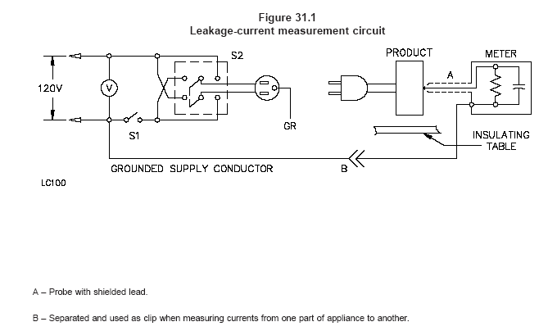

图31.1
泄漏电流测量电路

31.7 Normally a sample will be carried through the complete leakage current test program as covered by
31.6, without interruption for other tests. With the concurrence of those concerned, the leakage current
tests may be interrupted for the purpose of conducting other nondestructive tests. 31.7 一般样品必须进行泄漏电流测试程序，如31.6条所包含的，不中止其它的测试。泄漏电流测试可以中断作其它非破坏性的测试。
32 Operational Tests32 操作测试
32.1 Operation of an appliance while simulating anticipated conditions of use shall not increase the risk
of fire, electric shock, or injury to persons. 32.1 模拟预期电器实际工作时，不得存在火灾、电击或人身伤害的危险。
32.2 In conducting the test, the conditions mentioned in the manufacturer’s instructions, including cleaning, maintenance, and the use of accessories may be included or omitted so as to simulate reasonably foreseeable actions of the user. 32.2 在执行测试时，测试条件按电器制造商提供的使用说明书进行，包括清洁、保养，配件的使用可以包括在内也可以省略，以便模拟合理的可预见性使用的方法。
33 Normal Temperature Tests33 正常温度测试
33.1 General33.1 总则
33.1.1 An appliance, when tested under the conditions described in 33.1.3 – 33.2.4.1, shall comply with
all three of the following conditions: 33.1.1 当电器按33.1.3-33.2.4.1条的规定进行测试时，必须满足以下的三个条件：
a) The appliance shall not attain at any point a temperature sufficiently high to constitute a risk of
fire or to damage any materials employed in the appliance. a）电器中不得存在温度过高的点，导致产生火灾或损坏在电器上使用的材料；
b) At any time during the test – other than as indicated in 33.1.2 – temperature rises at specific
points shall not be greater than indicated in Table 33.1. b）测试期间，除了33.1.2条指明的外，规定点的温升值不超过表33.1中的限值。
c) The appliance shall comply with the requirement in 7.1. c）电器必须满足7.1条的要求。
33.1.2 Initial temperature transients may be in excess of the value shown in Table 33.1 if the duration and
extent of the excursion do not result in material property changes to the extent that risk of fire or electric
shock results. 33.1.2 如果持续时间后的温度不会改变材料性能从而导致产生火灾或电击，初始温度瞬间可以超过表33.1中的指定值。
33.1.3 All values in Table 33.1 are based on an assumed ambient (room) temperature of 25°C (77°F),
but a test may be conducted at any ambient temperature within the range of 10 – 40°C (50 – 104°F).
However, if the operation of an automatic thermal control during the test limits the temperatures under
observation, no temperature higher than 25°C (77°F) plus the specified maximum rise is acceptable.
33.1.3 表33.1中的值是基于假定在室温25℃，但可在环境温度为10-40℃之间进行测试，如果观察到通过自动控制器的动作来限制温度，没有温度超过规定的最高温升加上25℃所得的温度值，则可以接受。
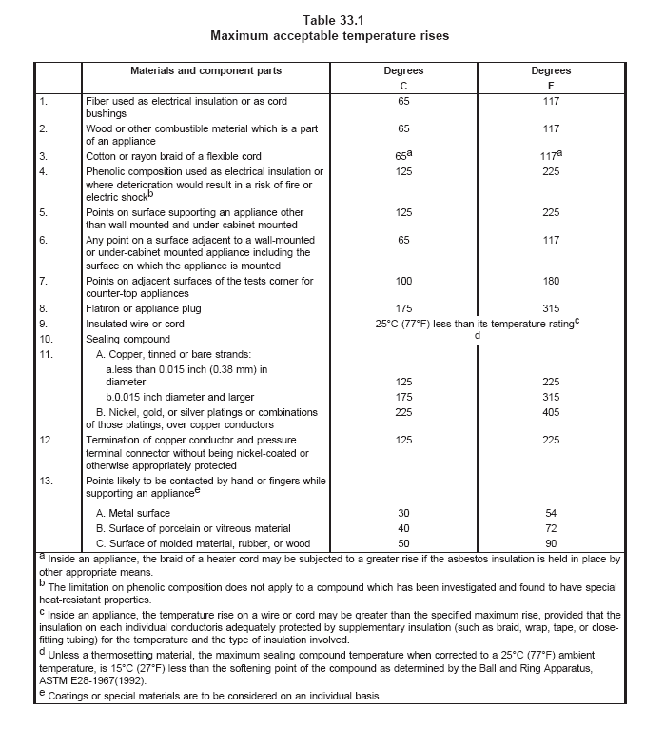

表33.1
最大允许温升
No. | 材料与元件 |  | ℃ | ℉
1 | 用作电器绝缘或软线护套保护的玻纤材料 |  | 65 | 117
2 | 木头或其它易燃性材料作为电器的一部分 |  | 65 | 117
3 | 棉或人造丝作为软线的纺织套 |  | 65ª | 117 ª
4 | 酚醛（电木）用作电器绝缘或用降低火灾或电击^{B} |  | 125 | 225
5 | 电器的支撑点，除了壁挂式或橱柜内安装使用的电器 |  | 125 | 225
6 | 壁挂式或橱柜内安装使用的电器，其安装接触面上的任一点 |  | 65 | 117
7 | 对于桌台式电器同测试墙角接触处 |  | 100 | 180
8 | 插片或电器插头 |  | 175 | 315
9 | 绝缘线或软线 |  | 小于其额定温度25℃（77℉）^{C}
10 | 密封胶 |  | ^{D}
11 | A 铜、镀锡或裸线
11 | a | 直径小于0.015英寸（0.30mm） | 125 | 225
11 | b | 直径等于或大于0.015英寸（0.30mm） | 175 | 315
11 | B 铜导体镀镍、金、银或它们的混合镀层 |  | 225 | 405
12 | 没有镀镍或其它适当保护的铜端子及压接连接器 |  | 125 | 225
13 | 放置电器时用手或手指接触的地方^{E}
13 | A 金属表面 |  | 30 | 54
13 | B 陶瓷或玻璃材料的表面 |  | 40 | 72
13 | C 模塑、橡胶或木制表面 |  | 50 | 90
A 电器的内部，加热器连接线的编织套可以超过温升值，如果石棉绝缘采用其它合适的方式固定；
B 酚醛树脂的温升限值不适用于经调查后并发现具有特别隔热特性的合成物；
C 电器的内部，线或软线上的温升可以超过最大温升限值，在每根单独导体上配备绝缘层（编织套、封套、胶套、封闭式套管）足以对温度及已存在的绝缘层起附加隔热保护作用。
D 除非热塑性材料，当精确到25℃（77℉）的环境温度时，密封胶的最大温度是15℃（27℉），小于树脂的软化点，作为评估由ASTM E28-1967（1992）。
E 涂层或特别材料被认为是在一层独特的基层上。
33.1.4 A gasket which is depended upon to prevent the entrance of water into an appliance during cleaning shall not become hard or brittle, shall not crack, and shall show no other signs of deterioration as a result of an accelerated-aging test in which the gasket is subjected to elevated temperatures. See 34.5. 33.1.4 在清洗时用于防水的密封胶圈，提高温度进行加速老化时的结果，应不会变硬或开裂，甚至存在这种趋势或者迹象。见34.5条。
33.1.5 The temperature to which the gasket is subjected during the test, as well as the duration of the test, is to be determined in accordance with the material of the gasket, the temperature to which it is subjected during operation, and other conditions of the particular application. Normally the appliance is to be operated dry and for a period of 240 h, except that an automatic coffee maker is to be initially filled with water.
33.1.5 测试时，密封胶圈涉及的温度以及测试周期，取决于胶圈的材料，正常工作时的温度，以及其它的特别应用条件，通常电器作240个小时的干烧，除自动咖啡机开始就需加满水的。
33.1.6 Following the accelerated aging, the sample is to be immersed, tested, and examined for the entrance of water in accordance with 34.7. 33.1.6 下面的加速老化测试，样品须浸透、测试并根据34.7考察是否漏水。
33.1.7 Temperatures are to be measured by thermocouples consisting of wires no larger than No. 24 AWG and no smaller than No. 30 AWG, except that a coil temperature may be determined by the change-of-resistance method if the coil is inaccessible for mounting thermocouples. When thermocouples are used in determining temperatures in electrical equipment, it is standard practice to employ thermocouples consisting of No. 30 AWG iron and constantan wire and a potentiometer–type instrument, and such equipment is to be used whenever referee temperature measurements by thermocouples are necessary. The thermocouple wire is to conform with the requirements for special thermocouples as listed in the table of limits of error of thermocouples Temperature–Measurement Thermocouples, ANSI MC96.1-1982. The thermocouples and related instruments are to be accurate and calibrated in accordance with good laboratory practice.
33.1.7 测量的热电偶用线不大于24AWG，也不得小于30AWG，如果线圈难以安装热电偶，则线圈可以用电阻法进行测量评估，当热电偶用作评估电气设备温度时，标准应使用30AWG的铁康铜线热电偶，以及电位计型仪表，使用这样的设备作为温度评估是很有必要。热电偶线应同ANSI MC96.1-1982中规定的特别要求的热电偶精度和误差表一致。热电偶和相关的仪器就经校核并应成为好的实验习惯。
33.1.8 For tests that are to be continued until constant temperatures are attained, thermal equilibrium is
to be considered to exist only if three successive readings indicate no change when taken at the
conclusion of each of three consecutive equal intervals of time, the duration of each interval being
whichever of the following is longer: 33.1.8 测试将持续直到获得热稳态，当在三次连续相等的时间的每一次终了时，如此连续三次读数没有改变，则认为达到热平衡；每个时间间隔持续如下任一个：
a) 5 minutes, or a） 5分钟，或者；
b) 10 percent of the total test time elapsed previous to the start of the first interval. b） 在读取第一个数之前所有时间总和的10%。
33.1.9 A thermocouple junction and adjacent thermocouple lead wire are to be securely held in good thermal contact with the surface of the material whose temperature is being measured. In most cases, good thermal contact will result from securely taping or cementing the thermocouple in place but, if a metal surface is involved, brazing, welding or soldering the thermocouple to the metal may be necessary. 33.1.9 热电偶的接合点和邻近热电偶的引线将同被测量的材料的表面保证良好的热接触，多数情况下，为了良好的热接触的结果是用胶布或胶水将热电偶保证在位，但是如果涉及金属表面，必要时可用铜焊、熔接或锡焊等方式固定热电偶。
33.1.10 To determine whether an appliance complies with the requirements in 33.1.1, the appliance is to
be operated continuously until constant temperatures have been reached. 33.1.10 评估电器是否符合33.1.1条的要求，电器将持续工作直到获得热稳定。
33.1.11 The test voltage is to be the highest of the following: 33.1.11 测试电压为以下最高值：
a) The marked voltage rating, a） 标识的额定电压；
b) 120 V, or b） 120V或；
c) The voltage that results in the appliance operating at rated wattage. c） 电器在额定功率下的工作电压。
33.1.12 In conducting a test to determine whether or not an appliance complies with the temperature requirements, it is to be mounted or supported as in service and tested under conditions approximating those of normal operation, except as otherwise noted. Temperatures are to be observed on nearby surfaces, on the supporting surface, at points of support, on attachment plugs, and at other points as may be necessary. 33.1.12 进行评估电器是否满足温度要求的测试时，电器将按使用状态进行安装或放置，并在近似正常工作的条件下进行测试，除非另有规定，温度将靠近表面观察，在支持表面上，支撑点上，插头及其它需要的地方。
33.1.13 A counter-top appliance is to be supported on two layers of white tissue paper on a softwood surface. 33.1.13 桌台式电器将放在铺有两层白纸的松木板上测试。
33.1.14 A counter-top appliance is to be tested in a test corner with the appliance located 4 inches (100 mm) away from the side and rear walls of the test corner. The 4-inch (100-mm) spacing is to be measured from the outer-most extremity of the appliance. The test corner is to consist of dull black-painted fir plywood not less than 3/8 inch (9.5 mm) thick, having such width and height that the walls extend not less than 2 ft (0.61 m) beyond the physical limits of the appliance. The vertical walls are to meet at a right angle. 33.1.14 桌台电器将在测试角上测试，电器的侧边同后背离墙4英寸（100mm）远距离，4英寸空间是从电器的最外部开始计量，测试角为黑色喷涂，厚度不小于3/8英寸（9.5mm）的松木板墙壁所具有的宽度和高度大于电器外观尺寸至少2英尺（0.61m），测试角三面互相垂直接合在一起。
Exception: An appliance such as a percolator with a relatively low surface temperature need not be
tested in an alcove corner. 注：电器如咖啡壶，具有相当低的表面温度不需在测试角上测试。
33.1.15 A cord-connected wall or under-cabinet mounted appliance is to be mounted on one wall or cabinet bottom of a test corner consisting of dull black-painted fir plywood not less than 3/8 inch (9.5 mm) thick, having such a width and height that the walls extend not less than 2 ft (0.61 m) beyond the physical limits of the appliance. The vertical walls are to meet at a right angle. Unless marked as described in 50.12, the appliance is to be placed as close to the corner wall as the construction will permit, and an under-cabinet appliance is to be in contact with the rear wall while a wall–mounted appliance is to be in contact with either the cabinet bottom or the counter, whichever results in the highest temperature. The cabinet bottom is to be 12 inches (300 mm) deep, located 16 inches (400 mm) above the counter top. The surface beneath the unit is to be softwood covered with a double layer of white tissue paper. 33.1.15 软线连接壁挂式或厨柜下安装的电器，安装在测试角的墙上或厨柜下，测试角为黑色喷涂，厚度不小于3/8英寸（9.5mm）的松木板墙壁所具有的宽度和高度大于电器外观尺寸至少2英尺（0.61m），测试角三面互相垂直接合在一起。除非如50.12条规定的标识，电器按其结构尽可能靠近墙壁放置，橱柜下安装的电器，后背贴墙，电器安装时靠近柜底或桌面安装，视产生高温的结果而定，柜台12英寸（300mm）深，离桌面16英寸（400mm）安装，整机下的松木板上铺上双层白纸。
33.1.16 Thermocouples are to be mounted on wood surfaces using the method illustrated in Figure 33.2
or the equivalent. Starting in the corner, thermocouples are to be placed every 3 inches (76 mm) on each
surface (Figure 33.3) so that a minimum area of 18 by 18 inches (460 by 460 mm) is covered by the
thermocouples on each surface. 33.1.16 热电偶采用图33.2中方法安装在松木板的表面上，从角落开始，每3英寸远布置一个热电偶，最少面积为18×18英寸（460×460mm），每个表面均匀布置。
33.1.17 During the normal temperature test, a temperature-limiting device provided for overheating
protection shall not operate. 33.1.17 正常温度测试期间，温度限制装置作为过热保护的装置不得动作。
33.1.18 An automatic temperature-regulating or -limiting control or other protective device provided as a
part of an appliance is to be shunted out of the circuit, unless the device is suitable for the application as
required by 45.2.1.1 and the control is unlikely to be defeated by the user.
33.1.18 自动温度调节或限制装置或其它保护装置作为电器的一个部件将被短路，除非该装置的应用适合45.2.1.1条的要求，并且该控制器不可能由用户失效
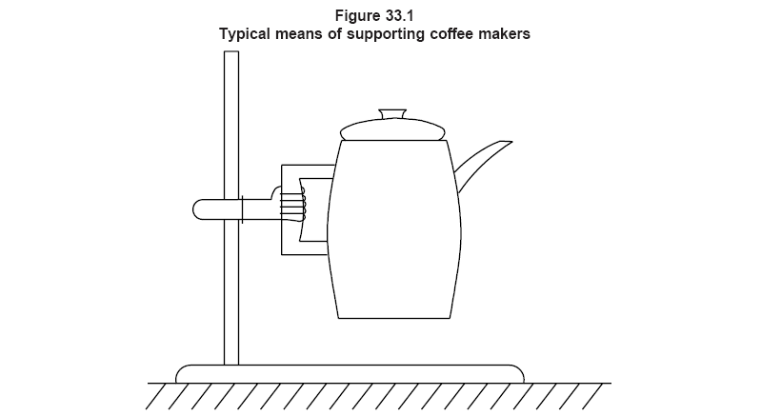
This is generated text for figtxt.
This is generated text for figtxt.
This is generated text for fi图33.1 典型的咖啡壶支撑方法gtxt.

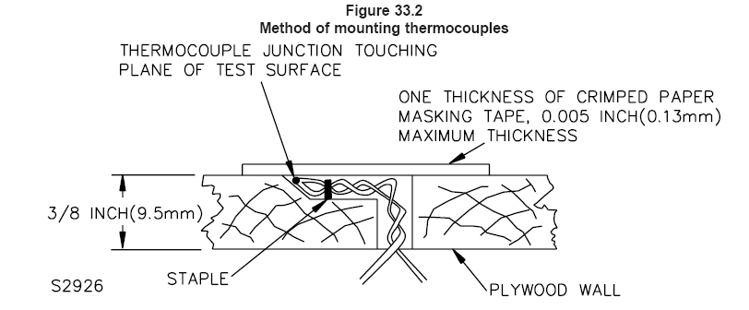

图33.2 热电偶的安装方法
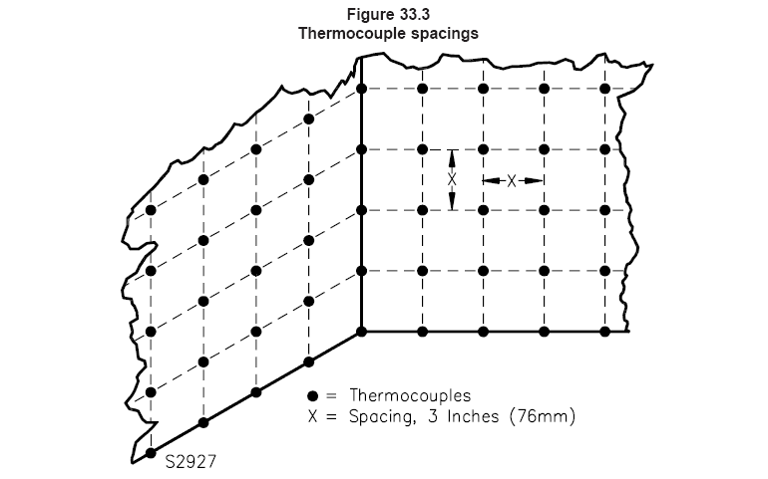
图33.3 热电偶布置
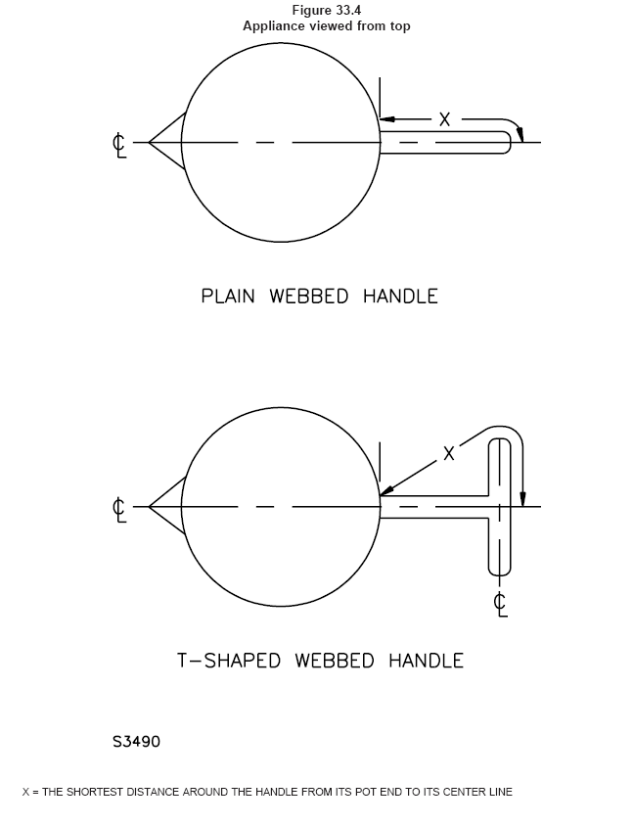
图33.4 电器的俯视图
33.1.19 If the construction of an appliance is such that cooking or heating of a liquid is a determining factor in the temperature attained, the intended duty of an appliance is to be taken into consideration. Accordingly, in determining whether an appliance complies with the requirements in 33.1.1, actual service conditions or an approximation thereof are to be employed. If the appliance is controlled by an adjustable thermostat, the thermostat is to be set to give maximum temperatures. If the appliance is controlled by a nonadjustable thermostat, it is to be allowed to operate at whatever temperature the thermostat permits. In each case, operation is to be continued until temperatures are stabilized. 33.1.19 如果电器的结构使用液体烹调或加热，是所测得温度的决定性因素，电器预期的作用将被考虑，相应的，评估电器是否符合33.1.1条的要求，按实际的使用条件或近似的条件进行，如果电器由可调节器式温控器控制，将允许其工作在温控器认可的温度内，对于各种因素，电器将持续工作至热稳定。
33.1.20 With reference to Item 13 of Table 33.1, points likely to be contacted by hand or fingers include
those points on the gripping surface, and adjacent surfaces close enough to be touched while supporting
the appliance in the normal intended manner. See 33.1.21 – 33.1.24. 33.1.20 参考13条及表33.1，由手或手指接触手把握柄上的某些点，以及正常使用时，同支撑电器必须接触的表面。见33.1.21~33.1.24。
33.1.21 The length of the gripping surface of a handle is considered to be as follows:
33.1.21 手把握柄表面的长度如下认为：
a) Four inches (102 mm) for an open or D-shaped handle. a） 4英寸（102mm）对于开口式或D型手把；
b) The entire handle for a webbed type handle. b） 完整手柄对于蹼形手柄。
33.1.22 Points on the surface of an appliance employing an open or D-shaped handle are not considered
likely to be contacted if: 33.1.22 如果是以下情况，电器使用开口或D型手把表面上某些点不认为可以接触：
a) They are protected by a barrier not less than 5/8 inch (15.9 mm) wide on which the temperature rise does not exceed the value indicated in Item 13 of Table 33.1, or a） 用不小于5/8英寸（15.9mm）宽的护栏保护，并且其上温度不超过表33.1中的13条之规定值；
b) A through-air spacing of not less than 1.5 inch (38 mm) at the index finger, tapering to 1.25 inch (32 mm) at the other end of the hand, is provided from the gripping surface to the hot part. b） 通过空气的间隙不小于1.5英寸（38mm）在插入手指处，在手把收尾处减至1.25英寸（32mm），将配置远离热表面抓握。
33.1.23 Points on the surface of an appliance employing a webbed type handle are not considered likely to be contacted if: 33.1.23 如果是以下情况，电器使用蹼型手把表面上某些点不认为可以接触：
a) They are protected by a barrier extending not less than 1/2 inch (12.7 mm) on either side of the web on which the temperature rise does not exceed the value indicated in Item 13 of Table 33.1, or a） 用不小于1/2英寸（12.7mm）宽的护栏保护，并且其上温度不超过表33.1中的13条之规定值；
b) The length ″x″ indicated in Figure 33.4 is not less than 4.25 inches. b） 标识在图33.4中的“X”的长度不小于4.25英寸。
33.1.24 If the temperature rise on a rivet or screw in a barrier or handle, which would be touched in the normal gripping or lifting action, exceeds the value given in Item 13 of Table 33.1, it is to be recessed at least half the diameter of the hole, and the hole is to be no larger than 3/8 inch (9.5 mm) in diameter. 33.1.24 护栏上铆钉或螺钉的温升，在正常提起或抓抓起使用时可以触及的地方，超过表33.1中的13条之规定值，将缩进洞的直径一半以上，洞的直径不得小于3/8英寸（9.5mm）。
33.1.25 To determine if the strength of a thermoplastic handle is adequate to maintain the minimum spacing to a hot surface mentioned in 33.1.22(b) or 33.1.23(b) while in a heated condition, the following test is to be conducted. The spacing is to be maintained after the vessel has been conditioned for one hour with water maintained at a temperature equal to the maximum temperature measured during the temperature test, including the ″keep warm″ cycle, or that temperature that occurs when a separate vessel is filled following a ″brew″ cycle. The spacing is to be measured while supporting the vessel with a 2 inch (51 mm) wide gripping area (centered over the intended gripping area) and after the vessel has been supported and maintained in a vertical position for one minute. See Figure 33.1. 33.1.25 如果热塑材料的手柄的强度足够保证33.1.22条（b）或33.1.23条（b）描述的距离热表面的间隙，当进行热态条件评估时，将进行以下的测试：该间隙必须保证，容器盛水保持在温度测试时的最大温度下1个小时，包括保温周期或当分离容器注入水进行酿制时的温度。该距离将进行测量，当支撑容器2英寸（51mm）宽的抓握面积（中间到预期抓握处），并且容器被支撑起来后保持在水平的位置1分钟，见图33.1示。
33.2 Specific test conditions 33.2 特别的测试条件
33.2.1 General33.2.1 总则
33.2.1.1 For most of the common types of heating appliances, standardized normal conditions for the
temperature test are given in 33.2.2.1 – 33.2.4.1. 33.2.1.1 多数普通加热电器，对于温度测试的标准条件给定在33.2.2.1-33.2.4.1中。
33.2.2 Vacuum-type coffee makers33.2.2 真空型咖啡机
33.2.2.1 The appliance is to be operated continuously, warming water in the intended decanters. As the water in the initial decanter reaches the temperature at which it is forced into the upper section of the coffee-maker, it is to be replaced by a fresh decanter of water at a temperature of 10 – 15°C (50 – 59°F). 33.2.2.1 电器连续工作，在容器中按预期目的加热水，当观察到水加热至咖啡机的最高的温度时，将容器中的水换成10-15℃（50-59℉）的冷水。
33.2.3 Automatic type appliances33.2.3 自动型咖啡机
33.2.3.1 With the thermostat set in the position that results in maximum temperatures, the appliance is to be operated for 3 c, as follows: at the beginning of each cycle, the appliance is to be filled with the intended amount of water and the thermostat is to be set at the position which results in maximum temperature. The water temperature is not to be higher than room temperature. The cycle is considered as having ended when the thermostat automatically switches to the low or off position. The interval between cycles is to be approximately 30 s. Temperatures are to be measured throughout the 3 c, and also when the appliance has subsequently operated at low heat until temperatures have become stabilized. 33.2.3.1 用自动恒温器设定在最高的温度处，电器工作3个周期，在每个周期的开始，电器将加入预期最大量的水并将温控器设定在最大温度处，水温不要高过室温。温控器自动处于最低位或跳断认为该周期结束。每个周期间间隔30秒，通过工作3个周期测量温度，并且电器随后工作在低热态直到温度稳定。
Exception No. 1: A coffee maker having a capacity greater than 75 oz (2.22 L) is to be operated for one,
rather than three brewing cycles. 注1：咖啡机的容量大于75安士（2.22升）只工作一次，不是三个周期。
Exception No. 2: Starting with cold water, a hot pot is to be operated for 30-min cooking 8 medium size eggs or the maximum number of eggs the appliance holds, whichever is less. Temperatures are to be monitored during the 30 min and the highest temperatures recorded. 注2：用冷水开始，加热盆中放入8个中等尺寸的鸡蛋或按电器所能容纳的数量，选取较小的，温度监视30分钟并记录最高的温度。
33.2.4 Nonautomatic type appliances33.2.4非自动型电器
33.2.4.1 The appliance is to be filled with the intended amount of water and operated until temperatures
have become stabilized. Additional water is to be added during the test if the water level becomes lower
than the half-full mark.
33.2.4.1 电器加入预定量的水并工作直到温度稳定，测试时如果水位低于充填量一半时应加水进去。
34 Leakage Current as a Result of Moisture Tests34 潮湿测试后的泄漏电流
34.1 An appliance employing insulation material liable to be affected adversely by moisture under
condition of normal use shall be conditioned for 48 h in moist air having a relative humidity of 88 ±2
percent at a temperature of 32.0 ±2.0°C (89.6 ±3.6°F). After the conditioning: The appliance shall comply
with the requirement in 31.1 in a repeat leakage current test, except that the test shall be discontinued
when leakage current stabilizes. 34.1 电器使用的绝缘材料在正常使用过程中会受到潮气的影响，必须在32.0±2.0℃（89.6±3.6℉）的温度下，88±2%的湿度的潮气下放置48小时。然后，电器重复进行泄漏电流测试时必须满足31.1条中的要求。除非电器的泄漏电流极为稳定。
34.2 An additional sample of the appliance shall be tested as follows, if glass–fiber sleeving is used as electrical insulation in a rope heater assembly. The appliance shall be operated for 96 continuous hours under the condition resulting in the maximum temperature on the sleeving, as determined from the normal temperature test, following which it shall be conditioned for 48 h in moist air having a relative humidity of 88 ±2 percent at a temperature of 32.0 ±2.0°C (89.6 ±3.6°F). After the conditioning, the appliance shall comply with the requirement in 31.1 in a repeat leakage test, except that the test shall be discontinued when the leakage current stabilizes. Following the leakage current test, the appliance shall also comply with the dielectric voltage-withstand test requirement of 35.1. 34.2 电器的另一个样品必须如下测试，如果玻璃纤维套管用作绳状加热组件的绝缘，在按正常温度测试使套管上产生最大的温度情况下，电器进行96小时的连续工作。然后在32.0±2.0℃（89.6±3.6℉）的温度下，88±2%的湿度的潮气下放置48小时。再进行泄漏电流测试必须符合31.1条的要求，除非泄漏电流稳定时才可以中断本测试。泄漏电流测试后，电器必须符合35.1条的耐压测试。
34.3 An appliance which is likely to be immersed in water for cleaning shall show a leakage current of no more than 0.5 mA and shall be capable of withstanding a potential of 1000 V when tested in accordance with 34.4 – 34.8. The test shall not result in the entrance of water into the interior of the appliance such that the water might come into contact with uninsulated live parts.
34.3 电器浸水清洗必须证明不超过0.5mA的泄漏电流，并且按34.4-34.8条测试时能承受1000V的电压测试。本测试不得存在水进入电器内部，导致水同裸露的带电体接触。
Exception: An appliance marked to indicate that it is not intended for immersion need not comply with
the requirements of 34.3. See 50.9. 注：标示指明预期不可浸水的电器不需满足34.3条的要求。见50.9条
34.4 Three samples of the appliance are to be heated as described in 34.6 and are then to be immersed immediately in water at a temperature of 10 – 25°C (50 – 77°F). The immersion is to be complete unless the appliance is marked to indicate that it is intended for partial immersion only (see 50.9), in which case each appliance is to be immersed only to the extent indicated. After 1 h of immersion, the samples are to be removed from the water, dried with a soft cloth to remove all surface moisture, including surface moisture from terminal pins, and the samples are to be tested for leakage current. 34.4 电器用三个样品进行34.6 规定的测试，进行加热后，立即浸入10-25℃（50-77℉）的冷水中，除非电器标示仅作部分浸入（见50.9），电器将浸入所允许的标识深度，否则将整个浸入水中，浸入1小时后，样品从水中取出，用软布擦拭干表面的水分，包括端子上的，然后进行泄漏电流测试。
34.5 The entire procedure of immersion and leakage current measurement is to be repeated four times, immediately following which each sample is to be subjected to a 1000-V dielectric voltage-withstand test as described in 35.1. The three samples are to be used for aging tests, and are required to comply with the requirements in 33.1.4 – 33.1.6. If there is an air cavity having electrical components, the three samples are to be disassembled and the internal parts visually examined for the presence of water. (See 34.3 and Table 34.1). 34.5 完全浸水和泄漏电流测试重复4次，然后每个样品按35.1条的规定进行1000V的介电电阻测试。3 个样品将进行老化测试，并要求符合33.1.4-33.1.6条。如果空穴中装有电气元件，三个样品将拆开，视检内部元件进水的情况（见34.3及表34.1）。
34.6 A nonautomatic coffee maker is to be operated as described in 33.2.4.1. An automatic coffee maker
is to be heated in accordance with 34.9. 34.6 非自动咖啡机按33.2.4.1条细节工作，自动咖啡机加热应符合34.9条。
34.7 Two additional samples of an automatic coffee maker, initially at room temperature, are to be operated dry until the thermostat automatically switches to the low or off position, and are then to be immersed immediately in water at a temperature of 10 – 25°C (50 – 77°F). After 1 h of immersion, the leakage current of each of the two samples is to be measured, and each sample is to be subjected to a 1000-V dielectric voltage-withstand test as described in 35.1. If there is an air cavity having electrical components, both samples are to be disassembled and the internal parts visually examined for the presence of water (see 34.3). 34.7 自动咖啡机的另两个样品，从室温状态干烧到恒温开关自动到低温位置或断开，立即浸入10-25℃（50-77℉）的冷水中，1小时后，两台样品进行泄漏电流测试，并且每个样品按35.1条的描述进行1000V的介电电阻测试。如果空穴中装有电气元件，三个样品将拆开，视检内部元件进水的情况（见34.3及表34.1）。
34.8 One of the samples tested in accordance with 34.7 (or an additional sample, if necessary) is to be
reassembled, filled with the intended amount of water, and operated with the thermostat at the maximum
setting until the temperature of a gasket or seal becomes stabilized. The temperature of the gasket or seal
is to be noted when the thermostat automatically switches to the low or off position. Without disconnecting
the appliance from the supply circuit, the utensil is to be emptied and operation without water continued
until the temperature of the gasket or seal again becomes stabilized.
34.9 The three samples to be used for the tests described in 34.4 and 34.5 are to be operated, as
described in 34.8, to the point at which the maximum temperature was observed.
34.8 用一个样品按34.7条测试（如果必要增加一个样品），将重新装配，装上预期注入的水，温控器设定在最大的条件下，直到密封垫或密封胶的温度稳定，当温控器自动复位或中断时，必须注意密封垫或密封胶的温度，此时电器不要断电，直到水烧干，并在干烧状态下使密封垫或密封胶的温度稳定。
34.9 按34.4和34.5条用作测试的两个样品，按34.8条的描述进行工作，直到观察到最大温度。
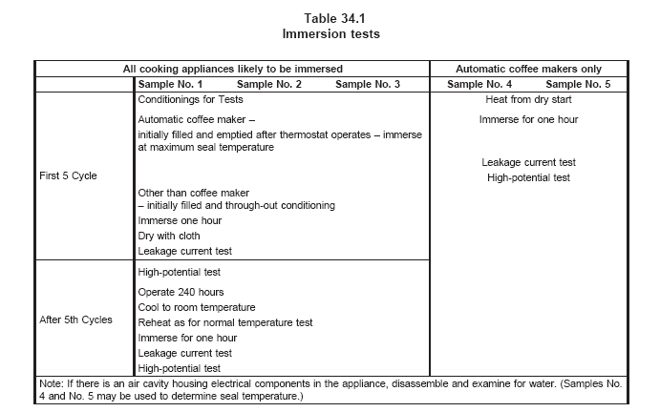

表34.1浸水测试
所有将浸水的烹调电器 |  |  |  | 仅对咖啡机
 | 样品1 | 样品2 | 样品3 | 样品4 | 样品5
开始5个周期 | 测试条件  自动咖啡机-  温控器断开后由开始注满状态到倒空-  浸入最大的密封的温度  非自动咖啡机  - 开始注满并保证至少一半状态  其它咖啡机  - 开始注满并保持自然状态  浸入1小时  用布擦干  泄漏电流测试 |  |  | 干烧加热  浸水1小时  泄漏电流测试  高压测试
第5个周期之后 | 高压测试  工作240个小时  冷却至室温  按正常温度测试进行预热  浸水1 小时  泄漏电流测试  高压测试
注：如果空穴中装有电气元件，三个样品将拆开，视检内部元件进水的情况。（样品4和样品5可以用于确定密封的温度）
35 Dielectric Voltage-Withstand Test35 介电电阻测试
35.1 An appliance shall be capable of withstanding for 1 min without an indication of unacceptable performance, the application of a potential applied between live parts and accessible metal parts. The appliance is to be at its maximum normal operating temperature. The test potential shall be 1000 V. 35.1 电器在它的最大工作温度时，1000V的测试电压施加在带电体同易触及金属部件之间，电器应能承受1分钟而无异常。
35.2 With respect to 35.1, an appliance having an enclosure constructed partly or totally of insulating material is to have accessible surfaces of the material closely wrapped in metal foil. The test potential is to be applied between live parts and the foil. 35.2 对于35.1条的检查，电器具有部分或全部的绝缘材料外壳，将在易接触的表面覆上金属箔，测试电压施加在带电体同金属箔之间。
35.3 With respect to 35.1 and 35.2, a part is considered to be accessible if it can be contacted by the probe illustrated in Figure 7.2 when applied in all possible articulated positions, with and without the parts referenced in 7.13 in place. 35.3 对于35.1和35.2条的检查，可以用图7.2示的探棒触及的部件，认为是易触及的部件，有没有该部件参考7.13条。
35.4 To determine whether an appliance complies with the requirements in 35.1, the test potential is to be applied as described in 35.6, by means of test equipment having the characteristics outlined in 35.5. 35.4 评估电器是否符合35.1条的要求，电压的施加按35.6条的描述进行，用35.5条指定性能的设备进行。
35.5 The test equipment for conducting the dielectric voltage-withstand test is to have the following
features and characteristics: 35.5 对于执行介电电阻测试的设备，应具有以下功能与特性：
a) A means for indicating the test voltage that is being applied to the appliance under test. This
may be accomplished by sensing the voltage at the test leads or by an equivalent means. a） 规定的测试电压是指测试时施加到电器上的电压，可以通过感应电压在引线上或同等的方式实现；
b) An output voltage that: b） 输出电压应具有：
1) Has a sinusoidal waveform, 1） 正弦波形；
2) Has a frequency that is within the range of 40 – 70 Hz, and2）具有频率在40-70的范围内
3) Has a peak value of the waveform that is not less than 1.3 and not more than 1.5 times
the root-mean-square value. 3） 具有的波形尖峰值不小于1.3倍也不大于1.5倍的rms值。
c) A sensitivity of the test equipment that is such that when a resistor of 120,000 ohms is connected across the output, the test equipment does not indicate unacceptable performance for any output voltage less than the specified test voltage, and the test equipment does indicate unacceptable performance for any output voltage equal to or greater than the specified test value. The resistance of the calibrating resistor is to be adjusted as close to 120,000 ohms as instrument accuracy can provide, but never more than 120,000 ohms. c）测试设备的灵敏度应如下，当连接120000欧姆的电阻在输出口时，测试设备不得显示输出电压小于规定测试电压的不良特性，同时测试设备不得显示输出电压大于规定测试电压的不良特性，校准电阻仪的电阻调节及120000欧姆人微言轻仪器精确校正，但不能超过120000欧姆值。
Exception: The sensitivity of the test equipment may be increased, a higher value of calibrating resistance may be used, if agreeable to those concerned.

35.6 The method of applying the test voltage to the appliance is to be such that there are not any transient voltages that result in the instantaneous voltage applied to the appliance exceeding 105 percent of the peak value of the specified test voltage. The applied potential is to be increased from zero at a substantially uniform rate so as to arrive at the specified test potential in approximately 5 s, and then is to be maintained at the test potential for one minute. Manual control of the rate of rise may be used.
35.6施加测量电压的方法，应不得存在瞬间电压即刻施加于电器上的电压，超过105%规定电压的尖峰值，所施加电压约在5秒内，从0以均匀的速度加至规定值，并保持该电压1分钟，可以使用手动控制施加速率。
36 Broken Element Test36 切断发热元件测试
36.1 An open-wire heating element in an appliance shall be so constructed and supported so that if the
wire is cut at any point there shall be no reduction of electrical spacings below the limits specified in this
standard. After being cut, no portion of the heating element wire shall be accessible to contact by the
articulate probe through any opening in the enclosure. 36.1 电器中的裸线加热元件，如果能从某点剪断，其结构与固定方式，应不会使电气间隙降到本标准允许值以下。剪断后，加热线部分不可能用探棒从电器外壳上的开孔伸入触及。
36.2 To determine compliance with 36.1: 36.2 从以下评估36.1条的合格性：
a) The appliance is first to have been operated until fully heated as in the Power Input or
Temperature Tests, and a） 首先电器按功率输入或正常温度测试工作直到充分加热，并且；
b) After cutting the heating element, the appliance is to be rotated 360° in the direction most likely
to cause contact between the heating element and accessible metal parts. b） 剪断发热元件后，在加热元件很可能同易触及金属部件接触的方向将电器旋转360度。
37 Strain Relief Test
37 应力消除测试
37.1 The strain-relief means provided on an attached flexible cord, when tested in accordance with 37.2,
shall be capable of withstanding for 1 min, without displacement, a pull of 35 lbf (156 N) applied to the
cord, with the connections within the appliance disconnected. 37.1 附带软线上配置的应力消除装置，按37.2条测试时，必须承担1分钟，没有位移。软线上施加35-lbf（156N），并且电器内连接处必须剪断。
37.2 The specified force is to be applied to the cord and so supported by the appliance that the
strain-relief means will be stressed from any angle that the construction of the appliance permits. The
strain- relief is not acceptable if, at the point of disconnection of the conductors, there is sufficient
movement of the cord to indicate that stress on the connections would have resulted. 37.2 规定力施加到软线上并由电器的应力消除装置支撑，按电器结构所允许的角度施加应力，如果在导体的断开点，软线存在有明显的位移，表明是由于应力产生的结果，则应力消除装置不可接受。
37A Push-Back Relief Test电源线推力测试Section 37A added January 9, 1999
37A.1 To determine compliance with 11.2.3, a product shall be tested in accordance with 37A.2 without
occurrence of any of the following conditions:
a) Subjecting the supply cord or lead to mechanical damage;
b) Exposing the supply cord or lead to a temperature higher than that for which it is rated;
c) Reducing spacings (such as to a metal strain-relief clamp) below the minimum required values; or
d) Damaging internal connections or components.
37A.2 The supply cord or lead is to be held 1 inch (25.4 mm) from the point where the cord emerges from
the product and is then to be pushed back into the product. The cord or lead is to be pushed back into
the product in 1 inch (25.4 mm) increments until the cord buckles or the force to push the cord into the
product exceeds 6 pounds-force (26.7 N). The supply cord or lead within the product is to be manipulated
to determine compliance with 11.2.3.
38 Metal Enclosure Impact Tests38 金属外壳冲击测试

38.1 A metal enclosure part shall comply with the tests outlined in 38.2 – 38.5. For polymeric enclosure
parts, see the Standard for Polymeric Materials – Use in Electrical Equipment Evaluations, UL 746C. 38.1 金属外壳部件的符合性测试描述在38.2-38.5中，对于塑料外壳部件的测试见UL 746C。
38.2 A metal enclosure part shall withstand the ball impact, with the appliance restrained, as described in 38.3 without occurrence of any one of the following conditions: 38.2 金属部件必须承担钢球冲击，模拟电器滥用之情形，按30.3条的描述进行，不得出现以下任一情形：
a) Making live parts accessible to contact with the articulate probe, see 7.11 and 7.12. a） 用有关节的探棒触及带电体，见7.11和7.12条；
b) Producing any other condition that results in damage of the enclosure so as to adversely affect the function of any safety or constructional feature, such as thermostats, overload–protective devices or strain relief. b） 产生其它危害外壳的结果对安全功能或结构性能造成负面影响，如恒温器、过载保护装置或应力消除装置。
c) Producing other conditions so that the appliance does not comply with the dielectric voltage–withstand requirements in Dielectric Voltage-Withstand Test, Section 35, after being subjected to the impact.
c） 冲击后产生的其它结果导致电器不能满足35部分的介电电阻测试。
38.3 Each of three samples of the appliance is to be subjected to one impact. This impact is to be imparted by dropping or swinging a 2-inch (50.8-mm) diameter steel sphere, weighing 1.18 lbf (0.535 kg) from a height that will produce an impact of 1.5 ft-lbf (2.03 J). The sample is to be rigidly supported and the impact is to be made perpendicular to the most vulnerable spots on the appliance enclosure that are exposed to a blow during intended use. A different spot on the enclosure is to be selected for each impact. See Figure 38.2 with respect to the ball drop impact test and Figure 38.3 for the ball pendulum impact test. 38.3 用3个电器样品，每冲击一次，本冲击采用自由落体或钟摆方式，用直径2英寸（50.8mm）的钢球，重1.18-lbf（0.535kg），从产生1.5ft-lbf（2.03J）的高度冲击电器，样品必须坚固支撑，并且冲击实际使用中外壳上最薄弱的地方，每次冲击 选择不同的冲击点。见图38.2球体自由落体冲击及图38.3自由钟摆冲击。
Exception: If the manufacturer elects, fewer than three samples may be used for the test in accordance
with Figure 38.1, wherein each series consists of one impact. The overall performance is acceptable upon
completion of any one of the procedures represented in Figure 38.1. 注：如果制造厂推荐按图38.1可用3个以上的样品测试，该处每个系列包含一次冲
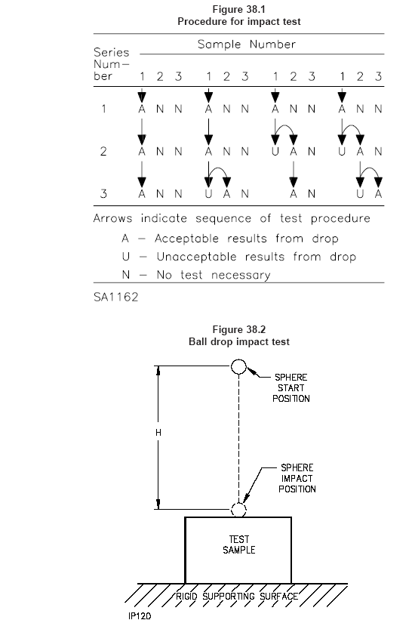

This is generated text for figtxt.
This is generated text for figtxt.
This is generated text for figtxt.

图38.1 冲击测试的过程
图38.2 球体跌落测试
38.4 With reference to Figures 38.2 and 38.3, the ″H″ designation represents the vertical distance the sphere must travel to produce the desired impact. For the pendulum impact, the sphere is to contact the test sample when the string is in the vertical position. The supporting surface is to be as described in 38.5. The backing surface for the pendulum impact is to consist of 3/4-inch (18 mm) plywood over a rigid surface of concrete or an equivalent nonresilient backing surface may be used. 38.4 参照图38.2和38.3，H表示产生合适冲击力时球体必须经过的垂直距离，对于钟摆测试，当用绳系住在其垂直位置，球体应冲击样品，对于支撑面如38.5条描述，对于钟摆后表面由3/4英寸（18mm）木板包覆在水泥支撑面或同等非弹性表面上面。
38.5 The supporting surface mentioned in 38.4 is to consist of a layer of tongue-and-groove oak flooring mounted on two layers of 3/4-inch (18-mm) thick plywood. The oak flooring is to be 3/4- by 2-1/4-inch (18- by 57-mm). The assembly is to rest on a concrete floor or an equivalent nonresilient surface. 38.5 描述在38.4条的支撑包含一层弹性沟槽的橡木板安装在两层3/4英寸（18mm）的木板上，橡木板为3/4~2-1/4英寸（18~57mm）。组件将支持在水泥或同等非弹性的表面上。
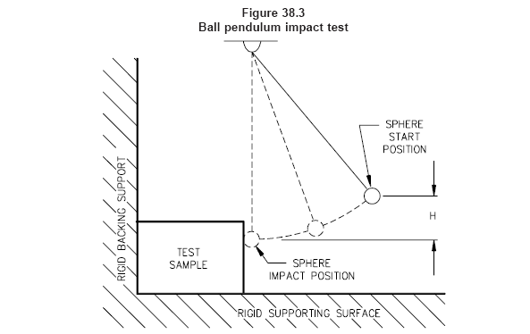

图38.3 球体钟摆测试
39 Thermal Degradation39 热老化
39.1 A thermoset material used for a part of an appliance where risk of fire, electric shock or injury to
persons is involved shall be resistant to thermal degradation at the maximum temperature to which it is
exposed during normal use of the appliance. The thermal-aging characteristics of the material may be
investigated by any one of the following procedures: 39.1 用在电器上的热塑材料，隐含有火灾，电击或人身伤害的风险，在正常的电器使用期间，必须能够承受其暴露在最大温度下的热老化，材料的热老化特性可以由以下的程序之一进行研究：
a) The material shall have a temperature index, based on historical data or a long–term thermal aging program, described in the Standard for Polymeric Materials – Long Term Property Evaluations, UL 746B, which indicates acceptability for use at the temperature involved or a） 材料必须具有温度指数，具体见UL 746B-指明允许使用的温度，或者
b) The product shall be operated with the input voltage adjusted so that the part in question operates at the maximum temperature obtained during the normal temperature test. The test is to be conducted with all temperature controls by-passed for a period of 1000 h. There shall be no visible degradation of parts at the conclusion of the 1000 h. b） 产品将调节电压按正常温度测试期间获得的最大温度进行工作，，本测试在所有温度下进行1000小时的工作，1000小时后结果不得存在明显缺陷。
40 Handle Securement Tests40 手把的安全性测试
40.1 General40.1 总则
40.1.1 A handle assembly shall not deteriorate so as to increase the risk of potential injury as a result of
being subjected to the test described in 40.2.1 – 40.6.3. Three samples are to be subjected to each test
unless otherwise specified in accordance with Figure 40.4. 40.1.1 手把组件不得变形增加潜在的伤害危险，进行描述在40.2.1-40.6.3条测试时，用3个样品将进行测试项目，除非另外规定符合图40.4。
40.2 Oven conditioning
40.2 烤箱条件
40.2.1 Prior to conducting any of the tests in this section, three samples of a vessel and handle assembly incorporating thermoplastic parts shall be conditioned in a full-draft circulating-air oven maintained at the maximum handle temperature recorded during the normal temperature test or the maximum handle temperature reached on a nonheated vessel within 5 min after it is filled following the brew cycle. The samples are to remain in the oven for 168 h. Following the conditioning and after the samples have cooled to room temperature, the samples are to be tested in accordance with 40.3.1 – 40.6.3. 40.2.1 在执行本部分的测试之前，用3个容器和热塑手柄组件，放置在鼓风式恒温箱中，保持正常温升测试时所测得的最大手把温度，或者是非加热容器在酿制过程中注满液体后5分钟内观察的最大温度，样品在鼓风烘箱里放置168h。然后取出放置使样品冷却至室温，应能够承受40.3.1-40.6.3条的测试。
40.2.2 If the temperature of the handle assembly exceeds the maximum assigned temperature rating of the material during the normal temperature test, the test in 40.2.3 is to be conducted in lieu of the test in 40.2.1. 40.2.2 在正常温度测试期间，如果手柄的温度超过其材料的所允许的最大额定温度参数值，40.2.3条中的测试将在40.2.1条的测试场所中执行。
40.2.3 Three vessels with handle assemblies are to be placed in a full-draft circulating-air oven for a period of 240 hours maintained at the maximum temperature recorded on the handle during the Normal Temperature Test or at the maximum temperature reached on a non-heated vessel within five minutes after it is filled following the brew cycle. During this time period, the vessels are to be removed from the oven and allowed to cool for five separate one-hour periods, at intervals not less than 24 hours. The 240-hour period is actual in-oven time and does not include the cool-down periods. During each of the cool–down periods, the vessels are to be supported by the handle assembly in the intended manner while loaded with No. 7 or No. 7-1/2 shot having a weight of the maximum intended capacity of water. Following the conditioning and after the vessels have cooled to room temperature, the vessels are to be tested in accordance with 40.3.1 – 40.6.3.
40.2.3 用3个带有手柄的容器，在鼓风恒温箱内放置240个小时，保持正常温升测试时所测得的最大手把温度，或者是非加热容器在酿制过程中注满液体后5分钟内观察的最大温度；在本测试期间，容器将从恒温箱中取出进行5次冷却，每次冷却1小时，每两次间的间隔不小于24小时。240小时是指在恒温箱内工作的时间，不包括冷却时间。冷却期间，容器按预期使用的方法用手把组件支持，容器内装载7号或7.5号的砂丸，重量为预期最大装水的质量。在此条件下进行并且容器冷却至室温后，容器应能承担40.3.1-40.6.3的测试。
40.3 Dishwashing40.3 清洗
40.3.1 Following the test of 40.2.1, an immersible vessel incorporating thermoplastic parts shall be conditioned as follows to simulate dishwasher cleaning. It shall be immersed in a commercially available dishwasher detergent solution – 25 g/L of water – for 1 h 150°F. Following this, it is to be removed, kept at room temperature for 1 h, oven aged at 160°F for 1 h, cooled to room temperature for 1 h. 40.3.1 进行40.2.1条的测试后，可浸水洗的热塑容器组件，必须按如下条件作清洁：用商场中采购的普通洗涤剂，按每升水稀释25g的比例，在150°F的条件下浸1小时，然后取出在室温下放置1小时，在160°F的恒温箱中进行1小时，冷却至室温放置1小时。
40.4 Flexing test40.4 扭曲测试
40.4.1 The three samples of the vessel are to be supported in the intended manner by the handle assembly while loaded with a mixture of water and gelatin having a weight equivalent to its maximum intended capacity of water. The test load is to be distributed such that the normal center of gravity is not changed. The handle assemblies are then to be flexed for 12,000 cycles in the normal plane of pouring, forward 45° from the vertical and backwards 45° from the vertical. Each cycle consists of tipping the vessel forward 45°, back to the vertical position, then back 45° and then forward to the vertical position. Following the above, the test is to be repeated for an additional 12,000 cycles with the flexing being performed from side to side, that is, 45° to the left and 45° to the right of the normal vertical position. The cycle rate is to be 6 – 8 cycles per minute. 40.4.1 容器的三个样品中盛满凝胶和水的混合物，重量为预期最大装水的质量，并按预期的使用的方法用手柄组件支撑着，测试负载是分布式的，使得重心不致改变，手把组件在正常水平和倒水方向之间扭曲12000个周期，垂直向前45度，垂直向后45度，每个周期包含向前45度，复位，向后45度，复位。以上进行后，然后在正常位置进行向左向右12000次的扭曲测试，按正常水平位置左45度，右45度，速率大约为每分钟6-8次。
40.5 Static load40.5 静态负载
40.5.1 Each vessel is then to be supported for 1 min in the intended manner by the handle assembly while loaded with a mixture of silica sand and water (80/20 percent by weight) having a weight equivalent to two times the weight of the maximum intended capacity of water. The lid is to be in place, but is not to be considered as part of the test weight. The test weight is to be distributed so that the normal center of gravity is not changed. The handle is to be gripped over a 2- to 4-inch (51- to 102-mm) wide gripping area (centered over the intended gripping area) for these tests.
40.5.1 每个容器中盛满沙水混合物（按重量比例为80:20），重量为预期最大装水的质量的两倍，并按预期使用的方法用手把组件支撑1分钟；盖子必须保持原位，但不得作为测试负载的一部分。测试负载是分布式的，使得正常重心不会改变。对于这些测试手把抓握处将超过2-4英寸（51-102mm）宽的抓握区域（抓握的中心超过预期抓握的区域）。
40.6 Static force40.6 静力
40.6.1 A force equal to two times the force exerted by the maximum intended capacity of water is to be applied for 1 min to the handle at an angle perpendicular to the side of the handle and parallel to the bottom of the vessel at a point as close to the point of securement as possible. The vessel is to be prevented from rotating while the force is applied. The force is to be applied with a 1/2 inch (12.7 mm) diameter rod terminating in a hemispherical end. See Figure 40.1.
40.6.1 负载为预期最大装水的质量的两倍，力垂直施加到手把上1分钟，平行容器的底部并尽可能靠近手把固定点施加，必须采用合适方式防止容器翻转，该力采用直径1/2英寸（12.7mm）带有半圆头的圆杆施加。见图40.1。
40.6.2 The test indicated in 40.6.1 is to be repeated with the force being applied in the same manner except that the point of application shall be such that the greatest torque is at the point of securement, or at two securement points for a ″D″ handle, see Figure 40.2.
40.6.2 除了施力点不同，40.6.1条规定的测试将重复在手柄进行，施加点为手柄固定处或D形手柄的两固定点间，产生最大力矩的地方。见图40.2。
is is generated text for figtxt.

This is generated text for figtxt.
40.6.3 A force equal to two times the force exerted by the maximum intended capacity of water is to be
applied for 1 min at the farthest extremity of the handle in a horizontal direction first pulling away from the
vessel, and then repeated pushing toward the vessel. The vessel is held for each test. See Figure 40.3.
40.6.3 同40.6.1力首先在水平方向向外拉1分钟，然后压向容器1分钟，每次测试时，容器必须固定住。见图40.3。
Exception: For a horizontal handle, the force is to be applied by first pulling up on the handle and then
repeated, pushing down on the handle. 注：对于水平手柄，该力先向拉手柄，然后向下压手柄。

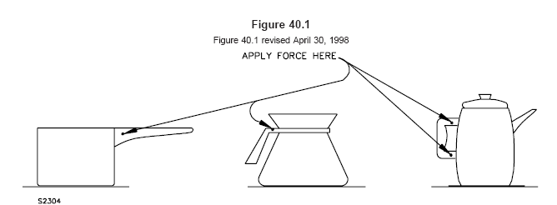
This is generated text for figtxt.
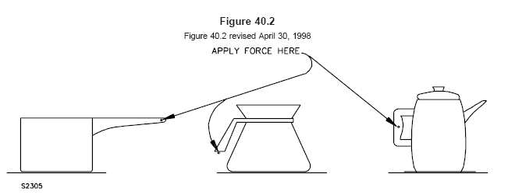
This is generated text for figtxt.
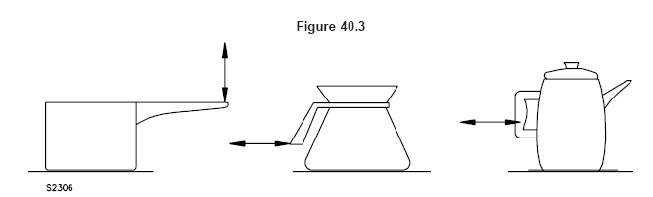
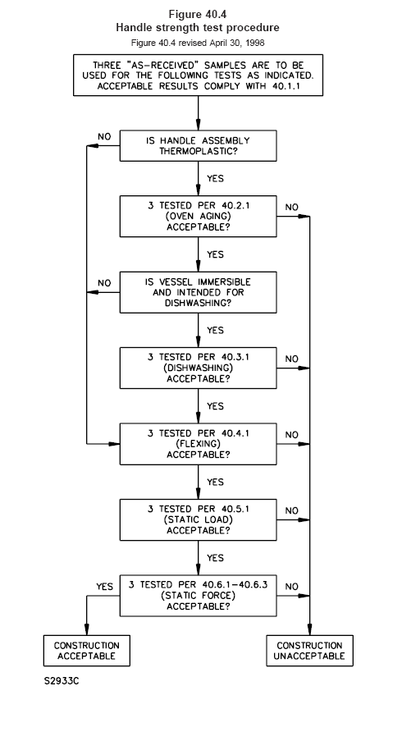

41 Under-Cabinet and Wall Mounted Appliances-Impact Test41 橱柜式和壁挂式电器的冲击测试
41.1 The impact test of 41.2 shall be conducted on all under-cabinet and wall mounted appliances without
occurrence of any of the following conditions: 41.1 在41.2条中规定的冲击测试必须在橱柜式及壁挂式电器上执行，且不得出现以下的条件：
- Making live parts accessible to contact with the articulate probe, see 7.10 and 7.11.
a) 使得带电体容易被有关节的测试指接触，见7.10和7.11条；
- Producing any other condition that results in damage of the enclosure so as to adversely affect the function of any safety or constructional feature, such as thermostats, overloadprotective devices or strain relief.
b) 产生某些条件造成外壳损坏，导致安全性能和结构性能受到负面影响，如恒温器、过载保护装置或应力消除装置；
- Producing other conditions so that the appliance does not comply with the dielectric voltagewithstand requirements in Dielectric Voltage-Withstand Test, Section 35, after being subjected to the impact.
c) 冲击后产生的某些情况导致电器进行35部分的介电电阻测试，不符合要求；
- Dislodging of the appliance or separable parts of the appliance.
d) 电器松散或者部件分离。
41.2 A 1.5 ft-lbf (2.03 J) impact is to be performed on all exposed sections of the enclosure, while the
unit is installed under a cabinet or on a wall. Each of three samples is to be subjected to one impact on
each surface. The impact is to be imparted by swinging a 2-inch (50.8 mm) diameter steel sphere,
weighing 1.18 lb (0.535 kg) from a height that will produce an impact of 1.5 ft-lbf (2.03 J). 41.2 当整机安装在橱柜下或墙壁上时，用1.5ft-lbf（2.03J）的力冲击在外壳上所有暴露的部分。三个样品的每一个在每一个表面均进行一次冲击。用绳子系住一个直径2英寸（50.4mm）的钢球，重量为1.18磅（0.535kg），从产生1.5ft-lbf（2.03J）冲击力的高度进行。
Exception: Any glass surface need not be subjected to this test.
注：所有的玻璃表面不需进行本项目。
42 Loading Test42 负载测试
42.1 A loading test is to be performed on the mounting brackets of an under-cabinet or wall mounted appliance with the appliance mounted in accordance with the manufacturer’s installation instructions, using the hardware and construction as described. A bracket shall not break, loosen, or pull out of the wall nor shall any portion of the unit attached to the mounting means be adversely affected as a result of this test. 42.1 负载测试将在橱柜式或壁挂式电器的搁架上进行。电器按照制造商提供的安装说明书进行安装，使用的紧固件和结构均按规定进行。本测试的结果不得出现搁架断裂、松散或从墙上拉出的不良现象，并且整机附带部分不得对安装造成不良影响。
42.2 The test load is to consist of the weight of the appliance plus three times the maximum normal load (food load, water, grounds, basket, and the like, based on cavity size and maximum recipe book weight recommendations). A gradually increasing force is to be applied to act vertically through the center of the gravity of the unit. The force is to be increased in a 5 to 10 s interval until the test load is applied to the mounting system and is to be sustained for a period of 1 min. For this test an under-cabinet unit is to be mounted on a wood board with a minimum thickness as specified by the manufacturer and a wall unit is to be mounted on 3/8 inch (4.8 mm) thick wall board. 42.2 测试负载为电器重量加上3数倍正常负载的重量（食品、水、面粉以及类似的东西，基于空间尺寸和说明书推荐的重量进行），逐渐通过整机的几何中心点施加力量，在5~10秒的间隔内将测试负载施加到安装体系上，并保持1分钟，对于本测试，橱柜下安装的电器将在制造商提供的说明书中规定的最小厚度的木板上进行，对于墙挂式电器将安装在3/8英寸（4.8mm）厚的墙板上进行。
42.3 If the mounting brackets are constructed of a thermoplastic material, they are to be conditioned for
7 h in an air circulating oven maintained at 70°C (158°F) or 10°C (18°F) higher than that measured during
the normal temperature test, whichever is higher, prior to performing the loading test.
42.3 如果安装架为塑料材料，在执行负载测试前将在70°C（158°F）的环境中或高于正常测试时所测得塑料温度10°C（18°F）的恒温箱中7个小时。
43 Abnormal Operation Tests43 非正常工作
43.1 General43.1 总则
43.1.1 If the conditions of normal operation are not representative also of abnormal conditions likely to be
obtained in actual service, an appliance shall not involve a risk of fire or electric shock when operated
continuously under such abnormal conditions. 43.1.1 如果正常工作不具代表性，非正常条件应近似实际使用，当在类似的非正常条件下持续工作时，电器不得存在着火或电击之危险。
43.1.2 The appliance shall have its voltage selector switch set in any supply circuit voltage position being connected to any one of the rated supply circuits. The combination of selector settings and supply circuit to which the equipment is connected is to be that which develops the most severe operating conditions. 43.1.2 电器必须将其电源选择开关设定在其某个额定电源供应的额定电压位置，选择器的设置组合和设备连接电源的电路将进行连接，是为了开发众多的工作条件。
43.1.3 If provided, an externally operable input voltage selector is to be operated for 25 c with the appliance operating at the minimum rated voltage and for 25 c with the appliance at the maximum rated voltage. Each cycle consisting of moving the voltage selector to its alternate position and back at the rate of six cycles per minute with the voltage selector in each position for 5 s. The operating and temperature controls are to be set as to result in the most adverse operating conditions. 43.1.3 如果配置，外部进行输入电压的选择器将操作电器工作在最小额定电压下25个周期，然后在最大输入电压下工作25个周期，每个周期包含选择器转换到相对位置后再复位，速率为每分钟6个周期，使选择器在每个位置均保持5秒，控制器和温控器均设定在最不利的工作状态下进行。
Exception: If an externally operable voltage selector switch interlocks with the power switch and cannot
be operated with the power switch in the on position, the test procedure will be as described in 43.1.4.
注：如果外部进行电压的选择器同电源开关联锁时，并且电源开关在接通的位置时电器不能工作，则测试程序按43.1.4条的规定进行。
43.1.4 For an externally operable voltage selector switch that interlocks with the power switch and cannot
be operated with the power switch in the on position, the voltage selector is to be operated for 25 c each
at the maximum and minimum voltages. Each cycle is to consist of the following steps: 43.1.4 对于外部的电压选择器同电源开关联锁，并且电源开关在接通的位置时电器不能工作，电压选择器将分别在最大最小工作电压下工作25个周期，每个周期按以下步骤进行：
a) With the power switch in the off position, move the voltage selector to the alternate position; a） 电源开关关断位置，移动电压选择器到相对的位置；
b) Turn the power switch on and operate the appliance for 5 s; b） 接通电源开关到并使电器工作5秒；
c) Turn the power switch off; c） 关断电源开关；
d) Move the voltage selector to the original position; and d） 移动电压选择器到原始位置；
e) Turn the power switch on and operate the appliance for 5 s. e） 接通电源开关使电器工作5秒。
43.1.5 To determine whether a risk of fire or electric shock actually exists, a separate burnout or abnormal test is to be conducted with the appliance operating continuously until the ultimate result has been observed. Unless otherwise indicated, the test is to be conducted on one sample with the applied voltage, method of mounting, and thermostat connection in accordance with 33.1.10 – 33.1.18. Accessible metal parts, those that can be contacted by the probe in Figure 7.2, and metal parts accessible during user servicing are to be connected to ground through a 3-A fuse. In most cases, continuous operation for 7 to 8 h will be necessary to determine that the ultimate result has been observed.
43.1.5 为了评估是否有着火或电击的危险存在，单独的燃烧或非正常测试在电器持续工作的条件下执行，直到最终的结果出现，除非有其它特别的说明，本测试将在一个样品上执行，工作电压，安装方法及自动恒温器的连接均按33.1.10~33.1.18进行，能用图7.2示的探棒触及的部件以及使用时易触及的金属部件，均通过3A的保险接地。大多数情况下，有必要连续工作7~8个小时，评估最终观察到的结果。
43.1.6 An appliance is to be located as close to the walls of the test corner as the construction will permit.
The test corner is also to be provided with a 12-inch (340-mm) simulated cabinet bottom, located 16
inches (400 mm) above the counter top. The cabinet bottom is to consist of a dull black–painted fir
plywood 3/8 inch (9.5 mm) thick. 43.1.6 电器将按其结构的允许条件尽可能靠近测试角的墙壁放置测试角配置12英寸（340mm）高的模拟柜底，并且距离桌面16英寸（400mm）的高度安装，柜底用3/8英寸（9.5mm）厚的黑色木板制成。
Exception No. 1: The test corner need not be used if temperatures obtained are not a factor affecting the result.
注1：如果所获取的温度不是影响结果的因素，则不需使用测试角。
Exception No. 2: When an appliance is more than 16 inches (400 mm) high and not more than 22 inches
(559 mm) high, the cabinet bottom is to be just over the appliance. When the appliance is more than 22
inches (559 mm) high, the cabinet bottom is to be omitted. 注2：当电器的高度超过16英寸（400mm）的高度，但不高于22英寸（559mm）时，柜底就在电器的顶部安装。如果电器的高度超过22英寸（559mm）则柜底将被省略。
43.1.7 When operated under such abnormal conditions, an appliance is considered to involve a risk of
fire if there is any emission of flame or molten metal (other than drops of melted solder), or if the operation
of the appliance results in the glowing or flaming of combustible material upon which the appliance may
be placed, or that may be adjacent to the appliance.
43.1.7 当在类似的非正常条件下工作时，如果存在火焰的喷射或熔化金属（除了锡焊熔化），或者电器工作的结果使得靠近电器放置或附近的易燃材料着火或焦化，则认为电器存在有着火的危险。
43.1.8 An appliance is considered to involve a risk of electric shock if the 3-A fuse connected from accessible metal parts of the appliance to ground opens during the test.器具在操作的条件下在外壳金属部件上连接1个3A的保险丝。
43.1.9 After having been subjected to an abnormal test, the appliance is considered to involve a risk of electric shock if the current measured through a 500 ohm resistor between an accessible part and ground is more than 5 mA. A solution of hard water (1/2 g of calcium sulphate CaSO42H2O per liter of distilled water) in an amount equal to the capacity of the container, is to be poured into the container and the current is to be measured as quickly as possible thereafter. Liquid need not be added if it is obviously apparent that the appliance will not hold liquid.

43.2 Specific test conditions43.2 特别的测试条件
43.2.1 General43.2.1 总则
43.2.1.1 For most of the common types of heating appliances, standardized abnormal test conditions are
given in 43.2.4.1 – 43.3.1. 43.2.1.1 加热电器的多数普通型号，标准的测试条件给定在43.2.4.1~43.3.1中。
43.2.2 Appliances with breakable exterior surfaces43.2.2 具有易碎外壳的表面
43.2.2.1 If an appliance has an exterior surface of glass, ceramic, or comparably brittle material in or on
which the heating element is mounted or that is an essential part of the enclosure of live parts, the material
shall be capable of withstanding the stresses to be encountered in actual service. 43.2.2.1 如果电器具有玻璃、陶瓷或类似易碎材料的外表，或者是在加热元件安装的位置，或者是带电体外壳的要害部分，该材料必须承受在实际使用过程中可能遇到的应力作用。
43.2.2.2 Certain specific tests are described in 43.2.2.3 but other tests may be necessitated by the
construction or intended operation of the appliance. 43.2.2.2 特别的测试方法规定在43.2.2.3条中，但电器的结构或预期使用的其它测试有必要执行。
43.2.2.3 The glass or ceramic surface shall withstand without cracking or breaking the application of a cloth fully saturated with water (the hard water solution described in 43.1.9) at room temperature, with the appliance in the fully heated condition. The quantity of water involved shall be sufficient to wet the surface completely. The appliance shall then comply with the requirement in 31.1 in a repeat leakage current test, except that the test shall be discontinued when leakage current stabilizes.
43.2.2.3 电器在充分加热的情况下，室温下的湿布（含有43.1.9条中规定的硬水溶液）覆盖在玻璃或陶瓷的表面，不得出现裂痕或破碎的现象，水的总量应可以充分打湿整个表面，电器必须满足31.1条的泄漏电流测试，除非泄漏电流稳定时可中止测试。
43.2.3 Dry operation43.2.3 干烧
43.2.3.1 The appliance shall be tested as follows, with all temperature controls or protective devices
shunted out of the circuit, except as noted in 33.1.18. 43.2.3.1 除了在33.1.18条的注意事项外，所有温度控制器及保护装置短路后,电器按如下条件进行测试：
a) An appliance that incorporates a device to limit temperatures shall be tested in accordance with 43.2.3.3. a） 电器组合有限制温度的装置必须按43.2.3.3条测试；
b) An appliance that does not incorporate a device to limit temperatures shall be tested in accordance with 43.2.3.4.
b） 电器没有限制温度的装置必须按43.2.3.4条测试。
43.2.3.2 If the appliance breaks, melts, or is otherwise damaged during the heating described in 43.2.3.3, 43.2.3.4 or 43.2.5.2 to the extent that it would be obvious to the user that the appliance is no longer useable and thereby likely to be discarded, the test is to be discontinued. The appliance is then to be tested for risk of electric shock in accordance with 43.1.9. 43.2.3.2 在进行43.2.3.3、43.2.3.4和43.2.5.3规定加热时，如果电器烧坏、熔化或其它的危险程度十分明显，用户不能长时使用并且因此而将废弃，测试将被中止，电器按43.1.9条进行触电危险测试。
43.2.3.3 One sample of an appliance that incorporates a device to limit temperatures is to be operated dry for one hour. After one hour of operation, (or less if heating element burnout or other cease-to-operate condition occurs), the appliance shall be disconnected from the source of supply and immediately filled with 10 – 20°C (50 – 68°F) tap water, then emptied and wiped dry simulating a cleaning operation. If the appliance utilizes a detachable power-supply cord, the plug is to be removed and replaced on the pin terminals five times. The appliance is then to be half-filled with hard water and tested for risk of electric shock in accordance with 43.1.9. If the sample is still operable and the leakage current did not exceed 5.0 mA, the sample is to be emptied, let cool to room temperature and the entire test procedure repeated, until a maximum of five such operations has been completed. After the fifth operation, the sample shall also be subjected to the dielectric voltage-withstand test described in Dielectric Voltage-Withstand Test, Section 35.
43.2.3.3 装有限制温度装置的电器，用一个样品干烧一个小时，工作之后（除非发热元件烧毁或其它不能工作的条件出现），电器将断开电源，并立即注入10~20°C（50~68°F）的水，然后倒空擦干表面的水分，模拟一个清洁的过程。如果电器是使用可拆卸式电源线，插头将取下并插回进行五次，然后电器加半水箱的水，按43.1.9条的规定进行触电测试。如果样品仍能工作，并且泄漏电流不超过5mA，样品将倒空水，并让其冷却至室温，并且全部的测试重复进行，直到最多完成5次工作，第5次之后，样品将按35部分的进行介电电阻测试。
43.2.3.4 Three samples of an appliance that does not incorporate a device to limit temperatures are to be tested in accordance with 43.2.3.3 except that one sample is to be operated dry for 5 min, the second sample for 15 min and the third sample for 30 min for each cycle rather than one hour. 43.2.3.4 没有组合限温装置的电器用3 个样品，按43.2.3.3的步骤进行测试，除了第一个样品干烧5分钟，第二个15分钟，第三个30分钟，而不是一个小时。
43.2.3.5 The appliance is to be filled to normal capacity with liquid and saturated grounds or other media, and operated at 110 percent of the voltage as determined from 33.1.11. All automatic controls shall be shunted out of the circuit except as noted in 33.1.18. The result is not acceptable if the container is pressurized so as to spit liquid from any opening including the spout. 43.2.3.5 电器注入正常容量的水和饱和的面粉或其它的介质，并且按33.1.11规定电压的1.1倍进行工作，所有自动控制装置将短路，除了33.1.18中的注意事项，如果容器在常压下从某些开口，包括出水口滴漏，均不可以接受。
43.2.3.6 A handle assembly that is utilized to lift and tilt a vessel to dispense a liquid shall be tested in accordance with 43.2.3.1 while being supported by the handle. The handle is to be gripped with a 2-inch (51-mm) gripping area (centered over the intended gripping area) for this test. The handle assembly shall not loosen, break, soften, deform, warp or otherwise deteriorate so as to increase the risk of injury to persons. This test is not applicable to a carafe or other nonintegrally heated vessel. 43.2.3.6 被用来挂起并倾倒分配容器内液体的手把，当用手把支撑测试时必须符合43.2.3.1要求。对于本测试
43.2.4 Overfill43.2.4 溢流
43.2.4.1 An appliance not intended to be immersed in water, shall not present a risk of electric shock after
being subjected to the test described in 43.2.4.2.
43.2.4.1 电器预期不可浸水，进行43.2.4.2条的测试后不得存在触电危险。
43.2.4.2 To determine that an appliance complies with the requirement in 43.2.4.1 it is to be tested as follows:
43.2.4.2 评估电器是否满足43.2.4.1条的要求，电器将如下测试：
a) A detachable power-supply cord provided with the appliance is to be removed, a) 随电器配置的可拆卸式电源线将被取下；
b) The appliance is to be supported normally on a horizontal surface unless filling requires another position, and b）除非注水需要从其它的位置进行，电器将按正常水平状态放置，并且；
c) A liquid-level gauge, vent or other opening, and the pouring spout or lip are to be sealed or otherwise modified to induce a uniform overflow of liquid around the top perimeter of the appliance. A hard water solution (see 43.1.9) is to be poured into the container through an orifice 3/8 inch (9.5 mm) in diameter. The appliance is to be first filled with the maximum amount of liquid the container will hold. An additional amount of the solution equal to 50 percent of the volume just mentioned [but not more than 1 pint (473 mL)] is then to be poured into the filled container. Any equivalent method which provides the same rate and amount of uniform flow of liquid around the top perimeter may be employed. Immediately following the test, the appliance is to be emptied, the exterior dried with a soft cloth to remove all surface
moisture, including surface moisture from exposed terminal pins, refilled to the normal level and tested for risk of electric shock. To determine whether a risk of electric shock exists, the current is to be measured through a 500 ohm resistor between accessible parts and ground, with the appliance connected to a 120 V supply circuit. A risk of electric shock is considered to exist if the current exceeds 5.0 mA. The current is to be again measured with reverse polarity of the supply circuit.
c）液体阀、气孔或其它开孔，以及出水口或盖子将被密封或用其它导致液体从电器上周溢流而下的方法进行。
硬水溶液(见43.1.9)通过直径3/8英寸（9.5mm）管子注入容器,电器首先注入最大容量的水，用50%最大容量的水，但不超过1品脱（473ml）注入到容器中，在保证同样的速率和同样量的水的情况下，可以采用其它同等的方法。测试后电器立即倒空并擦干表面水分，包括裸露插销端子上的水分，然后重新注入正常水位的水并进行触电危险之测试。为了评估是否存在触电的危险，在易触及部件同接地间串入500欧姆的限流电阻，电器接通120V的电源工作，如果通过限流电阻的电流超过5mA，则认为有触电的危险，然后将在插头反过来同电源连接后，再测试一次该电流。
43.2.5 Boil dry operation43.2.5 煲干操作
43.2.5.1 An appliance shall not involve a risk of electric shock when operated as described in 43.2.5.2
43.2.5.1 当电器按43.2.5.2的规定进行工作时，不得存在触电危险。
Exception: An appliance that incorporates a control that operates to prevent boiling of the liquid (such as
the thermostat of a percolator) need not be tested. 注：电器如果装有防止液体煲干的控制装置（如咖啡壶的恒温器），则不需进行测试。
43.2.5.2 A sample shall be filled with just enough water (hard-water solution described in 43.1.9) to cover the heating element. The appliance shall then be operated until all the water has been boiled off – or heating element burnout or other cease-to-operate condition occurs – at such time it shall be 3/4 filled with 10 – 20°C (50 – 68°F) hard water and tested for risk of electric shock in accordance with 43.1.9. 43.2.5.2 用一个样品注入刚好淹没加热元件的水（为43.1.9中规定的硬水），电器工作直到水被烧干，或者加热器被烧毁，或其它不能工作的情况出现，此时注入3/4容器容量的10~20°C（50~68°F）的硬水，并按43.1.9条进行触电危险测试。
43.2.6 Gaskets and seals43.2.6 密封圈和密封胶
43.2.6.1 An insulating washer, gasket, or the like used as a seal or barrier between uninsulated current-carrying parts and the liquid chamber of a liquid heating appliance shall be such that there is no leakage current of more than 0.5 mA between liquid in the appliance and ground after an appliance has been operated as described in 43.2.6.2. 43.2.6.1 密封垫片、垫圈，以及类似物作为为裸露承载电流部件的隔栏和液体加热器的密封用途时,电器按43.2.6.2的要求进行工作，应使得液体同地线间的泄漏电流不超过0.5mA。
43.2.6.2 The appliance is to be operated continuously for 168 h after having been filled with the liquid normally used in the appliance. Sufficient liquid is to be added from time to time to prevent the liquid chamber from becoming less than half full. The appliance is then to be subjected to a repeat leakage-current test (see 31.1) except that the test is to be discontinued when the leakage current stabilizes43.2.6.2 电器按正常状态加注液体连续工作168h，工作时不时加注液体保持容器中的液体不少于预期的一半，然后电器进行泄漏电流测试（31.1条），当泄漏电流稳定时可以中止本测试。.
43.2.6.3 An insulating washer, gasket, or hose as described in 43.2.6.1 shall not show any visible signs of deterioration, such as cracking, deformation, and the like, after being conditioned in accordance with Table 43.1.
43.2.6.3 在43.2.6.1中说明的绝缘垫片、垫圈或软管，按下表中43.1的条件进行测试时，不得出现明显的裂纹、变形或类似的老化现象。
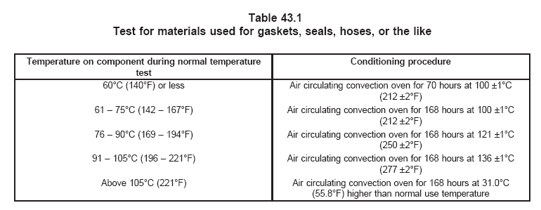
表43.1
用作垫片、垫圈及软管等类似材料的测试
正常温度测试时元件的 | 执行条件
60℃（140℉）或更小 | 100±1℃（212±2℉）的烘箱中进行70小时
61-75℃（142-167℉） | 100±1℃（212±2℉）的烘箱中进行168小时
76-90℃（169-194℉） | 121±1℃（250±2℉）的烘箱中进行168小时
90-105℃（196-221℉） | 136±1℃（227±2℉）的烘箱中进行168小时
105℃（221℉）以上 | 高出正常温度31℃（55.8℉）的烘箱中进行168小时
43.2.6.4 An identifiable gasket, seal, or similar protection shall be provided to reduce the risk of the entrance of water into wiring and electrical component spaces in products that are likely to be held under a tap-water faucet for filling or cleaning. Examples of these products are percolators, urns, hot pots, teapots and the like. 43.2.6.4 对于用手拿着在水龙头下注水或清洁的电器，如轻便式咖啡壶、咖啡瓮、热水壶、茶壶或类似产品，必须配置密封垫片、垫圈或类似的保护物，防止水进入电器内部，对电线电气元件造成危害。
43.2.6.5 Where the gasket, seal or similar protection mentioned in 43.2.6.4 cannot be determined as providing the protection necessary to comply, the design shall be evaluated following the overfill test described in 43.2.6.6, in place of the overfill test described in 43.2.4.2. 43.2.6.5 在43.2.6.4中所指的密封垫片、垫圈等到不能仅认为是保护的需要，在设计时就必须满足43.2.6.6和43.2.4.2中的溢流测试要求。
43.2.6.6 The appliance is to be subjected to the overfill test described in 43.2.4.2 a total of ten times. Prior to the initial overfill test the appliance is to be subjected to one heating cycle. The tests are to be conducted over a period of 15 d. The time between the tests are to be not less than 24 h. Only one leakage current test and dielectric voltage-withstand test are to be performed, following the last overfill test.
43.2.6.6 电器进行43.2.4.2中的溢流测试时，液体总量为其10倍，溢流前电器加热一个周期，本测试进行15天，每两次测试之间的时间不小于24小时，作完溢流测试后，仅作一次泄漏电流和介电电阻测试。
43.3 Dual voltage appliances43.3 双电压电器
43.3.1 In addition to the applicable test described in 43.2.3.1 – 43.2.6.6, a dual voltage appliance shall be subjected to the tests described in 43.1.6 – 43.1.8. These tests are subject to the test conditions described in 43.1.5 – 43.1.7 and to the acceptance criteria described in 43.1.9 – 43.2.2.2. There shall be no electrical or mechanical breakdown of the voltage selector switch. 43.3.1 为了满足43.2.6.1~43.2.6.6的测试，双电压电器必须进行43.1.6~43.1.8的测试项目，这些测试项目的测试条件在43.1.5~43.1.7给出，接受标准规定在43.1.9~43.2.2.2中。选择开关不得存在电气或机械损坏。
44 Secondary Circuit Component Failure Test44 二次电路的失效性测试
44.1 If an appliance employs one or more rectifiers, transistors, or similar solid-state components in a secondary circuit, a risk of fire or electric shock shall not develop when the circuit between any two terminals of any such component is open-circuited or short-circuited. If the appliance employs a capacitor in combination with one or more of the above-mentioned components, a risk of fire or electric shock shall not develop when the capacitor is short-circuited. Only one of the simulated fault conditions described above is to be imposed at one time. See 44.2 – 44.5.
44.1 如果电器在二次电路中使用一个或多个整流器、变压器或者类似的固态元件，这些元件的的端子间短路或开路时不会出现着火或触电之危险，如果电器组合一个或多个电容器在以上的电路中时，电容器的两端短路不会出现着火或触电现象，如上描述的现象每次仅能出现一次合理的失败情况，参见44.2~44.5。
Exception: Components located on the secondary of a Class 2 transformer need not comply with these
requirements. 注：2类变压器的二次电路上之元件不需满足此要求。
44.2 If a semiconductor rectifier is employed, three appliances are to be tested with the rectifier terminals
connected together. Three additional appliances are to be tested with the terminals of the electrolytic
capacitor connected together. 44.2 如果使用半导体整流器，在完整的电器上，将整流器的端子连接在一起，进行三次，然后，在另外的三台机上，将电解电容器的端子连接在一起进行测试。
44.3 Three complete tests are to be made under each of the conditions described in 44.2 using new
components in each test. The appliance to be tested is to be connected as indicated in 43.1.5. 44.3 在44.2中描述的每一次完整测试，必须使用新的元件进行，电器按43.1.5条描述的要求进行连接。
44.4 An unacceptable condition exists if flame is emitted from the overall enclosure of the appliance or if
a permanently conductive path is established between live parts and exposed dead metal. 44.4 如果火焰从电器的外壳内喷射出来，或者带电部分的裸露非带电体间出现长久导通的情况时，均是不允许的。
44.5 The tests described in 44.1 – 44.3 may be omitted if one or both of the following conditions exist: 44.5 描述44.1~44.3中的测试，如果为以下某一条件或全部条件均可以省略：
a) There is 10,000 ohms or more of additional series impedance in a circuit in which the voltage does not exceed 125 V. a）电路中具有1000欧姆或更大的阻抗，并且电压不超过125V；
b) There is 20,000 ohms or more of additional series impedance in a circuit in which the voltage
may be more than 125 but is no more than 250 V.
b）电路中具有2000欧姆或更大的阻抗，并且电压不超过250V；
45 Automatic Controls Test45 自动控制器测试
45.1 General45.1 总则
45.1.1 An automatic control for temperature regulating or temperature limiting shall be capable of performing successfully for 50 c of operation, when the appliance is connected to a supply circuit having a potential of 120 percent of the voltage specified in 33.1.11. There shall be neither electrical nor mechanical malfunction of the control, nor undue burning, pitting, or welding of the contacts. 45.1.1 当电器通入33.1.11条中规定电压的120%时，用作温度控制或温度调节的自动控制器，应具有可靠动作50个周期的能力，控制器不得存在电气或机械上的不良缺陷，触点不得烧坏，磨损或粘合在一起。
45.1.2 In tests to determine an automatic control complies with the requirements in 45.1.1, the appliance is to be connected to a grounded supply circuit; the enclosure of the appliance, if of metal, is to be connected to ground through a 3-A fuse; and the control, if single-pole is to be connected in an ungrounded conductor of the circuit. The device is to be operated at the rate of 10 cycles per minute, except that a faster rate of operation may be employed if agreeable to all concerned. The performance is unacceptable if the fuse in the grounding connection opens during the test.
45.1.2 评估自动控制器是否符合45.1.1条的要求，电器将被连接到有接地的电源上，如果电器的外壳是金属的，则通过3A的保险进行接地，并且控制器如果是单极的，将被装在非接地导体上。这些装置将在按每分钟工作10次的速率进行，如果允许从各个角落操作，则可以使用更快的速率。如果接地保险被烧断，则本测试失败。
45.2 Endurance45.2 耐久45.2.1 自动恒温器性
45.2.1 Thermostats
45.2.1.1 A thermostat shall be capable of withstanding an endurance test which shall consist of the number of cycles indicated in Table 45.1. Unless it is specified that the test be made without load, the thermostat shall make and break the rated current of the appliance while connected to a circuit of rated voltage. There shall be neither electrical nor mechanical malfunction of the thermostat, nor undue burning, pitting, or welding of the contacts.
45.2.1.1自动恒温器必须承受表45.1中所规定的耐久性测试之周期，除非明确说明空载进行，恒温器将连接到额定电源上通断电器额定的电流。自动恒温器不得存在电气或机械上的不良缺陷，触点不得烧坏，损坏或粘合在一起。
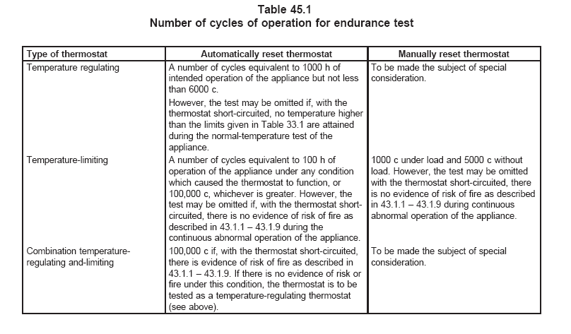
表45.1
耐久性测试的周期次数
恒温器的类型 | 自动复位恒温器 | 手动复位恒温器
温度调节器 | 周期数相当于预期1000小时的工作，但不得小于6000个周期。  如果在电器的正常温度测试过程中，恒温器短路的情况下没有温度超过表33.1中的规定值，则本测试可以省略。 | 将进行特别的评估项目。
温度限制器 | 周期数相当于电器工作在恒温功能下100小时的工作周期，或者100000个周期，选择较长者。如果恒温器短路按43.1.1~43.1.9条进行非正常工作不会出现着火之危险，则本测试可以省略。 | 1000个周期有负载，5000个周期没有负载，如果恒温器短路按43.1.1~43.1.9条进行非正常工作不会出现着火之危险，则本测试可以省略。
组合型温度调节-限制器 | 如果恒温器短路按43.1.1~43.1.9条进行非正常工作出现着火之危险，则进行100000个周期，如果恒温器短路时进行非正常工作不会出现着火之危险，则按温度调节型进行本测试。 | 将进行特别的评估项目。

45.2.1.2 With reference to 45.2.1.1 and Table 45.1, thermostats are classified as follows: 45.2.1.2 参照45.2.1.1和表45.1，自动恒温器分类如下：
a) A temperature-regulating thermostat is one which functions only to regulate the temperature of the appliance under normal conditions of use, and whose malfunction would not result in a risk of fire. a）温度调节器的功能仅对电器工作在正常条件下的温度进行调节，保证不会出现着火现象；
b) A temperature-limiting thermostat is one which functions only under conditions which produce abnormal temperatures. The malfunction of such a thermostat might or might not result in a risk of fire. b）温度限制器的功能仅对电器工作在非正常条件下的温度进行限制，温度控制器的失效有可能会出现着火现象；
c) A combination temperature-regulating and -limiting thermostat is one which functions to regulate the temperature of the heating appliance under normal conditions of use, and also serves to prevent a risk of fire which might result from conditions of abnormal operation of the appliance. c）组合型温度调节控制器的功能即调节电器工作在正常条件下的温度，同时在非正常条件下防止电器着火；
46 Permanence of Marking Tests46 标识永久性测试
46.1 A required marking shall be molded, die-stamped, paint-stenciled, stamped or etched metal that is permanently secured, or indelibly stamped lettering on a pressure-sensitive label secured by adhesive that upon investigation is found to be acceptable for the application. Ordinary usage (including the likely exposure to weather and other ambient conditions), handling, storage, and the like of the equipment is to be considered in the determination of the acceptability of the application. 46.1 必要的标识必须使用模制、印刷、丝印、印章或金属蚀刻等方法永久保持，或使用适合电器的夺敏材料标，用胶水粘在电器上作为永久标识，通过原始包装（包括类似的适用的其它环境条件等），运输，贮存及类似的均作为整个电器的评估是否可以接受的条件。
46.2 Unless it has been investigated and found to be acceptable for the application, a pressure–sensitive label or label that is secured by cement or adhesive shall comply with the adhesion requirements in Table 7.1 for indoor equipment, and Table 7.2 for outdoor equipment in the requirements for marking and labeling systems, UL 969.
46.2 除非压敏材料标签经研究并发现其适用于电器，否则该标签及胶水必须满足UL969室内和室外使用的相关要求。
46.3 Unless otherwise indicated, a required cautionary marking shall be located on a part that would
require tools for removal or that cannot be removed without impairing the operation of the product.
46.3 除非特别说明，必要的警告标必须放置在需用工具才能拆卸或不可能拆卸的地方，并且不得妨碍电器的正常操作。
MANUFACTURING AND PRODUCTION–LINE TESTS制造及现场测试
47 Dielectric Voltage-Withstand Test47 介电电阻测试
47.1 Each appliance shall withstand without an indication of unacceptable performance as a routine
production-line test, the application of a potential between: 47.1 每个产品必须承受日常的生产线测试，施加电压如下：
a) The primary wiring, including connected components, and accessible metal parts that are likely
to become energized, and a）主电路，包括连接元件和易触及的、可能会带电的金属部件；
b) Between primary wiring and accessible low voltage (42.4 V peak or less) metal parts, including terminals. The test potential shall be: b）主电路和易触及的低压金属部件、包括端子（42.4V尖峰或更小）间，测试电压按以下进行：
1) 1200 V applied for 1 s or1）1200V进行1秒钟；
2) 1000 V applied for 1 min. 2）1000V进行1分钟。
47.2 The appliance may be in a heated or unheated condition for the test.
47.2 电器可以在热态或冷态进行测试。
47.3 The test shall be conducted with the appliance complete – fully assembled. It is not intended that
the appliance be unwired, modified, or disassembled for the test. 47.3 本测试必须在电器完全组装的情况下进行，测试时电器不得改线、修改或拆卸。
Exception No. 1: A part, such as a snap cover or a friction-fit knob, that would interfere with performance
of the test need not be in place. 注1：零件如按钮盖或粘滞型手柄进行本测试时，可以不在原位上。
Exception No. 2: The test may be performed before final assembly if such a test represents testing the
complete appliance. 注2：如果再次在电器上进行，则可以在最终组装之前进行。
47.4 If the appliance employs a solid-state component that can be damaged by the test potential, the test on each appliance may be conducted before the component is electrically connected. In such a case, additional testing is to be made of a random sampling of each day’s production with the circuitry rearranged to reduce the likelihood of damage to any solid-state component but retaining representative dielectric stress of the circuit. 47.4 如果电器使用的固态元件可能受到测试电压的损坏，每个电器的测试可以在该元件进行电气连接之前进行。鉴于此，在每天的产品中随机增加测试，在保证测试电压的同时，电路重新布置以防止固态元件受到损坏。
47.5 The test equipment, when adjusted for production-line testing, is to produce an output voltage that is not less than the factory test value specified, nor is the magnitude of the test voltage to be greater than 120 percent of the specified test potential when the tester is used in each of the following conditions: 47.5 测试设备，当调节作为生产线检测时，输出电压不得小于工厂测试的规定值，当按以下条件测试时，电压值不得超过规定测试电压的120%：
a) If the test duration is one second, the output voltage is to be maintained within the specified range,
a）如果持续周期为1秒，输出电压被保持在特定值内；
1) When only a voltmeter having an input impedance of at least 2 megohms and a specimen of the product being tested are connected to the output terminals, and1）仅有一个具有输入至少2兆欧姆和一个半导体连接在输出端子上的电压表时；
2) When a relatively high resistance is connected in parallel with the voltmeter and the product being tested, and the value of the resistance is gradually reduced to the point where an indication of unacceptable performance just occurs. 2）当相关的高电阻同电压表并联，并且产品进行测试，电阻值逐渐降低直至不良特性出现。
b) If the test duration is one minute, the output voltage is to be maintained within the specified range, by manual or automatic means, throughout the one minute duration of the test or until there is an indication of unacceptable performance. b）如果测试持续周期为1分钟，测试电压保持在规定值，手动或自动进行1分钟，或直到不良特性出现。
47.6 The specified control of the applied voltage, manual or automatic, shall be maintained under conditions of varying line voltage. Higher test potentials may be used if higher dielectric stress is not likely to adversely affect the insulating systems of the product. 47.6 使用电压、手动或自动测试的特别使用不得违反线电压的要求，如果较高的电压不会对产品的绝缘造成负面影响，则可以施加较高的电压。
47.7 In addition to the characteristics indicated in 47.5, the test equipment is to have the following
features and characteristics: 47.7 为了满足47.5条的规定性能，测试设备必须具备以下的功能和特点：
a) A means of indicating the test voltage that is applied to the product under test. This may be accomplished by sensing the voltage at the leads or by equivalent means. a） 规定的测试电压是指测试时施加到电器上的电压，可以通过感应电压在引线上或同等的方式实现；
b) An output voltage that: b） 输出电压应具有：
1) Has a sinusoidal waveform, 1） 正弦波形；
2) Has a frequency that is within the range of 40 – 70 Hz, and2）具有频率在40-70的范围内
3) Has a peak value of the waveform th at is not to be less than 1.3 and not more than 1.5 times the root–mean–square value. 3） 具有的波形尖峰值不小于1.3倍也不大于1.5倍的rms值
c) A means of effectively indicating unacceptable performance. The indication is to be: c）测试设备对于不合格的灵敏度的指示必须如下指示：
1) Auditory if it can be readily heard above the background noise level, 1）能清晰地通过声音来进行评判；
2) Visual if it commands the attention of the operator, or2）通过操作者的视检；
3) A device that automatically rejects an unacceptable appliance. 3）设备自动判别不良品。
If the indication of unacceptable performance is auditory or visual, the indication is to remain active and conspicuous until the test equipment is reset manually. 如果是不良品的评判或视检的指示，必须直到通过手动复位，否则该指示一直保持。
d) When the test equipment is adjusted to produce the test voltage and a resistance of 120,000 ohms is connected across the output, the test equipment is to indicate an unacceptable performance within 0.5 second. A resistance of more than 120,000 ohms may be used to produce an indication of unacceptable performance, if the manufacturer elects to use a tester having a higher sensitivity. d）当测试设备连接120000欧姆的电阻在输出口时，测试设备不得显示输出电压小于规定测试电压的不良特性，同时测试设备不得显示输出电压大于规定测试电压的不良特性，校准电阻仪的电阻调节及120000欧姆人微言轻仪器精确校正，但不能超过120000欧姆值。
47.8 There is not to be any transient voltage applied to the appliance under test that results in the instantaneous voltage applied to the product exceeding 120 percent of the peak value of the test voltage that the manufacturer elects to use for this test. This requirement applies for the entire duration of the test, including the time that the voltage is first applied to the product and the time that the voltage is removed from the product. 47.8 对于本测试，对于制造选择的测试电压，测试时应不得存在瞬间电压即刻施加于电器上的电压，超过120%规定电压的尖峰值，测试周期为电压施加到电器上到测试完毕从电器取下的时间。
47.9 During the test, a sufficient number of primary switching components shall be in the on position so that all primary circuitry will be stressed. Both sides of the primary circuit of the appliance are to be connected together to one terminal of the test equipment. The second equipment terminal is to be connected to accessible dead metal. 47.9 测试期间，所有的开关必须处于接通的状态，以保证电路所有部分均能受压，，电器电路进出线将同测试设备的输出端的某一端连接在一起进行测试，测试设备的另一端将连接到易触及的非带电的金属上。
Exception: Resistive-type appliances and appliances utilizing motors, relays, coils or transformers, having circuitry not subject to excessive secondary build-up in case of indication of unacceptable performance during the test, may be tested with only one side of the primary circuit connected to the dielectric test equipment.
注：电阻型电器及电器利用马达、继电器、线圈、变压器组成的电路，测试期间电器不须进行额外二次嵌装指示不良特性，可以将电路的一边连接到测试设备上。
48 Polarization and Grounding Continuity Tests48 极性和接地连续测试
48.1 Polarization test48.1 极性测试
48.1.1 Each appliance provided with a polarized attachment plug (2-wire plug with one blade wider than the other) shall be tested for electrical-continuity between the grounded supply-circuit conductor of the attachment plug (wide blade of a 2-wire plug) and the part of the appliance that is intended to be connected to the grounded supply-circuit conductor. If the continuity cannot be readily determined by visual inspection and component checking, an electrical-continuity test is to be made. 48.1.1 每一个电器配置的极性插头（两线插头具有一个大头的插片）必须在接地导体同大头插片（宽边片）之间进行电气导通性测试，并且该部分预期是同接地导体相连接的；如果导通性不能通过视检和元件检查，则必须进行电气导通性测试。
48.2 Continuity of grounding connection48.2 接地连接的导通性
48.2.1 Each cord-connected appliance having provision for grounding shall be tested, as a routine
production-line test, to determine that grounding continuity exists between the ground blade of the
attachment plug and the accessible dead metal parts of the appliance that are likely to become energized. 48.2.1 每个具有接地保护的软线连接电器，必须进行测试，如例行的生产线测试五样，评估可能会带电的易触及导体和插头接地插片间的电气导通性。
48.2.2 Only a single test need be conducted if the accessible metal selected is conductively connected
by design to all other accessible metal. 48.2.2 如果易触及金属选择器设计成同其它易触及的金属相连接，仅需要进行一次测试。
48.3 Electrical indicating device48.3 电气指示装置
48.3.1 Any indicating device, such as an ohmmeter, a battery and buzzer combination, or the like, may
be used to determine compliance with the tests described in 48.1.1 – 48.2.2. 48.3.1欧姆表、电池和蜂鸣器的组合或类似的指示，按48.1.1~48.2.2评估其符合性。
RATINGS额定标识
49 Details49 细节
49.1 A heating appliance shall be rated in amperes, volt-amperes, or watts, and also in volts, and may be rated for alternating current only. The rating shall include the frequency if necessary because of control devices.
49.1 加热电器必须具有额定电流、伏-安或瓦特和电压，并且可以标识仅作交流使用，如果由于控制装置，额定标应具有频率。
MARKINGS标识
50 Details50 细节
50.1 A warning or caution marking shall comply with all of the following requirements: 50.1 警示标或提示语必须满足以下的要求：
a) The marking shall be permanently attached. a）标识必须永久标识；
b) The marking shall not be attached to parts removable by hand. b）标识不得在用手取下的附件上；
c) The marking shall be attached to parts that cannot be removed without impairing the operation
of the appliance or left off the appliance without being readily apparent. c）标识应在不损坏电器就不能拆卸的部件上或者脱落了就没有明显标识的位置上；
d) The marking shall have lettering that complies with the following requirements: d）标识上的字符必须满足以下要求：
1) The precautionary signal word (such as ″DANGER″, ″WARNING″, OR ″CAUTION″) shall be in letters not less than 3/32 inch (2.4 mm) high. 1）准备提示的词语（如“危险”“警告”或“注意”）不得小于3/32英寸（2.4mm）的高度；
- If contrasting color is used, lettering other than signal words can be a minimum of 1/16 inch (1.6 mm) high.
2）如果使用对比颜色，除了提示的词语，字符可以最小（1/16英寸）1.6mm 的高度。
50.2 All other markings required in this section shall be such that the marking is clear and legible under
conditions of intended use of the appliance. 50.2 本部分所有其它的标识，在预期的使用过程中必须清晰可见。
50.3 An appliance shall be legibly and permanently marked, with: 50.3 电器必须清晰并长久地标识如下内容：
a) The manufacturer’s name, trade name, trademark, or other descriptive marking by which the organization responsible for the product may be identified; a）制造商的名字，贸易商名字，商标或其它对产品负责的组织；
b) The date or other dating period of manufacture not exceeding any three consecutive months, which may be abbreviated or in a nationally accepted conventional code, or, in a code affirmed by the manufacturer;
b）日期或其它不超过三个月的制造时间段，可以使用简短的或国家机关认可习惯号码，或由制造商自己确认的号码；
c) A distinctive (catalog) (model) number or the equivalent; and c）特别的（种类）（型号）数字或同等的；并且
d) The electrical rating. d）电气范围。
A date code repetition time cycle shall not be less than 10 years.
日期号码反复使用的周期不得小于10年。
50.4 An appliance shall be marked, where readily-visible, to indicate that the appliance is intended for
household type usage, such as, ″Household Use Only″, ″Household Type″, and the like. Lettering shall
be not less than 3/32 inch (2.4 mm) high. 50.4 在电器明显可见的地方标识其预期为家庭使用，如“仅作家庭中使用”“家用型“等字符。字母高度不得小于3/32英寸（2.4mm）。
50.5 If a manufacturer produces or assembles appliances at more than one factory, each finished appliance shall have a distinctive marking – which may be in code – by which it may be identified as the product of a particular factory.
50.5 如果电器在不同的工厂制作或组装，每个产品必须明该产品由那个工厂制造或组装，可以使用字码表示。
50.6 If the construction of an appliance contemplates disassembly by means of a tool for the purpose of cleaning or similar servicing by the user (including replacement of a thermal cutoff) and, if such disassembly involves the exposure of persons to unintentional contact with any normally enclosed or protected live part, the appliance shall be plainly marked with a warning that such servicing should be done only while the appliance is disconnected from the supply circuit. See also 7.13. 50.6 如果电器结构上的可拆卸部件，由用户使用工具进行清洁或类似的工作时（包括热保险管的更换），并且类似的拆卸工作有可能全用户无意接触到由外壳或被保护的带电体时，电器上必须明确提示用户在断开电源前不要进行这些工作。参见7.13。
50.7 An appliance with an attached cord or detachable power-supply cord 4-1/2 ft (1.4 m) or longer in length shall be provided with specific instructions, which are not part of Important Safeguards, that state: ″To reduce the risk of injury, do not drape cord over the counter top or table top where it can be pulled on by children or tripped over unintentionally″ or an equivalent wording. 50.7 电器配备的软线或可拆卸式电源线的长度为4-1/2英寸（1.4m）或更长，必须配备特别的说明该部件正确使用，提示语为：为了减少人身的意外伤害，使用时不要将线悬挂在桌台的边缘，防止儿童拉扯造成电器意外的倾倒或类似的词语。
50.8 An appliance with an attached cord or detachable power-supply cord less than 4-1/2 ft (1.4 m) in length shall be provided with instructions, which are not part of Important Safeguards, that include the following information:
50.8电器配备的软线或可拆卸式电源线的长度小于4-1/2英寸（1.4m），在说明书中必须说明该部件并不十分安全，并且说明以下：
a) A short power-supply cord (or detachable power-supply cord) is to be provided to reduce risks
resulting from becoming entangled in or tripping over a longer cord. a）配备短的电源线（或可拆卸式电源线）是为了防止出现长电源缠绕或扯翻电器的现象。
b) Longer detachable power-supply cords or extension cords are available and may be used if care is exercised in their use. b）如果用户较为熟练，可以使用较长的可拆卸电源线或外部导线。
c) If a long detachable power-supply cord or extension cord is used, c）如果使用较长的可拆卸电源线或外部导线：
1) The marked electrical rating of the detachable power-supply cord or extension cord
should be at least as great as the electrical rating of the appliance, 1）可拆卸电源线或外部导线的额定范围不得小于电器的额定范围。
2) If the appliance is of the grounded type, the extension cord should be a grounding-type 3-wire cord, and2）如果电器是接地型的电器，必须使用三线接地型软线。
3) The longer cord should be arranged so that it will not drape over the counter top or table top where it can be pulled on by children or tripped over. 3）如果较长的软线经整理后不会悬挂在桌台边边缘，使得儿童不能拉扯。
50.9 An appliance thatis likely to be lifted and handled for cleaning purposes and has not been subjected to the Immersion Tests, inaccordance with 33.1.4and 34.3 shall be marked ″Do not immerse in water″ or with an equivalent wording. If the appliance is intended for partial immersion but not for complete immersion, it shall be marked ″Do not immerse beyond this point″ or with an equivalent wording to show the point beyond which it should not be immersed.
50.9 revised January 8, 199950.9 仅浸水清洁的电器，必须标明“不要浸水”或同等字样，除非电器经评估符合33.1.4和34.3项的要求。如果电器预期部分而非全部浸水，必须标识“浸水不要超过此处”或同等语表明不能浸的地方。
50.10 An appliance that utilizes a detachable power-supply cord shall be provided with: 50.10 使用可拆卸式电源线必须配置如下：
a) The appropriate detachable power-supply cord as indicated in Supply Connections, Section 11, or a）可拆卸电源线应符合电源线的连接，见11部分；或
b) Instructions that: b）说明书应为：
1) Advise the consumer that the appropriate detachable power-supply cord is not provided, and1）告诉客户合适的可拆卸电源线将不配备；
2) Specify which detachable power-supply cord or cords are appropriate. If long and short detachable power-supply cords are available, the instructions shall include information regarding the problems attendant with each. 50.11 The instructions in 50.10(b) shall be marked on the outer packaging material of the product, and in the instruction manual provided with the appliance.
2）说明何种可拆卸电源线适合，如果使用长或短的可拆卸电源线，说明书必须包括每一种电源线需要注意的问题。
50.11 在50.10（b）中提及的说明书必须标识在产品的包装盒上，并且随产品必须 附带操作手册。
Exception: The outer packaging material alone may carry the information from the instructions in 50.10(b) provided that the instruction manual supplied with the appliance contains a reference to the location of the information. 注：包装上标识的50.10（b）的说明书信息，可以只注明参照说明书中的位置。
50.12 If a specific spacing between a cord-connected wall or an under-cabinet mounted appliance and an adjacent surface is necessary so that temperatures higher than 90°C (194°F) are not obtained when the appliance is operated as intended, the appliance shall be marked ″Do not install closer than ____ inches (____ mm) to a (vertical, horizontal, and the like) surface″ or the equivalent. The value of the spacing to be used in the statement or the diagram shall not be less than that necessary so that temperatures higher than 90°C (194°F) are not obtained on the wall when the appliance is tested in the corner as described in 33.1.15. The statement or the diagram shall be legible and located so that it will be clearly visible during installation. 50.12 如果软线连接的墙上或壁橱下安装的电器规定安装尺寸，保证按预期使用时，温度不超过90℃（194℉），电器必须标识“同XXX面安装不要？？mm距离”或同等字符。该间隙值用提示语或图示，保证电器按33.1.15进行测试时，温度不超过90℃（194℉），该提示语或图示的位置必须在安装时容易看见。
50.13 An under-cabinet or wall mounted appliance shall be permanently marked with the following or equivalent ″CAUTION – To reduce the risk of fire do not place any heating or cooking appliance beneath this unit″. The marking is to be in lettering minimum 3/32 inch (2.4 mm) high, on the front of the appliance, or the front leading edge of the mounting bracket and shall be visible after the appliance is mounted. The lettering is to be on a contrasting background, or the letters are to be raised, or the equivalent so that the marking is readily readable.
50.13 壁橱或墙上安装的电器必须永久标识如下的或同等的警语：“注意—为了减少着火的危险，不要在电器下面放置加热或烹调电器。”该标识的字符高度不小于3/32英寸（2.4mm），并且位于电器的前面，或电器安装后装卸搁架，容易看见的地方。字符应有可对比的背景或者突出、或同等的标识容易识别。
51 Carton Marking51 包装箱标识
51.1 A carton (individual marketing container) for an appliance shall be marked to indicate that the
appliance is intended for household type usage, such as, ″Household Use Only″, ″Household Type″, and
the like. The marking shall: 51.1 电器的包装箱（单个产品包装）必须标识电器预期仅作为家庭使用，如：“仅作家庭使用”、“家庭型”以及类似的标识。该标识必须：
a) Be located on at least one outside surface and a）至少在包装箱的一个外表面上
b) Appear in lettering not less than the height specified in Table 51.1. b）字符不得小于表51.1中的规定值：
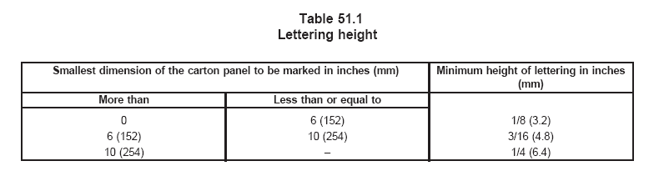
表51.1字符高度
包装箱标识面的最小尺寸英寸（mm） |  | 字符的最小高度英寸（mm）
大于 | 小于或等于
0 | 6（152） | 1/8（3.2）
6（152） | 10（254） | 3/16（4.8）
10（254） | - | 1/4（6.4）

INSTRUCTION MANUAL说明书
52 General52 总则
52.1 An instruction manual or the equivalent shall be provided with the appliance. The manual shall specifically warn the user against each potential risk and state the precautions that should be taken to guard against each risk. The safety instructions shall be a permanent part of the manual but separated in format from the other instructions, and shall appear before the operating instructions in the manual.
52.1 说明书或同等必须随电器一起配备，说明书必须告诉用户防止电击以及需要防止的每一个危险，安全介绍是说明书中一个固定的内容，并同其它说明单独放置，一般要求放置在操作说明之前。
52.2 The instruction manual shall include instructions or illustrations to identify important safety features.
52.2 说明书必须包含重要安全性能的说明或图示。
52.3 The height of lettering in the text and illustrations of the safety instructions shall be as follows:
52.3 安全介绍中的文本及图示中的字符必须如下要求：
a) Upper case letters shall be not less than 1/12 inch (2.1 mm) in height; a）大写字母的高度不得小于1/12英寸（2.1mm）；
b) Lower case letters shall be not less than 1/16 inch (1.6 mm) in height; b）小写字母的高度不得小于1/16英寸（1.6mm）；
c) The phrases ″IMPORTANT SAFEGUARDS″ and ″SAVE THESE INSTRUCTIONS″ shall be in letters no less than 3/16 inch (4.8 mm) in height. c）标题“安全事项”、“保存该说明书”的字符不得小于3/16（4.8mm）的高度。
52.4 The instruction manual shall include the safety instructions in All Appliances, Section 53 and the appropriate text from Specific Appliances, Section 54. 52.4 说明书必须包括通用电器的安全要求，见53部分和单独电器的特别要求，见54部分。
52.5 Unless otherwise indicated, the text of the instructions shall be verbatim to, or in equally definitive terminology as All Appliances, Section 53, and Specific Appliances, Section 54, except where specific conflict exists in the application of the text to a product or where the risk alluded to has been reduced. The items may be numbered, and the phrases ″Read all Instructions″ and ″Save these Instructions″ shall be first and last, respectively, in a list of items. Other important and safety instruction items considered appropriate by the manufacturer may be inserted.
52.5 除非其它的说明，说明书的文字必须同53和54部分一样或采用同等的意思词语，除非应用于电器的文本存在冲突，或此处危险间接降低。可以列成条款，加在“阅读本说明书”和“保存本说明书”中间，制造商认为重要的其它安全项目也可以加入。
52.6 For a dual voltage rated appliance, procedures to be followed in changing the voltage selector, if provided and providing the correct supply connection means for each voltage setting shall be provided. In addition, the following wording or equivalent shall be provided: ″For use in the U.S.A., the voltage selector switch should be placed in the 120 V position. For use in several countries overseas, the voltage selector may need to be placed in the 240 V position. Confirm the voltage available at each overseas location before using the appliance. For connection to a 240 V supply, use an attachment plug adapter of the proper configuration for the power supply receptacle.″
52.7 An appliance provided with a 2-wire polarized attachment plug shall include the following or
equivalent wording: ″This appliance has a polarized plug (one blade is wider than the other). To reduce
the risk of electric shock, this plug is intended to fit into a polarized outlet only one way. If the plug does
not fit fully into the outlet, reverse the plug. If it still does not fit, contact a qualified electrician. Do not
attempt to modify the plug in any way.″
52.6 对于双重电压电器，对于改变电压的选择，如果配置正确的的电源连接方式，必须配置相应原操作程序，另外还要标明以下语句：“对于在美国使用，电压必须设置在120V的位置，对于美国以外的使用，请在使用电器前，确认当地的电压。对于电器连接到240的电源上，请使用符合电源线插壮举的插座。”
52.7 电器附带的极性两扁插必须包括以下的语句：“本电器附带的是极性两扁插（一边为大头）。为了减少触电的危险，本插头仅适用于极性插座，如果插头不能插入插座中，请调转插头再试，如果仍不能插入插座，请联系电服务站，不要修改插头。”
53 All Appliances53 所有电器
53.1 The following applies to all appliances: 53.1 以下适合所有电器：
IMPORTANT SAFEGUARDS安全事项
When using electrical appliances, basic safety precautions should always be followed, including the
following: 当您使用电器时，基本的安全问题如下给出：
1. Read all Instructions. 1 请阅读说明书。
2. Do not touch hot surfaces. Use handles or knobs. 2 不要用手触摸热表面，请使用手柄或手把。
3. To protect against fire, electric shock and injury to persons do not immerse cord, plugs, or (state specific part or parts in question) in water or other liquid. 3 为减少人身伤害、触电或着火危险，不要将插头、电源线（或其它特别的零件或部分）浸在水中或其它的液体中。
4. Close supervision is necessary when any appliance is used by or near children. 4 当电器由儿童使用或使用时有儿童在旁边，请在一旁监控。
5. Unplug from outlet when not in use and before cleaning. Allow to cool before putting on or taking off parts, and before cleaning the appliance. 5 电器不用进行清洁时，请先取下插头，清洁前让电器充分冷却至室温。
6. Do not operate any appliance with a damaged cord or plug or after the appliance malfunctions, or has been damaged in any manner. Return appliance to the nearest authorized service facility for examination, repair or adjustment. 6 电器的电源线或插头出现问题或电器出现毛病时，请不要使用电器，将电器送至专业或认可服务机构进行维修保养。
7. The use of accessory attachments not recommended by the appliance manufacturer may result
in fire, electric shock or injury to persons. 7 使用非制造商推荐的配件可能会造成着火、触电或人身伤害。
8. Do not use outdoors (this item may be omitted if the product is specifically designed for outdoor use). 8 不要在户外使用（如果电器特别说明可以用于户外，则可以省略本条要求）。
9. Do not let cord hang over edge of table or counter, or touch hot surfaces. 9 不要让电源线悬挂桌台边缘，或接触较热的表面。
10. Do not place on or near a hot gas or electric burner, or in a heated oven. 10 不要靠近热源放置，也不要放置在烤炉内。
11. Always attach plug to appliance first, then plug cord into the wall outlet. To disconnect, turn any control to ″off,″ then remove plug from wall outlet. 11 一般先将插头装置在电器上，然后插入插座中，断开电源时，先将电器的控制开关关闭，然后从插座中取出插头。
12. Do not use appliance for other than intended use. 12 不要将电器它用。
13. Save these Instructions. 13 保存本说明书。
54 Specific Appliances54 特别的电器
54.1 Coffee makers, liquid heaters54.1 咖啡壳、液体加热器
1. (Special instructions covering lid placement and removal. Wording may vary.) 1 （介绍如何盖盖子及取下的方法，语句不定）
2. Scalding may occur if the lid is removed during the brewing cycles. 2 在煲水期间，如果取下盖子，会使人烫伤害。
54.2 Appliances with detachable handles54.2 具有可拆式手柄的电器
1. Be sure that handles are assembled and fastened properly. 1 请确认手柄是否完全组装并固定好。
2. (The manufacturer shall supply explicit instructions detailing the proper assembly of the handles.) 2 （制造商必须详细说明如何正确组装手柄）。
3. (The manufacturer shall explain how improper assembly of the handles can be determined.) 3 （制造商必须说明怎样才是不正确组装手柄）。
Exception: Items 2 and 3 may be located in any part of the instruction manual provided that the Important
Safeguards state ″ See instructions regarding Handles on Page ___″ or the equivalent wording. 注：上面2和3可以在安全事项中注明：“见说明书中手柄多少页 ”或同等语句。
54.3 Under cabinet and wall mounted appliances 54.3 壁橱下或墙上安装的电器：
a) To reduce the risk of fire, do not place any heating or cooking appliance beneath the appliance. a）为了减少着火危险，不要将加热或烹调电器放在电器下面；
b) To reduce the risk of fire, do not mount unit over or near any portion of a heating or cooking appliance. b）为了减少着火危险，不要将电器安装在加热或烹调电器的上面或附近；
c) To reduce the risk of electric shock, do not mount over a sink. c）为了减少触电危险，不要在水槽附近；
d) To reduce the risk of fire, do not store anything directly on top of the appliance surface when the appliance is in operation. d）为了减少着火危险，电器工作时，不要直接在电器上方贮存东西。
54.4 A cautionary marking that is required to be on an appliance shall be repeated in its entirety or with an equivalent wording in the instruction manual. The marking may be included in the Important Safeguards. 54.4 电器第一次使用时需要预热，必须标识同等的语言提示，该提示语可以放在安全事项中。
54.5 Dual voltage rated appliances54.5 双电源电器
1. Be sure dual voltage selector, if provided, is in correct voltage position before operating. Before plugging in, read the information about the dual voltage contained in instruction section of this manual. 1 如果配置有电源选择器，工作前确认正确的电压位置，在插上插头并，请先阅读说明书中有关双电压部分。
2. ″This appliance was set at the factory to be operated at ____ V. Refer to operating instructions section of this manual for conversion to ____ V operation″ or equivalent. The blanks are to be filled in with the appropriate voltage information. 2 “该电器在工厂中已设定在 V工作，参考说明书中本部分转换到 V工作。”或同等语句，在正确的电压下将注满水进行。
Exception: This construction does not apply if an appliance operates over a range of voltages and requires no adjustment by the user, such as an appliance that employs a positive temperature coefficient (PTC) heating element intended for use over a range of voltages and requiring no adjustment by the user.
注：如果电器工作超过其额定的电压并且不需要用户地去调节，如电器使用PTC发热元件预期使用超过其额定电压的并不需要用户去调节，则本内容不适用。
55 User Maintenance55 用户保养
55.1 The instruction manual shall include appropriate instructions and caution statements for cleaning, user-maintenance (such as lubrication or nonlubrication) operations recommended by the manufacturer, and shall warn a user that any other servicing should be performed by an authorized service representative. The manual or other literature packaged with the product shall also indicate that the product is for household use. 55.1 说明书必须适当的介绍清洁和用户保养的注意事项（如润滑油），以及制造厂建议的工作方法，以及警告用户某些服务将由授权的机构执行。用户手册和产品的包装必须标明该产品只能为家庭使用。
55.2 Instructions for mounting an under-cabinet or wall mounted appliance shall be provided. The actual instructions shall be located on the appliance, or in the literature packed with the appliance. The actual instructions shall not be in the Important Safeguards, however, there may be a reference to them in the Important Safeguards. (Such as ″Wall or under-the-cabinet mounting should follow the directions in the installation instructions″).55.2 对于墙上和壁橱下安装的电器必须配备说明书。操作说明必须在电器上标明，或印刷在电器的外表上，操作说明不在安全事项中，但它们可以参考安全事项。

SUPPLEMENT SA - HOUSEHOLD ELECTRIC DRIP-TYPE COFFEE MAKERS AND SIMILAR
DRIP-TYPE BREWING APPLIANCES
SA1 Scope
SA1.1 The requirements in this supplement cover household electric drip-type coffee makers and other similar drip-type brewing appliances that are to be cord-connected to a nominal 120 V supply in accordance with the National Electrical Code. These requirements are in addition to or modify the applicable requirements in Sections 1 – 55.

SA1.2 The appliances covered by this standard are automatic (temperature-regulated) and are used to heat water to a temperature greater than 46°C (115°F) as part of the intended brewing function. The coffee or other beverage brewed by these appliances are dispensed automatically or manually.

SA1.3 In the text of this supplement, reference to drip-type coffee makers is to be understood to apply to all drip-type appliances covered by this supplement. Reference to containers is to be understood to apply to the carafe or other container provided as part of the appliance to hold the brewed beverage.
SA2 Assembly
SA2.1 A drip-type coffee maker carafe shall be completely assembled before shipping and not require any assembly by the user.
SA3 Corrosion Protection
SA3.1 Iron, steel or aluminum parts shall be protected against corrosion as determined by compliance with SA12.3 and SA12.4 where deterioration would increase the risk of fire or electric shock. SA3.2 The effects of severe humidity and moisture resulting from the test in Operation Degradation, Section SA12, and the humidity conditioning test in Leakage Current as a Result of Moisture, Section SA15, shall be evaluated. There shall be no visible degradation that would result eventually in unacceptable performance of the appliance.
SA4 Supply Connections
SA4.1 The length of an attached flexible cord or a detachable power supply cord provided with an under-cabinet or wall-mounted drip-type coffee maker shall be minimum 3 ft (0.9 m) and maximum 4.5 ft (1.4 m) long.
Exception: The cord length may be a maximum of 7.0 ft (2.1 m) if a means is provided for storing the excess length of cord.
SA5 Gaskets and Seals
SA5.1 An identifiable gasket, seal, or similar protection shall be provided to reduce the risk of the entrance of water and steam into wiring and electrical component spaces as determined by examination following the test in Operation Degradation, Section SA12.
SA5.2 Where the gasket, seal or similar protection mentioned in SA5.1 cannot be determined as providing the protection necessary to comply, the design shall be evaluated following the test in Operation Degradation, Section SA12.
SA6 Water Connections
SA6.1 Each water connection of elastomeric-type tubing whose failure could result in an increase in the risk of fire or electric shock shall be secured by an adhesive which meets the requirements in the Adhesives – Specialized Applications, Section 69 of UL 746C, a clamp, or friction alone, and shall comply with one of the following:
a) A means of retaining the elastomeric-type tubing at a water connection that can be subjected to increased pressures, is acceptable if there is no water leakage as the result of the hydrostatic pressure test described in SA6.2 or SA6.5. If the elastomeric-type tubing is secured by friction alone, it shall additionally comply with the elongation and tensile strength properties test described in SA6.4.
b) A means of retaining the elastomeric-type tubing at a water connection that can only be subjected to the normal head pressure by its position, is acceptable if there is no water leakage as the result of the hydrostatic pressure test in SA6.3 or SA6.5. If the elastomeric-type tubing is secured by friction alone, it shall additionally comply with the elongation and tensile strength properties test in SA6.4.
SA6.2 One drip-type coffee maker with water connections, as described in SA6.1(a), is to be subjected to a hydrostatic–pressure test. The coffee maker is to be filled with water so as to exclude air and is to be connected to a hydraulic pump. The pressure is to be raised gradually to a gauge pressure of 15 psi (103 kPa) and held at that value for 1 minute. The results are not acceptable if the water connections of the coffee maker burst or leak.

SA6.3 One drip-type coffee maker with water connections, as described in SA6.1(b), is to be subjected to a hydrostatic pressure test. The coffee maker is to be filled with water so as to exclude air and is to be connected to a hydraulic pump. The pressure is to be raised gradually to a gauge pressure equivalent to 10 times the maximum head pressure that the connection would be subjected to at overflow conditions, and held at that value for 1 minute. The results are not acceptable if the water connections of the coffee maker burst or leak.

SA6.4 Three samples of the elastomeric-type material used for a water connection that is secured by friction alone are to be tested for tensile strength and elongation. Three additional samples are to be artificially aged for 168 h in water maintained at 100°C (212°F). Following the aging, the samples are to be tested for tensile strength and elongation. The results are acceptable if the values following aging are at least 75 percent of the original values recorded on the unaged samples.
SA6.5 At the manufacturer’s option, and as a substitute for the tests described in SA6.2 and SA6.3, three drip-type coffee makers with water connections as described in SA6.1 are to be subjected to a blocked operations test. The outlet tube of each coffee maker is to be blocked. The coffee makers are then to be filled with water and operated for a period of 1 hour. The results are not acceptable if the water connections of any of the three coffee makers burst or leak.
SA7 Thermal Conductivity
SA7.1 The assembly of a thermostat or other control that is dependent upon heat transfer through a thermal bridge or from the surface on which the control is mounted for proper operation, shall be constructed to reduce the risk of the following:
a) Loosening of the control or bridge due to corrosion or thermal cycling, and
b) Change in the properties of the thermal bridge or surface materials from electrolytic action due to use of dissimilar metals in a wet or moist environment, metal fatigue, or corrosion. SA7.2 Compliance with the requirements in SA7.1 is to be determined following the test in Operation Degradation, Section SA12.
SA8 Grounding
SA8.1 A conductive connection between separate metal parts (accessible and inaccessible) in a drip-type
coffee maker that has no provision for grounding shall be provided only if needed for functional purposes.
SA9 Operating Controls
SA9.1 An operating control device shall have a current and voltage rating not less than that of the circuit (load) it controls. The temperature rating of the materials used in such a device shall not be exceeded during the normal operation test unless the requirement for transient temperatures mentioned in SA14.1 apply.
SA9.2 A manual operating control, such as a switch, shall be provided to turn a drip-type coffee maker off when not in use.
Exception No. 1: A drip-type coffee maker with an automatic shutoff manual-reset operating control that
operates in 5 min or less after energization of the coffee maker is acceptable.
Exception No. 2: A drip-type automatic coffee maker with an automatic shutoff manual reset operating
control that operates in more than 5 min after energization need not be provided with an additional manual
on-off control if the product complies with all of the following:
a) No keep warm feature after brewing is provided.
b) Automatic operation of the manual reset system will cause disconnection of all ungrounded conductors from the supply to all heating assemblies at the end of one brewing cycle.
c) The manual reset operating control shall be trip free; that is, the automatic tripping shall be independent of the manipulation or position of the reset button, handle, lever, or the like. A manual reset control designated type M1 or M2 in accordance with the Standard for Temperature-Indicating and -Regulating Equipment, UL 873, is considered to comply with these requirements.
d) The manual reset operating control shall not reset automatically as a result of changes in
environmental temperature at temperatures above minus 35°C (minus 31°F).
e) The manual reset operating control shall be capable of withstanding an endurance test consisting of 6000 c under load.
SA9.3 The operating control mentioned in SA9.2 shall disconnect or cause disconnection of the ungrounded conductor from the supply to the heating assembly. When the ungrounded conductor cannot be identified, such as with products provided with a nonpolarized attachment plug, the control is to be of a double-pole type to open both circuit conductors.
Exception: If the warming plate is the only exposed metal part and is coated with an acceptable thickness
of insulating material or isolated (not likely to become energized), the operating control need not
disconnect the ungrounded conductor.
SA9.4 In a drip-type coffee maker provided with a polarized attachment plug, all additional operating
controls with single-pole switching capability shall be wired in the ungrounded conductor.
Exception: See SA11.3.4.
SA10 Power-On Indicator
SA10.1 A drip-type coffee maker shall be provided with a power-on indicator that is readily visible and
distinguishable from the off position.
Exception: A drip-type coffee maker with an automatic shutoff manual-reset operating control that
operates in 5 min or less need not be provided with a power-on indicator.
SA10.2 The power-on indicator shall be significantly different from any indicator that may be used to indicate ″off″ on the product. Indicators, such as an illuminated switch, pilot light and colored flag, are means of complying with SA10.1. An ordinary on-off position marking is unacceptable.
SA11 Temperature Controls
SA11.1 General
SA11.1.1 A separate temperature limiting-type device is required only if the short-circuiting of a temperature-regulating control during abnormal operation (see Abnormal Operation, Section SA19) increases the risk of fire or electric shock. A single combination regulating-limiting control is unacceptable for this purpose.
SA11.1.2 Glossary
SA11.1.2.1 Set-point Temperature Rating (T s-p)– The temperature at which the thermostat’s electrical load switching contacts change state upon temperature rise. Added SA11.1.2.1 effective May 3, 2002
SA11.1.2.2 Maximum Normal Use Temperature Rating (T max)– The maximum temperature permitted on the thermostat’s sensing surface during normal operation of the coffee maker. This temperature is equal to or greater than T s-p. Added SA11.1.2.2 effective May 3, 2002
SA11.1.2.3 Maximum Dry Operation Temperature Rating (T dry)– The maximum temperature permitted on the thermostat’s sensing surface during abnormal (dry) operation of the coffee maker. This temperature is equal to or greater than T max. Added SA11.1.2.3 effective May 3, 2002
SA11.2 Temperature regulating
SA11.2.1 An automatic reset temperature-regulating thermostat that operates more than once during a complete cycle of brewing and warming shall comply with the applicable requirements for drip-type coffee maker thermostats in the Standard for Temperature-Indicating and -Regulating Equipment, UL 873.
SA11.2.2 An automatic reset temperature-regulating thermostat that operates only once during a complete brewing cycle and does not cycle in the keep warm mode shall comply with the applicable requirements in the Standard for Temperature-Indicating and -Regulating Equipment, UL 873 and be tested for 100,000 c at rated current and voltage.
SA11.2.3 The insulating material of a temperature regulating control shall have a Comparative Tracking Index of 175 or more. The Comparative Tracking Index (CTI) is referenced in the Standard for Polymeric Materials – Use in Electrical Equipment Evaluations, UL 746C. SA11.2.3 revised January 8, 1999
SA11.3 Limiting-type devices
SA11.3.1 A limiting-type device shall consist of one of the following:
a) A single thermal cutoff with an established TH-100 rating (which includes having a Conductive
Heat (CH) rating) as described in the Standard for Thermal Cutoffs for Use in Electrical
Appliances and Components, UL 1020, and as tested per SA14.8 and SA14.10;
b) Two thermal cutoffs such that one of the following conditions is met:
1) Each of the thermal cutoffs has a Conductive Heat (CH) rating as described in the Standard for Thermal Cutoffs for Use in Electrical Appliances and Components, UL 1020; or
2) One thermal cutoff has a Conductive Heat (CH) rating:
i) and temperature on the stationary contact lead of the thermal cutoff without a CH rating is greater than or equal to the temperature on its case, as tested per SA14.10, or
ii) the CH rated thermal cutoff has a set-point temperature equal to or higher than the thermal cutoff without a CH rating; or
3) The temperature on the stationary contact lead of both thermal cutoffs without a CH rating is greater than or equal to the temperature on their respective cases as tested per SA14.10.
c) A single-operation thermostat; or
d) A manual-reset thermostat that is inaccessible to the user without the use of tools.
Exception: A drip-type coffee maker that does not include a keep warm feature, and is provided with an automatic shut-off manual reset operating control (see Operating Controls, Section SA9) need only be provided with a single thermal cutoff. The thermal cutoff need not have a TH-100 or a Conductive Heat (CH) rating. SA11.3.1 revised May 4, 2001
SA11.3.2 A single-operation thermostat or a manual-reset thermostat that is provided as the thermal
limiting device shall comply with the applicable requirements in the Standard for Temperature-Indicating
and -Regulating Equipment, UL 873 for limiting controls.
SA11.3.3 A thermal cutoff shall comply with the applicable requirements in the Standard for Thermal
Cutoffs for Use in Electrical Appliances and Components, UL 1020.
SA11.3.4 If a grounding-type attachment plug is provided or the enclosure of the drip-type coffee maker has metal parts that are likely to become grounded, such as a metal bottom with bumped-out metal feet, the limiting-type device shall be located in the ungrounded supply conductor (if it can be identified) and the temperature-regulating control shall be in the other conductor. If the ungrounded supply conductor cannot be identified, the limiting-type device shall be located in one supply conductor and the temperature-regulating control shall be located in the other supply conductor.
SA12 Operation Degradation
SA12.1 A drip-type coffee maker shall be operated to represent all of the intended functions in accordance with the Use and Care Literature provided with the coffee maker. Such operation shall not result in an electrical or mechanical condition that might impair compliance with the requirements in the Standard.
SA12.2 To determine compliance with SA12.1, three samples are each to be operated for 100 c of normal use. Each cycle is to simulate making a full container of brew followed by a keep-warm period of 30 min. The first 80 c are to be conducted using water only, without coffee or other brewing material. The remaining 20 c are to be conducted using water and fresh coffee or other brewing material of a type recommended by the manufacturer. Each cycle is to be conducted so as to rapidly follow the previous cycle, unless the manufacturer’s operating instructions indicate some other acceptable procedure is to be followed. The water used shall be a solution of 1/4 g of sodium chloride per liter of distilled water or water having an equivalent conductivity at 25°C. If necessary, the test samples may be cleaned between cycles in accordance with the manufacturer’s instructions. The basket and filter are to be in place for all cycles.
Exception: The 30-min keep-warm period may be omitted if the drip-type coffee maker does not
incorporate a keep-warm mode.
SA12.3 Following the 100 c of operation, each sample shall comply with:
a) The leakage-current test described in 31.1,
b) Overfill test described in SA19.4.1.1, and
c) The dielectric voltage-withstand test described in 35.1. Each sample is then to be disassembled and examined. There shall be no visible indication of corrosion.
SA12.4 If applicable, after the 100 c of operation, each sample of a drip-type coffee maker with a thermal bridge shall also be examined for compliance with SA7.1. One sample shall acceptably complete the dry-operation test described in SA19.3.4. There shall be no deterioration of the thermal bridge that could increase the risk of fire or electric shock after dry operation.
SA13 Leakage Current
SA13.1 The leakage current, when tested in accordance with 31.3 – 31.7, shall not be more than 0.5 mA.
Exception: The leakage current of an appliance incorporating a sheath type heating element shall not
exceed 2.5 mA during the first 5 minutes after reaching the leakage current limit of 0.5 mA or 0.75 mA,
as applicable, and at the end of this time, the leakage current shall be not more than the 0.5 mA or 0.75
mA limit as applicable – the leakage current is to be monitored during heat-up and cool-down.
SA14 Normal Temperature
SA14.1 The initial temperature transients may be in excess of the values shown in Table 33.1 if the duration and extent of the excursion do not result in risk of fire or electric shock, and do not result in changes of the properties of materials to the extent that risk of fire or electric shock results. A transient temperature rise not exceeding the maximum temperature rise specified in Table 33.1 by more than 20 percent is acceptable.
SA14.2 A limiting-type control shall not operate during the normal temperature test.
SA14.3 A drip-type coffee maker is to be operated for 5 c of actual brewing. At the beginning of each cycle, the sample is to be filled with the intended amount of water. The water temperature is not to be higher than room temperature. The cycle is considered as having ended when all brew is delivered to the container. The time interval between cycles is to be:
a) The minimum time necessary for refilling the reservoir and brew basket, or
b) 30 s for the first two refills and 3 min for the second two refills, whichever is longer. Temperatures are to be measured throughout the 5 c, and also when a drip-type coffee maker has subsequently operated at low heat, when a keep warm mode is provided, until temperatures have become stabilized. If a separate switch is provided to de-energize the brewing element or warming element, it is to be left in the on position for all phases of the test. During operation of the drip-type coffee maker in the low-heat mode, temperatures are to be measured under the following conditions in the sequence given below:
1) Container full, resting on warmer surface.
2) Container empty, resting on warmer surface.
3) Container removed.
SA14.4 The drip-type coffee maker is also to be tested in accordance with any operating procedure
recommended in the manufacturer’s instructions that could result in temperatures higher than those
attained while conducting the test described in SA14.3.
SA14.5 A counter-top drip-type coffee maker is to be supported on a softwood surface painted flat black.
SA14.6 A wall- or under-cabinet mounted drip-type coffee maker is to be mounted on one wall or cabinet bottom of a test corner consisting of dull black-painted fir plywood not less than 3/8 inch (9.5 mm) thick, having such a width and height that the walls extend not less than 2 ft (0.61 m) beyond the physical limits of the drip-type coffee maker. The vertical walls are to meet at a right angle. The sample is to be placed as close to the corner wall as the construction will permit, and an under-cabinet appliance is to be in contact with the rear wall while a wall-mounted drip-type coffee maker is to be in contact with either the cabinet bottom of the counter, whichever results in the highest temperature. The cabinet bottom is to be 12 inches (340 mm) deep, located 16 inches (400 mm) above the counter top. The surface beneath the unit is to be softwood covered with a double layer of white tissue paper. The maximum allowable temperature on supporting and adjacent surfaces is 90°C (194°F).
SA14.7 The temperature of a regulating thermostat’s sensing surface shall not exceed its maximum normal use temperature rating, Tmax , as defined in SA11.1.2.2 during normal operation of the coffee maker. Revised SA14.7 effective May 3, 2002
SA14.8 The sensing surface of a thermal cutoff as defined in SA11.3.1 (a) shall not exceed 90% of its established TH-100 temperature (stated in degrees centigrade) during normal operation of the coffee maker. SA14.8 revised May 4, 2001
SA14.9 To determine compliance with SA14.7, thermocouples are to be secured at the periphery of the regulating thermostat’s surface that is in contact with the part being sensed. Temperatures are to be measured during the normal operation tests described in SA14.3 and SA14.4.SA14.9 revised May 4, 2001
SA14.10 To determine compliance with SA14.8 and SA11.3.1 (b), thermocouples are to be secured at the midpoint of the longitudinal axis of the thermal cutoff body at any point along its circumference. In addition, to determine compliance with SA11.3.1 (b), a thermocouple is to be secured on the stationary contact lead of the thermal cutoff approximately 1 mm from the tip of the insulator cone. Temperatures are to be measured during the steady state condition of the keep warm stages (carafe full, carafe empty, no carafe) of the normal operation test described in SA14.3 and SA14.4. SA14.10 revised October 31, 1996
SA15 Leakage Current as a Result of Moisture
SA15.1 A drip-type coffee maker shall be conditioned for 48 h in moist air having a relative humidity of 88 ±2 percent at a temperature of 32.0 ±2.0°C (89.6 ±3.6°F). After the conditioning, the sample shall comply with the requirement in 31.1 in a repeat leakage-current test, except that the test may be discontinued when the leakage current stabilizes.
Exception: The leakage current of an appliance incorporating a sheath type heating element shall not exceed 2.5 mA during the first 5 minutes after reaching the leakage current limit of 0.5 mA or 0.75 mA, as applicable, and at the end of this time, the leakage current shall be not more than the 0.5 mA or 0.75 mA limit as applicable – the leakage current is to be monitored during heat-up and cool-down. SA15.1 revised January 8, 1999
SA15.2 An additional sample of the drip-type coffee maker shall be tested as follows, if glass-fiber sleeving is used as electrical insulation. The sample is to be operated for 96 continuous h under the condition resulting in the maximum temperature on the sleeving, as determined from the normal temperature test, following which it is to be conditioned for 48 h in moist air having a relative humidity of 88 ±2 percent of a temperature of 32 ±2.0°C (89.6 ±3.6°F). After the conditioning, the sample shall comply with the requirement in 31.1 in a repeat leakage-current test, except that the test may be discontinued when the leakage current stabilizes. Following the leakage-current test, the sample shall also comply with the dielectric voltage-withstand test requirement in 35.1.
Exception: The leakage current of an appliance incorporating a sheath type heating element shall not exceed 2.5 mA during the first 5 minutes after reaching the leakage current limit of 0.5 mA or 0.75 mA, as applicable, and at the end of this time, the leakage current shall be not more than the 0.5 mA or 0.75 mA limit as applicable – the leakage current is to be monitored during heat-up and cool-down. SA15.2 revised January 8, 1999
SA16 Stability
SA16.1 To determine compliance with 26.4, the complete drip-type coffee maker as a unit is to be placed on a plane inclined at an angle of 15° to the horizontal. The unit is to be positioned and loaded with whatever combination of separable components, liquid, basket with saturated grounds, or other media (material) that results in the maximum tendency to overturn under conditions of normal use. Saturated grounds are to be obtained from a normal brewing cycle. The container is to contain a minimum of 5 oz (148 mL) of liquid. The unit is to be prevented from sliding on the inclined surface. The unit shall not overturn.
SA16.2 In addition to the unit not overturning during the test described in SA16.1, the container on units
provided with warming plates shall not come off the drip-type coffee maker base as a result of the test. SA16.3 A container provided with the drip-type coffee maker that has a critical angle of balance of less than 45° and has a capacity of more than 17.5 oz (520 mL) shall withstand the tip–over test described in 26.11, with the following acceptable results:
a) The average rate of liquid emitted during the first 5 s from the container during any tip over shall not be more than 4-1/2 oz/s (133 mL/s). The average of the average rates of liquid emitted for all tip–overs shall not be more than 3-1/2 oz/s (104 mL/s). The rate shall be computed by using the time period of 5 s.
b) The lid, if one is provided, shall stay in place.
c) A container shall not break or crack.
Exception: A container that breaks during this test, but complies with 26.12 without breaking or cracking
is acceptable.
SA17 Loading Test
SA17.1 A loading test is to be performed on the mounting brackets of an under-cabinet or wall mounted drip-type coffee maker with the appliance mounted in accordance with the manufacturer’s installation instructions, using the hardware and construction as described. A bracket shall not break, loosen, or pull out of the wall nor shall the unit separate from the bracket as a result of this test. The test load is to consist of four times the normal maximum load (full carafe, grounds, basket and the like) and applied as follows: A gradually increasing force is to be applied to act vertically through the center of gravity of the unit. The force is to be increased in a 5 to 10 s interval until a load of four times the weight of the unit is applied to the mounting system (weight of unit plus force of three times the weight of the appliance) and is to be sustained for a period of 1 min. For this test an under–cabinet unit is to be mounted on a wood board with a minimum thickness as specified by the manufacturer and a wall unit is to be mounted on 3/8 inch (4.8
mm) thick wallboard. If the mounting brackets are constructed of a thermoplastic material, they are to be conditioned for 7 h in an air circulating oven maintained at 70°C (158°F) or 10°C (18°F) higher than that measured during the normal temperature test, whichever is higher, prior to performing the loading test.
SA18 Impact Test
SA18.1 The impact test of SA18.2 and SA18.3 are to be conducted on all under-cabinet and wall
mounted drip-type coffee makers.
SA18.2 A 1.5 ft-lbf (2.03 J) impact is to be performed on different sections of the enclosure, including the reservoir while the unit is installed under a cabinet or on a wall. The container is to be filled to the maximum recommended level and located on the warming plate for this test. Dislodging of the container or reservoir off the drip–type coffee maker is unacceptable. Each of three samples are to be subjected to one impact. The impact is to be imparted by swinging a 2 inch (50.8 mm) diameter steel sphere, weighing 1.18 lb (0.535 kg) from a height that will produce an impact of 1.5 ft-lbf (2.03 J).
SA18.3 The container is to be subjected to the dynamic stability test outlined in 26.12 and Figure 26.2 except that the container is not to be dislodged off the drip–type coffee maker while the unit is tilted at the maximum angle permitted by the mounting means in various positions of removal or insertion of the unit or 10°, whichever is more.
SA19 Abnormal Operation
SA19.1 General
SA19.1.1 Continuous operation of a drip-type coffee maker under any foreseeable condition of use shall
not increase the risk of fire or electric shock to unacceptable levels.
SA19.1.2 To determine compliance with SA19.1.1, a separate burnout or abnormal test is to be conducted with the drip-type coffee maker operating continuously while placed on a softwood test surface covered with two layers of white tissue paper until the ultimate result has been observed. Unless otherwise indicated below, the test is to be conducted with the applied voltage, method of mounting, and the thermostat connections in accordance with 33.1.11 – 33.1.18 and SA14.6. In most cases, continuous operation for 7 – 8 h will be necessary to determine that the ultimate result has been observed.
SA19.1.3 When the drip-type coffee maker is operated under such abnormal conditions, there shall be
no flaming or glowing of the enclosure material or material upon which the drip-type coffee maker is
placed, and no emission of flames or molten metal (other than drops of melted solder).
SA19.1.4 After having been subjected to an abnormal test, the drip-type coffee maker is considered to
involve a risk of electric shock if the current measured through a 500-ohm resistor between an accessible
part and ground is more than 5 mA with the input voltage adjusted to 120 V. A solution of hard water (1/2
gram of calcium sulphate, CaSO4 ·2H2 O, per liter of distilled water) in an amount equal to the capacity
of the coffee maker, is to be poured into the reservoir and the current is to be measured. Liquid need not
be added, if it is obvious that the coffee maker will not hold liquid.
SA19.2 Specific test conditions
SA19.2.1 For most of the common types of drip-type coffee makers, standardized abnormal–test
conditions are given in SA19.3.1 – SA19.4.4.1.
SA19.3 Dry operation
SA19.3.1 One sample of a drip-type coffee maker is to be operated three times dry, starting from a cold condition, with all temperature controls connected in the circuit each time. The first two operations are to be terminated after 1 h. The third operation is to continue for 7 or 8 h or until ultimate results occur. A temperature-limiting device shall not operate during this test.
SA19.3.2 The temperature of a regulating thermostat’s sensing surface shall not exceed its maximum dry operation temperature rating, Tdry, as defined in SA11.1.2.3 with all temperature controls connected in the circuit.
Revised SA19.3.2 effective May 3, 2002
SA19.3.3 To determine compliance with SA19.3.2, thermocouples are to be secured at the periphery of
the thermostat that is in contact with the part being sensed. Temperatures are to be measured during the
dry operation tests described in SA19.3.1.
SA19.3.4 The test described in SA19.3.1 is to be repeated with all temperature-regulating controls rendered inoperative. The test is to be conducted so that each required limiting-type device is caused to operate in its intended manner.
SA19.4 Overfill
SA19.4.1 General
SA19.4.1.1 To determine that a drip-type coffee maker complies with the requirement in SA19.1.4, it is to
be tested as follows:
a) The drip-type coffee maker is to be supported as intended on a horizontal surface unless filling requires another position. A hard-water solution (see SA19.1.4) is to be poured into the container through an orifice 3/8 inch (9.5 mm) in diameter. The unit is to be first filled with themaximum amount of liquid the reservoir will hold. An additional amount of the solution equal to 50 percent of the volume just mentioned, but not more than 1 pint, (470 cc) is then to be poured into the fill ed reservoir. An equivalent method that provides the same rate and amount of uniform flow of liquid may be employed. If the unit is provided with a detachable powersupply cord, the cord is to be removed during overfilling. Immediately following the test, the unit is to be emptied. The exterior is to be dried with a soft cloth to remove all surface moisture, including surface moisture from exposed terminal pins. The unit is then to be refilled to the normal level, and the current through a 500–ohm resistor measured as described in SA19.1.4.
b) In addition, for a drip-type coffee maker in which electrical components are located below the water outlet, the container is to be filled to its normal full level and poured into the water reservoir. The unit is then to be operated as intended, but without the container in place. During the entire cycle, the current through a 500-ohm resistor is to be measured as described in SA19.1.4.
SA19.4.2 Overvoltage
SA19.4.2.1 The drip-type coffee maker reservoir is to be filled to normal capacity with water and the basket is to be filled to normal capacity with coffee grounds or other appropriate brew material. The unit is then to be operated at 110 percent of the voltage as determined from 33.1.11. All temperature controls are to be connected in the circuit. The results are not acceptable if liquid is emitted in other than its intended direction or if water splashes more than 3 inches (76 mm) from the outer perimeter of the material. If a temperature-limiting device operates, the voltage is to be reduced until the device does not operate.
SA19.4.3 Fusible devices
SA19.4.3.1 A fusible device (thermal cutoff or fusible link) shall be capable of opening a circuit in the intended manner without causing the short-circuiting of live parts and without causing live parts to become grounded to the enclosure while the drip-type coffee maker is connected to a circuit having a voltage in accordance with 33.1.11 and operated in the normal position under any single-fault condition that would cause it to open.
SA19.4.3.2 To determine if a drip-type coffee maker with a fusible device complies with the requirements in SA19.4.3.1, five samples of the drip-type coffee maker are to be operated as described in SA19.3.1 with any other thermally operated control device in the appliance short-circuited. If the drip-type coffee maker is provided with more than one thermal cutoff as required by SA11.3.1, the drip-type coffee maker is to be operated with all but one thermal cutoff bypassed. The test sequence is to be repeated as many times as necessary so as to evaluate the operation of each thermal cutoff. During the test the enclosure is to be connected through a 3 A fuse to a supply conductor not containing the thermal cutoff. The A fuse shall not open.
Exception No. 1: A single sample of the drip-type coffee maker may be tested five times with the fusible
device being replaced after each test if agreeable to those concerned.
Exception No. 2: The number of fusible devices tested may be reduced by the number of fusible devices
that operated (opened) during other abnormal tests, such as the dry-operation test described in SA19.3.2.
SA19.4.4 Water value failure
SA19.4.4.1 To determine that a drip-type coffee maker with a removable reservoir complies with the requirement in SA19.1.4, it is to be tested as follows: The coupling valve in the unit into which the reservoir is inserted is to be caused to fail in such a manner that the reservoir water leaks into the area surrounding the valve. The reservoir is to be filled to the maximum capacity specified by the manufacturer with a hard water solution (see SA19.1.4). When the reservoir is empty a leakage current test is to be performed using a 500 ohm resistor between accessible metal parts and ground. The leakage current shall not exceed 5 mA.
19.5 Restricted water inlet
SA19.5.1 A drip-type coffeemaker employing a removable water reservoir shall comply with SA19.1.3 and
SA19.1.4 after it has been subjected to a restricted water flow into the inlet of the hot water generator as
described in SA19.5.2 and SA19.5.3.
SA19.5.2 A water flow restricter is to be placed in the water inlet tubing to the hot water generator. The restricter shall be constructed of aluminum having a length of 0.25 inch, an inside diameter of 0.10 inch, and an outside diameter which fits snugly into the water inlet tubing. The removable reservoir is to be filled to maximum capacity with distilled water. The coffee maker is to be operated from a cold start. The unit is to be operated until:
a) All water has been brewed, or
b) The temperature regulating device opens and remains open, or
c) The temperature limiting device opens, or
d) Other conditions which terminate a brew cycle.
Continued cycling of the temperature regulating control prior to all water being brewed is not considered
to be the end of a brew cycle.
SA19.5.3 If the drip-type coffee maker completes the brew cycle, the diameter of the orifice is to be reduced by an increment of 0.005 inch and the test procedure outlined in SA19.5.2 is to be repeated. The orifice diameter is to continue to be reduced in 0.005 inch increments until:
a) The temperature regulating device opens and remains open, or
b) The temperature limiting device opens, or
c) Other conditions which terminate a brew cycle.
SA20 Tests by Manufacturer
SA20.1 Polarization verification
SA20.1.1 If a drip-type coffee maker is provided with a polarized attachment plug (2-wire plug with one blade wider than the other), electrical continuity shall be determined between the grounded supply-circuit conductor of the attachment plug (wide blade of a 2-wire plug) and the part of the coffee maker that is intended to be connected to the grounded supply-circuit conductor. If the continuity cannot be readily determined by visual inspection and component checking, an electrical-continuity test is to be made.
SA20.2 Continuity of grounding connection
SA20.2.1 When a drip-type coffee maker is provided with a grounding-type attachment plug, each coffee maker shall be subjected to an electrical-continuity test between the grounding blade of the attachment plug and all conductive parts that are accessible (only those parts that might present a risk of electric shock).
SA20.3 Indicator
SA20.3.1 Any indicating device such as an ohmmeter, a low-voltage battery-and-buzzer combination, or
the like, can be employed in the tests described in SA20.1.1 and SA20.2.1.
SA21 Details
SA21.1 An under-cabinet or wall mounted drip-type coffee maker is to be permanently marked ″Do not
place any electric or gas-heating appliance beneath this unit″. The marking is to be in letters, minimum
3/32 inch (2.4 mm) high, on the front of the appliance. The lettering is to be on a contrasting background,
or the letters are to be raised, or the equivalent so that the marking is readily readable.
SA21.2 The date code marking required in 50.1 may be located on the attachment plug of the
power-supply cord.
SA21.3 A permanent marking shall be provided on the part of the enclosure that has to be removed to
replace or reset a temperature-limiting device. The marking shall include the signal word ″WARNING″ and
the following or the equivalent: ″To Reduce the Risk of Fire or Electric Shock, Do Not Remove This Cover.
No User Serviceable Parts Inside. Repair Should Be Done By Authorized Service Personnel Only.″
Exception: See SA22.1.1 when using graphical symbols.
SA22 Graphical Symbols and Supplemental Marking
SA22.1 No user-serviceable Parts compartment warning
SA22.1.1 The combination of the two graphical symbols (a lightning flash with arrow point within an equilateral triangle, and an exclamation point within an equilateral triangle) and the supplemental marking – ″WARNING – RISK OF FIRE OR ELECTRIC SHOCK – DO NOT OPEN″ depicted in Figure SA22.1 may be provided on the surface of the appliance enclosure through which the user might gain access to the interior, as an alternative to the marking required by SA21.3.
This is generated text for figtxt.
Figure SA22.1
No user-serviceable parts of compartment warning graphical symbols with supplemental marking
SA22.2 Graphical symbol size and color
SA22.2.1 A required graphical symbol shall be permanent and comply with the applicable specifications
contained in this section. It shall either:
a) Be printed directly on the appliance (or on an attached label), or
b) Be molded or stamped in the enclosure surface to which it is required to be applied. The color of a graphical symbol that is printed on the product (or on an attached label) shall contrast with the color of the surrounding surface. The provision of color contrast is preferred, but not required, for a graphical symbol that is molded or stamped in a material. Portions of a molded or stamped graphical symbol that are not in a color contrasting with the background color, shall have a depth or raised height of at least 0.010 inch (0.25 mm) to provide contrast and definition. See Figure SA22.2.
SA22.3 Supplemental marking size and color
SA22.3.1 A required supplemental marking (the marking that is accompanied by graphical symbols) shall
be permanent and comply with the applicable specifications contained in this section. It shall either:
a) Be printed directly on the appliance (or on an attached label), or
b) Be molded or stamped in the enclosure surface to which it is required to be applied.
SA22.3.2 For a supplemental marking that is printed on the appliance (or on an attached label), the precautionary signal word ″WARNING″ shall be in letters not less than 1/16 inch (1.6 mm) high. The other words ″RISK OF FIRE OR ELECTRIC SHOCK – DO NOT OPEN″ which form the text of the supplemental marking shall be in letters not less than 1/32 inch (0.8 mm) high. The color of the signal- word letters shall contrast with the color of their background, and with the letters of the text. For example, if the signal-word letters are orange colored against a brown background, the letters of the text shall be brown colored against an orange background. Conversely, if the signal-word letters are brown colored against an orange background, the letters of the text shall be orange colored against a brown background. The inherent color or the base material on which the supplemental marking is printed may be used as one of the two contrasting colors required to generate this marking.
SA22.3.3 For a supplemental marking that is molded or stamped in a material, the provision of color
contrast is preferred, but not required. If a molded or stamped supplemental marking is provided with color
contrast, the requirements in SA22.3.2 shall apply.
SA22.3.4 If a molded or stamped marking is not in a color contrasting with the background color, the precautionary signal word ″WARNING″ shall be in letters not less than 3/32 inch (2.4 mm) high; the other words ″RISK OF FIRE OR ELECTRIC SHOCK – DO NOT OPEN″ that form the test of the supplemental marking shall be in letters not less than 1/16 inch (2.4 mm) high. The letters of the signal word against their surrounding background surface, and the letters of the text against their background, shall have a depth or raised height of at least 0.010 inch (0.25 mm). If the signal-word letters are raised with respect to their background, the test letters shall be lowered with respect to their background. If the signal–word letters are lowered with respect to their background, the text letters shall be raised with respect to their background. The plane of the surface in which the supplemental marking is stamped or molded may serve as one of the raised or lowered reference planes required to generate this marking. See Figure SA22.2.
This is generated text for figtxt.
SA22.4 Size of outlines and symbols
SA22.4.1 The width and height of the outline around the supplemental marking shall be geometrically
proportional to the letter sizes described in SA22.3.2 and SA22.3.4. The equilateral triangles that are a
part of the graphical symbols shall have a height not less than 3/8 inch (9.5 mm). The exact dimensions
of the symbols within the triangles are not specified, but they shall be similar to that shown in Figure
SA22.1 and in proportion to the height of the triangles.
SA22.5 Explanation of graphical symbols in the operating instructions
SA22.5.1 The operating instructions accompanying the appliance shall include an illustration of the graphical symbols marked on the appliance, and an explanation of their meaning; for example, see the symbols on the next page. This is generated text for figtxt.
This is generated text for figtxt.
SA22.5.1 revised May 4, 2001
SA22.5.2 The combination of the two graphical symbols and supplemental marking required by SA22.1.1 plus the word ″WARNING ″, and the following statement, or the equivalent: ″TO REDUCE THE RISK OF FIRE OR ELECTRIC SHOCK, DO NOT REMOVE THIS COVER. NO USER–SERVICEABLE PARTS INSIDE. REPAIR SHOULD BE DONE BY AUTHORIZED SERVICE PERSONNEL ONLY ″, shall appear on the cover page, the reverse side of the cover page, or the very next page of the instruction manual. See Figure SA22.1.
Figure SA22.2
Example of a molded/stamped graphical symbol and supplemental marking without color contrast
Figure SA22.2 revised November 22, 1996

The lightning flash with arrowhead symbol, within an equilateral triangle, is intended to alert the user to the presence of uninsulated ″dangerous voltage″ within the product’s enclosure that may be of sufficient magnitude to constitute a risk of fire or electric shock to persons.
The exclamation point within an equilateral triangle is intended to alert the user to the presence of important operating and
maintenance (servicing) instructions in the literature accompanying the appliance.

SA22.5.3 With regard to the location of the markings required in SA22.5.2 :
a) A cover page, its reverse side, or the next following page that is intended to be unfolded before reading is to be considered as only one page regardless of how page numbers are designated thereon by the manufacturer.
b) Instructions that are located on either side of a single sheet (leaf), and which may or may not be folded in some manner thereby producing the effect of multiple discrete pages is considered acceptable.
SA23 Important Safeguards
SA23.1 The following or equivalent statements that apply to a particular drip-type coffee maker
construction shall be in the instruction manual:
IMPORTANT SAFEGUARDS
When using electrical appliances, basic safety precautions should always be followed to reduce the risk
of fire, electric shock, and/or injury to persons including the following:
1. Read all instructions.
2. Do not touch hot surfaces. Use handles or knobs.
3. To protect against electric shock, do not place cord, plugs, or appliance in water or other liquid.
4. Close supervision is necessary when any appliance is used by or near children.
5. Unplug from outlet when not in use and before cleaning. Allow to cool before putting on or
taking off parts, and before cleaning the appliance.
6. Do not operate any appliance with a damaged cord or plug or after the appliance malfunctions, or has been damaged in any manner. Return appliance to an authorized service facility for examination, repair or adjustment.
7. The use of an accessory not evaluated for use with this appliance may cause injuries.
8. Do not use outdoors.
9. Do not let cord hang over edge of table or counter, or touch hot surfaces.
10. Do not place on or near a hot gas or electric burner, or in a heated oven.
11. Always attach plug to appliance first, then plug cord into the wall outlet. To disconnect, turn any control to the off position, then remove plug from wall outlet. (Applies to an appliance with detachable power-supply cord only.)
12. Do not use appliance for other than intended use.
13. (Special instruction covering lid placement and removal on appliances requiring lids. Wording may vary.)
14. Appliances with Glass Containers
A. The container is designed for use with this appliance. It must never be used on a range top. (Unless specific instructions for use on a range top are provided and include the precautions to be observed.)
B. Do not set a hot container on a set or cold surface.
C. Do not use a cracked container or a container having a loose or weakened handle.
D. Do not clean container with cleansers, steel wool pads, or other abrasive material.
15. Under-Cabinet and Wall-Mounted Drip-Type Coffee Makers
A. To reduce the risk of fire or electric shock, do not place any electric or gas–heating
appliance beneath the drip-type coffee maker.
B. To reduce the risk of fire, do not mount unit over or near any portion of a heating or cooking appliance.
16. SAVE THESE INSTRUCTIONS.
SA23.2 Instructions required by other paragraphs of this Standard are not to be included with the Important Safeguards.
SA23.3 A cautionary marking required to be on a drip-type coffee maker shall be repeated in its entirety
in the instruction manual. The marking may be included in the Important Safeguards.
SA24 User Maintenance
SA24.1 The instruction manual shall:
a) Include instructions for operating, cleaning, and user maintenance and
b) Warn a user that servicing should be performed by an authorized service facility.
SA24.2 Instructions for mounting an under-cabinet or wall mounted drip-type coffee maker shall be provided. The actual instructions shall be located on the appliance or in the literature packed with the appliance. The actual instructions shall not be in the Important Safeguards, however, there may be a reference to them in the Important Safeguards (such as ″Wall or under-the-cabinet mounting should follow the directions in the installation instructions″).
Standards for Components
Standards under which components of the products covered by this standard are evaluated include the following:
Title of Standard − UL Standard Designation
Attachment Plugs and Receptacles – UL 498
Cord Sets and Power-Supply Cords – UL 817
Flexible Cord and Fixture Wire – UL 62
Polymeric Materials – Long Term Property Evaluations – UL 746B
Polymeric Materials – Short Term Property Evaluations – UL 746A
Polymeric Materials – Use in Electrical Equipment Evaluations – UL 746C
Switches, Special-Use – UL 1054
Tape, Polyvinyl Chloride Polyethylene and Rubber Insulating – UL 510
Temperature-Indicating and -Regulating Equipment – UL 873
Terminals, Electrical Quick-Connect – UL 310
Thermal Cutoffs for Use in Electrical Appliances and Components – UL 1020
Tubing, Extruded Insulating – UL 224
Wire Connectors and Soldering Lugs for Use With Copper Conductors – UL 486A
Wires and Cables, Rubber-Insulated – UL 44
Wires and Cables, Thermoplastic-Insulated – UL 83
Superseded requirements for
the Standard for
Household Electric Coffee Makers and Brewing-Type Appliances UL 1082, Fifth Edition
The requirements shown are the current requirements that have been superseded by requirements in revisions issued for this Standard. To retain the current requirements, do not discard the following requirements until the future effective dates are reached.
SA14.7 A regulating thermostat shall not be subjected to temperatures in excess of the sum of its established normal override temperature and its maximum assigned set-point temperature during normal operation.
SA19.3.2 A regulating thermostat shall not be subjected to temperatures in excess of the sum of its established dry override temperature and its maximum assigned set-point temperature during dry operation with all temperature controls connected in the circuit.

