SPECIFICATION FOR APPROVAL |  |  | CUSTOMER:
LONGDING PART: |  | REV: | CUSTOMER PART NO.:
 |  | A
PART NAME: |  | SPEC | ISSUE DATE:
CONTENT：
page
1.Configuration and Dimension--------------------------------------4
2.Winding specification---------------------------------------------------5
3.Electrical characteristics------------------------------------------------6
4.Material list-------------------------------------------------------------7
5.Reliability tests---------------------------------------------------------8
APPROVAL BY | CHECK BY |  |  | DRAWING BY

SPECIFICATION FOR APPROVAL |  | CUSTOMER:
LONGDING PART: | REV: | CUSTOMER PART NO.:
 | A
PART NAME: | SPEC | ISSUE DATE:
1.Configuration and Dimension UNIT：mm：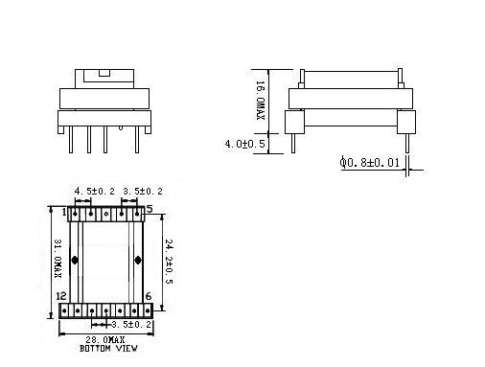
NOTS：1.GAP 放于PIN1---5侧,磁芯接缝须点胶.
2.成品PIN4 CUT OFF.产品侧面贴标签：ZST 5V/±12V-26V 3.3VAC
3.绕制时一定要用宽3.8mm厚0.2的挡墙,起头收头在顶部.套管要深入挡墙,起收头用固定胶带打直角出线.
4.W2线改为2UEW0.17线,密绕2层.
5.W3改为0.3*2P密绕一层,绕制时骨架反过来插入机台,直接挂PIN5开始绕线.W5,W6和W7,W8为同层串绕.W5,W7靠近PIN1—5
W6,W8靠近PIN6—12.
6.产品必须抽真空.

SPECIFICATION FOR APPROVAL |  | CUSTOMER:
LONGDING PART: | REV: | CUSTOMER PART NO.:
 | A
PART NAME: | SPEC | ISSUE DATE:
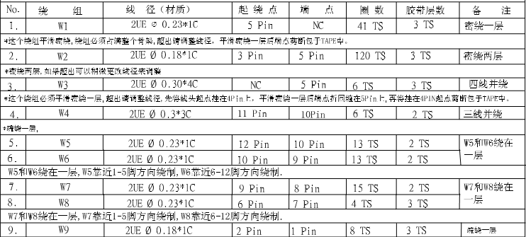
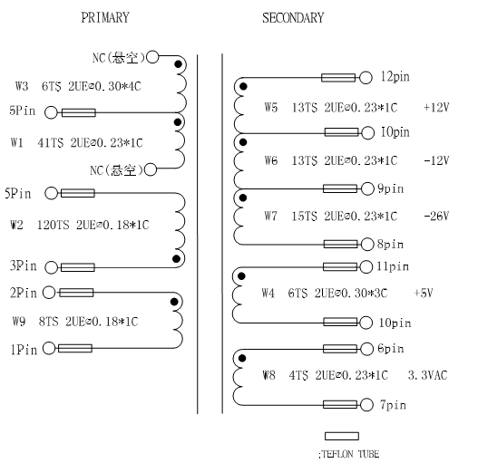

SPECIFICATION FOR APPROVAL |  | CUSTOMER:
LONGDING PART: | REV: | CUSTOMER PART NO.:
 | A
PART NAME: | SPEC | ISSUE DATE:
3.Electrical characteristics
ELECTRICAL CHARACTERISTICS
NO | ITEM | TEST TERMINAL | SPECIFICATION | TEST INSTRUMENT
1 | INDUCTANCE  @10KHz,1.0V | L(3---5) | 1.2mH±10% | CH1062 LCR METER
2 | PRIMARY  LEAKAGE  INDUCTANCE  @10KHz,1.0V | Lk(3---5)  PIN1—2 AND SEC SHORT | 250uHMAX | CH1062 LCR METE
3 | DCR | R(3—5) | 4.0ΩMAX | CH502B METER
3-1.HI-POT TEST:
ITEM | HI-POT . VOLTAGE
PRI TO SEC | AC 3.5KV/M 50/60Hz 5mA
PRI TO CORE | AC 1.5KV/M 50/60Hz 5mA
SEC TO CORE | AC 1.5KV/M 50/60Hz 5mA
3-2. INSULATION RESISTANCE:
THE INSULATION RESISTANCE BETWEEN COIL TO CORE AND COIL TO COIL
IS OVER 100MΩ AT DC500V.

SPECIFICATION FOR APPROVAL |  | CUSTOMER:
LONGDING PART: | REV: | CUSTOMER PART NO.:
 | A
PART NAME: | SPEC | ISSUE DATE:
4.Material list
NO | SUB PART | REW MATERIAL
NO | SUB PART | MATERIAL | SUPPLIER OF THE MATERIAL | TEMP | UL NO.
1 | BOBBIN | T375J94V-0(BLACK) | SHULIN CO.,LTD | 150℃ | E59481(S)
2 | CORE | FERRITE CORE EEL16 PC40 | KANGSHUN ELECTRIC CO.,LTD  XINLI ELECTRIC CO.,LTD | N/A | N/A
3 | WIRE | 2UEW | JU FENG ELECTRIC CO.,LTD | 130℃ | E206882
4 | TAPE | #11660,#06660 | YA HUA ADHESIVE TAPE CO.,LTD | 130℃ | E178516(N)
5 | EXPOX | E-500 | LIDUO ELECTRIC  CO.,LTD | N/A | N/A
6 | TUBE | T.F.L | GREAT HONGDING OR EQU | 200℃ | E158258(S)
7 | PIN | TINNED COPPER WIRE | OPTIONAL | N/A | N/A
8 | VARNISH | BC-346A  (HELLCAL COIL) | JOHNC DOLPH  CO.,LTD | 200℃ | E51047(M)

SPECIFICATION FOR APPROVAL |  | CUSTOMER:
LONGDING PART: | REV: | CUSTOMER PART NO.:
 | A
PART NAME: | SPEC | ISSUE DATE:
5.Reliability tests:
NO | TESTITEM | TEST CONDITION | SPECIFICATION
1 | HEAT RESISTANCE TEST | TEMP:85℃±2℃  TIME:96HRS(MIN) | *INDUCTANCE:WITHIN±5%OF INITIAL VAIUE  *THE ORTHER FUNCTIONS MUST  MEET THE SPEC
2 | COLD RESISTANCE  TEST | TEMP:25℃±2℃  TIME:96HRS(MIN) | *INDUCTANCE:WITHIN±5%OF INITIAL VAIUE  *THE ORTHER FUNCTIONS MUST  MEET THE SPEC
3 | HUMIDITY TEST | TEMP:40℃±2℃  TEMP:90-95%  TIME:500HRS(MIN) | *INDUCTANCE:WITHIN±5%OF INITIAL VAIUE  *THE ORTHER FUNCTIONS MUST  MEET THE SPEC
4 | HIGH TEMP LIFE | TEMP:85℃±2℃  TIME:500HRS(MIN) | *INDUCTANCE:WITHIN±5%OF INITIAL VAIUE  *THE ORTHER FUNCTIONS MUST  MEET THE SPEC
5 | THERMAL CYCLE TEST | STEP1: 25℃±2℃60±10MIN  STEP2:AMBIENT TEMP  STEP3: 80℃±2℃  STEP4:AMBIENT TEMP  STEP1-4,5 CYCLES | *INDUCTANCE:WITHIN±5%OF INITIAL VAIUE  *THE ORTHER FUNCTIONS MUST  MEET THE SPEC
6 | TERMINAL  STRENGTH | TENSILE:1.0KG  (MIN)TEMP:30±5SEC | *INDUCTANCE:WITHIN±5%OF INITIAL VAIUE  *THE ORTHER FUNCTIONS MUST  MEET THE SPEC
7 | SOLDER ABILITY | TEMP:235℃±5℃  TIME:3±0.5SEC | *SOLDER ATTACHMENT95% ABOVE
8 | SOLDERING HEAT RESISTANCE | TEMP:260℃±5℃  TIME:5±0.1SEC | *INDUCTANCE:WITHIN±5%OF INITIAL VAIUE  *THE ORTHER FUNCTIONS MUST  MEET THE SPEC

