

Http://
Address

Conduction Test Report

Project No.:
Standard: | EN55015 Conducted Test (QP) | Power Source: | AC 230V 50Hz
Test item: | Conduction Test | Date: | 2009-8-29
Temp./Hum.(%RH): | 26/60%RH | Time: | 6:28:26
EUT: |  | Test By:
Model:
Company:
Note:

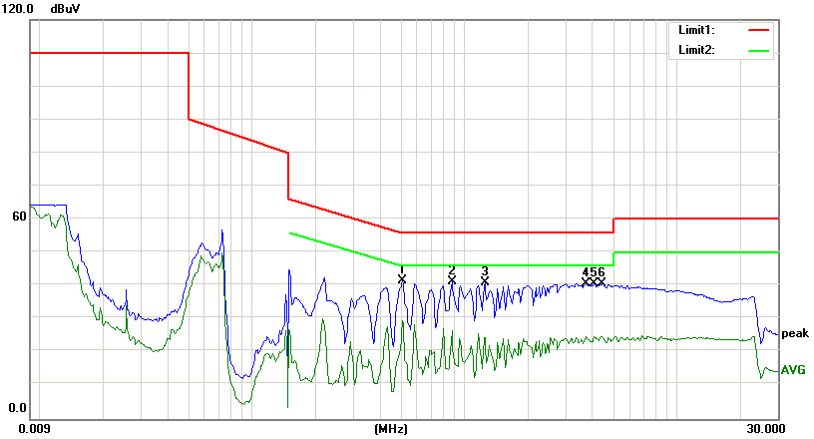

No. | Frequency | Reading | Correct | Result | Limit | Margin | Remark
 | (MHz) | (dBuV) | Factor(dB) | (dBuV) | (dBuV) | (dB)
1 | 0.5150 | 31.32 | 10.11 | 41.43 | 56.00 | -14.57 | peak
2 | 0.8750 | 31.24 | 10.11 | 41.35 | 56.00 | -14.65 | peak
3 | 1.2500 | 30.69 | 10.12 | 40.81 | 56.00 | -15.19 | peak
4 | 3.7450 | 30.52 | 10.17 | 40.69 | 56.00 | -15.31 | peak
5 | 4.1100 | 30.43 | 10.18 | 40.61 | 56.00 | -15.39 | peak
6 | 4.4800 | 30.47 | 10.19 | 40.66 | 56.00 | -15.34 | peak

