iP7302 18W LED Driver with iP7700 Test Report

T8 18W LED Driver Demo Board Base on
PFC Flyback Switch iP7302
Part Number: IS7302_7700_DP01 (19.2V0.8A)
Outline Dimension: L x W x H (225mm / 20mm / 12.5mm)

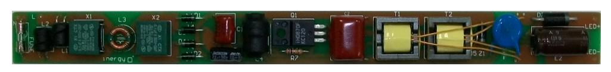

Photo1. Top View

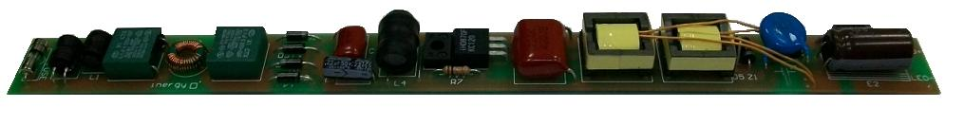

Photo2. Side View

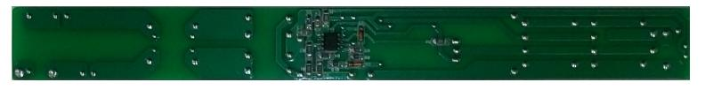

Photo3. Bottom View
Contents
1. Test Equipments ---------------------------------------------------------------------------------------------------------- 4
2. Demo Board Specification --------------------------------------------------------------------------------------------- 4
3. Demo Board Test Item List -------------------------------------------------------------------------------------------- 5
4. Electronic Characteristics Test Data ------------------------------------------------------------------------------- 7
4.1 Efficiency -----------------------------------------------------------------------------------------------------------------6
4.2 Ripple & Noise ----------------------------------------------------------------------------------------------------------7
4.3 Over Shoot -----------------------------------------------------------------------------------------------------------10
4.4 Time Sequence Characteristic ----------------------------------------------------------------------------------12
4.5 Voltage stress on MOSFET----------------------------------------------------------------------------------------15
4.6 Current Limit ---------------------------------------------------------------------------------------------------------17
5. Schematic -------------------------------------------------------------------------------------------------------------------18
6. BOM List ---------------------------------------------------------------------------------------------------------------------19
7. PCB Layout -----------------------------------------------------------------------------------------------------------------21
7.1 Top silkscreen --------------------------------------------------------------------------------------------------------21
7.2 Bottom Silkscreen ---------------------------------------------------------------------------------------------------21
7.3 Bottom layer -----------------------------------------------------------------------------------------------------------21
8. Transformer-----------------------------------------------------------------------------------------------------------------22
8.1 Schematic & Winding -----------------------------------------------------------------------------------------------22
9. EMI Test ----------------------------------------------------------------------------------------------------------------------23
9.1 Conduction (EN55015 Class B) ---------------------------------------------------------------------------------23
10. Revision History ---------------------------------------------------------------------------------------------------------31

Figure List
Figure 1 The waveform of Ripple & Noise at Vin = 90Vac/60Hz & full-load --------------------------------8
Figure 2 The waveform of Ripple & Noise at Vin = 110Vac/60Hz & full-load ------------------------------8
Figure 3 The waveform of Ripple & Noise at Vin = 220Vac/50Hz & full-load -----------------------------9
Figure 4 The waveform of Ripple & Noise at Vin = 264Vac/50Hz & full-load -----------------------------9
Figure 5 The waveform of Over shoot at Vin = 90Vac/60Hz & full-load ------------------------------------10
Figure 6 The waveform of Over shoot at Vin = 110Vac/60Hz & full-load -----------------------------------11
Figure 7 The waveform of Over shoot at Vin = 220Vac/50Hz & full-load ------------------------------------11
Figure 8 The waveform of Over shoot at Vin = 264Vac/50Hz & full-load -----------------------------------12
Figure 9 The waveform of Turn on Time at Vin = 90Vac/60Hz & full-load -------------------------------- 13
Figure 10 The waveform of Turn on Time at Vin = 110Vac/60Hz & full-load -----------------------------13 Figure 11 The waveform of Turn on Time at Vin = 220Vac/50Hz & full-load -------------------------------- 14
Figure 12 The waveform of Turn on Time at Vin = 264Vac/50Hz & full-load -----------------------------14
Figure 13 The waveform of Drain at Vin = 264Vac/50Hz & full-load -----------------------------------------15
Figure 14 The waveform of Drain at Vin = 264Vac/50Hz & full-load startup-------------------------------- 16
Figure 15 The waveform of rectifier at Vin = 264Vac/50Hz & full-load -------------------------------------16
Figure 16 The waveform of rectifier at Vin = 264Vac/50Hz & full-load startup------------------------------17
Figure 17 The waveform of Conduction-L at Vin = 110Vac/60Hz & full-load ---------------------------- 23
Figure 18 The waveform of Conduction-L at Vin = 110Vac/60Hz & full-load ---------------------------- 25
Figure 19 The waveform of Conduction-L at Vin = 230Vac/50Hz & full-load ---------------------------- 27
Figure 20 The waveform of Conduction-L at Vin = 230Vac/50Hz & full-load ---------------------------- 29

1. Test Equipments
Name | Mark
AC Source | Extech 6905
Oscilloscope | Tektronix DPO3014
Power Meter | Voltech PM100
Load | 18W LED
True RMS Multi-meter | Fluke 287
Differential Probe | LDP-6002

2. Demo Board Specification
Parameter | Specification
Input Voltage | 90Vac~264Vac
Input Frequency | 47Hz~63Hz
Output Voltage and Current | 19.2V/0.8A
Output Power | 16W (max.)
Efficiency | > 80% Full Load
Conduction | EN55015 Class B

3. Demo Board Test Item List
All test conditions is base on ambient temperature 25℃;
Test item | Specification | Result
Efficiency | >80% Full Load | Pass
Ripple & Noise | --- | ---
Overshoot | --- | ---
Turn on time | <3S | Pass
Voltage stress on MOSFET | ≤700V | Pass
Constant Current | 0.8A (±3%) | Pass
Short Circuit Protection | --- | ---
EMI Test - Conduction | EN55015 Class B | Pass

4. Electronic Characteristics Test Items List
All test conditions is base on ambient temperature 25℃;
4.1 Efficiency
Test Condition:
We chose input voltage value, including 90V, 100V, 110V, 220V, 230V, 264Vand 100% Load Current, Then Calculate the efficiency.
 | 90Vac | 100Vac | 110Vac
Vout (V) | 19.23 | 19.22 | 19.22
Iout (mA) | 802.1 | 802.4 | 803
Pin (W) | 18.68 | 18.51 | 18.4
Pout (W) | 15.424 | 15.422 | 15.434
PF | 0.998 | 0.998 | 0.998
η (%) | 82.57 | 83.32 | 83.88
THD (%) | 6.9 | 4.2 | 5

 | 220Vac | 230Vac | 264Vac
Vout (V) | 19.23 | 19.21 | 19.23
Iout (mA) | 809.4 | 804.2 | 812.6
Pin (W) | 18.904 | 18.83 | 19.42
Pout (W) | 15.565 | 15.449 | 15.63
PF | 0.956 | 0.95 | 0.914
η (%) | 82.34 | 82.04 | 80.46
THD (%) | 7.7 | 7.8 | 8.8

4.2 Ripple & Noise
Test Condition:
The ripple & noise are measured by using 20MHz bandwidth Limited oscilloscope with a 10uF low impedance electronic capacitor and a 0.1uF Ceramic capacitor.
Test data and results are as follows:

Vin | V(p-p)Full Load | Spec | Result | Note
90V/60Hz | 4.6 V | -- | -- | Figure 1
110V/60Hz | 4.6 V | -- | -- | Figure 2
220V/50Hz | 5.0 V | -- | -- | Figure 3
264V/50Hz | 5.2 V | -- | -- | Figure 4

Full Load: 19.2V/0.8A

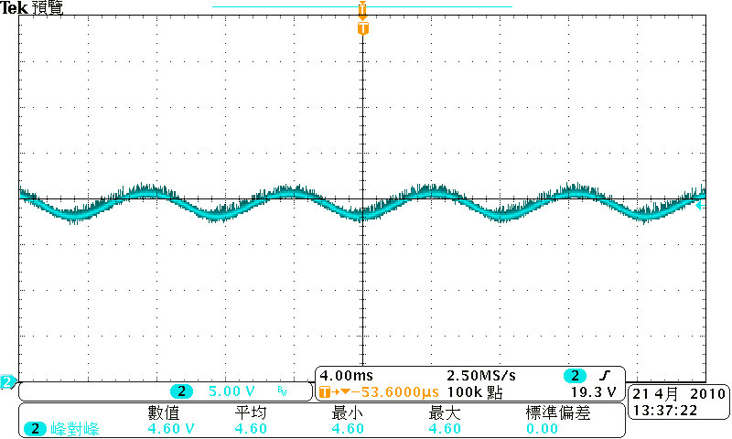

Figure 1 The waveform of Ripple & Noise at Vin = 90Vac/60Hz & full-load

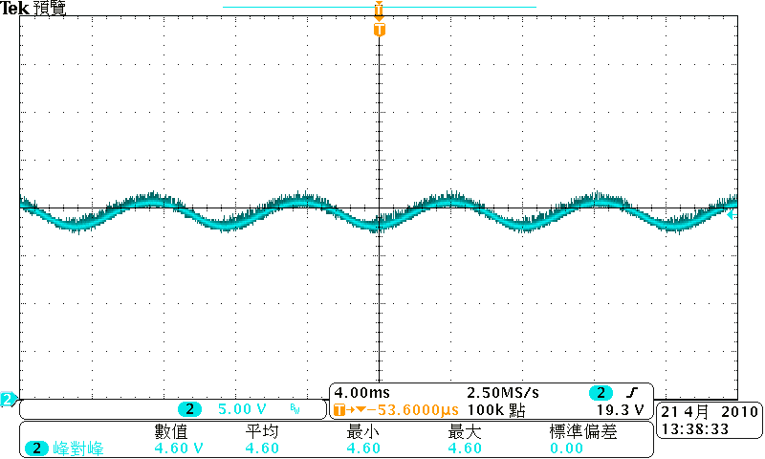

Figure 2 The waveform of Ripple & Noise at Vin = 110Vac/60Hz & full-load

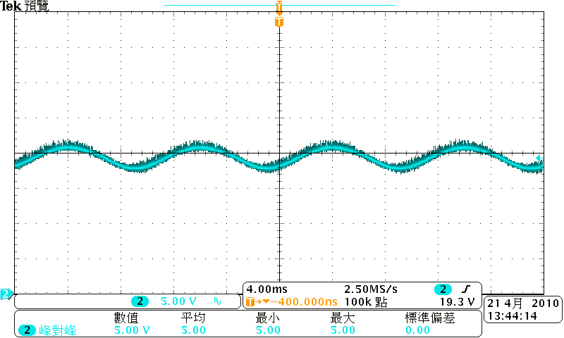

Figure 3 The waveform of Ripple & Noise at Vin = 220Vac/50Hz & full-load

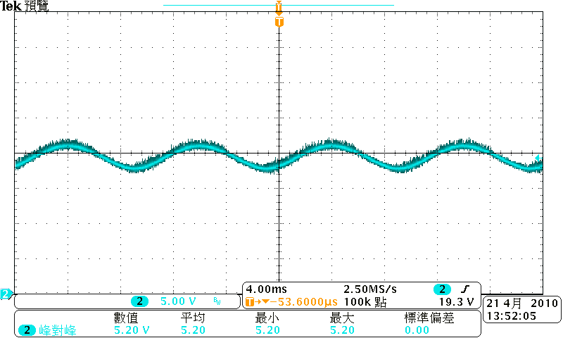

Figure 4 The waveform of Ripple & Noise at Vin = 264Vac/50Hz & full-load
4.3 Over Shoot
Test Condition:
Over Shoot value test point are all at PCB end
Test data and results are as follows:

Vin | Load | Test Item | Spec(%) | Test Data | Result | Note
90V/60Hz | Full Load | Over Shoot | -- | 13% | -- | Figure5
110V/60Hz | Full Load | Over Shoot | -- | 17% | -- | Figure6
220V/50Hz | Full Load | Over Shoot | -- | 33% | -- | Figure7
264V/50Hz | Full Load | Over Shoot | -- | 37% | -- | Figure8

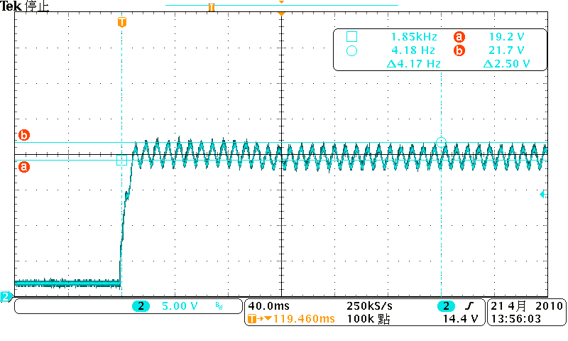

Figure 5 The waveform of Over shoot at Vin = 90Vac/60Hz & Full load

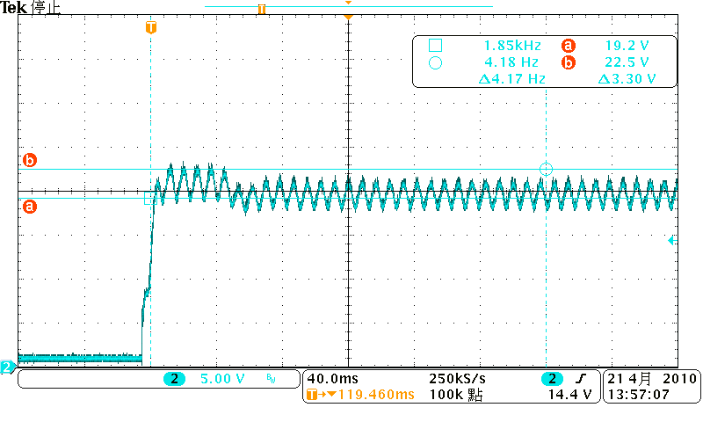

Figure 6 The waveform of Over Shoot at Vin = 110Vac/60Hz & Full load

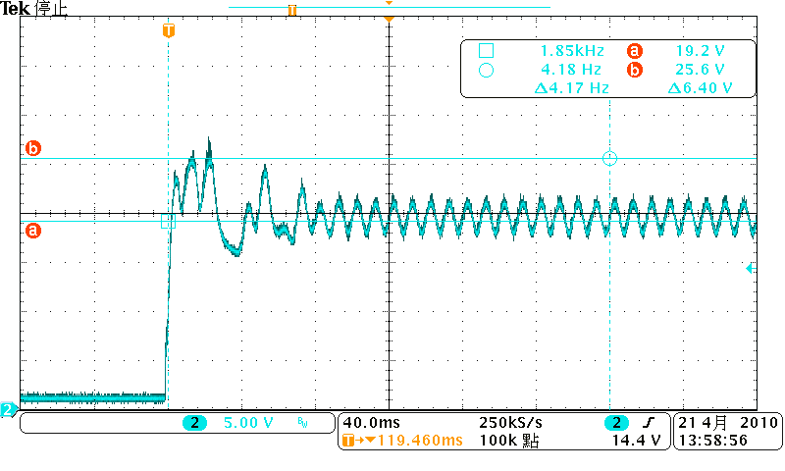

Figure 7 The waveform of Over Shoot at Vin = 220Vac/50Hz & Full load

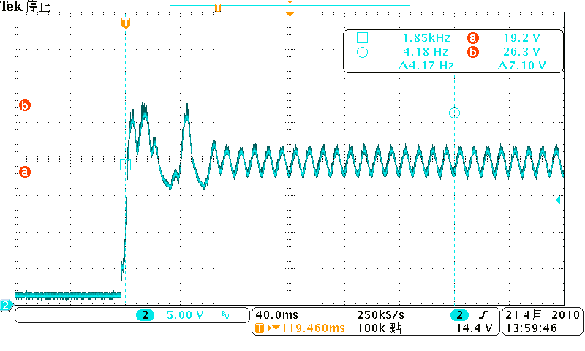

Figure 8 The waveform of Over Shoot at Vin = 264Vac/50Hz & Full load

4.4 Time Sequence Characteristic
Test Condition:
Turn on delay time , Hold up time, Rising time and Falling time are all base on full load.
Test data and results are as follows:
Item | Vin(ac) | Test Data | Spec | Result | Note
Turn on delay time | 90V/60Hz | 2.05S | <3S | Pass | Figure 9
Turn on delay time | 110V/60Hz | 1.81S | <3S | Pass | Figure 10
Turn on delay time | 220V/50Hz | 779mS | <3S | Pass | Figure 11
Turn on delay time | 264V/50Hz | 635mS | <3S | Pass | Figure 12

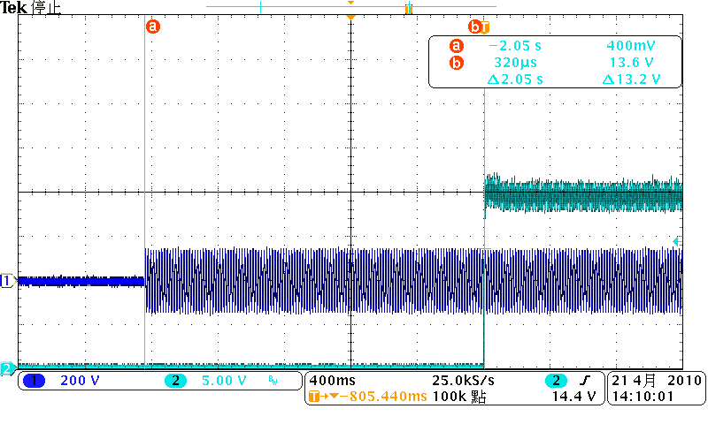

Figure 9 The waveform of Turn on Time at Vin = 90Vac/60Hz & full-load

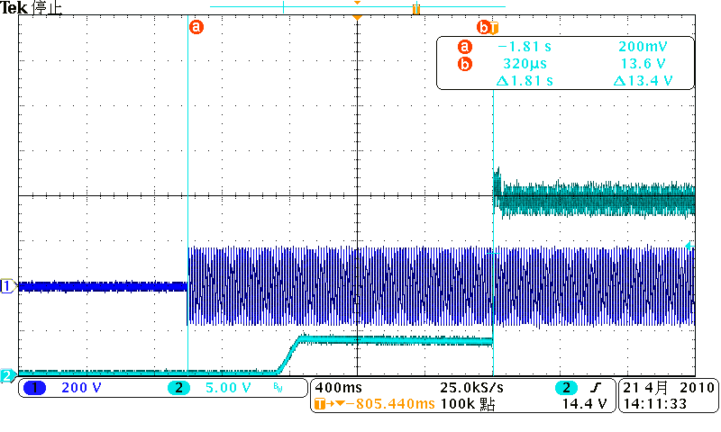

Figure 10 The waveform of Turn on Time at Vin = 110Vac/60Hz & full-load

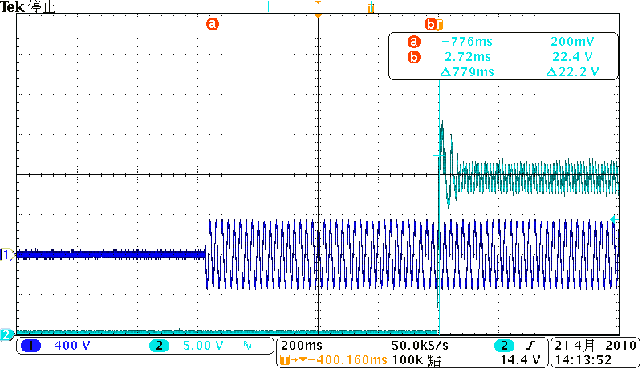

Figure 11 The waveform of Turn on Time at Vin = 220Vac/50Hz & full-load

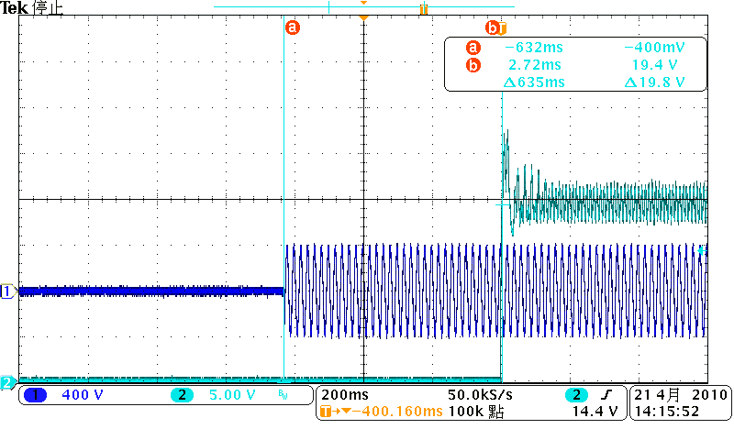

Figure 12 The waveform of Turn on Time at Vin = 264Vac/50Hz & full-load

4.5 Voltage stress on MOSFET
Test Condition:
Measure the voltage on MOSFET and secondary rectifiers on full load.

Vin(V) | State | Stress on  MOSFET | Note | Rating | Stress on  rectifier | Note | Rating
264 | Normal | 604V | Figure13 | 700V | 75.2V | Figure15 | 100V
264 | Startup | 680V | Figure14 | 700V | 79.2V | Figure16 | 100V

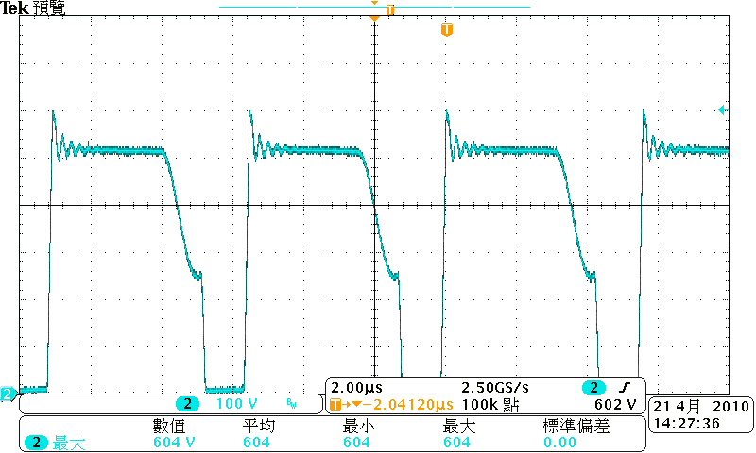

Figure 13 The waveform of Drain at Vin = 264Vac/50Hz & full-load

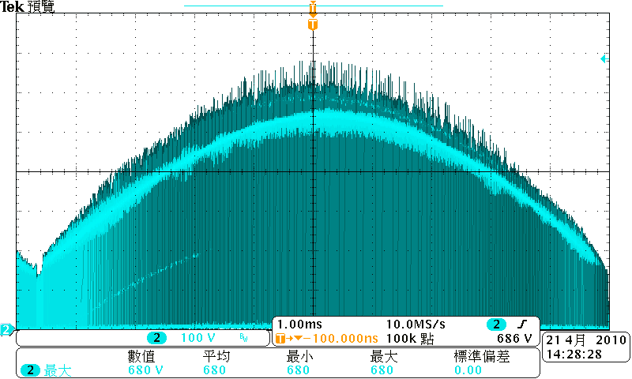

Figure 14 The waveform of Drain at Vin = 264Vac/50Hz & full-load Startup

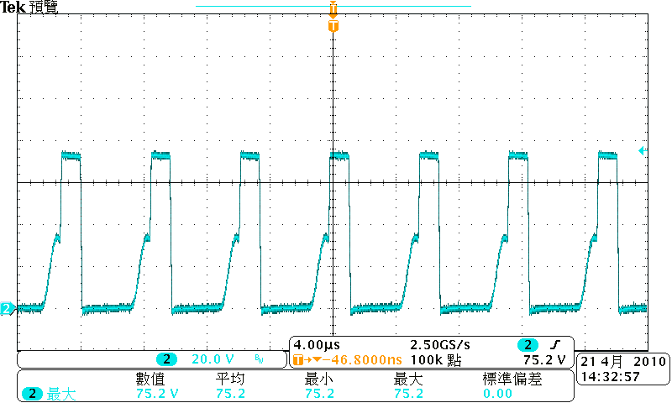

Figure 15 The waveform of rectifier at Vin = 264Vac/50Hz & full-load

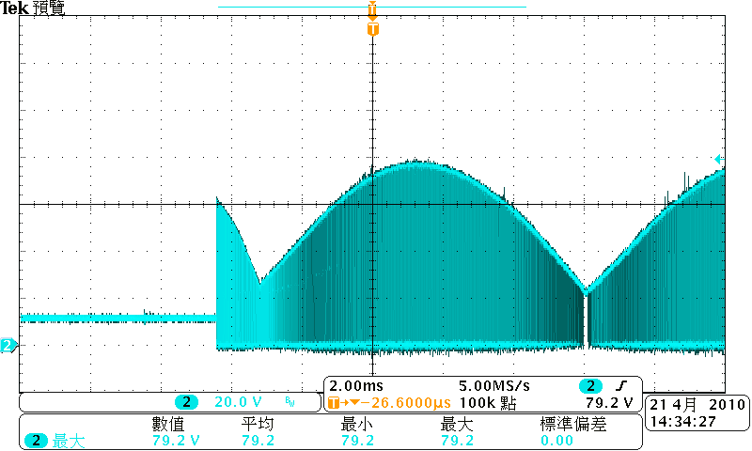

Figure 16 The waveform of rectifier at Vin = 264Vac/50Hz & full-load Startup

4.6 Constant Current
Input Voltage | Current Limit Value(A) | Result
90V /60Hz | 0.802 | PASS
100V /60Hz | 0.802 | PASS
110V /60Hz | 0.803 | PASS
220V /50Hz | 0.809 | PASS
230V /50Hz | 0.804 | PASS
264V /50Hz | 0.813 | PASS

5. Schematic

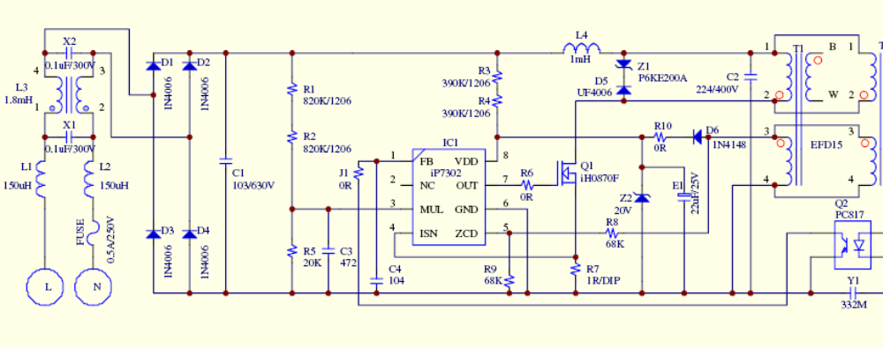

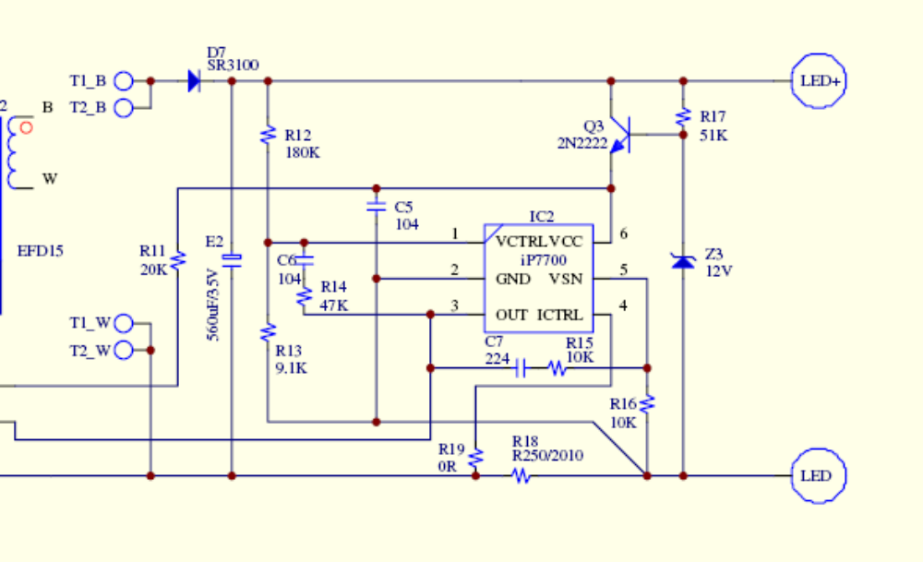

6. BOM List

序號 | 品 名 | 規 格 | 數量 | 製程 | 打件位置
10 | 晶片電阻 | RES SMD 1/4W 820K F 1206 | 2 | SMD | R1,R2
20 | 晶片電阻 | RES SMD 1/4W 390K F 1206 | 2 | SMD | R3,R4
30 | 晶片電阻 | RES SMD 1/4W 0R F 1206 | 2 | SMD | R6,J1
40 | 晶片電阻 | RES SMD 1/8W 20K F 0805 | 2 | SMD | R5,R11
50 | 晶片電阻 | RES SMD 1/8W 68K F 0805 | 2 | SMD | R8,R9
60 | 晶片電阻 | RES SMD 1/8W 0R F 0805 | 2 | SMD | R10,R19
70 | 晶片電阻 | RES SMD 1/8W 180K F 0805 | 1 | SMD | R12
80 | 晶片電阻 | RES SMD 1/8W 9.1K F 0805 | 1 | SMD | R13
90 | 晶片電阻 | RES SMD 1/8W 47K F 0805 | 1 | SMD | R14
100 | 晶片電阻 | RES SMD 1/8W 10K F 0805 | 2 | SMD | R15,R16
110 | 晶片電阻 | RES SMD 1/8W 51K F 0805 | 1 | SMD | R17
120 | 晶片電阻 | RES SMD 1/2W 0R25 F 2010 | 1 | SMD | R18
130 | 晶片電容 | CAP SMD NPO 472 25V 0805 | 1 | SMD | C3
140 | 晶片電容 | CAP SMD NPO 104 25V 0805 | 3 | SMD | C4,C5,C6
150 | 晶片電容 | CAP SMD NPO 224 25V 0805 | 1 | SMD | C7
160 | PWM IC | iP7302 SO8 | 1 | SMD | IC1
170 | REFERENCE IC | iP7700 SOT-23-6L | 1 | SMD | IC2
180 | BIPOLAR | 2N2222 | 1 | SMD | Q3
190 | 二極體 | 1N4148 75V/200mA | 1 | SMD | D6
200 | 二極體 | 20V ZENER | 1 | SMD | Z2
210 | 二極體 | 12V ZENER | 1 | SMD | Z3
220 | 二極體 | 800V/1A 1N4006 GENERAL | 4 | DIP | D1,D2,D3,D4
230 | 二極體 | 600V/1A UF4006 ULTRAFAST | 1 | DIP | D5
240 | 二極體 | 100V/3A SR3100 SCHOTTKY | 1 | DIP | D7
250 | 二極體 | P6KE200A TVS | 1 | DIP | Z1
260 | POWER MOS | iH0870F TO-220 | 1 | DIP | Q1
270 | 電阻 | RES DIP 1/4W 1R0 F | 1 | DIP | R7
280 | X-CAP | 0.1uF/300VAC | 2 | DIP | X1,X2
290 | Y-CAP | 332M | 1 | DIP | Y1
300 | 金屬皮膜電容 | 103/630V | 1 | DIP | C1
310 | 金屬皮膜電容 | 224/400V | 1 | DIP | C2
320 | 鋁質電解電容 | 22uF/25V LONG LIFE | 1 | DIP | E1
330 | 鋁質電解電容 | 560uF/35V LONG LIFE | 1 | DIP | E2
340 | 光耦合器 | PC817 DIP4 | 1 | DIP | Q2
350 | 電感 | 150uH | 2 | DIP | L1,L2
360 | 電感 | 1mH | 1 | DIP | L4
370 | 共模電感 | 1.8mH | 1 | DIP | L3
380 | 變壓器 | EFD15 | 2 | DIP | T1,T2
390 | 保險絲 | 250VAC 500mA | 1 | DIP | FUSE

7. PCB Layout
7.1 Top Silkscreen

7.2 Bottom Silkscreen

7.3 Bottom Layer

8. Transformer
8.1 Schematic & Winding
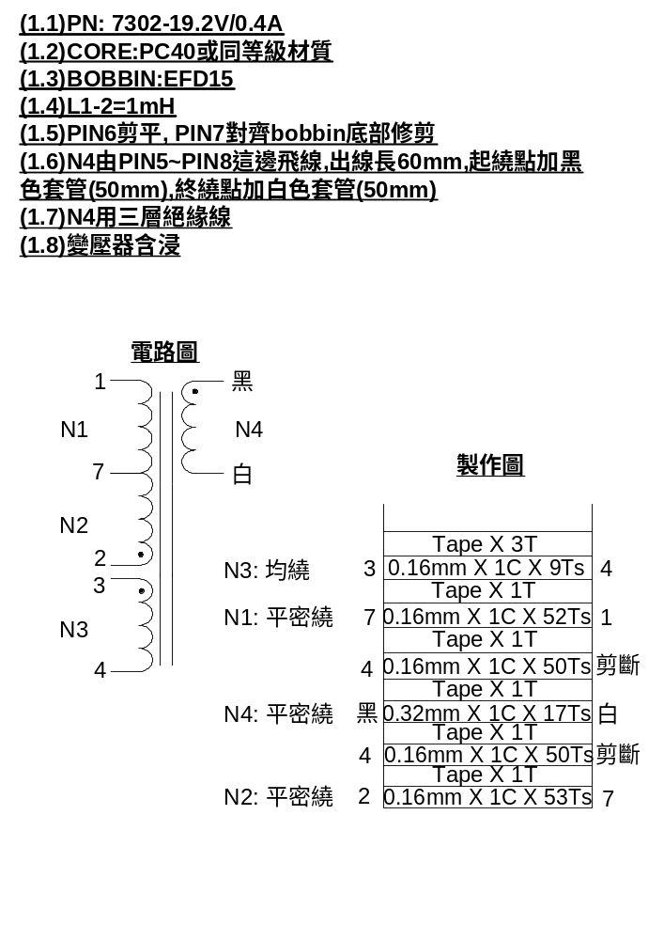

9. EMI Test
9.1 Conduction (EN55015 Class B)

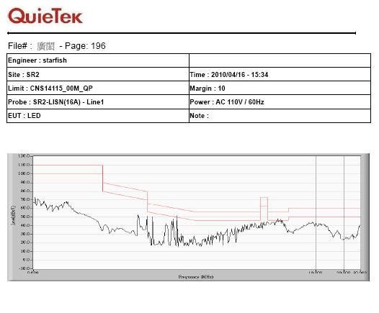

Figure 17 The waveform of Conduction – L at Vin =110Vac/60Hz & full-load

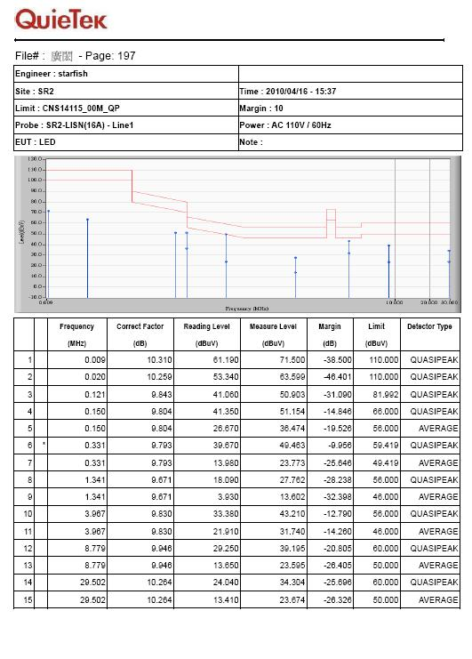

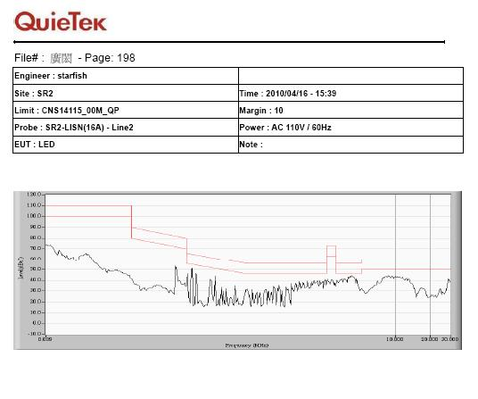

Figure 18 The waveform of Conduction – N at Vin =110Vac/60Hz & full-load

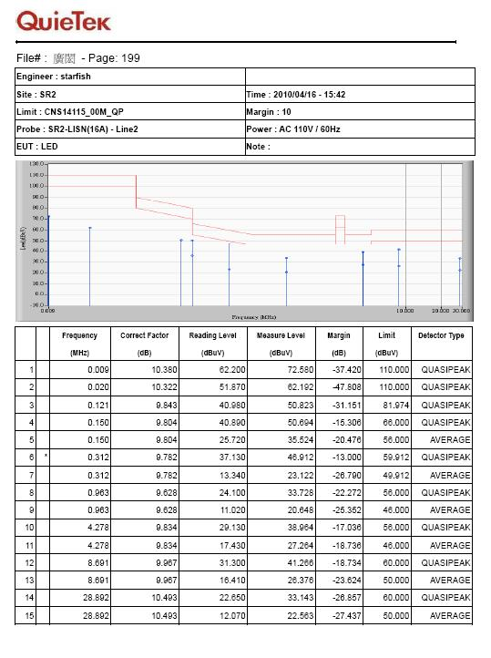

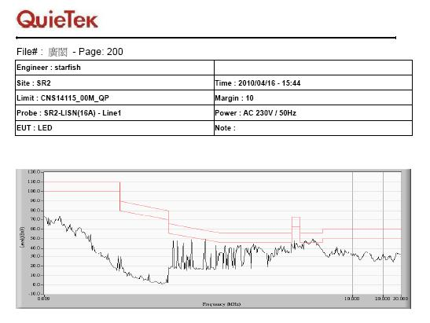

Figure 19 The waveform of Conduction – L at Vin =230Vac/50Hz & full-load

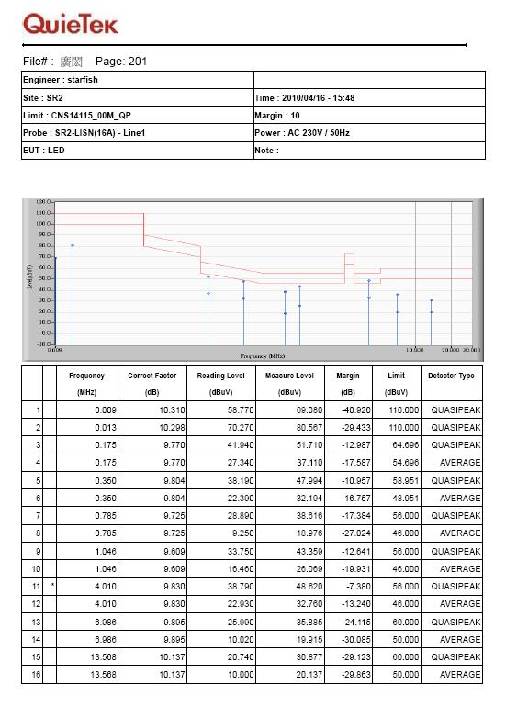

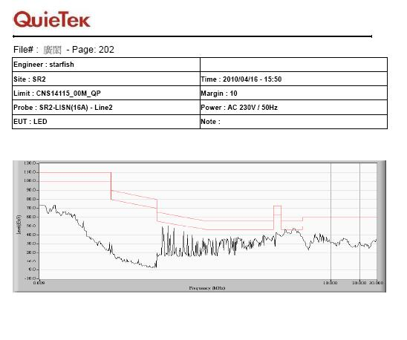

Figure 20 The waveform of Conduction – N at Vin =230Vac/50Hz & full-load

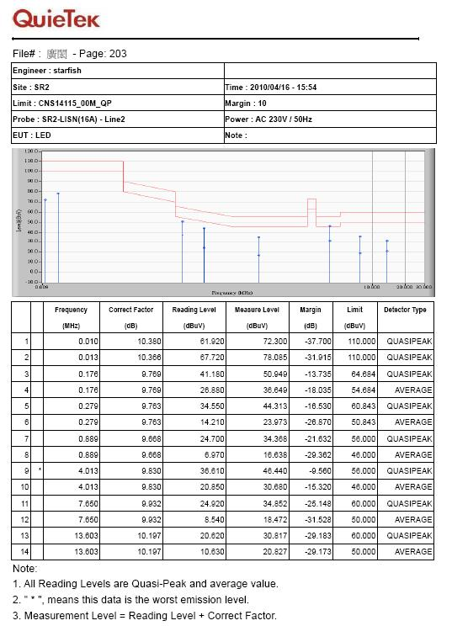

10. Revision History
Ver. | Date | Change Notice
1.0 | 2010/04/21 | Original
1.1 | 2010/05/18 | C7 change to 224

