iP7302 7W LED Driver with iP7701 Test Report

7W LED Driver Demo Board Base on
PFC Flyback Switch iP7302
Part Number: IS7302_7701_DB02 (18V~21V/0.3A)
Outline Dimension: L x W x H (48.8mm / 31.0mm / 20.0mm)

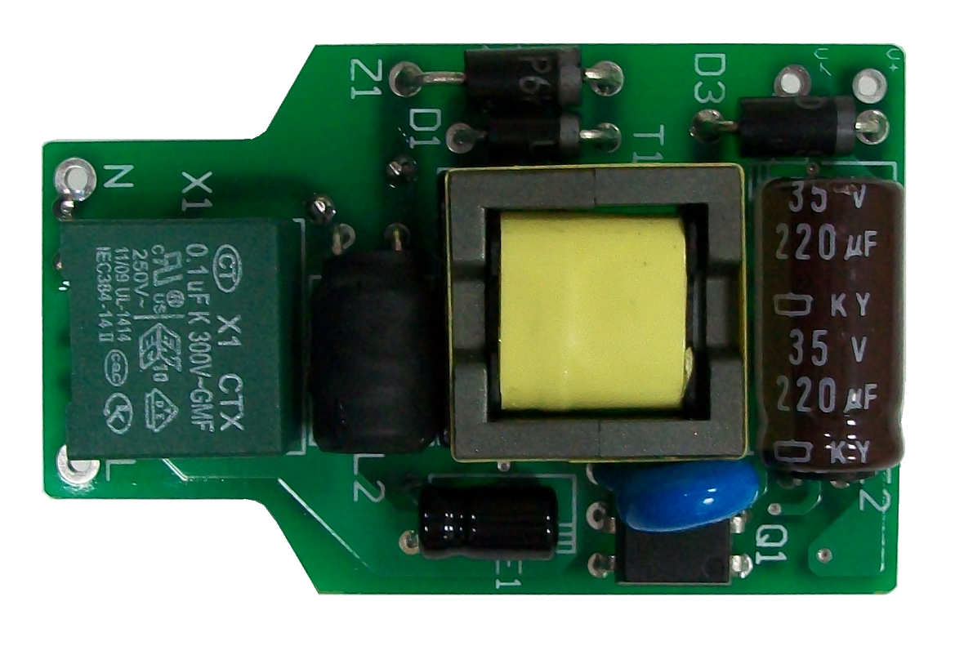

Photo1. Top View
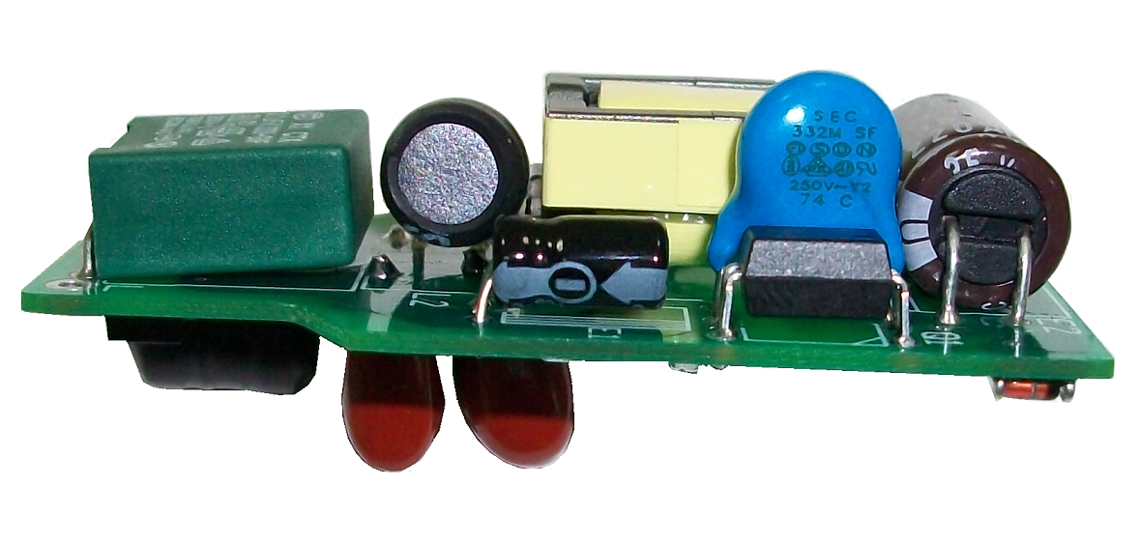

Photo2. Side View
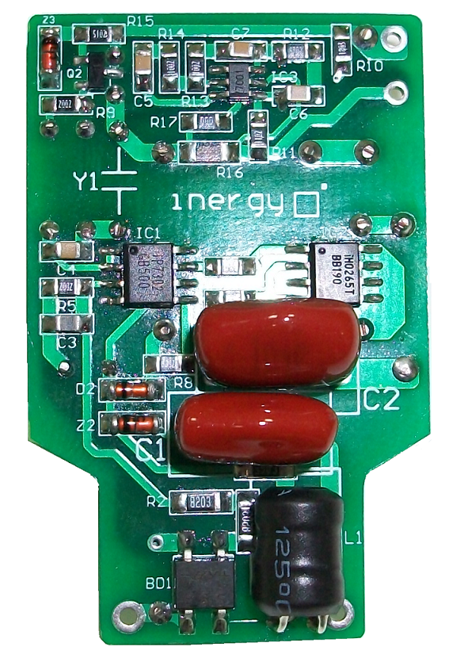

Photo3. Bottom View
Contents
1. Test Equipments ---------------------------------------------------------------------------------------------------------- 4
2. Demo Board Specification --------------------------------------------------------------------------------------------- 4
3. Demo Board Test Item List -------------------------------------------------------------------------------------------- 5
4. Electronic Characteristics Test Data ------------------------------------------------------------------------------- 6
4.1 Efficiency -----------------------------------------------------------------------------------------------------------------6
4.2 Ripple & Noise ----------------------------------------------------------------------------------------------------------7
4.3 Over Shoot -----------------------------------------------------------------------------------------------------------10
4.4 Time Sequence Characteristic ----------------------------------------------------------------------------------12
4.5 Voltage stress on MOSFET----------------------------------------------------------------------------------------15
4.6 Current Limit ---------------------------------------------------------------------------------------------------------17
5. Schematic -------------------------------------------------------------------------------------------------------------------18
6. BOM List ---------------------------------------------------------------------------------------------------------------------19
7. PCB Layout -----------------------------------------------------------------------------------------------------------------20
7.1 Top silkscreen --------------------------------------------------------------------------------------------------------20
7.2 Bottom Silkscreen ---------------------------------------------------------------------------------------------------20
7.3 Bottom layer -----------------------------------------------------------------------------------------------------------20
8. Transformer-----------------------------------------------------------------------------------------------------------------21
8.1 Schematic & Winding -----------------------------------------------------------------------------------------------21
9. EMI Test ----------------------------------------------------------------------------------------------------------------------22
9.1 Conduction (EN55015 Class B) ---------------------------------------------------------------------------------22
10. Revision History ---------------------------------------------------------------------------------------------------------30

Figure List
Figure 1 The waveform of Ripple & Noise at Vin = 90Vac/60Hz & full-load --------------------------------8
Figure 2 The waveform of Ripple & Noise at Vin = 110Vac/60Hz & full-load ------------------------------8
Figure 3 The waveform of Ripple & Noise at Vin = 220Vac/50Hz & full-load -----------------------------9
Figure 4 The waveform of Ripple & Noise at Vin = 264Vac/50Hz & full-load -----------------------------9
Figure 5 The waveform of Over shoot at Vin = 90Vac/60Hz & full-load ------------------------------------10
Figure 6 The waveform of Over shoot at Vin = 110Vac/60Hz & full-load -----------------------------------11
Figure 7 The waveform of Over shoot at Vin = 220Vac/50Hz & full-load ------------------------------------11
Figure 8 The waveform of Over shoot at Vin = 264Vac/50Hz & full-load -----------------------------------12
Figure 9 The waveform of Turn on Time at Vin = 90Vac/60Hz & full-load -------------------------------- 13
Figure 10 The waveform of Turn on Time at Vin = 110Vac/60Hz & full-load -----------------------------13 Figure 11 The waveform of Turn on Time at Vin = 220Vac/50Hz & full-load -------------------------------- 14
Figure 12 The waveform of Turn on Time at Vin = 264Vac/50Hz & full-load -----------------------------14
Figure 13 The waveform of Drain at Vin = 264Vac/50Hz & full-load -----------------------------------------15
Figure 14 The waveform of Drain at Vin = 264Vac/50Hz & full-load startup-------------------------------- 16
Figure 15 The waveform of rectifier at Vin = 264Vac/50Hz & full-load -------------------------------------16
Figure 16 The waveform of rectifier at Vin = 264Vac/50Hz & full-load startup------------------------------17
Figure 17 The waveform of Conduction-L at Vin = 110Vac/60Hz & full-load ---------------------------- 22
Figure 18 The waveform of Conduction-L at Vin = 110Vac/60Hz & full-load ---------------------------- 24
Figure 19 The waveform of Conduction-L at Vin = 110Vac/60Hz & full-load ---------------------------- 26
Figure 20 The waveform of Conduction-L at Vin = 110Vac/60Hz & full-load ---------------------------- 28

1. Test Equipments
Name | Mark
AC Source | Extech 6905
Oscilloscope | Tektronix DPO3014
Power Meter | Voltech PM100
Load | 7W LED
True RMS Multi-meter | Fluke 287
Differential Probe | LDP-6002

2. Demo Board Specification
Parameter | Specification
Input Voltage | 90Vac~264Vac
Input Frequency | 47Hz~63Hz
Output Voltage and Current | 20V/0.3A
Output Power | 6.3W (max.)
Efficiency | > 80% Full Load
Conduction | EN55015 Class B

3. Demo Board Test Item List
All test conditions is base on ambient temperature 25℃;
Test item | Specification | Result
Efficiency | >80% Full Load | Pass
Ripple & Noise | --- | ---
Overshoot | --- | ---
Turn on time | <2S | Pass
Voltage stress on MOSFET | ≤650V | Pass
Constant Current | 0.3A (±3%) | Pass
Short Circuit Protection | Recovery | Pass
EMI Test - Conduction | EN55015 Class B | Pass

4. Electronic Characteristics Test Items List
All test conditions is base on ambient temperature 25℃;
4.1 Efficiency
Test Condition:
We chose input voltage value, including 90V, 100V, 110V, 220V, 230V, 264Vand 100% Load Current, Then Calculate the efficiency.
 | 90Vac | 100Vac | 110Vac
Vout (V) | 19.91 | 19.9 | 19.91
Iout (mA) | 297.8 | 298 | 297.9
Pin (W) | 6.97 | 6.94 | 6.92
Pout (W) | 5.93 | 5.93 | 5.93
PF | 0.984 | 0.988 | 0.989
η (%) | 85.07 | 85.45 | 85.7

 | 220Vac | 230Vac | 264Vac
Vout (V) | 19.9 | 19.9 | 19.9
Iout (mA) | 298.3 | 298.2 | 298.3
Pin (W) | 7.08 | 7.11 | 7.23
Pout (W) | 5.94 | 5.93 | 5.94
PF | 0.966 | 0.958 | 0.916
η (%) | 83.84 | 83.46 | 82.1

4.2 Ripple & Noise
Test Condition:
The ripple & noise are measured by using 20MHz bandwidth Limited oscilloscope with a 10uF low impedance electronic capacitor and a 0.1uF Ceramic capacitor.
Test data and results are as follows:

Vin | V(p-p)Full Load | Spec | Result | Note
90V/60Hz | 4.6 V | -- | -- | Figure 1
110V/60Hz | 4.6 V | -- | -- | Figure 2
220V/50Hz | 5.0 V | -- | -- | Figure 3
264V/50Hz | 4.8 V | -- | -- | Figure 4

Full Load: 20V/0.3A

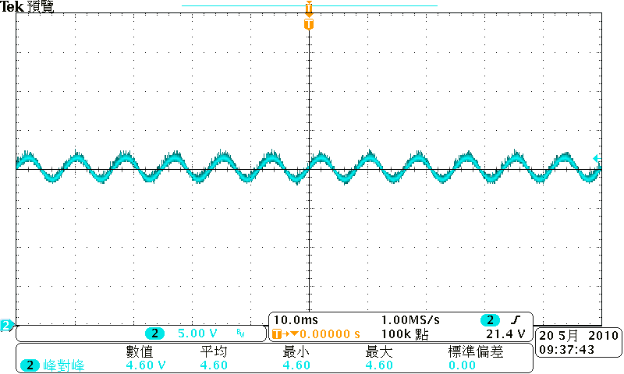

Figure 1 The waveform of Ripple & Noise at Vin = 90Vac/60Hz & full-load

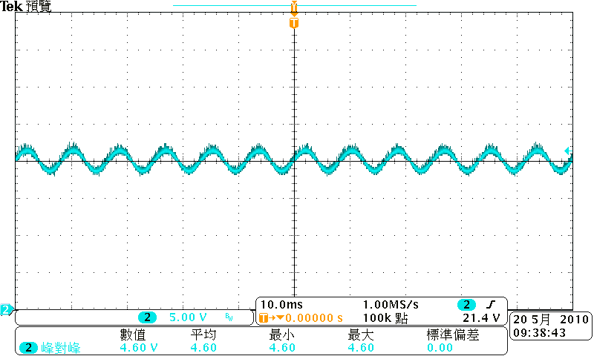

Figure 2 The waveform of Ripple & Noise at Vin = 110Vac/60Hz & full-load

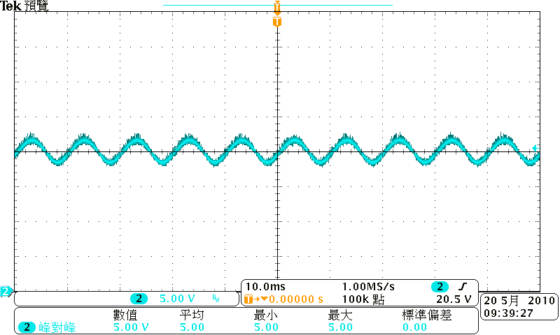

Figure 3 The waveform of Ripple & Noise at Vin = 220Vac/50Hz & full-load

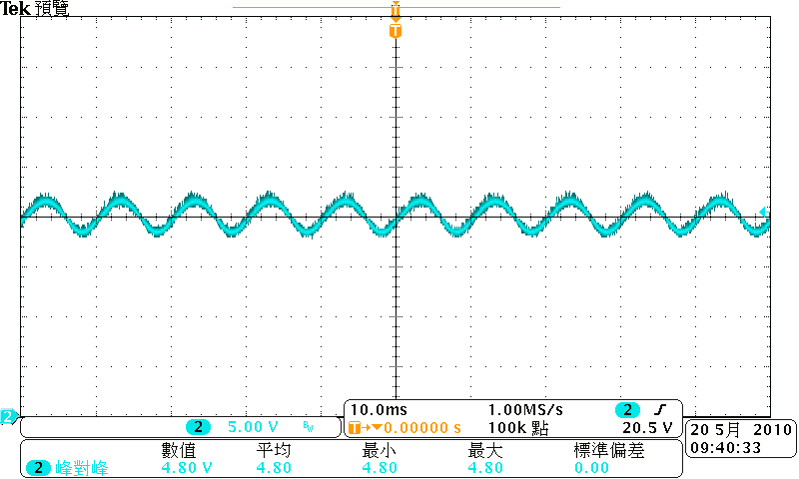

Figure 4 The waveform of Ripple & Noise at Vin = 264Vac/50Hz & full-load
4.3 Over Shoot
Test Condition:
Over Shoot value test point are all at PCB end
Test data and results are as follows:

Vin | Load | Test Item | Spec(%) | Test Data | Result | Note
90V/60Hz | Full Load | Over Shoot | -- | 15% | -- | Figure5
110V/60Hz | Full Load | Over Shoot | -- | 20% | -- | Figure6
220V/50Hz | Full Load | Over Shoot | -- | 36% | -- | Figure7
264V/50Hz | Full Load | Over Shoot | -- | 42% | -- | Figure8

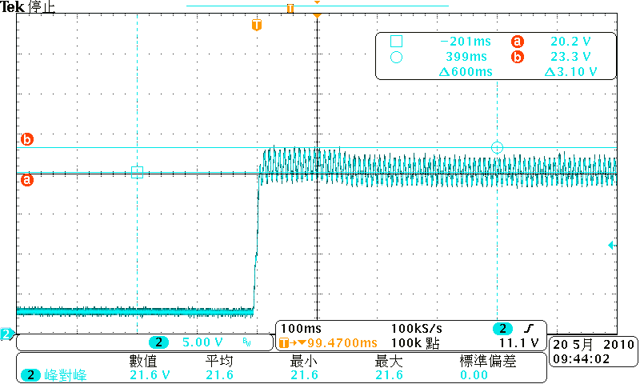

Figure 5 The waveform of Over shoot at Vin = 90Vac/60Hz & Full load

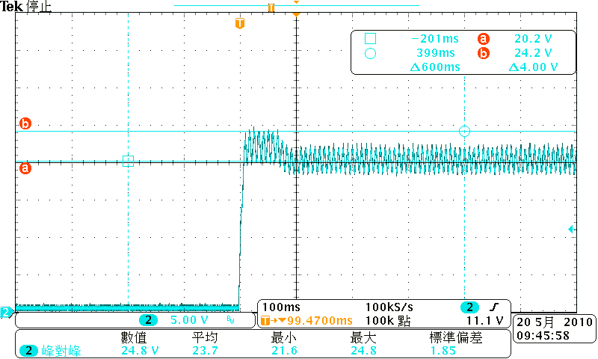

Figure 6 The waveform of Over Shoot at Vin = 110Vac/60Hz & Full load

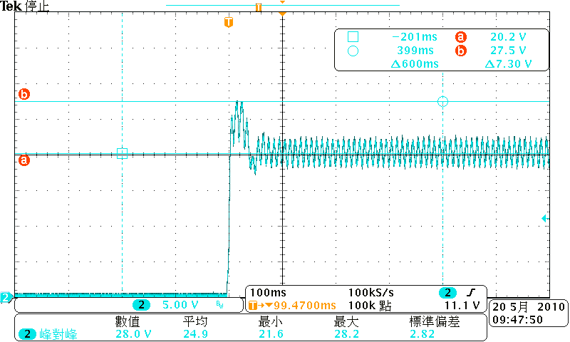

Figure 7 The waveform of Over Shoot at Vin = 220Vac/50Hz & Full load

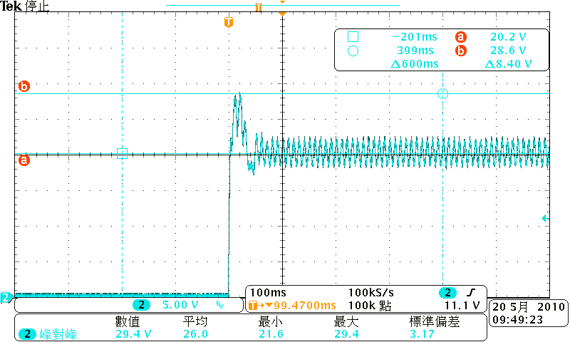

Figure 8 The waveform of Over Shoot at Vin = 264Vac/50Hz & Full load

4.4 Time Sequence Characteristic
Test Condition:
Turn on delay time , Hold up time, Rising time and Falling time are all base on full load.
Test data and results are as follows:
Item | Vin(ac) | Test Data | Spec | Result | Note
Turn on delay time | 90V/60Hz | 1.77S | <2S | Pass | Figure 9
Turn on delay time | 110V/60Hz | 1.43S | <2S | Pass | Figure 10
Turn on delay time | 220V/50Hz | 685mS | <2S | Pass | Figure 11
Turn on delay time | 264V/50Hz | 568mS | <2S | Pass | Figure 12

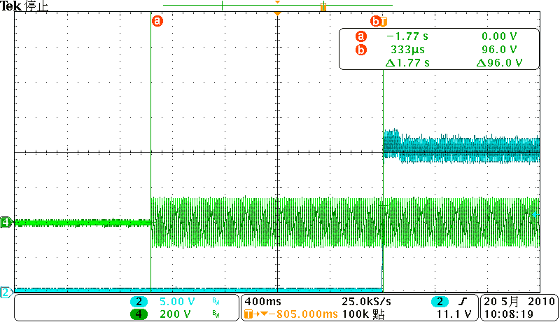

Figure 9 The waveform of Turn on Time at Vin = 90Vac/60Hz & full-load

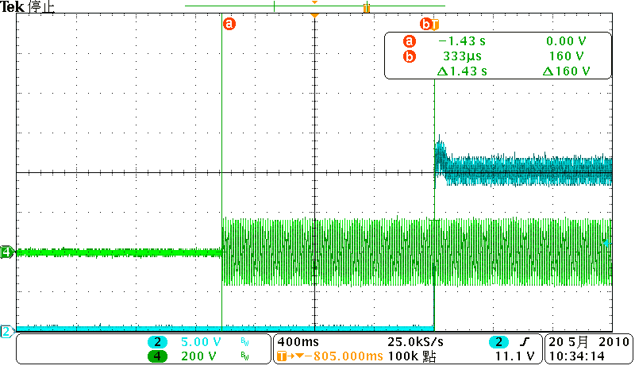

Figure 10 The waveform of Turn on Time at Vin = 110Vac/60Hz & full-load

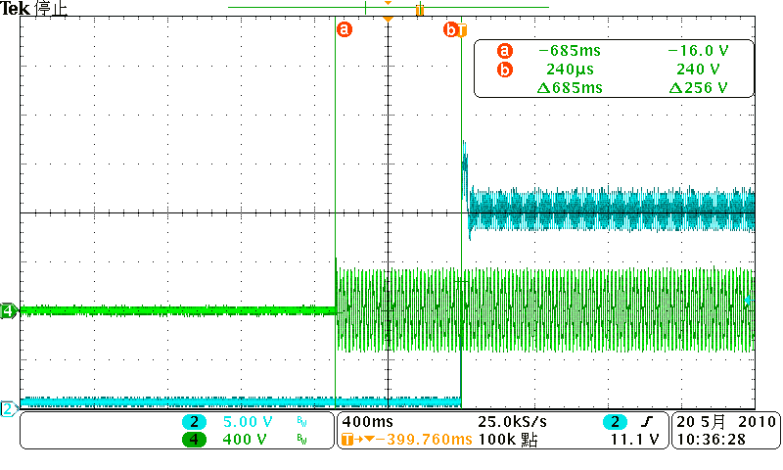

Figure 11 The waveform of Turn on Time at Vin = 220Vac/50Hz & full-load

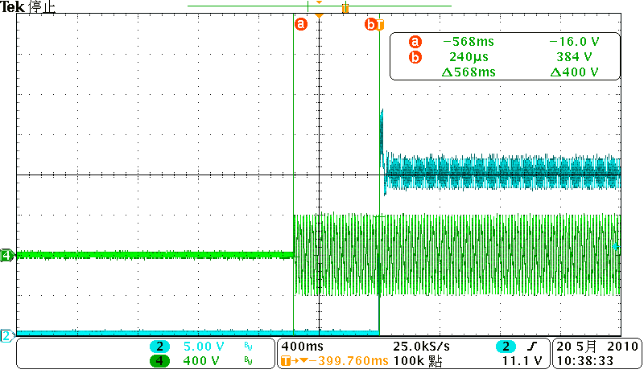

Figure 12 The waveform of Turn on Time at Vin = 264Vac/50Hz & full-load

4.5 Voltage stress on MOSFET
Test Condition:
Measure the voltage on MOSFET and secondary rectifiers on full load.

Vin(V) | State | Stress on  MOSFET | Note | Rating | Stress on  rectifier | Note | Rating
264 | Normal | 596V | Figure13 | 650V | 86.4V | Figure15 | 100V
264 | Startup | 612V | Figure14 | 650V | 92.8V | Figure16 | 100V

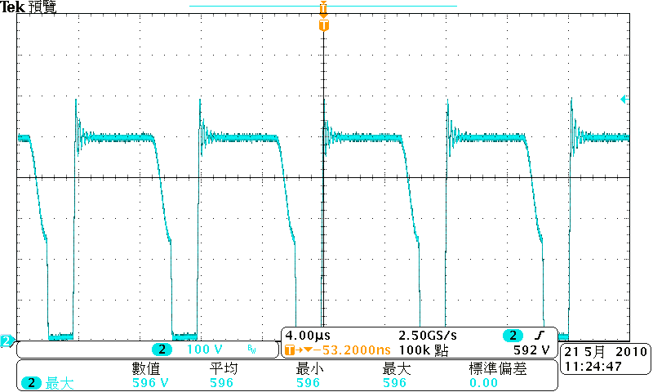

Figure 13 The waveform of Drain at Vin = 264Vac/50Hz & full-load

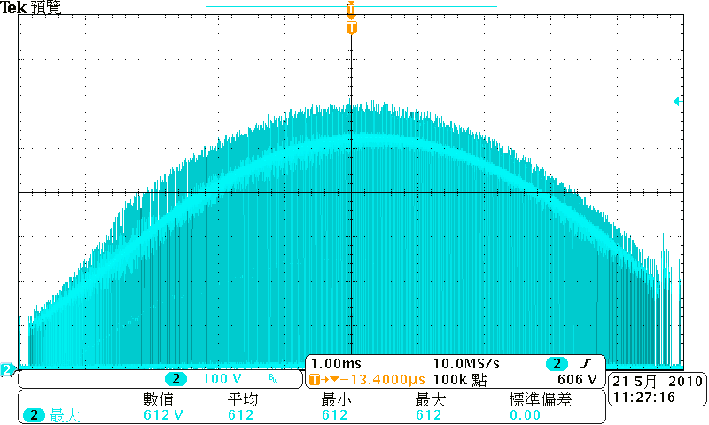

Figure 14 The waveform of Drain at Vin = 264Vac/50Hz & full-load Startup

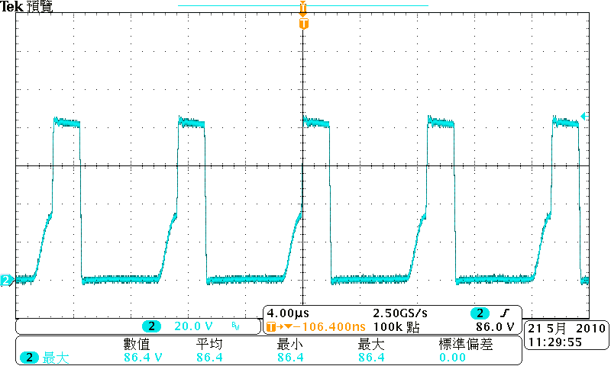

Figure 15 The waveform of rectifier at Vin = 264Vac/50Hz & full-load

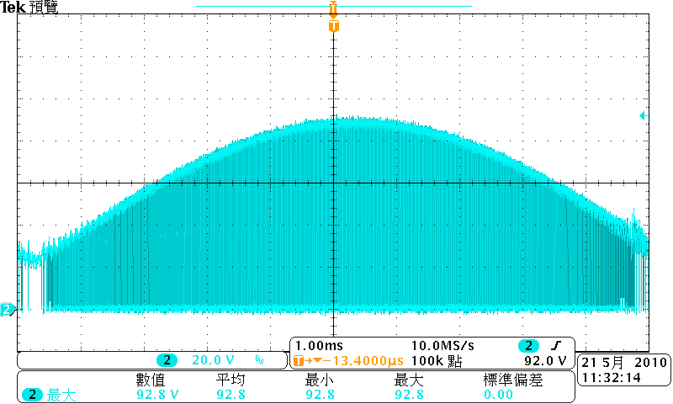

Figure 16 The waveform of rectifier at Vin = 264Vac/50Hz & full-load Startup

4.6 Constant Current
Input Voltage | Current Limit Value(A) | Result
90V /60Hz | 0.298 | PASS
100V /60Hz | 0.298 | PASS
110V /60Hz | 0.298 | PASS
220V /50Hz | 0.298 | PASS
230V /50Hz | 0.298 | PASS
264V /50Hz | 0.298 | PASS

5. Schematic

6. BOM List
序號 | 品 名 | 規 格 | 數量 | 製程 | 打件位置
10 | 晶片電阻 | RES SMD 1/4W 820K F 1206 | 2 | SMD | R1,R2
20 | 晶片電阻 | RES SMD 1/4W 330K F 1206 | 2 | SMD | R3,R4
30 | 晶片電阻 | RES SMD 1/4W 2R7 F 1206 | 1 | SMD | R7
40 | 晶片電阻 | RES SMD 1/8W 20K F 0805 | 2 | SMD | R5,R9
50 | 晶片電阻 | RES SMD 1/8W 0R F 0805 | 1 | SMD | R6
60 | 晶片電阻 | RES SMD 1/8W 68K F 0805 | 1 | SMD | R8
70 | 晶片電阻 | RES SMD 1/8W 180K F 0805 | 1 | SMD | R10
80 | 晶片電阻 | RES SMD 1/8W 10K F 0805 | 3 | SMD | R11,R13,R14
90 | 晶片電阻 | RES SMD 1/8W 47K F 0805 | 2 | SMD | R12,R15
100 | 晶片電阻 | RES SMD 1W 0R33 F 2512 | 1 | SMD | R16
110 | 晶片電阻 | RES SMD 1/8W 1K F 0805 | 1 | SMD | R17
120 | 晶片電容 | CAP SMD NPO 333 25V 0805 | 1 | SMD | C3
130 | 晶片電容 | CAP SMD NPO 104 25V 0805 | 4 | SMD | C4,C5,C6,C7
140 | PWM IC | iP7302 SO8 | 1 | SMD | IC1
150 | POWER MOS | iH0265T SO8 | 1 | SMD | IC2
160 | REFERENCE IC | iP7701 SOT-23-6L | 1 | SMD | IC3
170 | 橋式整流器 | B6S 600V/0.8A | 1 | SMD | BD1
180 | BIPOLAR | 2N2222 | 1 | SMD | Q2
190 | 二極體 | 20V ZENER | 1 | SMD | Z2
200 | 二極體 | 12V ZENER | 1 | SMD | Z3
210 | 二極體 | 800V/1A UF4007 ULTRAFAST | 1 | DIP | D1
220 | 二極體 | 1N4004 400V/1A GENERAL | 1 | DIP | D2
230 | 二極體 | 100V/2A SR2100 SCHOTTKY | 1 | DIP | D3
240 | 二極體 | P6KE200A TVS | 1 | DIP | Z1
250 | X-CAP | 0.15uF/300VAC | 1 | DIP | X1
260 | Y-CAP | 332M | 1 | DIP | Y1
270 | 金屬皮膜電容 | 103/630V | 1 | DIP | C1
280 | 金屬皮膜電容 | 473/400V | 1 | DIP | C2
290 | 鋁質電解電容 | 22uF/25V LONG LIFE | 1 | DIP | E1
300 | 鋁質電解電容 | 220uF/35V LONG LIFE | 1 | DIP | E2
310 | 光耦合器 | PC817 DIP4 | 1 | DIP | Q1
320 | 電感 | 1mH | 2 | DIP | L1,L2
330 | 變壓器 | EFD15 | 1 | DIP | T1
7. PCB Layout
7.1 Top Silkscreen

7.2 Bottom Silkscreen

7.3 Bottom Layer

8. Transformer
8.1 Schematic & Winding

9. EMI Test
9.1 Conduction (EN55015 Class B)

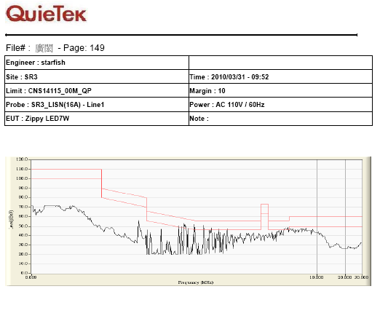

Figure 17 The waveform of Conduction – L at Vin =110Vac/60Hz & full-load

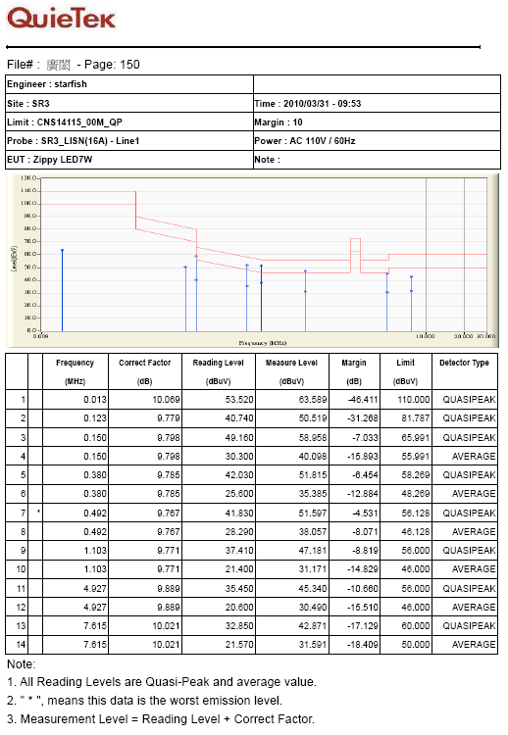

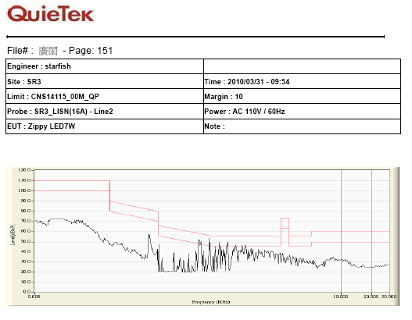

Figure 18 The waveform of Conduction – N at Vin =110Vac/60Hz & full-load

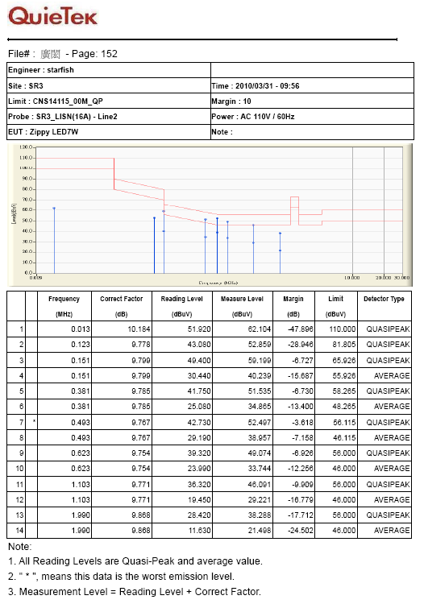

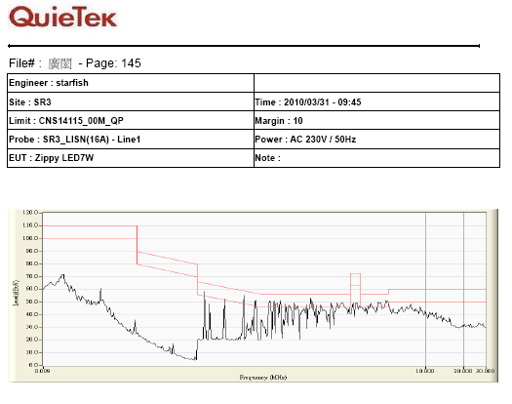

Figure 19 The waveform of Conduction – L at Vin =220Vac/50Hz & full-load

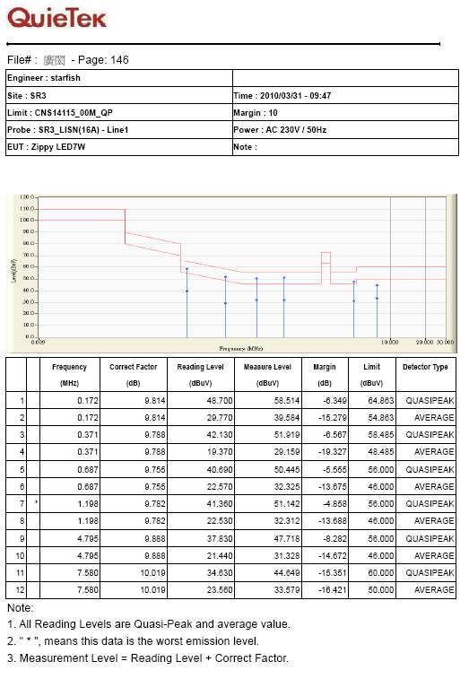

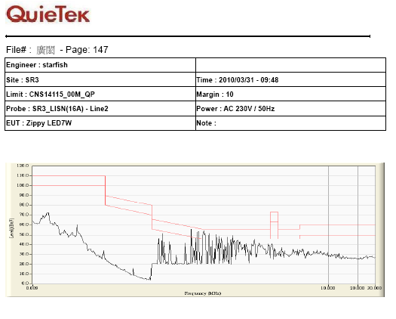

Figure 20 The waveform of Conduction – N at Vin =220Vac/50Hz & full-load

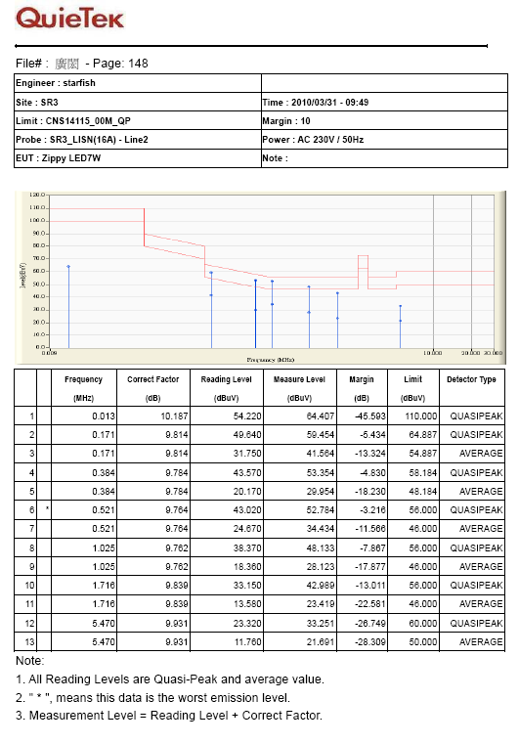

10. Revision History
Ver. | Date | Change Notice
1.0 | 2010/05/04 | Original
1.1 | 2010/05/18 | IC3 change to iP7701  R16 change to R330/2512

