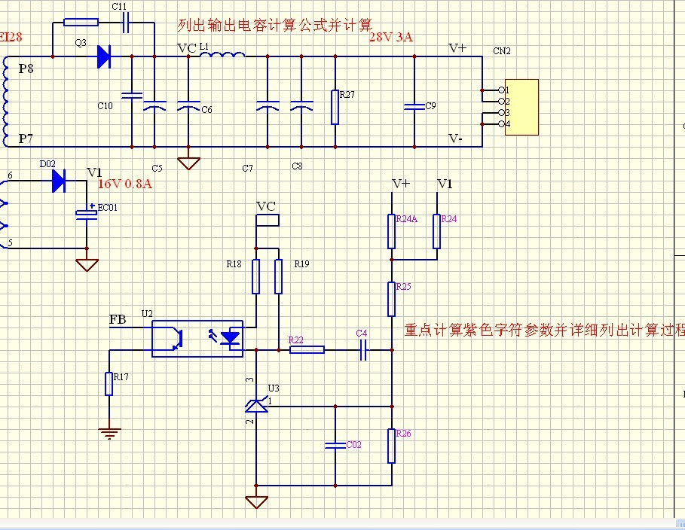
- Vref1=V1*R26/R24A+R25+R26
Vref2=V1*R26/R24+R25+R26
Vref1=Vref2=2.5V
V1=28V
V2=16V
由以上已知条件得出R24A+R25+R26和R24+R25+R26的比值是7：4
- 设定R26=5K,R25=1K
- Vref1=V1*R26/R24A+R25+R26
2.5=28*5/R24A+1+5
R24A=50K
Vref2=V1*R26/R24+R25+R26
2.5=16*5/R24+1+5
R24=26K
- 设定TL431的响应频率50Hz,C4=0.1uF
F=1/R22*C4
50=1/R22*1*10⁻⁷
R22=200K

